Some Joy for the Poorest West Bank Families - posted Thursday, November 23, 2006
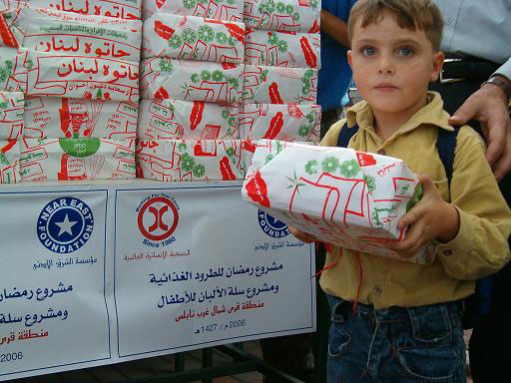
Where our multifaceted programs are concentrated, NEF celebrated the holy month of Ramadan and following Eid al Fiter feast in the "cluster" of nine villages northwest of Nablus, conducting a broad campaign of food distribution. Again NEF teamed with Human Concern International. Poor families received about 500 food packages and 570 packages of dairy products, while 400 packages of sweets went to kindergarten children.
Selected locations were agricultural communities suffering high unemployment: Aseera Alshamalya, Ignisieya, Nusf Ijbeel, Biet Umreen, Yaseed, Al Bathan, Talouza, Sabastiya and Burqa. All have been hard hit by price reductions for their produce and increased costs for raw materials due to Israeli closure policies in the Palestinian Territories.
"This campaign provides some modest relief for poor families suffering from increasing economic hardship," commented Rawan Ghosheh, a United Nations Volunteer with NEF. "I remember in particular the happiness of Ava Muntaser and Hamzeh Ousama, little kindergarten children hurt psychologically and economically....of a mother from Aseersa Al Shamaleya who said the rice package had come just in time..."
"The food distribution also promoted solidarity and spirit among the people and international associations as well as activated community associations. They contribute by selecting those most in need of assistance," she added.

Read more at: http://www.neareast.org/main/news/article.aspx?id=536

