JOINT WOMEN’S PROGRAMME
Annual Report 2013-14

I
VISION AND MISSION
Joint Women's Programme (“JWP”) has been striving for women's self-worth and empowerment, attracting active participation of women, both rural and urban, in spite of the age-old patriarchal, socio-cultural mindset of society. It is a matter of great satisfaction that men are also coming forward and treating women as equal partners in society. The JWP’s focus on mobilizing community leaders in the process of gender sensitization has yielded very encouraging results. Several years of grassroots social action, coupled with participation in national as well as international movements on women and children’s rights, has made Dr. Jyotsna Chatterji, the Director of JWP, and her teammates the guiding light of this movement. JWP is fortunate to have the services of the Coordinator, Ms. Padmini Kumar and Ms. Vimla Pant, Supervisor & Accounts Officer, and all members of the JWP. It has become a role model for an inclusive organization for individual and social development. JWP is duly registered under the Society's Registration Act, 1860 from April 2004; Registration Number S-49003 of 2004. It functions under the collective leadership and support of a fully committed Governing Body.
As a nonprofit, secular and rights based organization, its innovative mission is to facilitate the coming together of Government functionaries, Law enforcing agencies, civil society groups, grassroots organizations and socially concerned individuals, on issues affecting rural and urban women and children under one umbrella. In addition to lobbying and advocating for the rights of the deprived and marginalized women and children, it also runs education cum protection Centres for children, skill training programmes for adolescents and women such as tailoring, computer training and “Durry “making. It also runs and adult education classes for older women and young mothers at Nithari village in Noida, UP, Faridabad, Haryana and Jamia Nagar, New Delhi. JWP believes and promotes mobilized action at grassroots with the help of sensitized community leaders and groups to ensure educational development facilities, care and protection.
JWP addresses all issues and concerns of women such as low status, denial of basic human rights), food, clothing and shelter; violence and crime, including rape, forced marriage and trafficking; lack of education and poor health, ignorance about rights, discrimination, desertion and sexual harassment; lack of control over resources such as land; and low level of decision making powers to name a few. Also for children (denial of identity, low or no status of girl child, malnutrition and poor health, child marriage, child labour, trafficking and prostitution; alarming number of school dropouts and lack of education, and child abuse - physical, sexual, mental and emotional etc.) These are the avowed goal of JWP, because it has been striving to ensure a holistic policy for the development of children and women with suitable and sustainable infrastructure for the 'survival, protection, development and participation', for a truly civil society to become a possibility.
Eradication of all types of exploitation and denial of basic rights of women and children through awareness generation programmes and mobilized action, by networking with likeminded organizations, institutions and individuals is JWP’s commitment. Networking with national women’s organizations for equal justice for women in every field, has led to amendments in laws and policies and new enactments, through advocacy with the law makers has been a successful strategy. The joint struggle for 33% reservation of seats for women in State Assemblies and Parliament is a case in point since 1995. It still needs to be seen through.
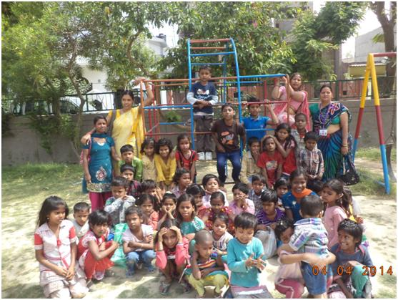

As a partner of the India Alliance for Child Rights, JWP has been enabled to participate in policy analysis, schemes and programmes related to children in order to put pressure on the government for necessary mechanisms for implementation of the above at every level of child rights. JWP is fully aware that with the shifting working population in towns and cities all over India, a lot more needs to be done for children of migrants and displaced families who are mostly from Scheduled Castes/Scheduled Tribe/Minority groups.

II

JWP’S EDUCATION-CUM-PROTECTION CENTRE “MERA SAHARA”, NITHARI VILLAGE, NOIDA, U.P.

Another successful year has concluded for MERA SAHARA, the children’s Centre and community action. The whole community has accepted it as its own. It has continued to fill the void of the much needed primary education and protection from violence for the little children. JWP is very thankful to our supporters for this ongoing miracle for the community where both the parents are out to work the whole day. JWP focuses on the fact that four parameters of child rights - survival, protection, development and participation - are met with equal justice as everyday reality for all the children in this locality is disturbing and changing. We have been rewarded with enhanced awareness, participation and appropriate action for peace and prosperity in the community. Social harmony has replaced quarrels and violence.

THE CENTRE

The academic year 2013-14 for the Centre, started on 11th of April. The teachers were instrumental in the admission of 20 children into mainstream schools. 80 new admissions took place in the three classes and 30 new kids joined the crèche. The parents filled the admission forms given to them with children’s’ names, local addresses and attached photographs of their children as per our norm.
Dr. Jyotsna Chatterji, the Director, chaired an orientation refresher programme for the teachers on May 7, 2013 to reinforce their understanding and responsibilities as teachers for underprivileged children of the society. The bench mark of this exercise, therefore, was understanding the psychology of children, their strengths and weaknesses, developing interpersonal relationships and promoting equality, using play way methods and storytelling, preparing teaching materials, preparing the daily lesson plans, keeping track of attendance of children and monitoring their participation and reaction. Our lesson plans are in accordance with the syllabus prescribed by the U.P. Govt. for classes 1, 2, 3 & 4.
The weekly staff meetings, conducted by Dr. Jyotsna and Ms. Padmini Kumar, have continued to evaluate the weekly progress of children’s participation in their classes. Other issues of child labour, abuse, absence from classes etc. have also been discussed and actions plans formulated and carried out to address the problems.

The teachers have made an exemplary contribution by giving their support and guidance to the children, and have enabled the admission of those qualified into mainstream schools and have been monitoring their performance.

The meetings between parents and teachers have been held by the Director of JWP to inform the parents about their children’s progress and the importance of ensuring cleanliness, good health and peaceful family atmosphere as a special need for child development.

Accounting and book keeping procedures have been fine tuned, including expenditures incurred and the funds remaining in the hands of the accountant, for miscellaneous expenses. All the vouchers, receipts and bills have been properly recorded and filed. The children’s attendance, teachers’ attendance, leave applications and assets have also been filed as usual.
Class IV had to be started last year as 6 of our class III students had qualified for class IV but were unable to go to other schools for lack of ability to pay school fees. This required space as well as a new staff person. JWP is seriously considering starting class V this year for the same reason, resources permitting, of course. The new teachers are Ms. Gayatri Sharma, a post graduate in Sanskrit, and Ms. Anju Singh, a graduate, and both of them happen to be local persons.

NUMBER OF CHILDREN

The Centre had, on an average, 130 plus children in 2013 – 14.
The Centre received 25 more children in February 2014, including school dropout children, taking the strength to 145.
20 children have gone to the mainstream schools.
10 children have dropped out.
10 children have gone to their villages or migrated to other places.
CURRICULUM
Mera Sahara follows the UP School Board syllabus and curriculum and supplies the books and stationery free of cost to the children.
ACTIVITIES
Annual Day
JWP’s Mera Sahara Protection – cum – Education Centre for the children of migrant laborers of Nithari celebrated its Annual Day and Prize Distribution at Community Centre of Noida, Sector 31, on 15th April, 2013.
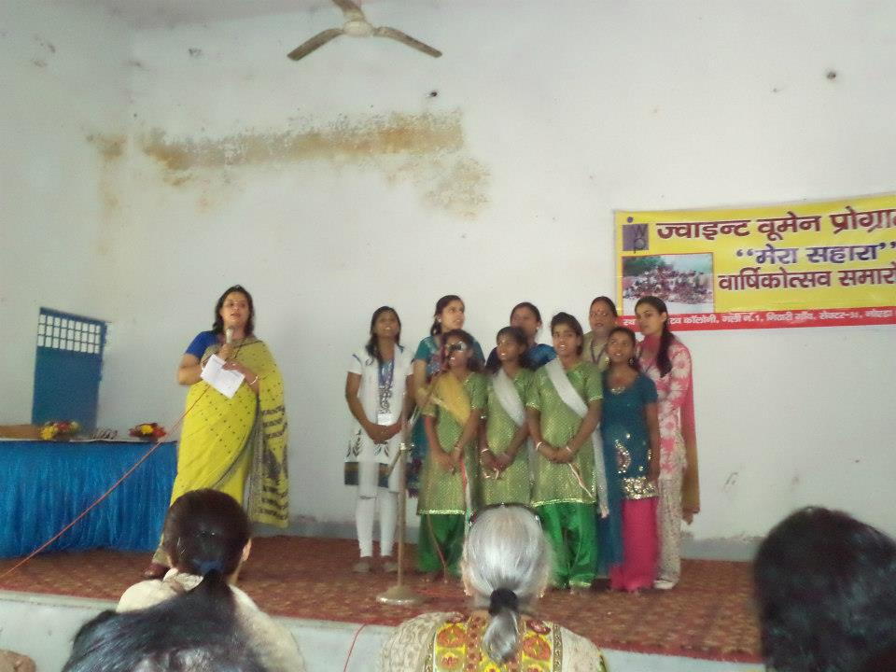
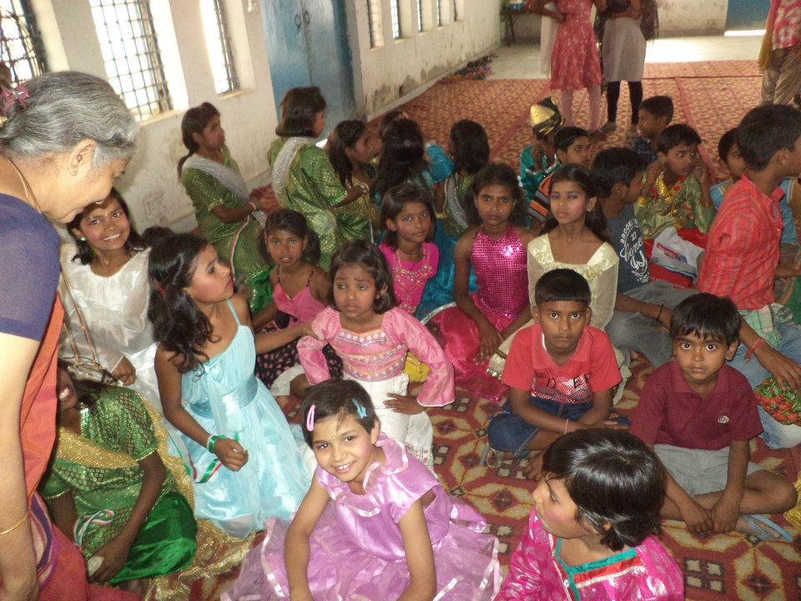

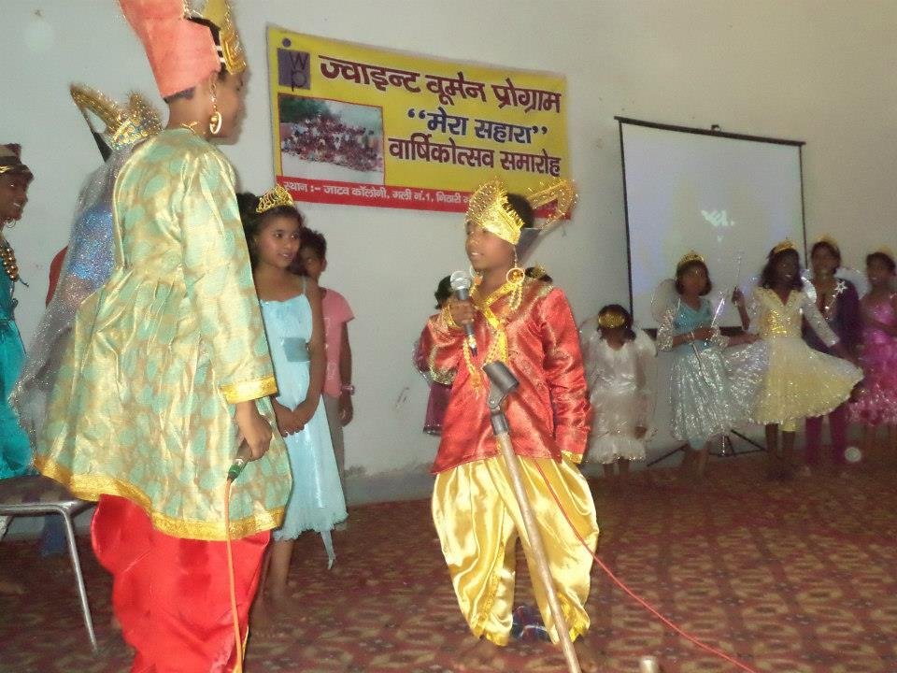
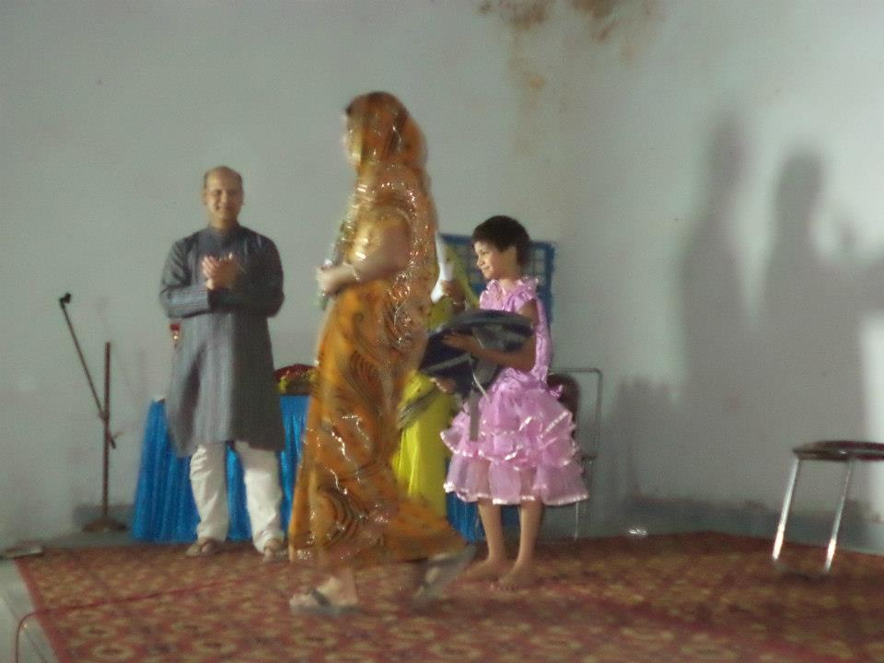

Children visit the museum
M/s. Tata Consultancy Services (TCS) team took the children from Mera Sahara and some from the community on a trip to Science Museum on 5th May, 2013. The happy faces below show how much the group enjoyed it.
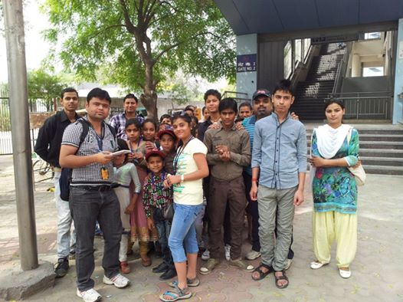
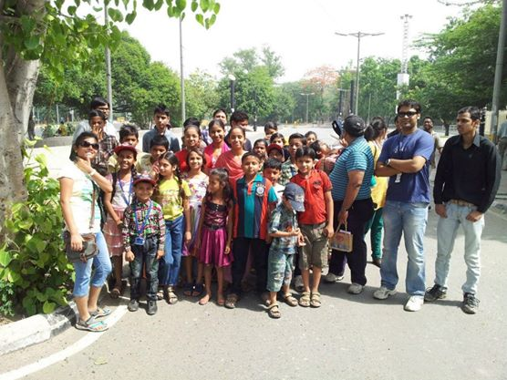

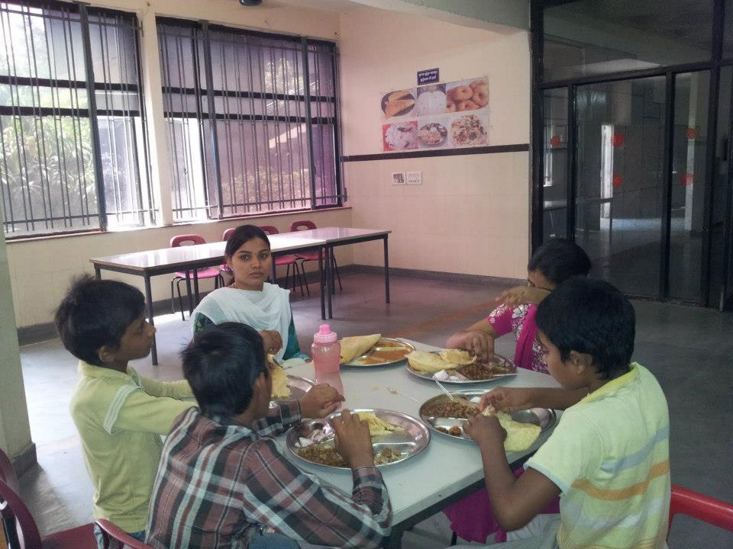
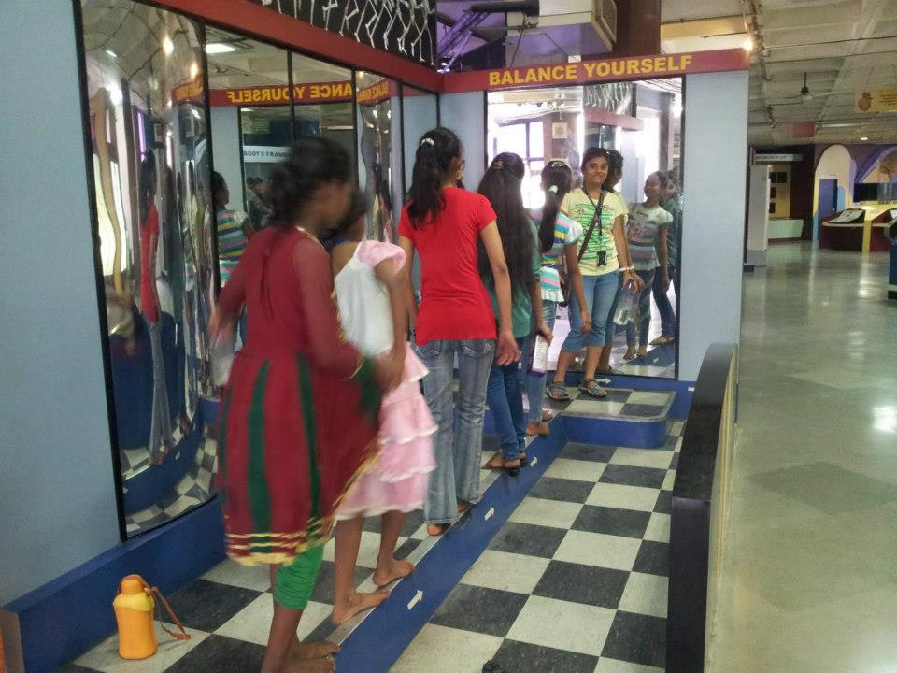

Health Camps at Mera Sahara
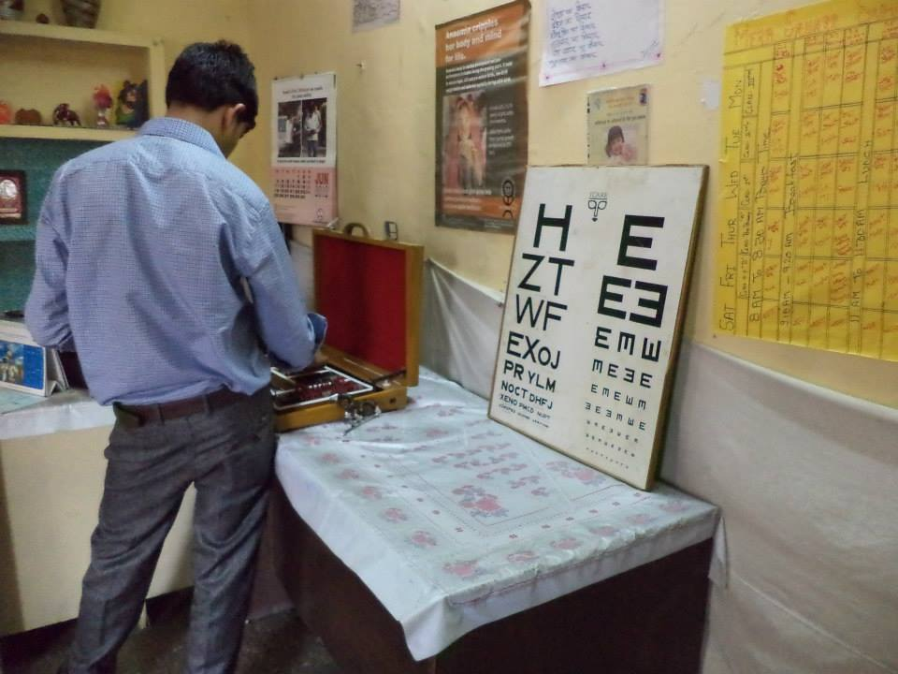
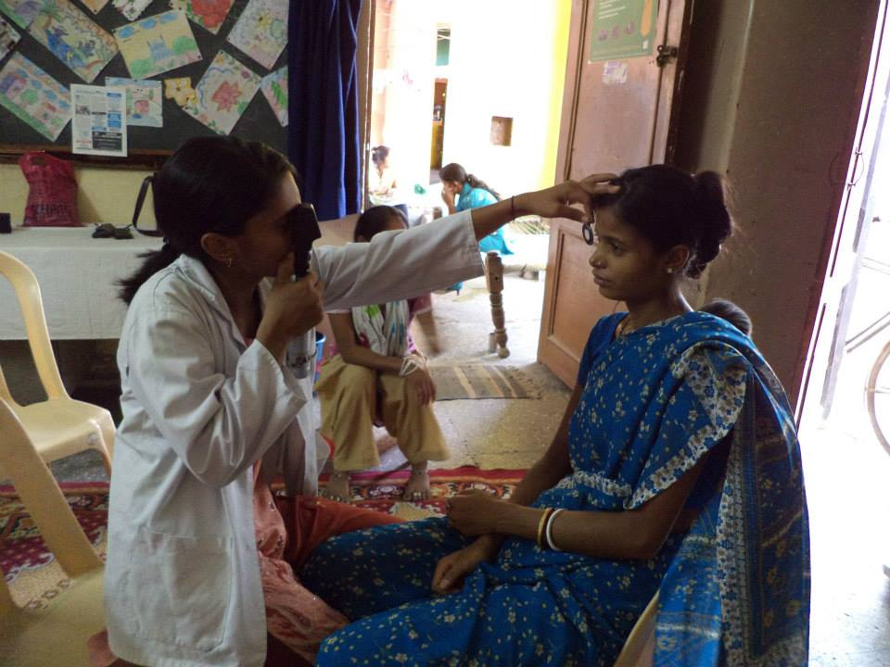
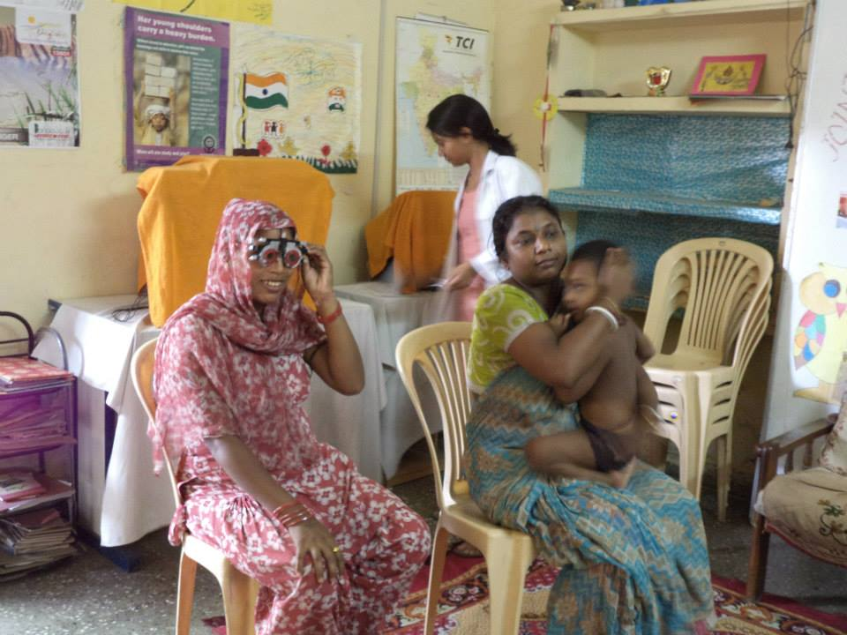

Fun with science
It is very heartening for JWP and TCS that the community children and the children of Mera Sahara, total 50, took part in the 'Fun with Science' activity even in this oppressive weather. It was a group of involved children trying to create a comprehensive, interactive and enjoyable learning session. While the older children had fun with science, the younger ones enjoyed the word making, fun with the dictionary and learning spellings through the scrabble board game. We will have this kind of sessions at least once a month to make learning more Creative and interesting!
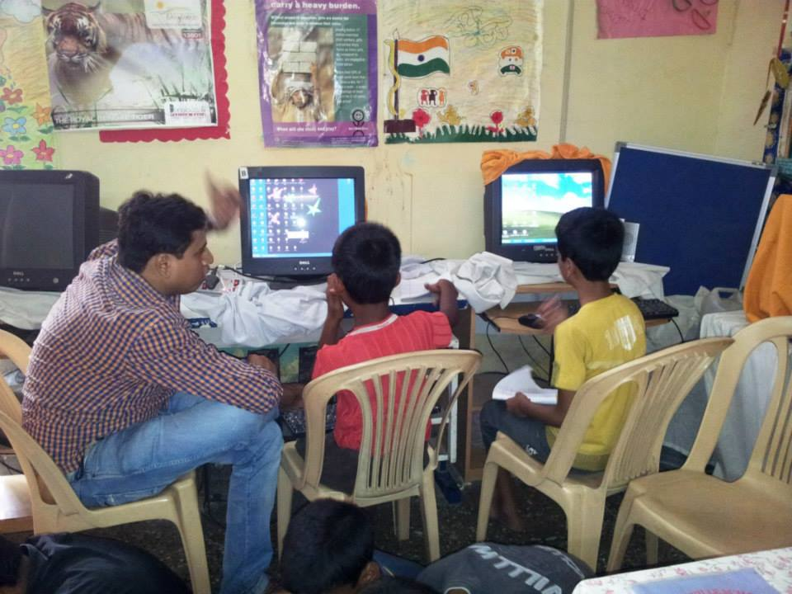
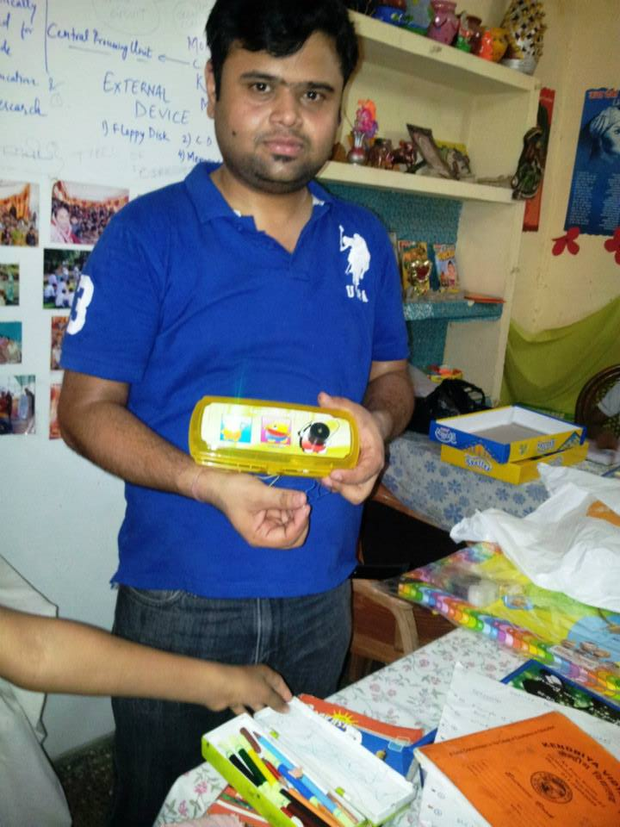

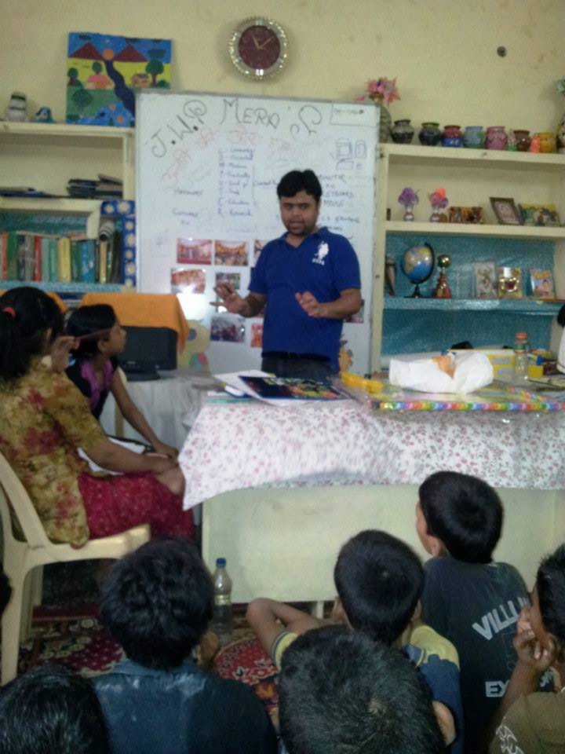
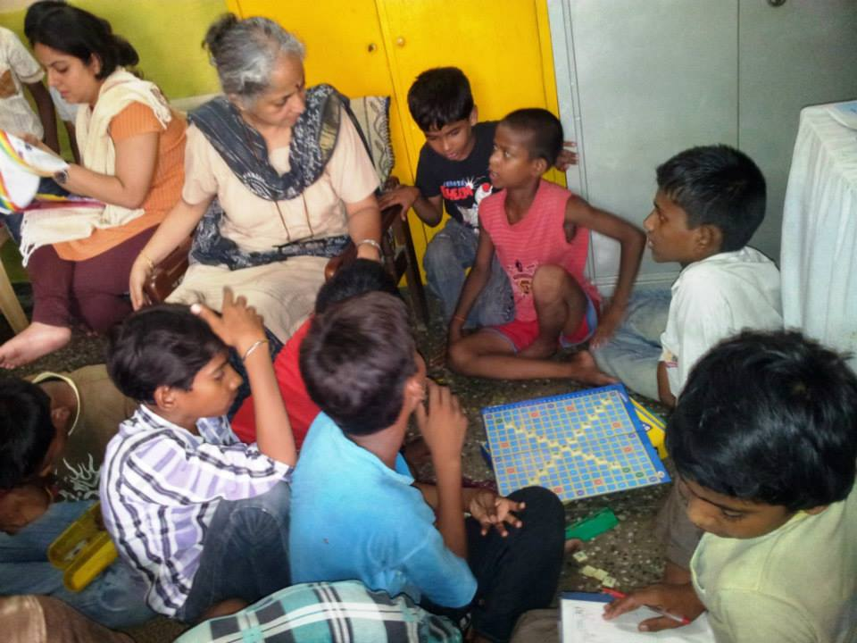

During the rainy seasons we celebrated ‘Tree Plantation Day’ in our school. The children brought pot and plants and Ms. Vimla Pant explained to the children about the plants, trees and their beneficial role to our environment including the benefits of seasonal fruits.
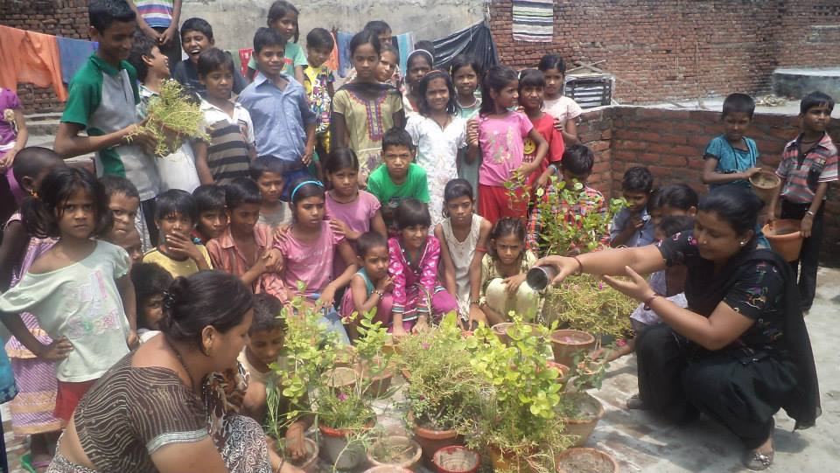
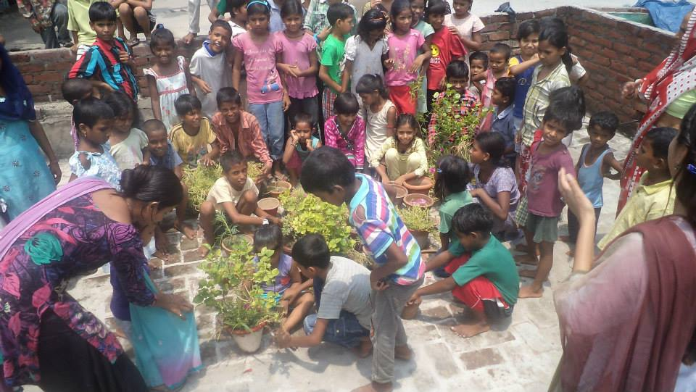
An interesting visit was by the Idealogue Foundation Group from Turkey, who distributed food grains and essentials to the people of Nithari village on 5th of August, 2013.

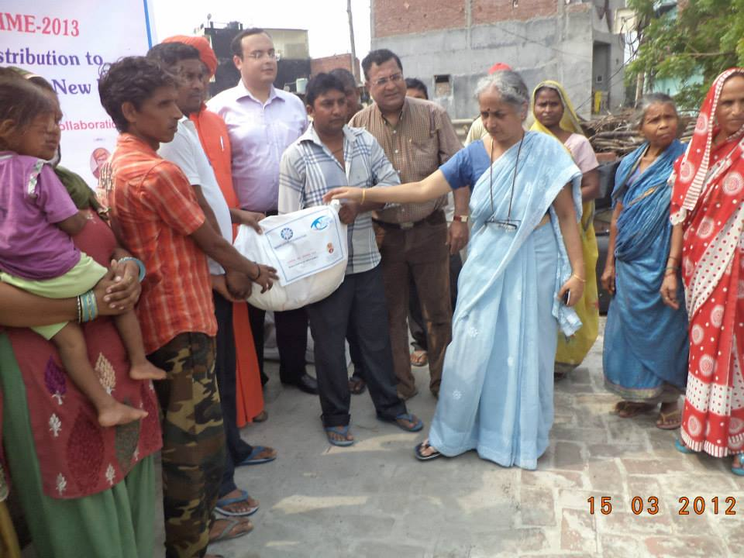

Some memorable moments were captured on Independence Day celebrations at Mera Sahara, Nithari.
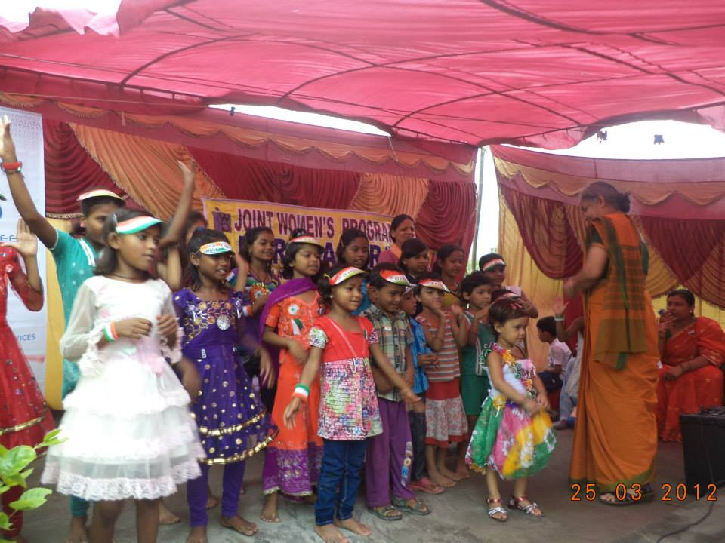
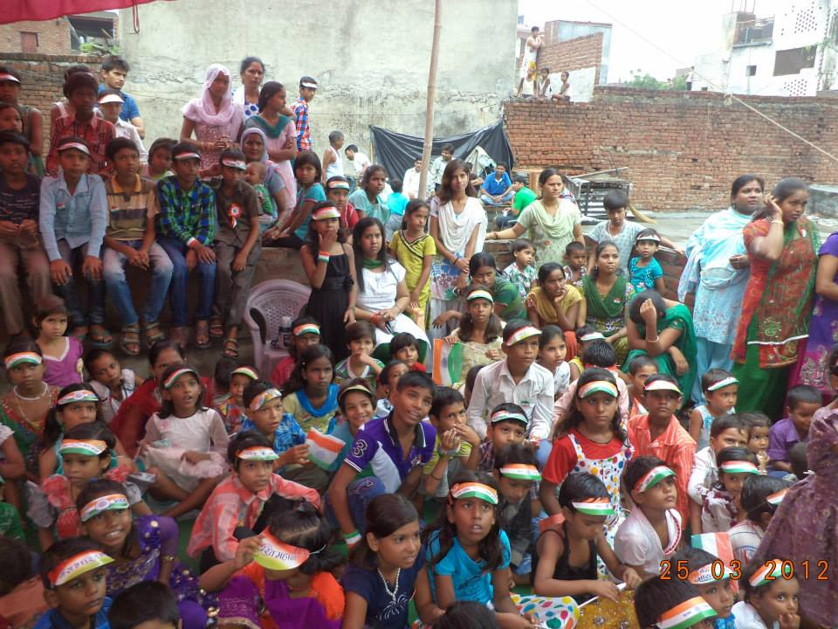

Jamashtami Celebration
Two children from nursery section were dressed up as Radha and Krishna and taken around the Centre and the children thoroughly enjoyed admiring them and dancing around them! Memorable Janmashtami for the kids!

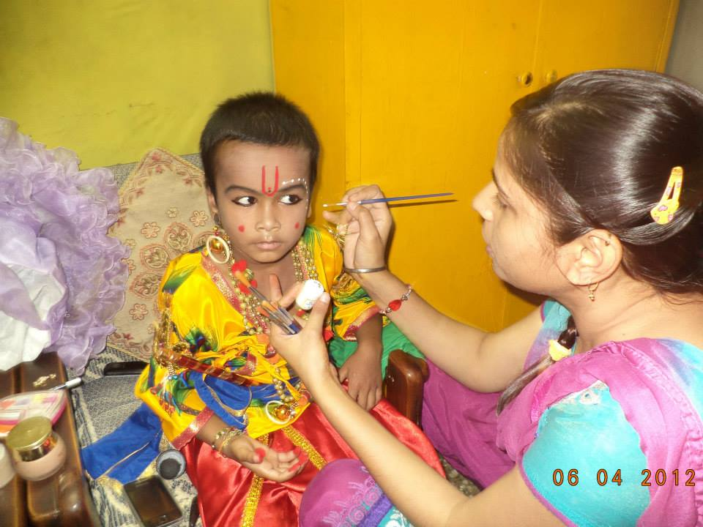
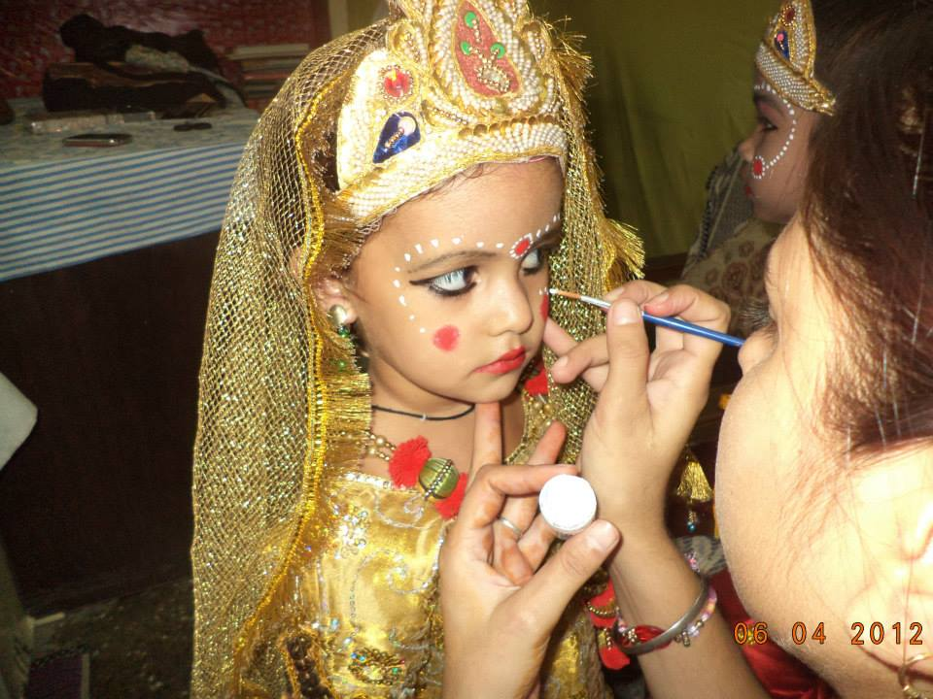

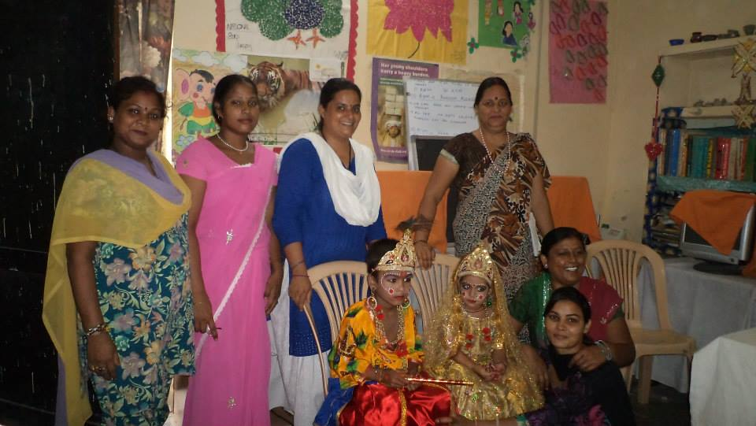
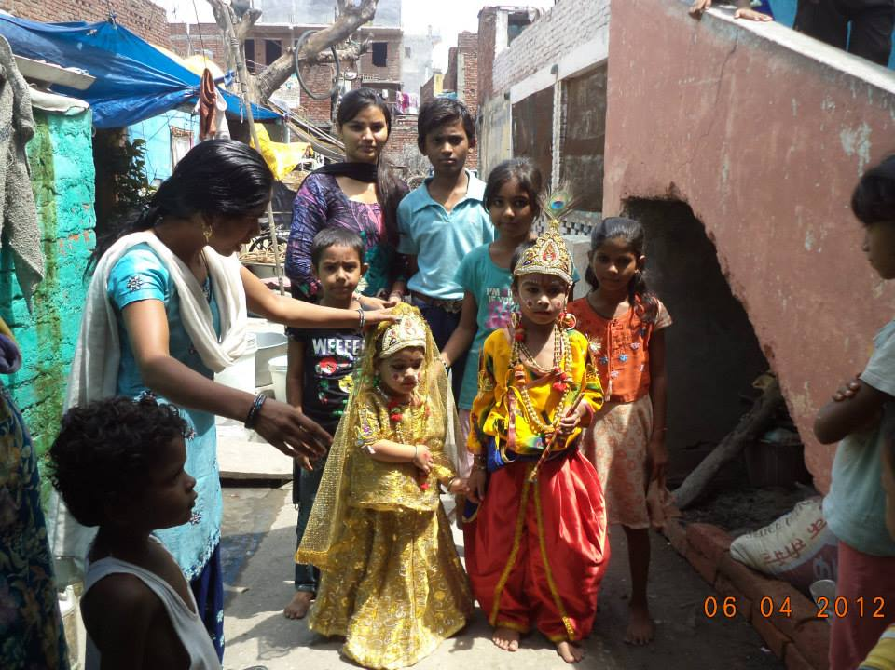

Dr. Jyotsna Chatterji participated a meeting with teachers of the Centre on Teachers Day to discuss their problems and their successes at the Centre when
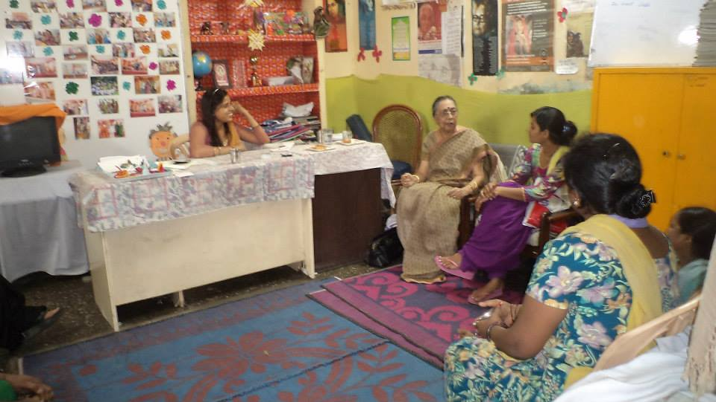

Teachers’ Day was celebrated at Mera Sahara Centre. The members of the Lioness Club of Noida also interacted with the children and presented gift hampers to the teachers and toffees to the children. Photos reflect the happiness all around.
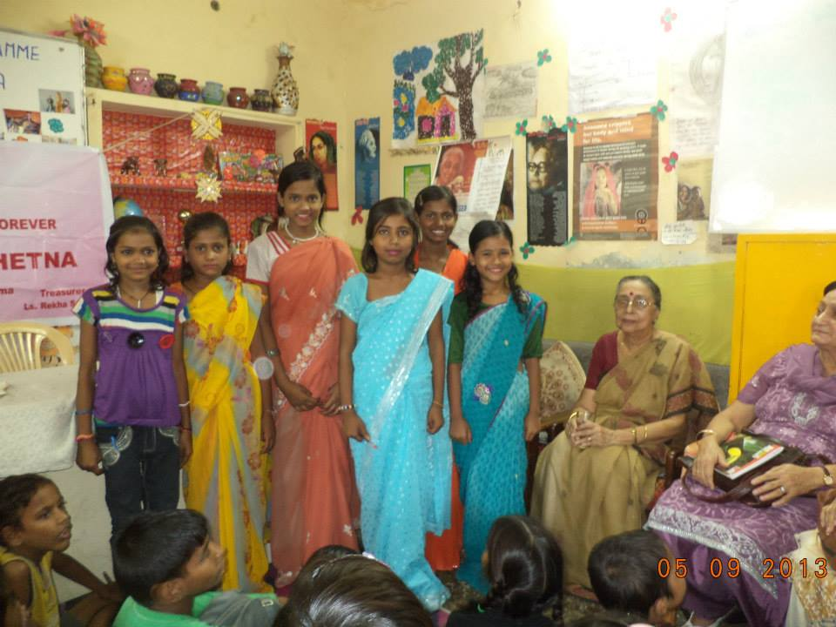
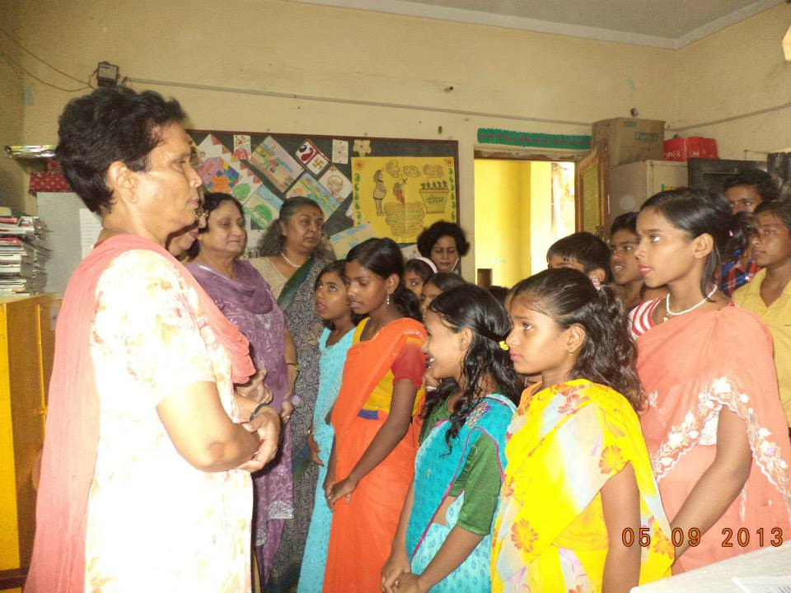

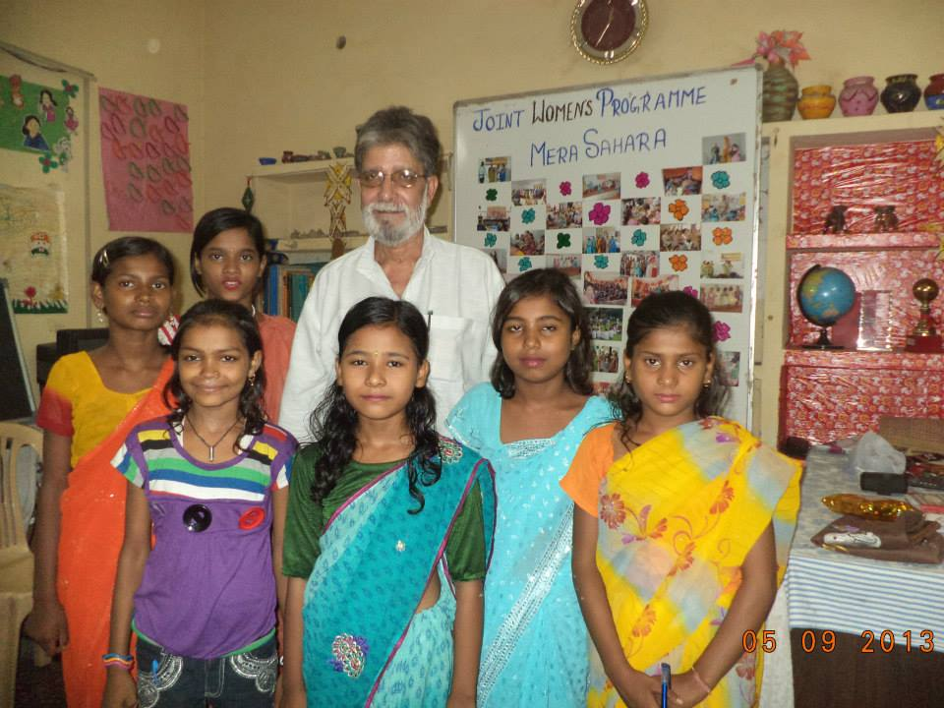
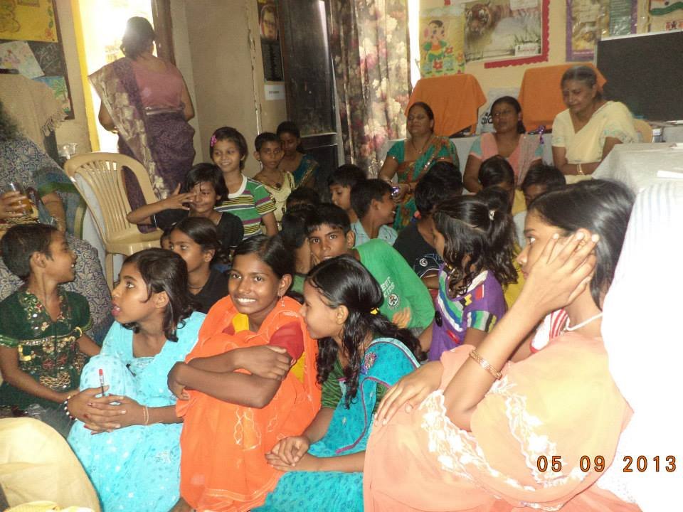

Lioness Club members distributed free school uniforms to the children of Mera Sahara on Sept 19, 2014.
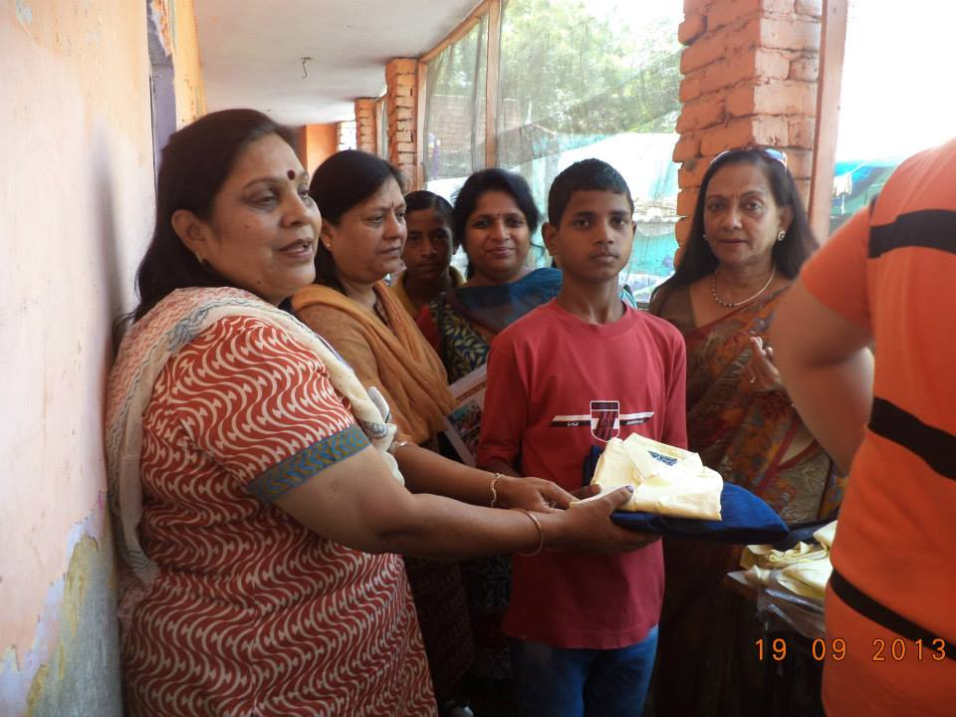
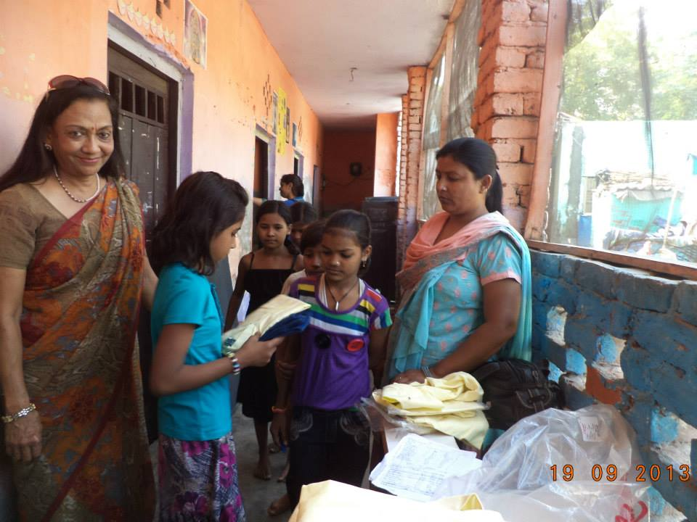

Kids are trying out new uniforms with beaming faces.
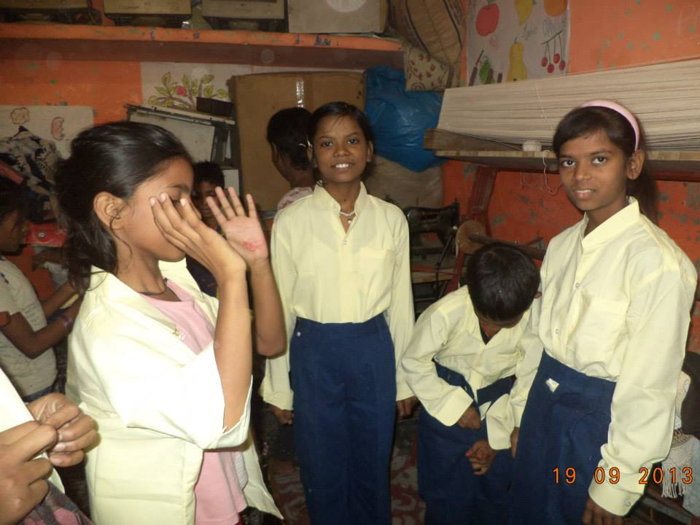
Dr. Jyotsna Chatterji with staff members and Lioness Club members planned a meeting on women's legal rights for the community women and men.
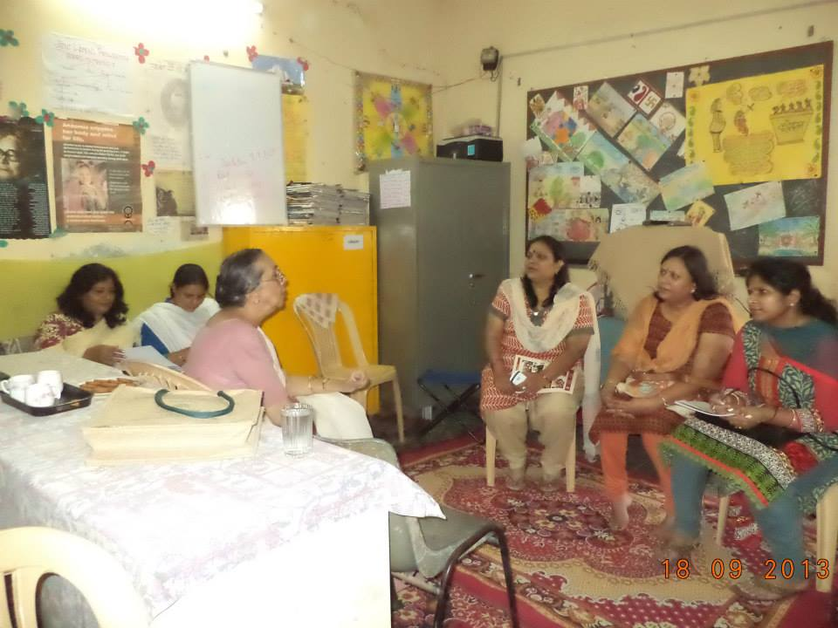

Vimla Pant coordinated the CBN Foundation's photo shooting process. She was very happy with Anushka's bold answers and her not feeling shy while facing the camera. She gave her a hug and a small gift of appreciation.
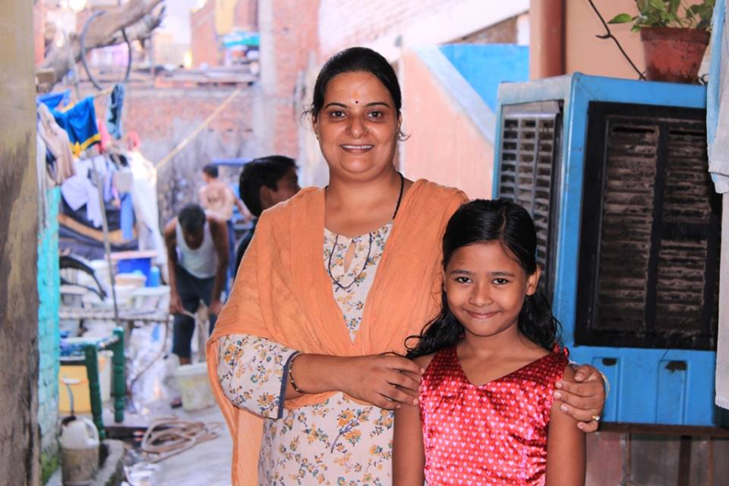
Gandhi Jayanti was celebrated with great enthusiasm at Mera Sahara Protection cum Education Centre. Singing, reading and dance competitions were conducted by JWP and TCS members. Stories from Gandhiji's life were enumerated. The importance of peace, harmony and non discrimination of caste and gender was explained to them. Later TCS volunteers, who had brought a guitar, played on it. The children enjoyed singing 'Raghupati Raghav Rajaram' with the accompaniment of the guitar. The children were given sweets at the end of the event and 1st, 2nd and 3rd position holders were given additional sweets!
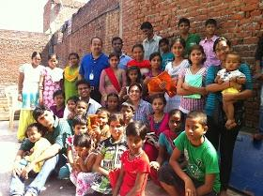
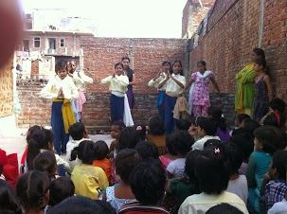

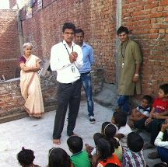
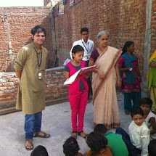

Visit of Sarika Baheti, social activist, and Indian Police Service Officers’ Wives’ Welfare Association on 30th September, 2013 was very interesting as children participated in the discussions on their interests, rights and future plans.
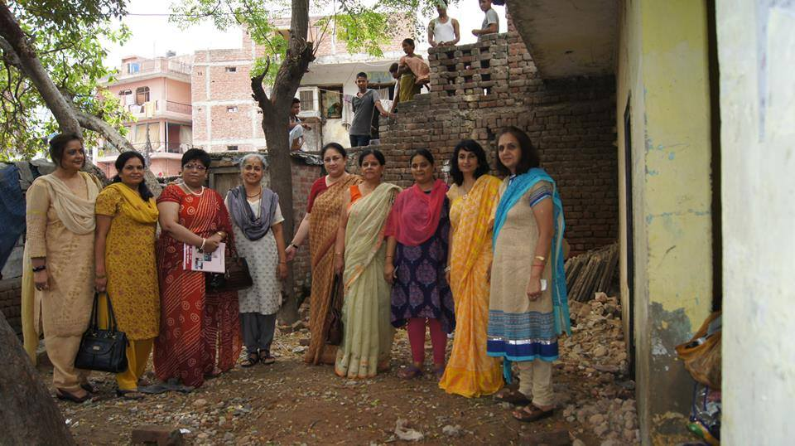
The Ministry of Women and Child Development and the National Commission for Women, Govt. of India, held a ‘Vatsalya Mela’ in Dilli Haat, New Delhi. Mera Sahara team was invited to present a skit on ‘Falling Sex Ratio in India and its impact on the Girl Child’. 7 members and 5 Children participated in the programme. The skit was authored by Ms. Amrita Singh, our class teacher, and the total programme was led by Ms. Vimla Pant. This programme was much appreciated and the team was asked to perform again on the 16th & 28th of November, 2013. On the 16th November, 2013, the second performance was at ‘Vatsalya Mela’ in Dilli Haat, Pritampura, Delhi and the 28th November programme on ‘Girl Child Education’ was also at Dilli Haat, Pritampura, Delhi.
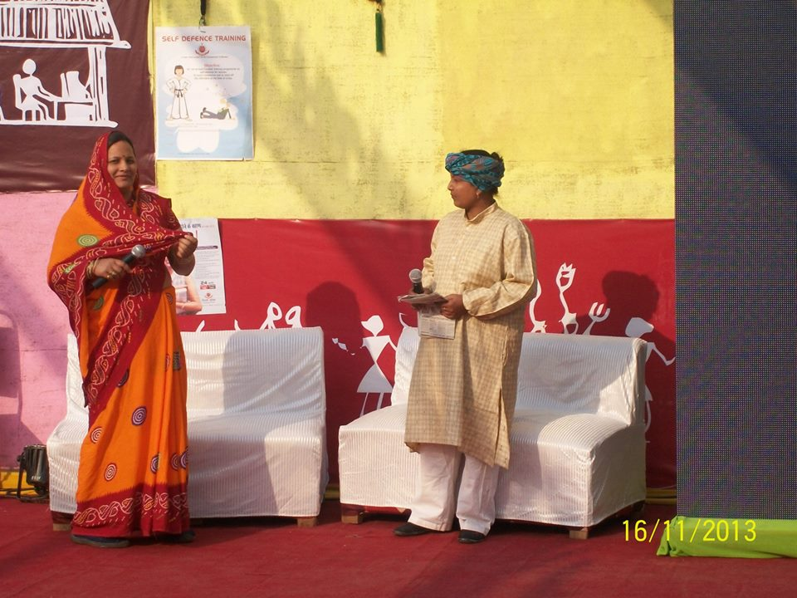
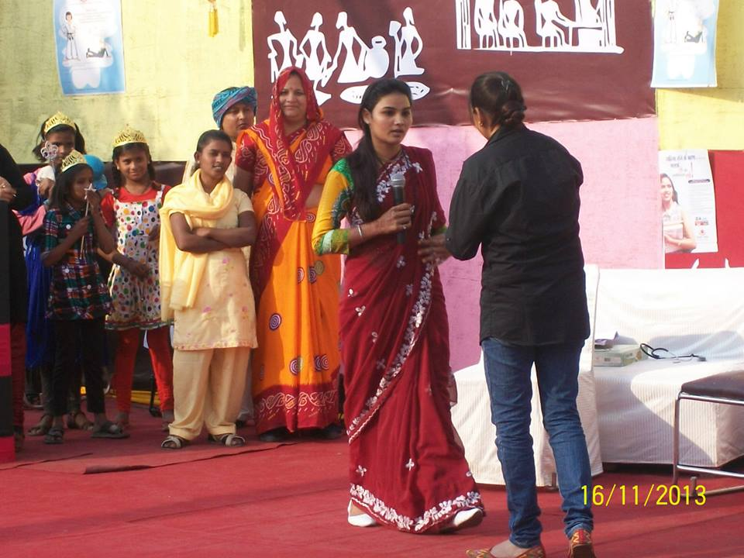

The Centre children were invited by the Lioness Club in Noida to take part in the ‘Vishal Bal Divas ‘celebration in Sardar Patel Vidyalaya, Nithari, Noida.
Dipali (Class 3) won a prize for reciting a poem on the girl child. The children won group prize for dancing and seven individual prizes in the drawing competition.
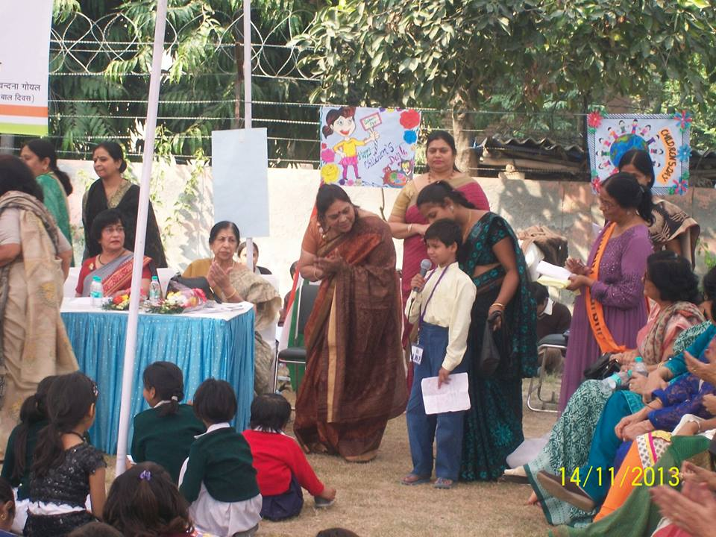
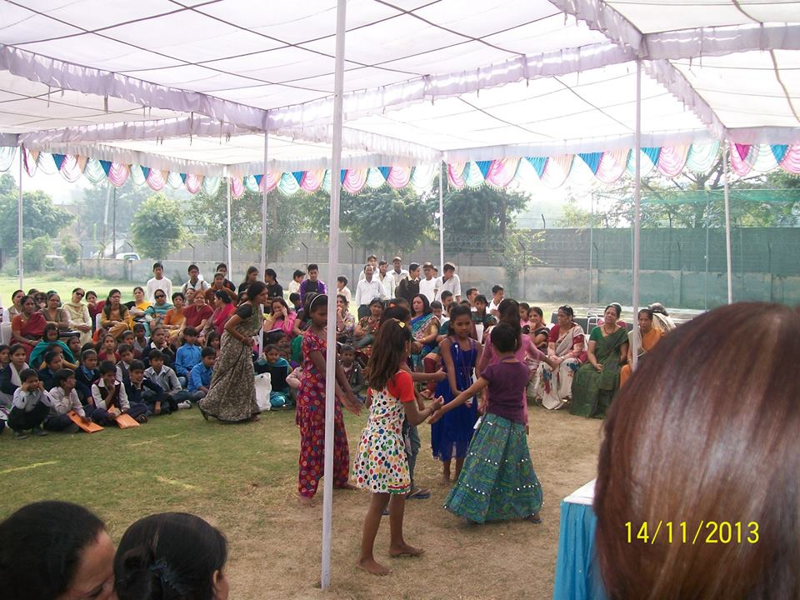

Inauguration of Vatsalya Mela by National Commission for Women and WCD on 14th Nov, 2013 at Dilli Haat, INA
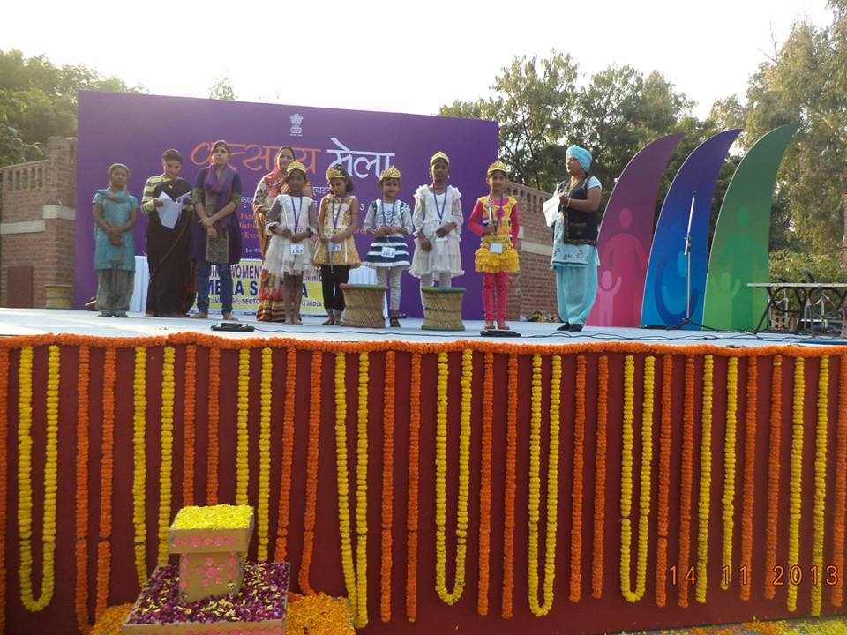
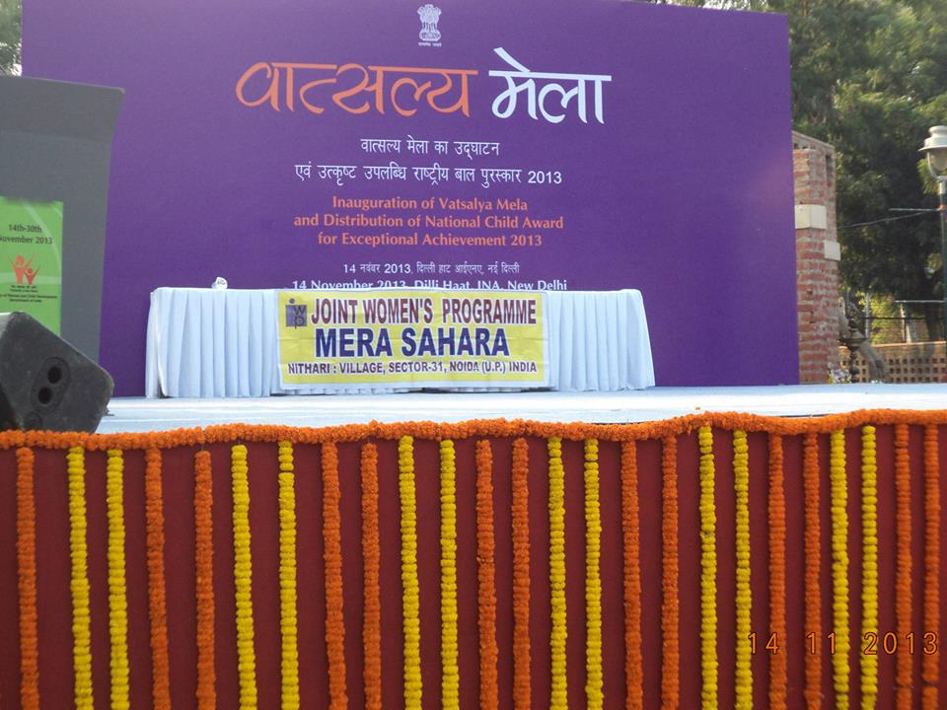

Ms. Rohini Muthuswami, Asha for Education, volunteer in India, visited Mera Sahara Centre on the 28th of Nov. and was very impressed by the developments
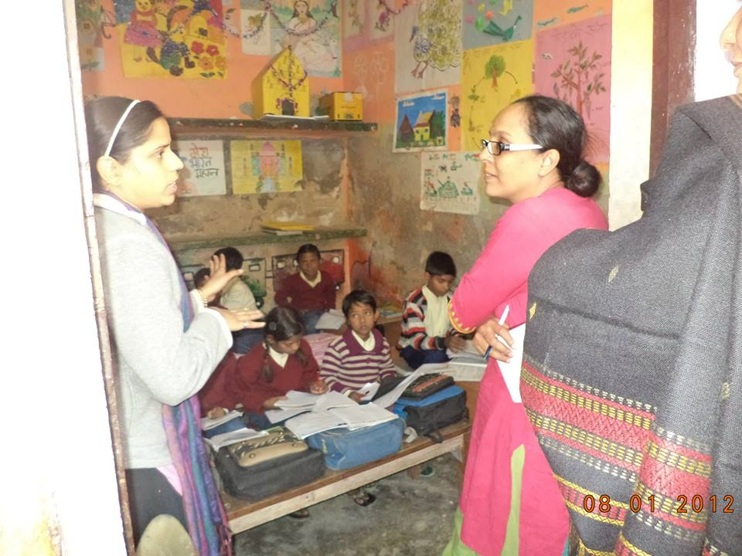
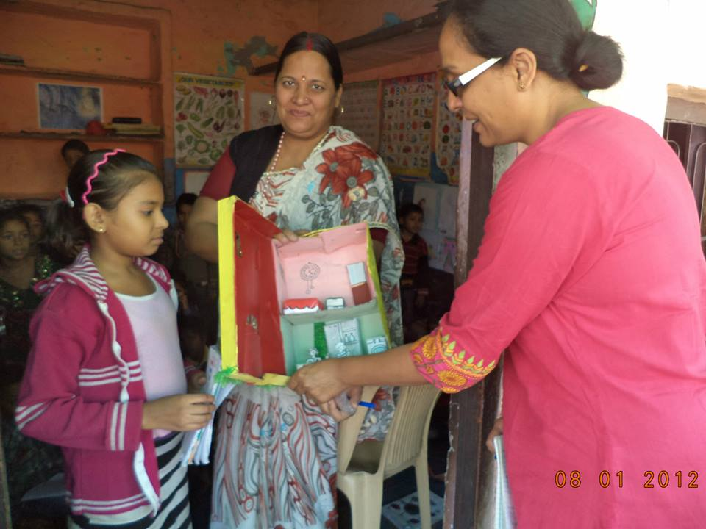

Mera Sahara teachers and students with the TCS team visited the Zoo on 25thDecember, 2013. Thanks to the Zoo administration for giving free passes to kids below 12 Years. JWP also thanks TCS “Maitree” Team and all the Volunteers who decided to be with the Children on this Day and help in overall planning to make this event a memorable one for every one in the New Year, 2014!!!

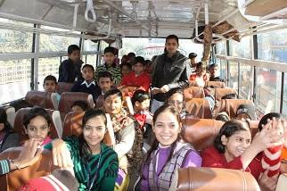
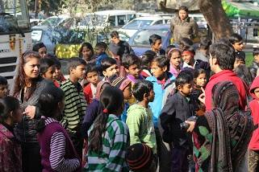

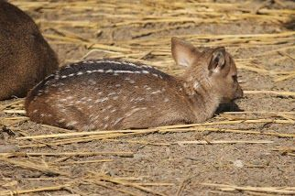
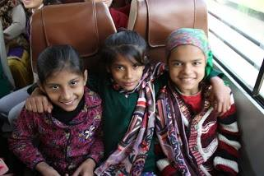

Mera Sahara has shifted to a new location in Nithari on 18th December and started functioning with renewed energy and enthusiasm. It was formally inaugurated by Dr. Jyotsna Chatterji on 26th December. Christmas was also celebrated the same day with great enthusiasm and sharing of gifts and sweets.
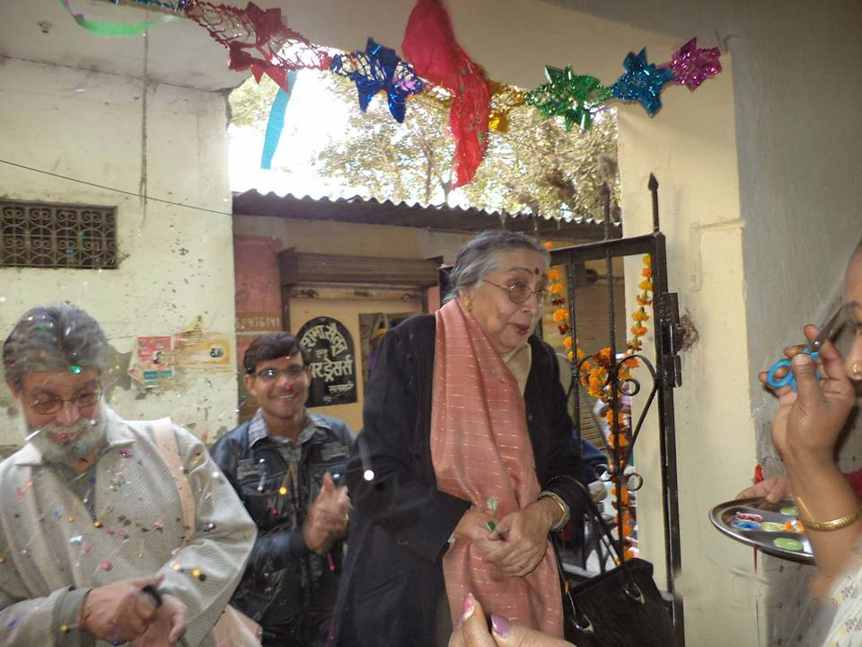
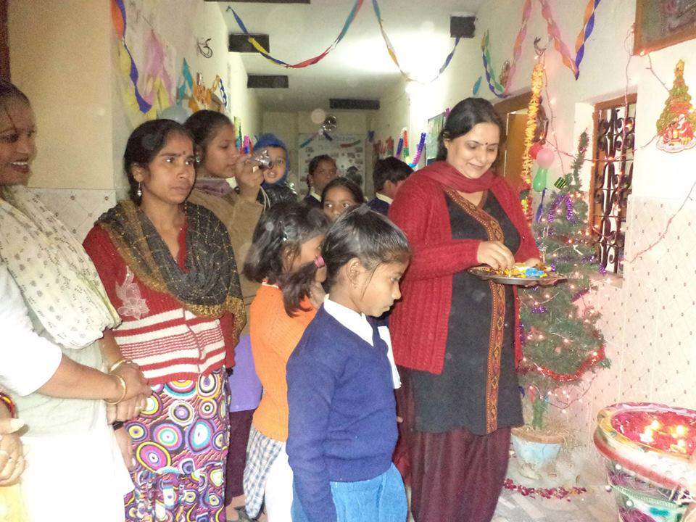

26thJanuary, 2014 (India’s Republic Day Celebration)
Republic Day was celebrated by all the children and staff of Mera Sahara Center. At first the national flag was hoisted on the terrace of the school and then the National Anthem was sung by all the staff and children. The children presented beautiful dances and songs depicting nation building messages. Hindi debate competition on Republic Day was between classes 3 and 4. Geeta was adjudged the best speaker on Republic day. The celebrations ended with sweets, cakes and bananas offered to all the children.
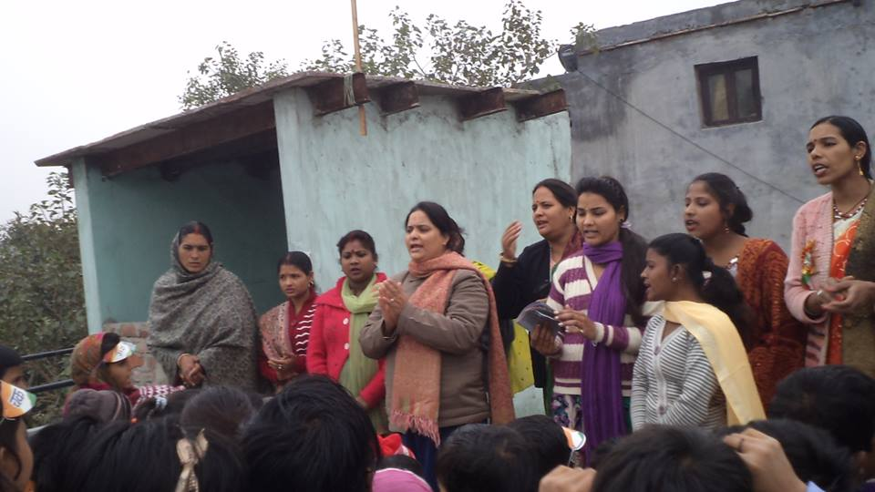
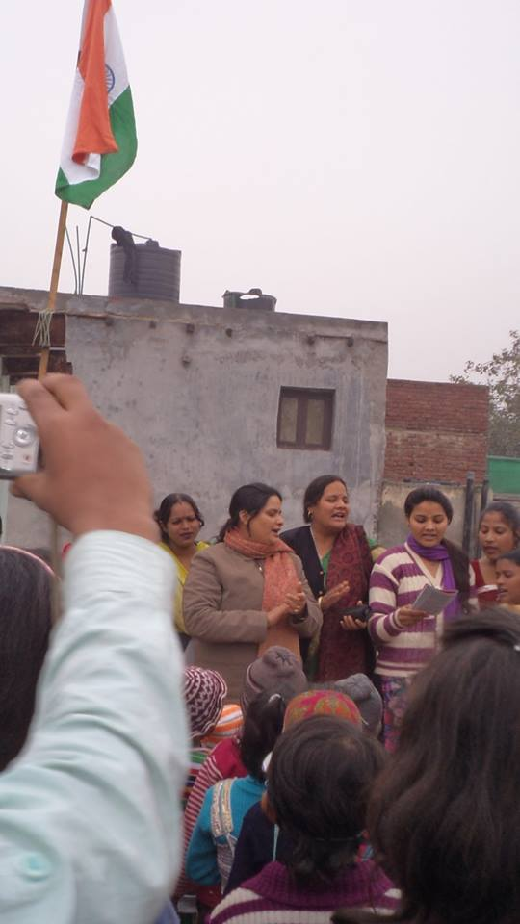

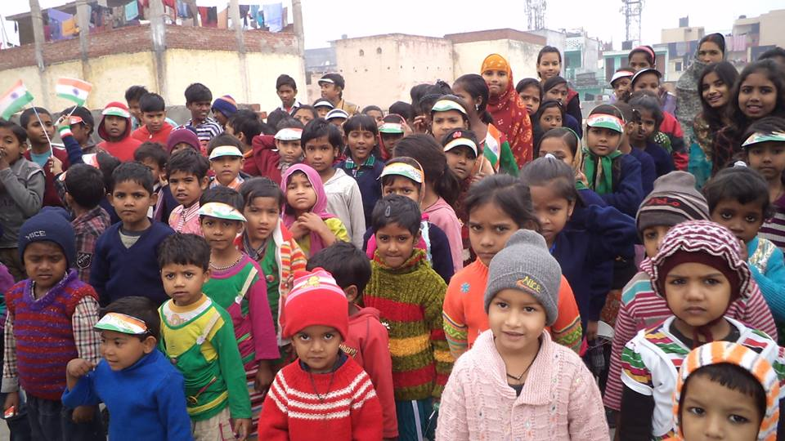

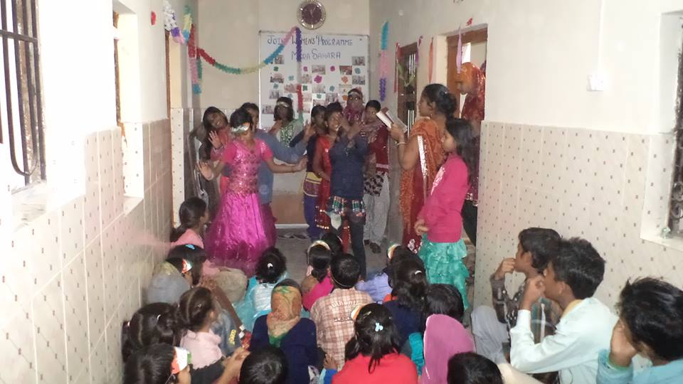

Vasant Mahotsav was held on 22nd February, 2014, at Govt. Primary School Nithari Village, Sector - 31. Our children participated with great enthusiasm.
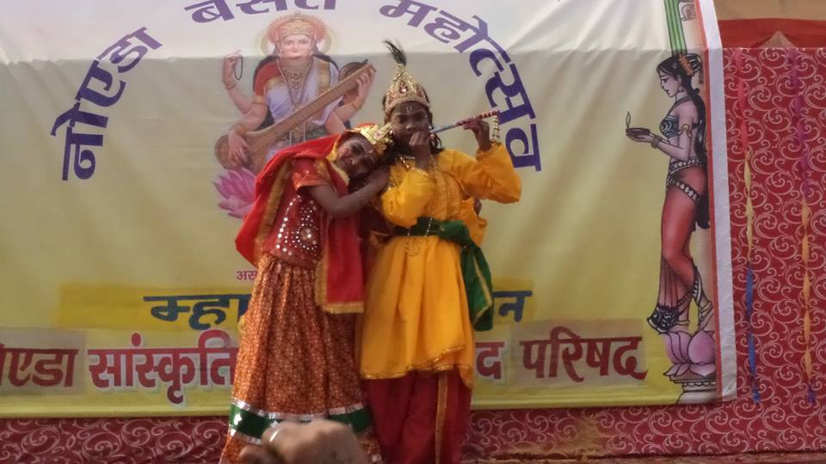
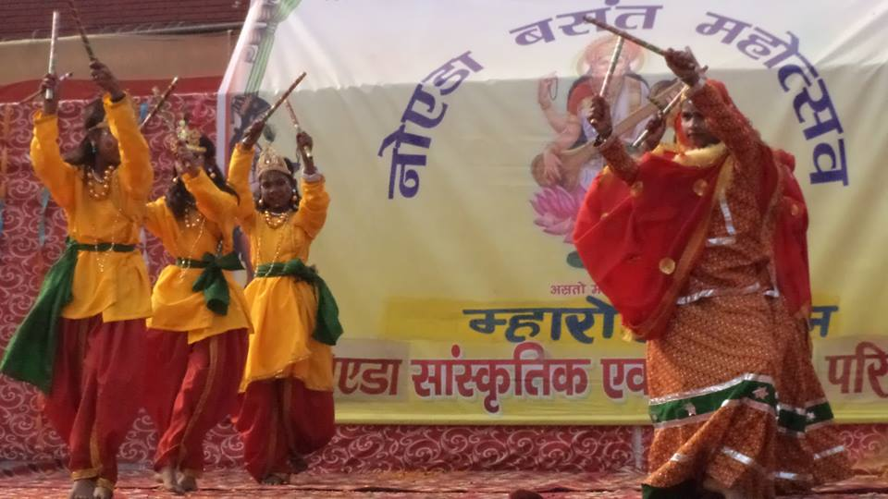

Dr. Christina Schwabeland visited our project Mera Sahara, the JWP's initiative for the empowerment of Women and rights of children. Christina is teaching at University of Bedfordshire, England. She is on a research trip to India to learn about the grass root work carried out by national level organizations, like JWP which is headed by Dr. Jyotsna Chatterji.
She interacted with the skill Centre women and the children of the community and asked several questions regarding the role played by JWP in the process of the development of women and children and the role of the community in a multi-religious group.
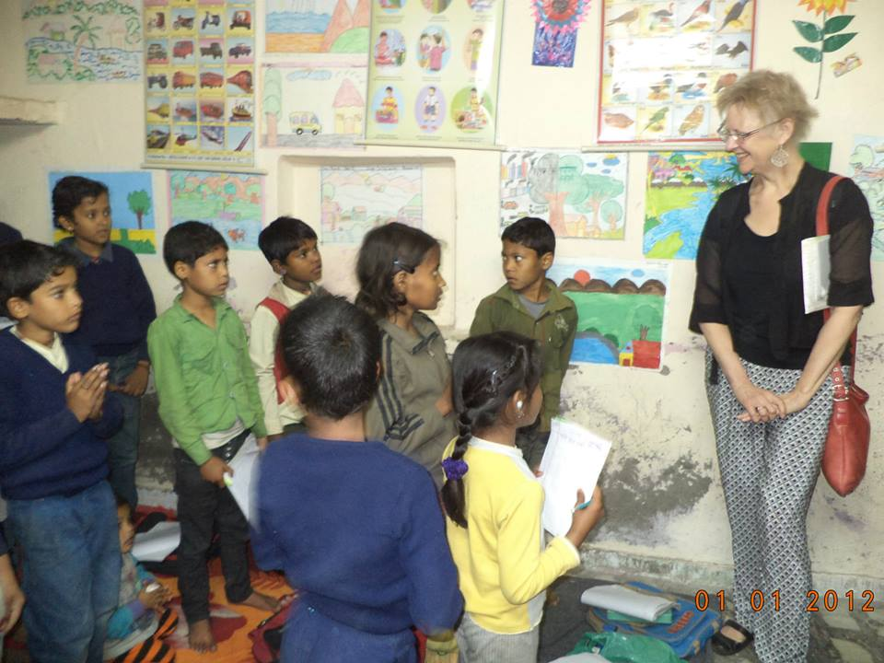

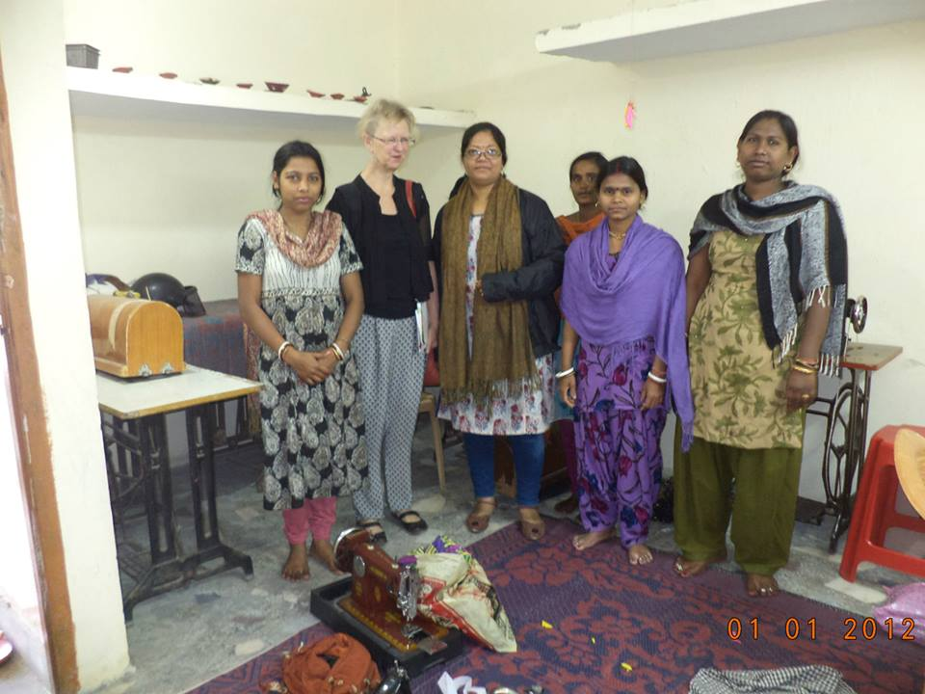

These are pictures of 9th March, 2014, programme conducted at our Mera Sahara Centre and Govt. Primary School in Nithari.
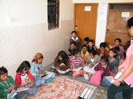
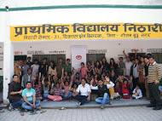

The Nithari Computer Literacy Programme, being run by the volunteers of TCS NOIDA, every Sunday, introduced new team members of TCS to the JWP's Community Children Programme in Nithari.
The children enjoyed the quiz programme and later had a singing session with a keyboard and guitar to liven up the event.
Ms. Sangeeta Talukdar's visit from Women's Association of India, UK, was encouraging for us. She had learnt about “Mera Sahara” from Dr. Chatterji’s letter to her organization in the UK.

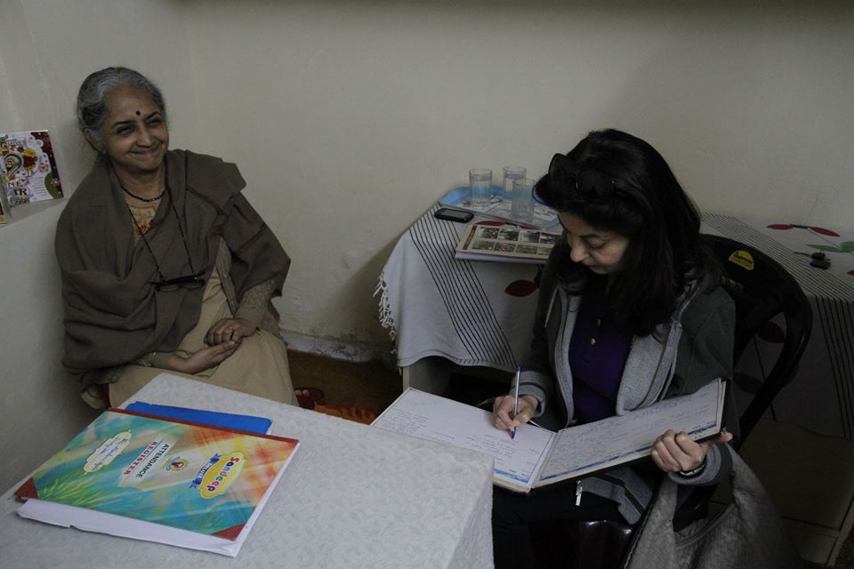
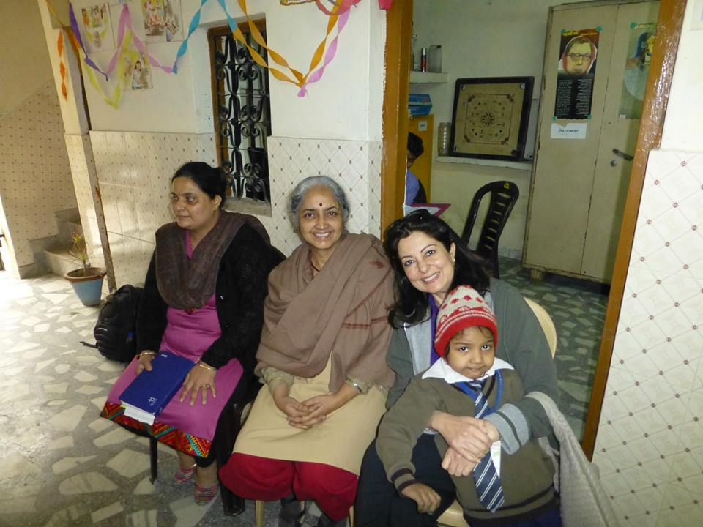

'Mera Sahara' celebrated Holi festival on the 15th of March. The children were asked to bring colours without chemicals. Amrita, our Pre Primary class teacher, explained the importance of playing with colours with community to celebrate harmony and peaceful coexistence. She also narrated stories from the epic Mahabharata. The children were made to shout 'HO HO Holi re' to set the mood for the festival of colours.
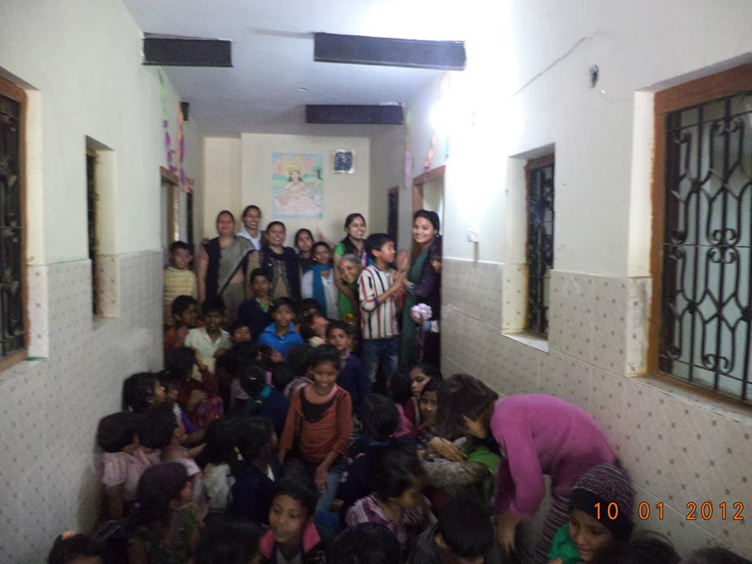
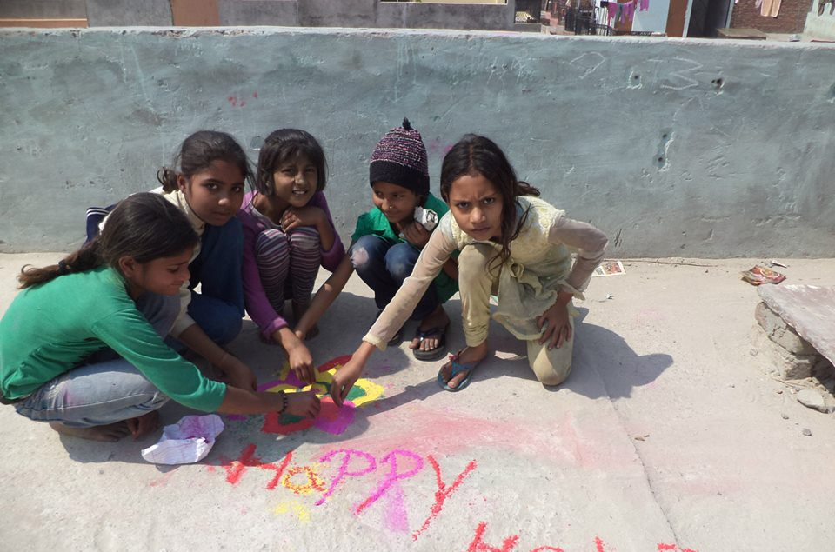

'Outstanding Women' for this year was awarded to Dr. Jyotsna Chatterji, Director of Joint Women's Programme, on the occasion of International Women's Day celebrations organized by National Commission for Women (NCW).
Ms. Padmini Kumar is seen receiving the award from Dr. Charu Wali Khanna, Member, NCW, on behalf of Dr. Jyotsna Chatterji, who could not be present at the grand ceremony because of hospitalization. Ms. Mamta Sharma, Chairperson NCW, is looking on.
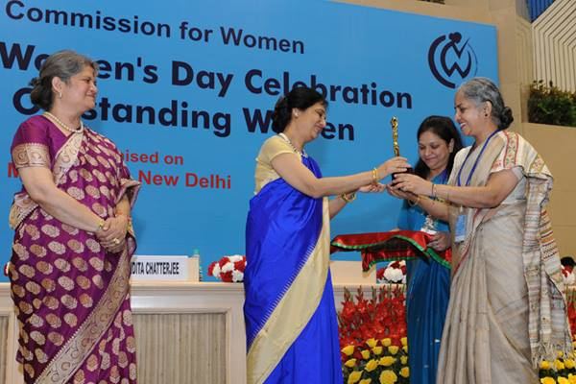
III
WOMEN AND COMMUNITY
JWP is running three centers for women and community.
- Mera Sahara Nithari village, Noida.
A holistic empowerment and development of women and community is running into its 6th year with changes visible all around with better health, economic status and confident faces.
Besides the protection-cum-education center for the children of migrant laborers with a crèche for infant siblings, it runs adult education program for school dropout adolescent girls and women. Tailoring, computer literacy and Durry making are popular for skill development.
There are regular meetings with community women and they have started to participate in JWP activism for issues related to women; such as One Billion Rising (OBR) against Violence and 33% reservation of seats for women in State Assemblies and Parliament with street meetings/plays etc.
Skill Centre for school drop outs at Mera Sahara:

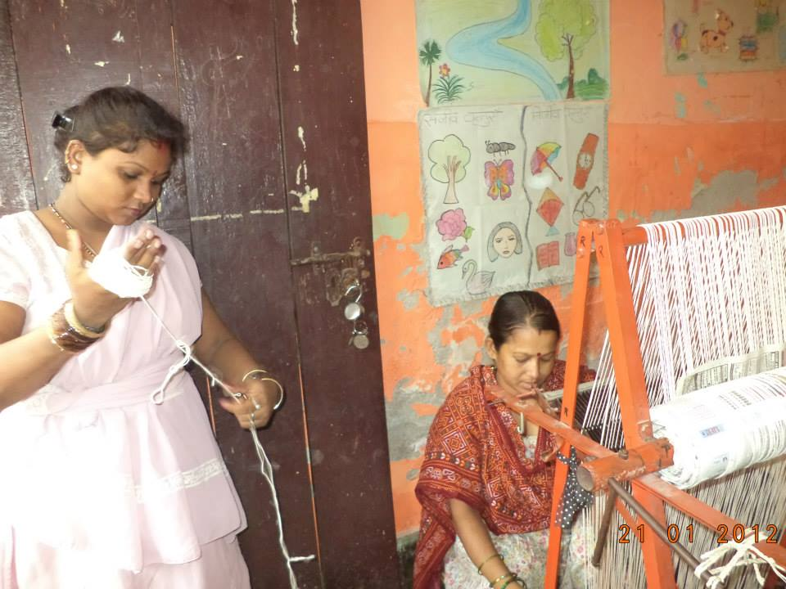

For the pre Rakshabandhan sale of products made by the JWP Skill Training Centre, in a nearby colony, the products were made by our students and ex students. Jute bags, waste cloth bags for carrying vegetables, milk packets and small grocery items and durries, were a big hit with women. The women from the Centre had a great experience marketing them. The motivation and encouragement was given by JWP and TCS Staff. People appreciated the concept of re inventing the habit of carrying cloth bags to shops which would eventually reduce the use of poly bags.
The profit was distributed among the skill training students and some amount has been retained to buy raw material for the next sale event. We plan to hold such sales in the next few months too.
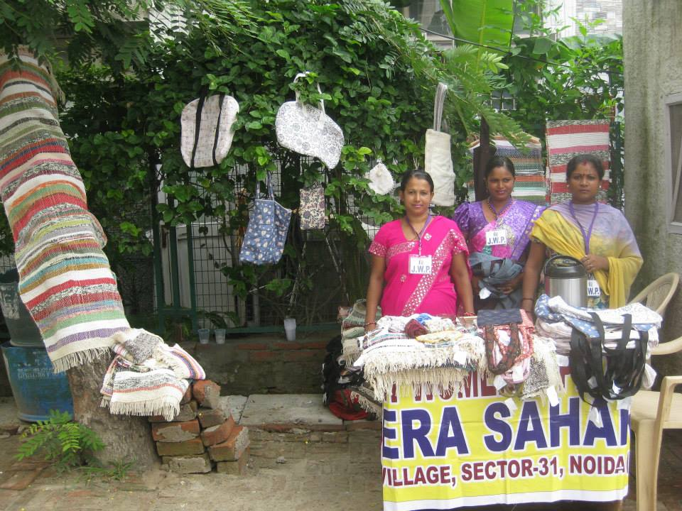
On the occasion of International Women's Day, JWP Skill Development Centre of Mera Sahara, Nithari, Noida, put up a stall at the Press Club of India in New Delhi. Durries made out of rags, eco friendly jute bags, pouch bags, waste cloth bags and greeting cards made out by the Centre children were the main attraction.
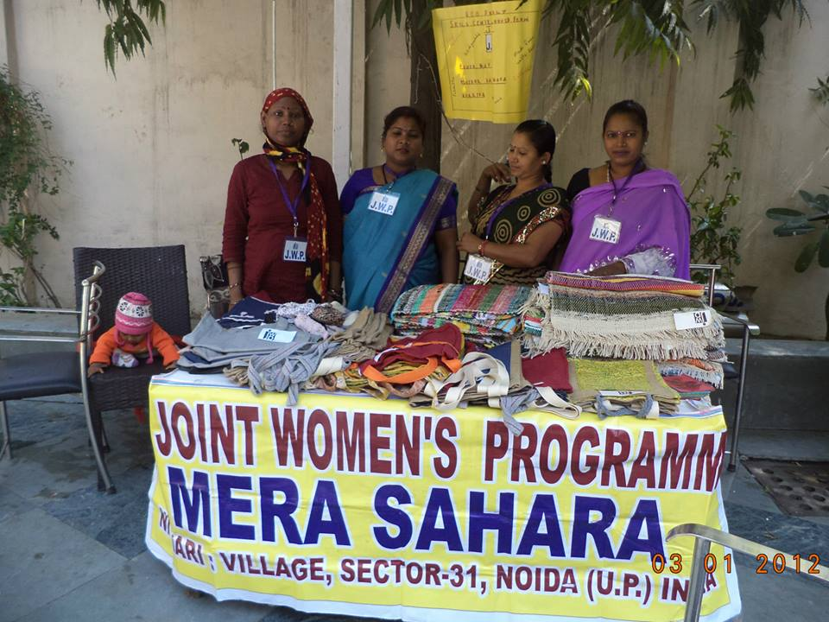
Social activism of Mera Sahara family.
JWP, with the help of Arya Samaj, Sector 29, Noida, UP, was instrumental in getting two couples from marginalized sections in Nithari, married on 23rd February, 2014.
1. Ruby and Dilip's daughter Dolly got married to Vishnu. Ruby is a trainer in Durry making class which is being run by JWP in Nithari, Noida.
Ruby has faced a lot of opposition for being bold and helping women around her to fight domestic violence. JWP has been helping her fight this issue at her home. She is also a ‘link’ member of JWP's community programme in Nithari. She attends our adult education classes. She was determined to wait till her daughter completed her schooling to get her married.
2. The second marriage of the day was a revolutionary widow remarriage with a widower. Kiran, the bride, has 2 children and Rishipal, the groom, has one child. Our new member, Priya Suresh, has been instrumental in bringing them together.
JWP's awareness programmes on domestic violence and other women's issues have brought many community women to think about educating their girl children, rather than sending them to work. JWP members participated in the weddings to bless the couples.
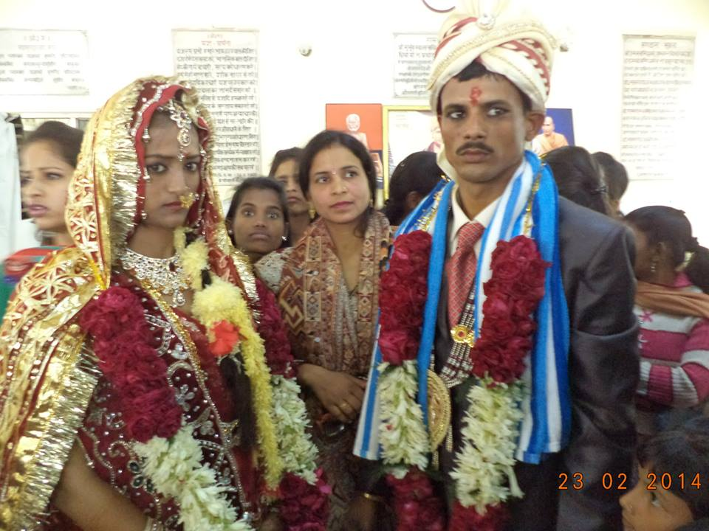

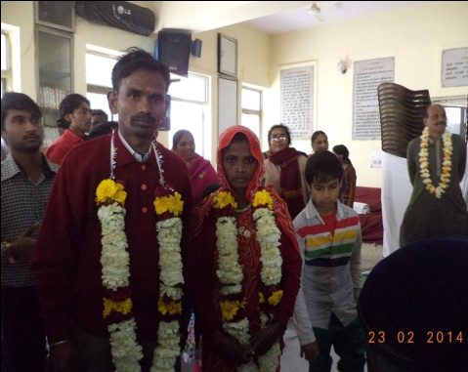

An existing development in these colonies has been, as a result of advocacy, that women have got their voting rights after JWP members took it up with the local Pradhan.
First they were able to get their ration cards and now the Voter ID cards. They had been refused these basic rights even though they were residents of Nithari for several years. The reason being that they were tenants and not the owners!!
Dr. Jyotsna Chatterji had been instrumental in getting staff to network with the Pradhan who in return got a sizable number of votes from the community to win in the last Panchayat elections!!!

So staff felt a sense of achievement and satisfaction when these women came back with big smiles as they had cast their votes!
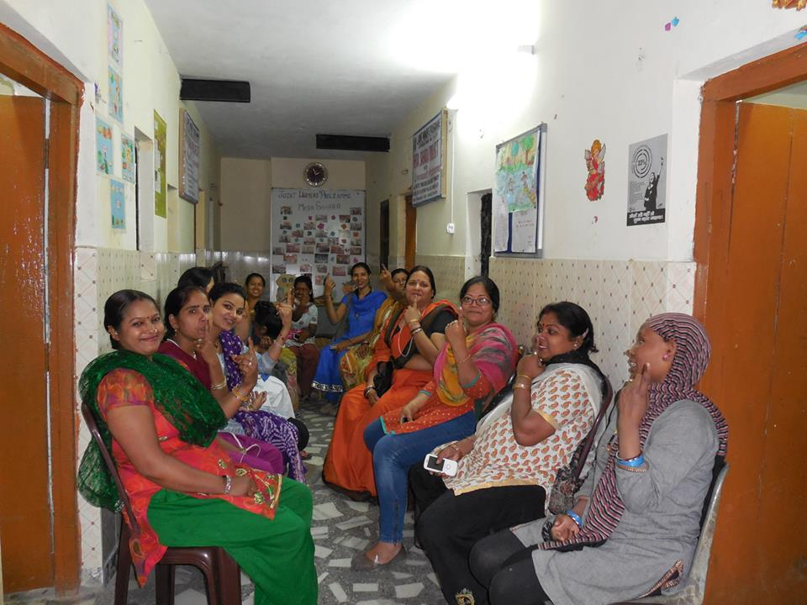
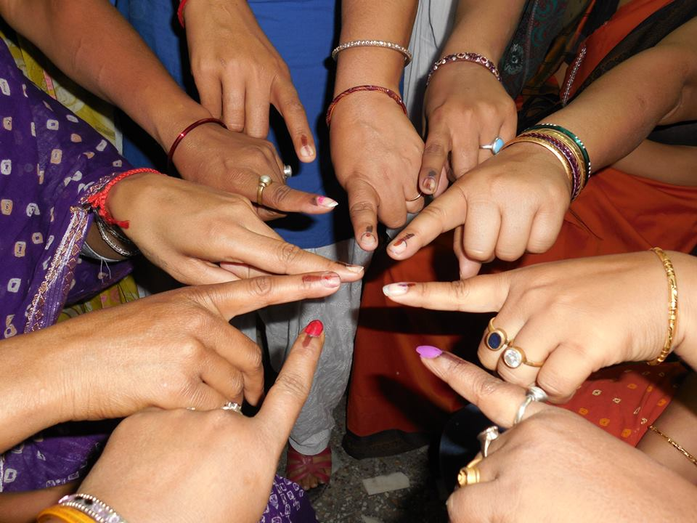
On the roads
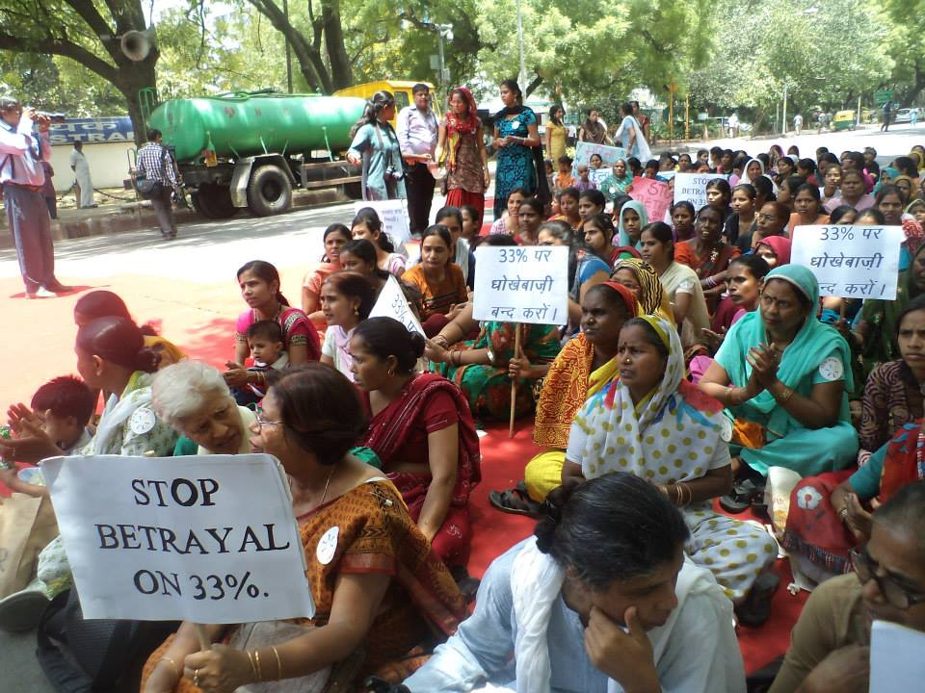
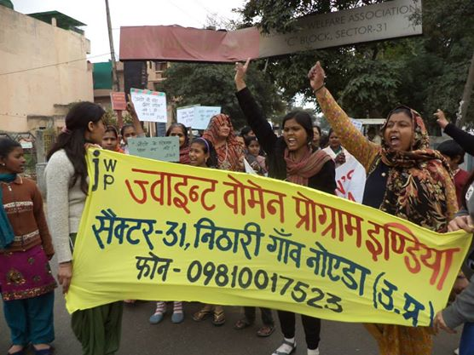

JWP's monthly meeting resumed after a break due to local problems that had to be solved first
About 45 young and several older women have been attending the meeting regularly.
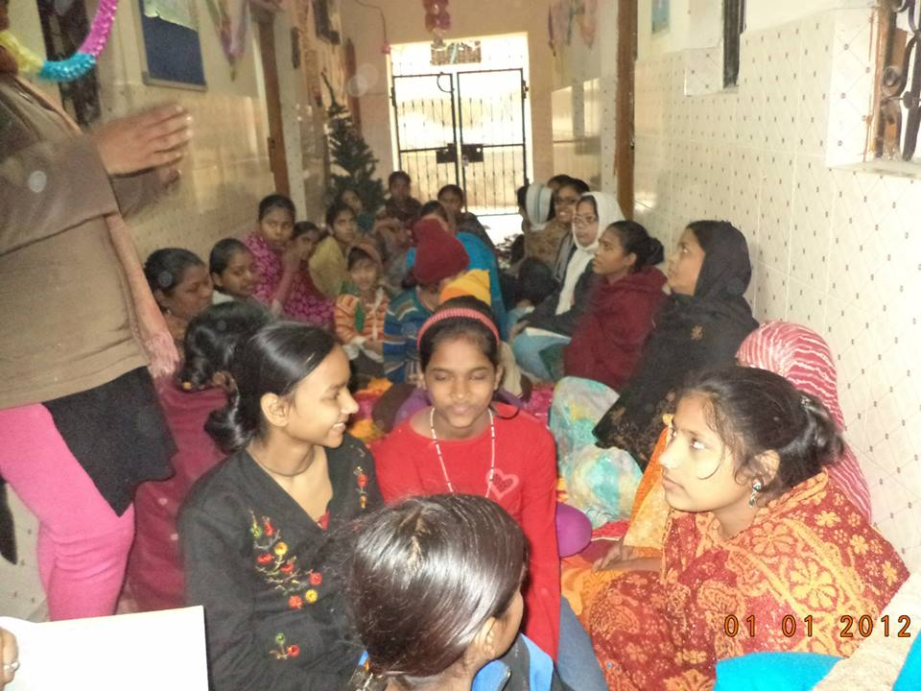Dr. Chatterji, our Director, informed the community women about three issues that they need to address, namely, Birth Certificates for the children, stopping child labour and child marriage. These meetings conducted regularly by the members of JWP, suggests ways and means to address issues and the plan for action.

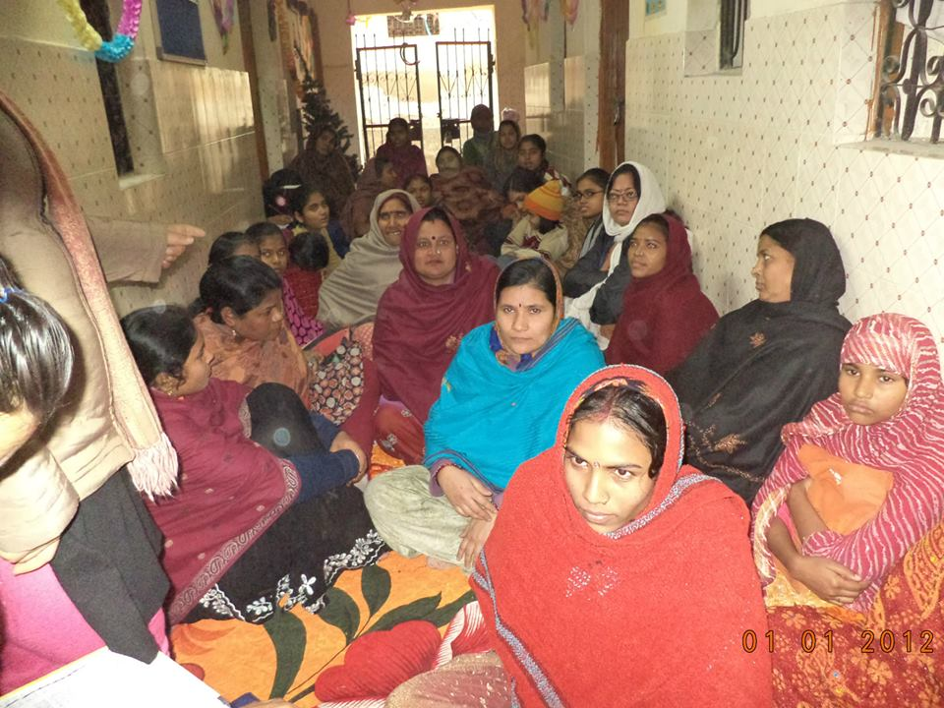

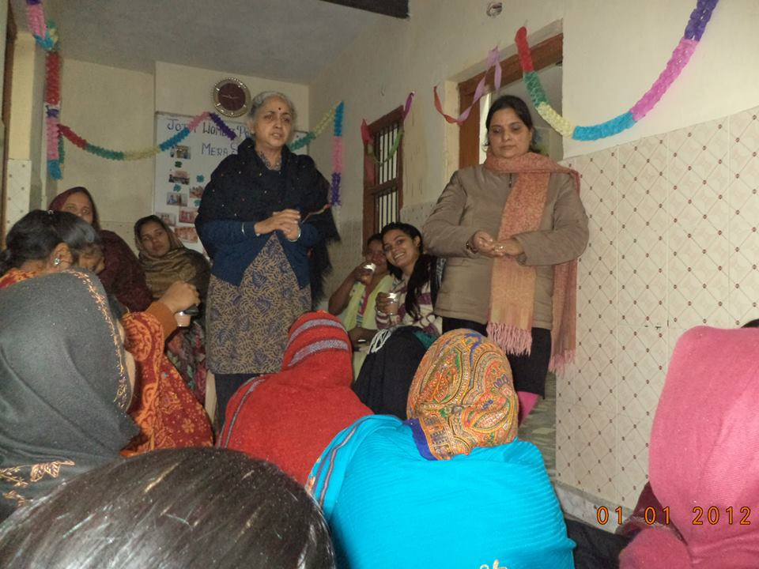
- Muslim Women's Programme in Jamia Nagar, New Delhi
The participants are from West Bengal, Bihar and Uttar Pradesh. All of them stay at the Batla House, Dhobi Ghat area in New Delhi.
In the meeting Ms. Nikhat, a woman organizer, discussed about the Rights of Women in Islam. The points that were being discussed are as follows:
- Women's Rights in Islam
The issue of women in Islam is a topic of great misunderstanding and distortion due partly to lack of understanding, and also partly because of some Muslims who have misinterpreted the teachings of Islam. Nikhat spoke about what Islam teaches as basis and source of the Quran-the words of Allah, and the sayings of the Prophet, his deeds and his confirmation. Islamic laws are derived from these sources. To facilitate the discussion they discussed the position of women from a spiritual, economic, social, and political standpoint.
From the religious aspect, there are seven points to remember:
According to the Quran, men and women have the same spirit; there is no superiority in the spiritual sense between men and women. [Noble Quran 4:1, 7:189, 42:11]
The Quran makes it clear that all human beings (and the phraseology doesn't apply to men or women alone, but to both) are human; He breathed some of his spirit, a divine touch when He created him or her. [Noble Quran 15:29 See also 32:9]
Some of His spirit here means not in the incarnation sense, but the pure, innate spiritual nature that God has endowed her or him with.
Married Women &Property Rights in Islam
More than 1300 years earlier, this right was clearly established in Islamic law."Whatever men earn, they have a share of that and whatever women earn, they have a share in that." [Noble Quran 4:32]
Secondly, there is no restriction in Islamic law that says a woman cannot work nor have a profession that her only place is in the home. In fact, by definition, in a truly Islamic society, there must be women physicians, women nurses, women teachers; she has equal right to learning. And if she chooses to work, or if she's married with the consent of her husband, she's entitled to equal pay, not for equal work, but for work of equal worth.
Thirdly, when it comes to financial security, Islamic law is more supportive in many respects towards women. These are seven examples:
• During the period of engagement, a woman is to be on the receiving side of gifts.
•At the time of marriage, it is the duty of the husband, not the bride's family to pay for a marital gift. The Quran called it a gift, and it is exclusively the right of the woman. She doesn't have to spend it on the household; she doesn't have to give it to her father or anyone else. She keeps it as her own.
• If the woman happened to own any property prior to marriage, she retains that property after marriage. It remains under her control. Also, in most Muslim countries, the woman keeps her own last name, and her own identity.
•If the woman has any earnings during her marital life, by way of investments of her property or as a result of work, she doesn't have to spend one penny of that income on the household, it is entirely hers.
•The full maintenance and support of a married woman is the entire responsibility of her husband, even though she might be richer than he is. She doesn't have to spend a penny.
•At the time of divorce, there are certain guarantees during the waiting period and even beyond for a woman's support.
•If the widow or divorcee has children, she's entitled to child support.
The duty, not the right, the duty of education, as the Prophet said, is a duty on every Muslim, male and female.
The approval and consent of the girl to marriage is a prerequisite for the validity of marriage in Islam. She has the right to say yes or no.
Husbands' and wives' duties are mutual responsibilities.
On the question of attire, the Quran and the sayings of the Prophet did not say women must adopt a particular dress of a particular country. It only gives basic boundaries. This was not to restrict women, but to provide a virtuous society where sexual attraction is not the main obsession of everyone. This forces everyone to respect the woman for what she is as a human being, as an intellectual and a spiritual being, rather than being diverted to her sexuality.
Finally, a few words about political involvement, the verse quoted earlier, Surah 9:71, which speaks about men and women being supporters and helpers of each other was taken by some jurists to mean that it involves also public life. How could they ordain the good and forbid the evil without women being active in the affairs of their society?
During the reign of 'Umar’, women participated in law making. 'Umar’ made a proposal of a certain regulation concerning marriage. A woman in the mosque stood up and said, "'Umar’, you can't do that." 'Umar’ did not tell her, "Shut up, you are a woman, you have nothing to do with politics, etc." He asked, "Why?" She made her argument on the basis of Quran. In front of everybody, he stood up and said, "The woman is right and 'Umar’ is wrong," and he withdrew his proposal. That was the spirit in the early days of Islam.
Discussions
There were plenty of interactions from among participants. Women (specially the Muslims women) were curious to learn about Muslim women rights. One of the women wanted to know whether love marriage is a right given to women in Islam. We replied, yes, love marriage is a right given to women in Islam. One of the women wanted to know, can women divorce in Islam? Here, also, we replied in the affirmative. Apart from the above said questions and answers there were many more discussions and there were many doubts and confusions which we cleared and many more things regarding rights of women especially related to Islam which we tried to make them understand such as, whether women of Islam faith can give Khula or not, whether women can work outside of the house and many more. The discussion was successful in making them understand more about their own faith and the positive ways in which they could take forward their lives.
Outcome of the meeting:
The outcome of the meeting had a positive result to those who came to participate and also who came to attend the meeting. They were very happy with the talk and many of them became aware of their own rights and are also looking forward to such kind of eye opening talks.
Next plan: We are going to organize our next meeting in a different area of Batla House in Joga Bayi with our second group. Our topic will be ‘Domestic Violence.
- Mehka Angan, Faridabad, Haryana
JWP Coordinator, Ms. Kiran Arora, conducts awareness generation training programmes for women and oversees a tailoring centre in village Tigaon in Faridabad, Haryana, in a potters’ mohalla.
This programme is conducted thrice a week. The women learn to stitch simple dress items of daily use. The programme is continuing to impart more skill. The women are also taught to learn how to read and write to become self dependent as much as possible.
Twenty three girls and women participate regularly in the awareness meetings on laws pertaining to women. The salient points of law awareness programmes were:
- What is the Constitution of India?
- What is meant by ‘Law’?
- What are the Policies?
- What are the Sections?
- What is an Act?
- What are the Rules?
They were also introduced to the judicial structure, Civil and Criminal suits and various aspects of disputes.
- How to go about complaints, petitions and suits?
- Detailed discussion on Appeals.
- Introduction of PILs and Writ Petitions.
The women were pleasantly surprised to know that it is our fundamental right to take help of the Supreme Court in safeguarding their rights. The next issue taken up was regarding free legal aid.
Vidhik Sewayen Pradhikaran 1987 is an Act that empowers the following groups for free legal aid:
- Women and Children.
- Victims of illegal trades and bonded laborers.
- Scheduled Caste and Scheduled Tribe people.
- Physically challenged people.
- Victims of riots, floods, droughts, earthquakes, Caste violence and industrial disasters.
- Industrial laborers.
- People who are in prisons, juvenile homes, protection Centres, mental asylums or nursing homes.
- The people who earn in a year less than the limit set by governments. This limit may vary from state to state. A simple affidavit of annual income less than the limit is enough to get free legal aid.
Right to Information Act (RTI) -this law is also thoroughly explained to women so that they could use it.
Ms. Arora described in detail why RTI is important.
Information comes from many sources – governmental or administrative reports, minutes of meetings, copies of entries in registers, rules and procedures of departments, maps and drawings of projects under construction, bills and vouchers of purchases etc. All these things are information for a common citizen.
Who gives us this right was also described in detail. How a citizen can demand information was also explained. In case our request for information is delayed or rejected, we can lodge a complaint with Information Commission or get redressed through judiciary. The RTI is for all the citizens of India including government servants.
Schemes run by states
The girls and women were introduced to various welfare schemes run by the government, such as widow pension, old age pension, Ladli Yojna and schemes for the physically challenged so that the women can avail the benefits of these schemes.
The women were also introduced to many health issues during pregnancy and lactating mothers after delivery. They were made to understand the importance of nutritional diets during these critical phases.
Rights of working women
These rights were explained:
- Minimum wages.
- Fixed working hours.
- Rest and leaves including a weekly off day.
- Regular and timely payment of wages.
- Maternity conveniences.
Several training manuals are used for the awareness programme.
Ms. Manisha teaches tailoring to girls.
Ms. Poonam runs the adult education Centre.
Ms. Nirmal visits the women in their homes and brings them together to participate in the programmes.
Dr. Jyotsna Chatterji, Director of JWP, and Ms. Kiran Arora take the legal awareness classes.
Another issue discussed was sexual exploitation of women; the points mentioned were:
- Attempts for physical contact, striking sexual relationship or demanding such favours.
- Comments and/or jokes of sexual nature.
- Showing obscene books or photos.
- Any type of undesirable and indecent action.
The women were informed about the steps to check this menace with special emphasis on the Supreme Court ruling. These rules have jurisdiction over government, semi-government and private work places.
The women were also informed about the provisions of compensation in case of work related accidents of laborers.
Depending on the age and wages of the labourer, the compensation for diseases was also discussed.
They were also made aware about Lok Adalat and contract labour. While discussing the condition of laborers in unorganized sector, they were told that generally these issues are related with social welfare. The legal rights were explained in detail to enable them to continue to struggle for their rights.
National Rural Employment Guarantee Act 2005was also discussed during the period.
The salient features of this Act are:
- One person from each family is entitled to employment for at least 100 days in every financial year.
- In case of absence of gainful employment, there is the right to get unemployment allowance on day to day basis.
The women were told about who can get employment and how to get it. They were explained the implications of 100 days of guaranteed employment and how to apply for it and when to expect it and where in great detail.
The facilities to be provided at places of work and treatment and compensation for accidents were made clear to them.
What to do in cases of not getting employment even after applying was also taken care of.
When does unemployment allowance become due and who will pay it, were also explained minutely.

The conditions or situations that debar one from unemployment allowance:
- If someone refuses to do the work allotted to her/him.
- Not reporting for work even after 15 days of calling.
- Someone who is absent from work a week without proper permission or authorization or goes on leave for more than a week every month.

Bonded Labour was explained in detail including its definition and laws related to it.
Bandhua Mukti Morcha vs Union of India (1984 3SL.C 161) makes it amply clear that:
- Those who force bonded labour can be imprisoned for up to 3 years.
- They can be fined up to two thousand rupees.
While touching on socio-religious issues, they were informed about anti untouchability laws with provisions for punishment for its practitioners.
How to safeguard our rights:
- By registering complaints in a Police Station.
- Providing complete details of the accused – name, address and the offence committed.
One special Act has been promulgated for the weaker castes of society named as Scheduled Caste and Scheduled Tribe (Prevention of Atrocity) Act 1989.
The Act takes care of punishment and compensation for crimes committed against them. The phone number for lodging complaints was also provided.
Medical Termination of Pregnancy Act 1971 was explained and this programme is still running.
Our adult education and tailoring classes are running smoothly.
The topics for discussion for the future are:
- Adoption laws.
- Hindu Marriage and Inheritance Act.
- Inheritance law applicable to Muslims.
- Christian marriage and inheritance.
It is sincerely hoped that these programmes will help the women to face challenges of life with more confidence and assurance – the avowed aim of women’s empowerment.

IV
GENERAL PROGRAMMES
During the monsoon session of Parliament 2013, Dr. Jyotsna Chatterji, with Dr. Sayeeda Hamid (Member Planning Commission) and Ms. Brinda Karat (Member of Parliament) spoke about the struggles of the women's movement, during a public meeting organized by JWP and other sister organizations. Dr. Chatterji emphasized that the present Govt. must take up the Bill for 33 % reservations for women in the next session of Parliament and get it passed in the Lok Sabha.
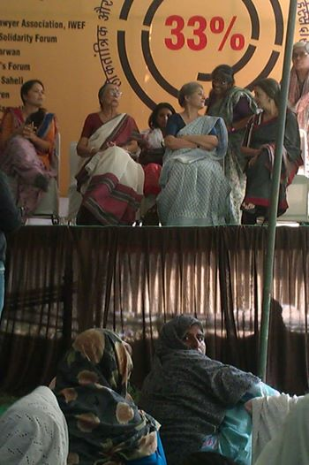

Some of the staff members of Mera Sahara who participated in the rally are standing in front of the banner.

.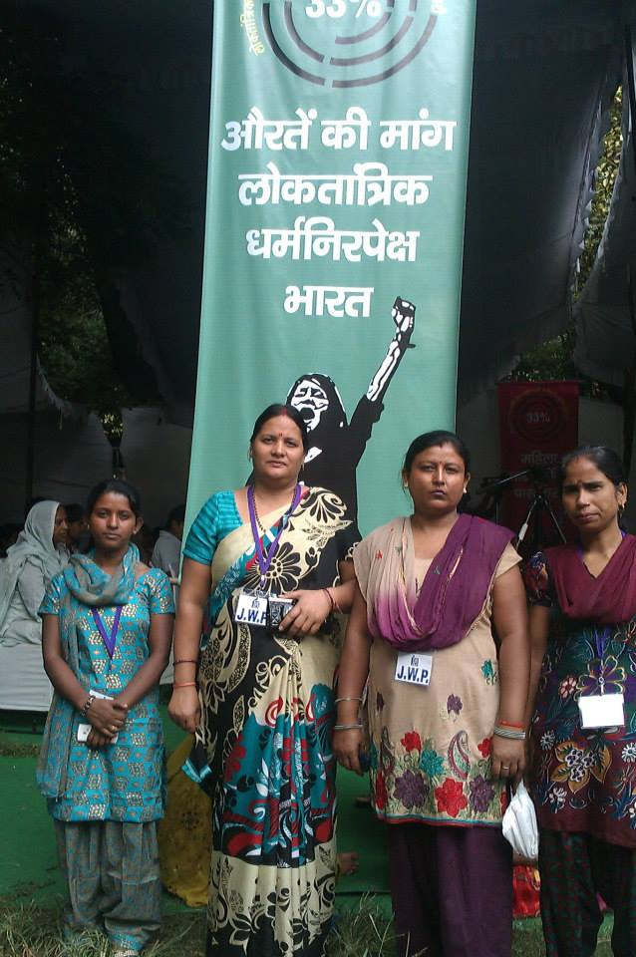

There was a 15 day long protest demonstrations, 1-14 December, organized by the national level women's groups to highlight unabated violence against women and to demand 33% reservation in the parliament. Vimla Pant, in the front row, is seen leading our women.

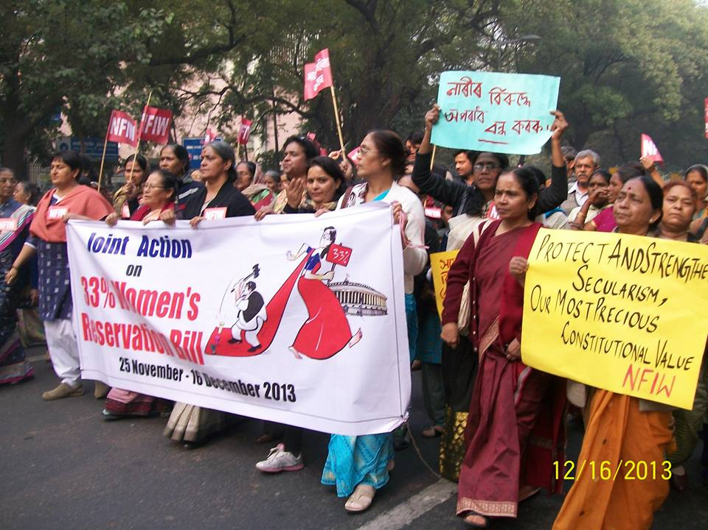

On 12th February, Joint Women's Programme took part in a massive meeting to demand the passage of the Bill for 33% seats reservation for women in the Lok Sabha by the end of the last session, called by a number of National level Women's Organizations. The meeting was held at Jantar Mantar, New Delhi. JWP Community women participated in it and urged the government to pass it immediately.
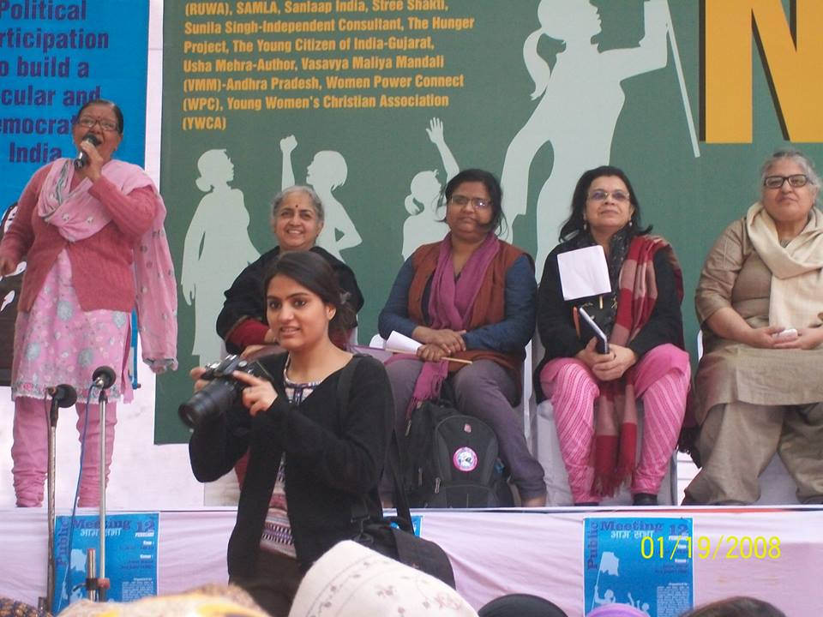
14th February, Valentine's Day, was observed as peace and non-violence day for the discriminated in society all over the World.
JWP had inspired community women to pick up courage to venture out after 5 pm to take part in the annual event of One Billion Rising. The event was organized by Sangath-Southasia to spread the message of peace and non-violence especially for women and other discriminated sections of the society including the disabled. The event was witnessed by more than a thousand people at the Central Park, Rajiv Chowk.
What is worth mentioning here is that women from every class and caste of the society took part in it to send out a message to the world emphasizing the rising violence against women and the need to stop it now! JWP took part in the theme song- 'Jago-re-Jago, Dilli jago'
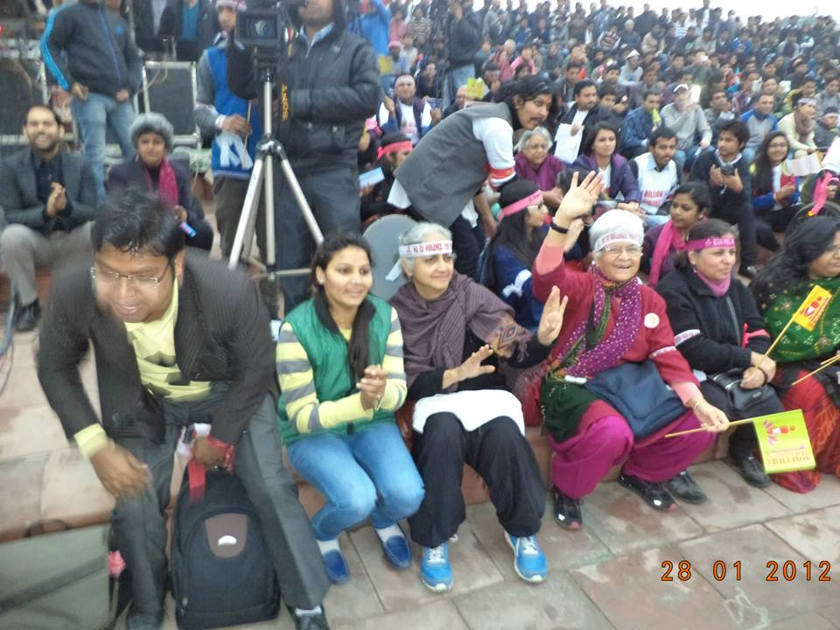

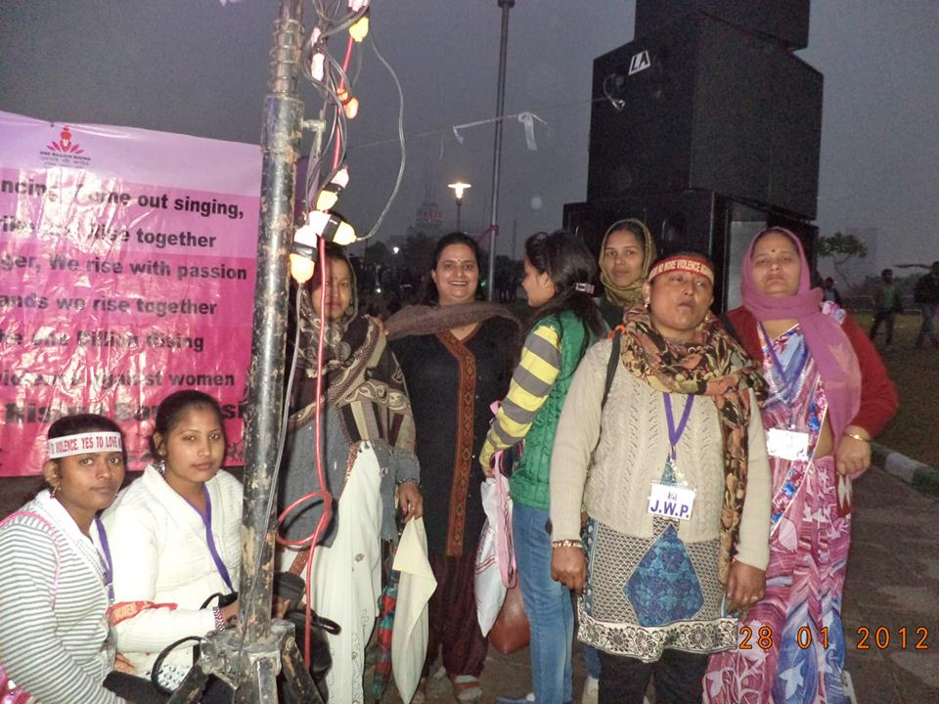

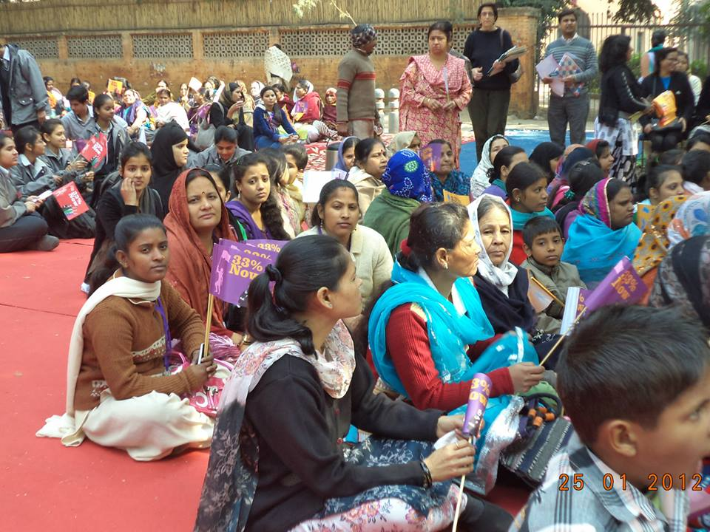
These are the pictures of JWP community women taking part in a 15 days long demonstration and meetings held by National Women's Rights organizations against increasing violence on women.

JWP members Dr. Jyotsna Chatterji, Ms. Padmini Kumar and community women participated regularly to show the organization's solidarity on the serious issues concerning women's safety and the need for the authorities and judiciary to look into the delivery of justice.
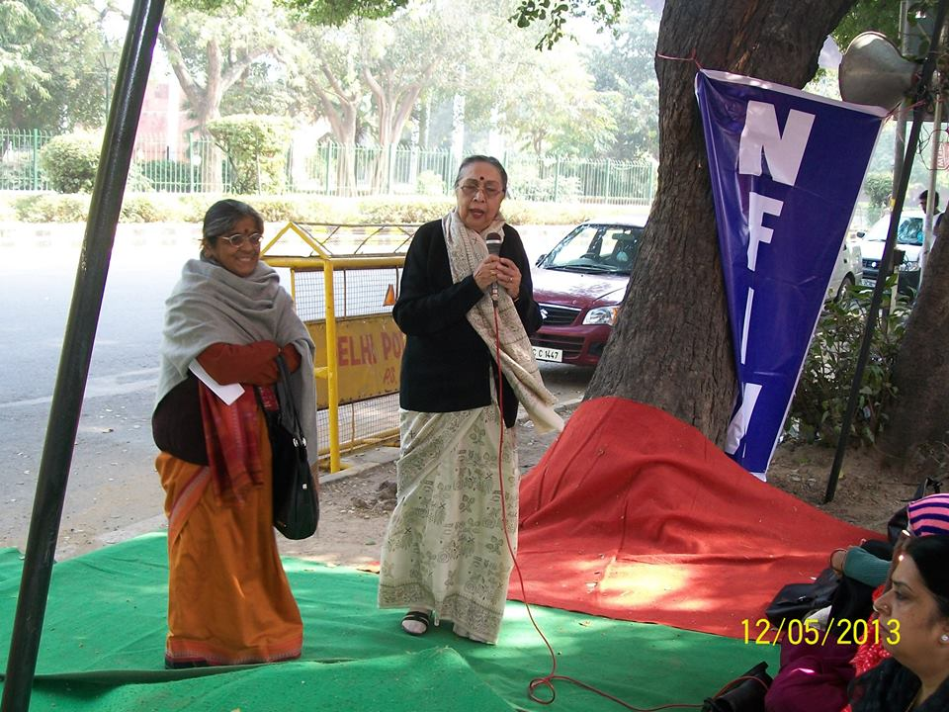
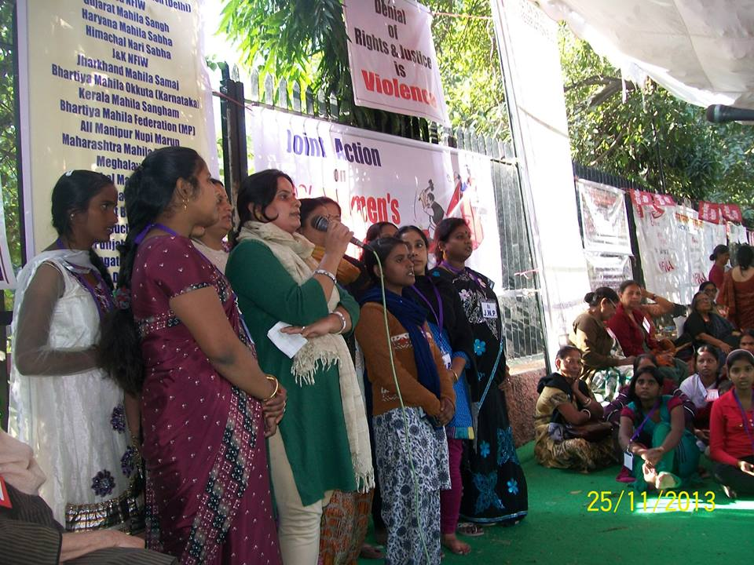
A massive meeting of National Women's organizations was arranged at Jantar Mantar on 8th March.
Speeches by the organizations focused on the burning issues of:
1. rising violence against women,
2. rising incidents of trafficking,
3. rising incidents of harassment at work place,
4. poverty giving rise to violence,
5. 33% reservation for women in the Parliament.

A play put up by the Nithari project of JWP, on female foeticide, patriarchy and empowered woman taking control of her life was very much appreciated by everyone.

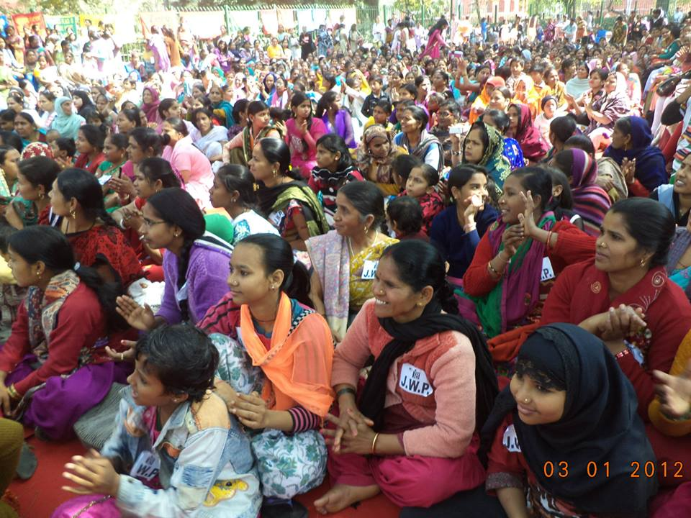

V

PARTNERSHIP FOR CHILD RIGHTS-RESEARCH AND NETWORKING
Joint Women’s Programme believes that the purpose of education is not only to develop capable individuals but also to build a just society. This requires that children will get education based on the principles of equality, non-discrimination and human rights.
The establishment of children’s right as a fundamental right for 6-14 age groups has underlined the importance of giving all children the opportunity to learn and to grow up as informed, aware and mindful persons with good sense as well as good hearts.
In this context and with this rationale, The Joint Women’s Programme, The WeCan Women’s Coalition Trust and fellow movers the Joint-NGO India Alliance for Child Rights advocacy initiative started the project to investigate, enquire, research on the issues of content of the textbooks and classroom processes – both where teachers teach to where children come from and are taught.
The aim of this project is to examine and assess how the issues of violence/non violence and of diversity are reflected and conveyed in all school courses and contents.
The main thrust of the study is to examine two major components.
- The contents of textbooks and
- The teaching-learning process from the point of human rights as enumerated in the Constitution of India and reflected in the national commitment to unity in diversity and India’s efforts to uphold the principle on non violence.
The project has just completed its Phase One in which desk research, contact and network building and interviews of the expert has been done. The second phase is now starting. The project is supported by the INGO, Child Fund India.
Consultancy for strategic design to develop and strengthen National Alliance for Child rights Group
The NACG is a voluntary entity at country level. It generally strengthens civil society organizations, children, media, media, academia and other civil society actors on a voluntary basis to promote coordination, networking, joint advocacy, sharing of good practices and lessons learnt on VAC. The NACG supports national efforts to end violence against children through a synergetic and contributes to the implementation of the SAIEVAC’s action plan at the national level.
In India, some of the challenges in setting up the NACG include the large size of the country and consequently the wise and diverse geographic and democratic representativeness of different CSOs and the large number of coalitions and networks already existing at different levels.
The process of setting up the NACG is lengthy and as it needs to ensure ownership, participation and representativeness across the country.
The objectives of NACG in India are:
- Bring together existing coalitions, NGOs, INGOs and UNICEF to promote further synergies in action and debate on VAC;
- Support the implementation of SAIEVAC’s regional plan of action to which India has committed;
- Promote good practices, lessons learnt and debates taking place in India.
To initiate the formation of NACG, three meeting were held at Delhi with the interim Working Members. Members came from Kolkata, Guwahati, Chennai and Delhi.
Basically, the strategies were discussed for a practical way forward to develop and strengthen NACG. Rules and procedures were discussed and formulated. The structure of NACG was formulated and finalised. The structure of regional groups was discussed and the procedure for regional group formation along with the thematic group formation criterion finalised.
The following five thematic issues were emphasized and worked up:
- Child Marriage
- Sexual abuse and exploitation
- Trafficking
- Corporal punishment
- Child Labour
The National Thematic Focal Point person (NTFP) was to be identified and expected to act as the facilitator for identification of good practices, initiate dialogues and discussion among NGOs, networks and alliances on the designated thematic issues.
This partnership programme has been a very successful event in bringing together child rights organizations on a common platform for research, advocacy and action.

VI
FUTURE PROGRAMMES
JWP initiatives need to be strengthened and encouraged. The advocacy and action for Women's Empowerment and Child Rights must continue at grass root level. Gender sensitization training programmes, community advocacy programmes and also taking part in all network activities with other national level women’s organizations need to be planned, strengthened and thoroughly executed.
After moving into a new three storey building with 12 regular rooms, JWP feels confident of strengthening Mera Sahara, the Education-cum-Protection Centre at Nithari, Noida. It plans to expand its programmes for capacity building and skill development of adolescent children in other city slums and urban villages. Unfortunately, most of the adolescent children and youth of weaker sections of society have little openings for further training and often give up education after class 10. Generally, these young people waste time loitering on the streets and thus get sucked into anti-social activities. JWP has approached several corporate houses for funding for the computer education and other skill development programmes.
Total empowerment for women and children is the endevour and will continue to inspire JWP and its advocacy and actions will continue with more proactive participation from the women and children. The most satisfying outcome for us is the growing leadership and the increasing confidence among the community women and local leaders. JWP will continue to ensure the increasing participation of children on making decisions to improve their quality of life within the community.

VII

OUR GRATITUDE
We are very grateful to ASHA for Education, The Ford Foundation, The Women's Association of India of the UK, M/s. Intercontinental Technocrats Pvt. Ltd., CBN Foundation, Tata Consultancy Services, War Widows Association, Nirmal Manufacturing and Marketing Company, Mahagun Developers, UNICEF, Lioness Club of Noida, Child Fund India, Save the Children and M/s. USHA International Ltd.

Our special thanks for Sai Seva Mandir for providing freshly cooked and nutritious food for our children every day.

We also acknowledge and thank several individual supporters who continue to help with funds and gifts for children. They are Ms. Pramila Malhan, Mrs. Prabha Krishna, Mrs. Sarika Baheti, Dr. Bhupendra Jain and Mr. Devendra Jain, IPS Wives Welfare Association, Ms. Geeta Rajmani, Ms. Rekha Sudhir, Shri. Ramsaran Sharma, Mrs. Priyali Prakash Mr. & Mr. Dhruv Prakash and Smt. Bimlesh Sharma, village Pradhan of Nithari for their regular support.

We are also grateful to Advocate Bulbul Das, who has been helping us and our legal awareness and action programme and Ms. Anju Grover for her advice regarding our website development and other media related matters.

We are very thankful to our team with Dr. Jyotsna Chatterji, Director and Secretary of JWP and Ms. Padmini Kumar for her unwavering commitment, Ms. Vimla Pant, the competent Centre-in-charge, A. Rashid and all the dedicated members of staff.

JWP’s accounts are audited by M/s A. K. Nair & Co., Chartered Accountants, New Delhi, who have stood with us with their professional advice and support. Finally we extend our gratitude to the JWP Board Members who have advised us and have supported us in all our decisions and actions.

CONCLUSION

Mera Sahara Centre in Nithari, Noida, is the activity Centre for JWP. It is gaining strength and overcoming several obstacles. The local office of JWP functions from the school building to work with the children for their full protection and development, and also women’s rights and action.

JWP’s other Centres in Jamia Nagar, New Delhi & Faridabad, Haryana are also doing well with many women coming forward to belong to the women’s rights movement.

Report prepared by

- Rashid
Documentation
Joint Women’s programme

