Fighting infant mortality

- Mission and objectives of services for underweight malnourished babies :
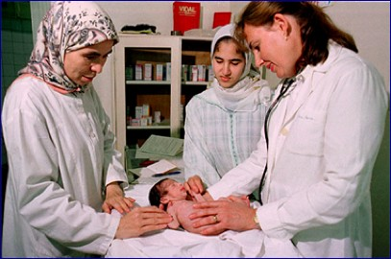
Mission :

- To fight infant mortality (distributing milk and clothes and offering medical
- Family planning and educating and sensitizing the mothers
- Following up with infants until their weight is of a healthy standard
- Helping with the status of unmarried mothers

Objectives :
1. Fight ignorance
2. To bring the babies to a standard weight of 9 kg
3. Improve the status of unmarried mothers
4. Make vaccination charts
5. Produce and disseminate information on the hygiene of the health of mother and child

- Operations:
a. Weekly consultation of mother with pediatrician
* Making sure babies are healthy
* Family planning
* Researching and discussing hereditary diseases
* prevention from sexually transmitted deseases
* Researching the infections amongst mothers (urinary infections)

b. Giving information and sensitization
Three half-days are dedicated to the babies who are unhealthy : Monday, Tuesday and Thursday. Before giving them the medical attention they need, we organize half-an-hour courses for the mothers. These courses are regular and the subjects of discussion are often the same ones: contraception, nutrition, civism and hygiene Repetition helps the women retain the information.

c. Frequency of meetings/courses
3 times a week: Monday, Tuesday and Thursday afternoons
- Who is involved :
A diverse team : 3 pediatrician, 10 volunteers, 2 nursery assistants
Partners to ensure the distribution of milk, flour and other foodstuffs
Great motivation…

- Situation in 2006
Year | Treated  10/1 to 09/30 | Deaths | Illnesses  Hydrocephalus, down’s syndrome, heart condition  … | Infants who attained a normal weight
2000-2001 | 345 | 7 | 5 | 333
2001-2002 | 348 | 5 | 4 | 339
2002-2003 | 340 | 3 | 6 | 331
2003-2004 | 341 | 5 | 25 | 311
2004-2005 | 328 | 4 | 20 | 304
2005-2006 | 314 | 7 | 35 | 275
TOTAL | 2016 | 31 | 95 | 1893
The table compares babies treated since the year 2000
- Infant mortality 22°/°° in 2006
- 35 children reached of diseases including 25% resulting from marriages between blood relations
- Smallest baby weight in 2006 was 1.3kg
- Other illnesses in addition to malnutrition : (down’s syndrome, heart problems, gluten allergies, respiratory problems, hydrocephalus, …) : 11%
Characteristics of the helped families
Questionnaires are distributed and filled by the mothers who are receiving these services. This step enables us to have information on the families and to detect common characteristics in terms of, lifestyle, resources, etc. Thus we could see that, although the majority of the mothers declare being married, more than 5 % of the moms receiving the service are unmarried mothers or their husbands have left them. The graph shows this. Concerning the mothers’ education, the investigations reveal, without surprise that the majority of these women are illiterate (43%), 29% of them state to have the primary education level and 27% reached the secondary studies. With the question "does the the husband work? " 79% declare that yes, 20% of the mothers have an unemployed husband. We specify however that for the 79% women whose husbands work, in the majority of the cases the work is unstable and occasional. We also noted in the questionnaires, that 24 % of the questioned women married between 12 and 18 years. We hope that the provisions of the Moudawana will contribute to reduce this rate. 75% of them live in more popular districts, 11% live in the shantytowns and finally 14 % live in douars (often unhealthy habitats in the periphery of Casablanca).
