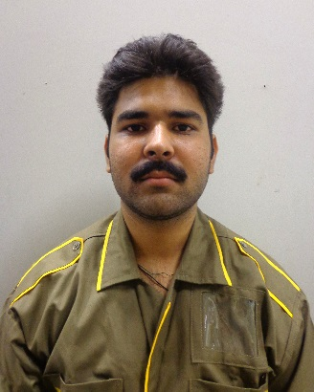

“The best way to predict your future is to create it.” Abraham Lincoln

“I began my career as a Factory worker and within five months I’ve been promoted to Management level. Who has this kind of career progression in such a short span of time?”
Waqas Ahmed is in awe of what AmanTECH was able to make possible for him.

As is the case with most lower class Pakistani families, Waqas had several siblings to support. He knew from the get go that he had to rise above his surroundings and knew that AMANTECH would make that possible for him.

He started out doing a part time diploma and teaching Mathematics at a government institute until he joined AmanTECH to study the metal machining course.

At the age of 19 this landed him a job at Alsons Pakistan in August 2014. Alsons Pakistan is a leading name in the Pakistan Automotive Industry by providing expertise in the manufacturing of automotive parts (sheet metal, parts assembly and plastics molding). Waqas’ technical expertise and proficiency in Microsoft Office and English helped him rise among the ranks from being a Worker in Production to an Inspector in Quality Control.

The Production Manager at Alsons spoke highly of Waqas and the contributions he made to Alsons in his time there. Consequently, the Placement team was also able to interact with a team of Senior Managers from Atlas Honda (Lahore) who were performing a procedural audit at Alsons. As the shift supervisor, Waqas was handling all their queries and guiding them through the factory. “I helped conduct 90% of the Audit” he asserted with pride.

His ability to step up to new challenges enabled his promotion to Quality Control Manager.

“I don’t have words to describe what AmanTECH means to me. It went above and beyond any other institute. Not only did I benefit from technical expertise- but I also learned how to manage people which is a skill that will take me further in life. Once I graduated I was not left in a lurch. The Placement department took extra care to ensure that we all found employment at the end of our course.”

When asked about AmanTECH’s impact on his accomplishments, he stated:
“AmanTECH doesn’t just provide an education- it nurtures talent and believes in its students.
I am lucky to have been a part of this revolution of change.”

