When the buying stops, the killing can, too
Reducing Demand for Elephant Ivory in Asia
January 2015 - Current

PUBLIC SERVICE ANNOUNCEMENTS
We distributed Kathryn Bigelow’s animated short film “Last Days.” The film reached over 550,000 viewers on the video-sharing website Youku in the first two days of its China release.

We also began distribution of “Hunted,” our latest PSA featuring Li Bingbing in partnership with Wanda Cinema Line Corporation. The PSA is being shown in 150 cinemas and more than 1300 screens throughout China prior to movie screenings.

Developed and distributed an abbreviated PSA featuring Prince William for the 40-story video screen façade of Citi Tower on the Bund in Shanghai.
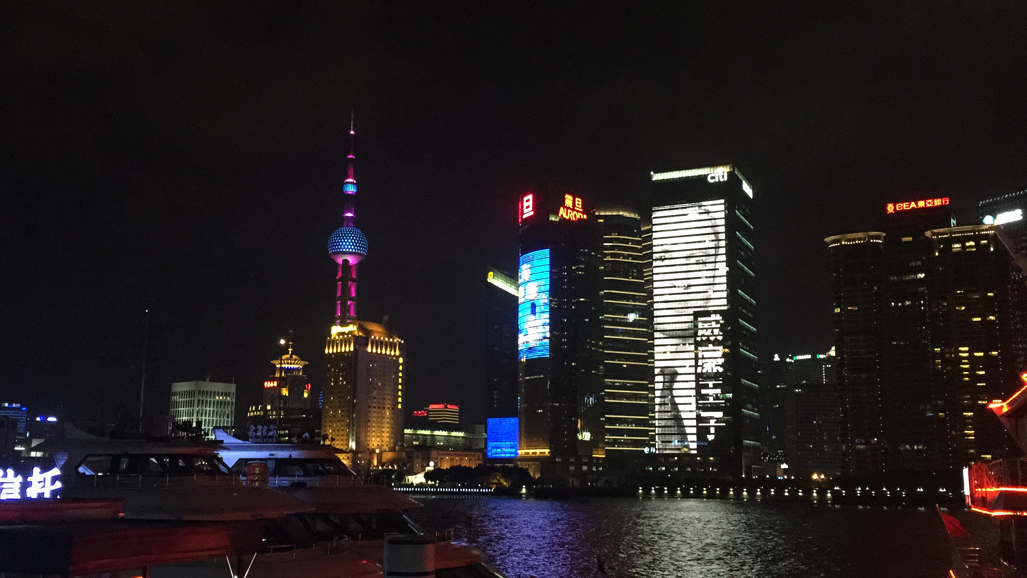

A special cut 15-second PSA with Prince William running on the world’s largest video screen, Citi Tower, on the Bund in Shanghai

BILLBOARDS
A total of 107 of our new Ivory Free billboards featuring Li Bingbing were distributed throughout three Beijing and Shanghai airports (displayed December through February 2015). In Hong Kong, we have secured placement of the Li Bingbing Ivory Free billboards on the Star Ferry. In Thailand, we placed Li Bingbing Ivory Free billboards in the Bangkok International Airport (February-March).

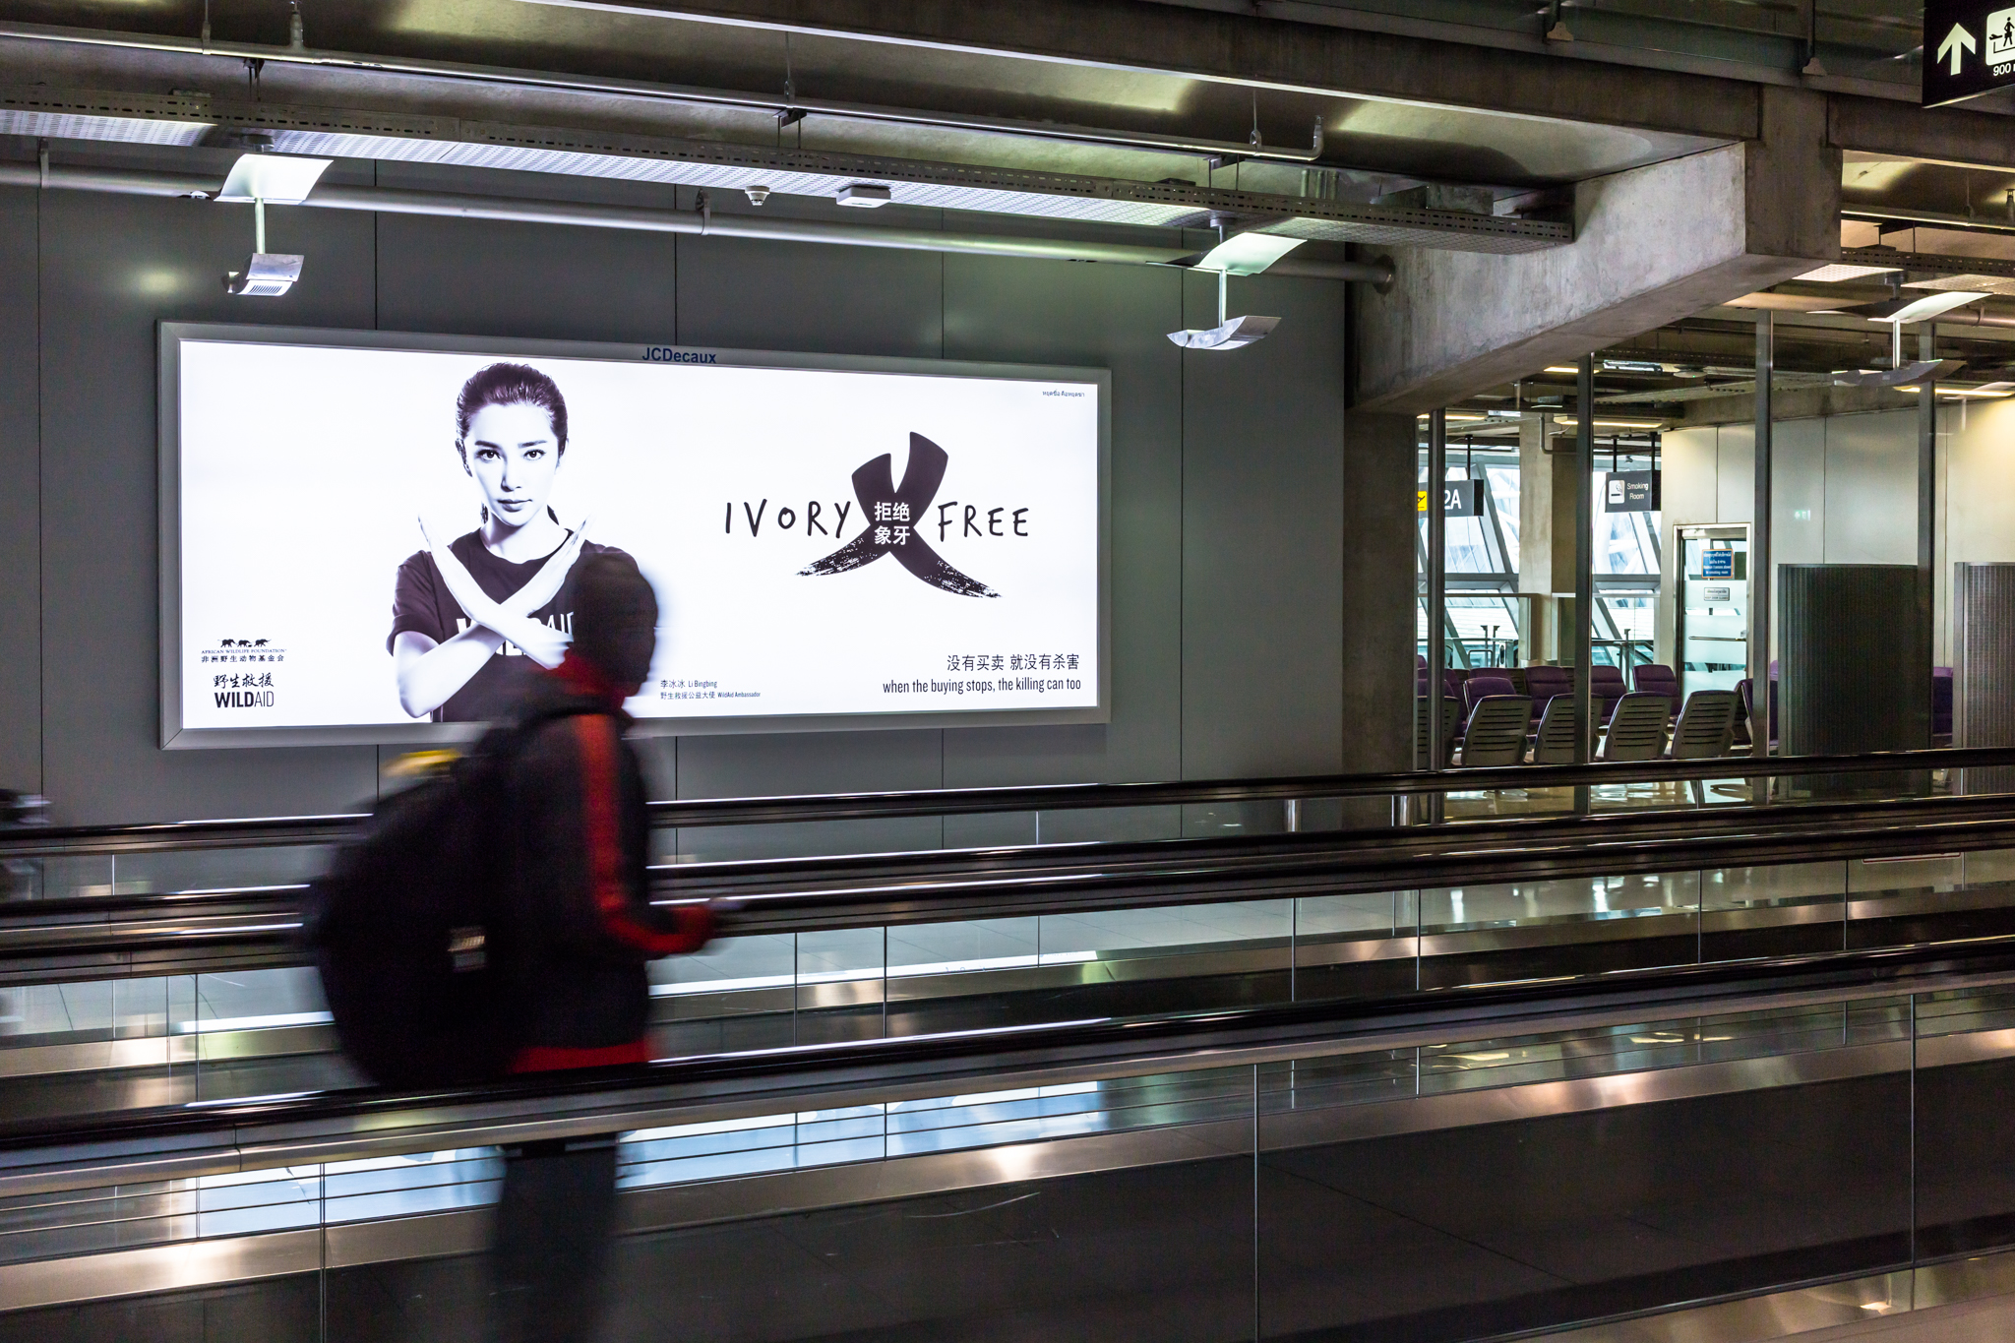
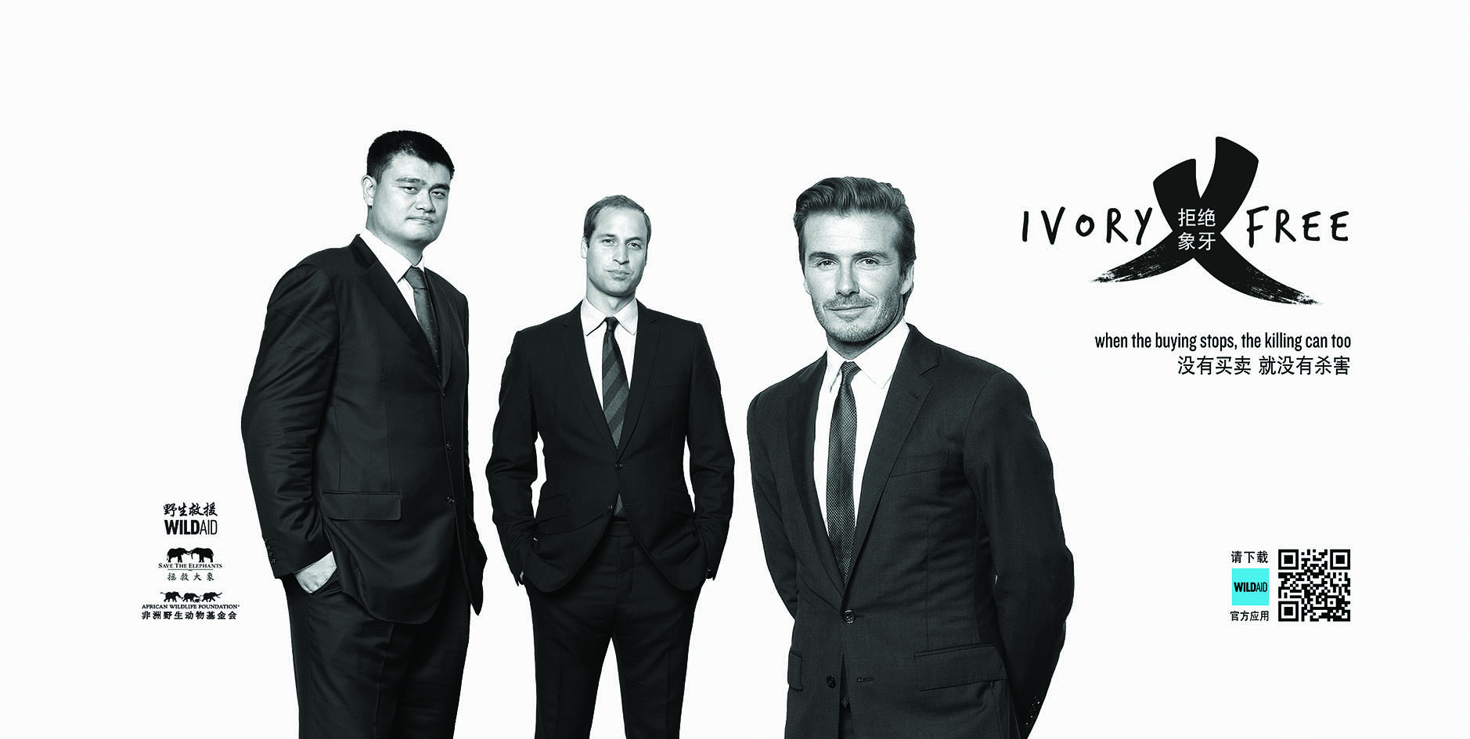

Li Bingbing billboard in the BKK airport Yao Ming, Prince William, and David Beckham billboard

To coincide with Prince William’s visit to China at the beginning of March, we released Ivory Free billboard designs featuring Prince William, Yao Ming, and David Beckham. More than 100 billboards were placed at airports in Beijing, Shanghai, and Chengdu.

We also began designing a new Ivory Free billboard with Chinese concert pianist Lang Lang, for release in May.

MEDIA OUTREACH
Youku Talk Show with Li Bingbing and Huang Nubo
Our ivory campaign was heavily featured in a talk show with Li Bingbing and Huang Nubo on Youku. The show was entirely about ivory: Li Bingbing talked about her visit to Africa and the devastating poaching scenes she saw there, Nubo talked about elephants in southwest China and his work with WildAid and they discussed responsible lifestyles that include avoiding wildlife products like ivory.
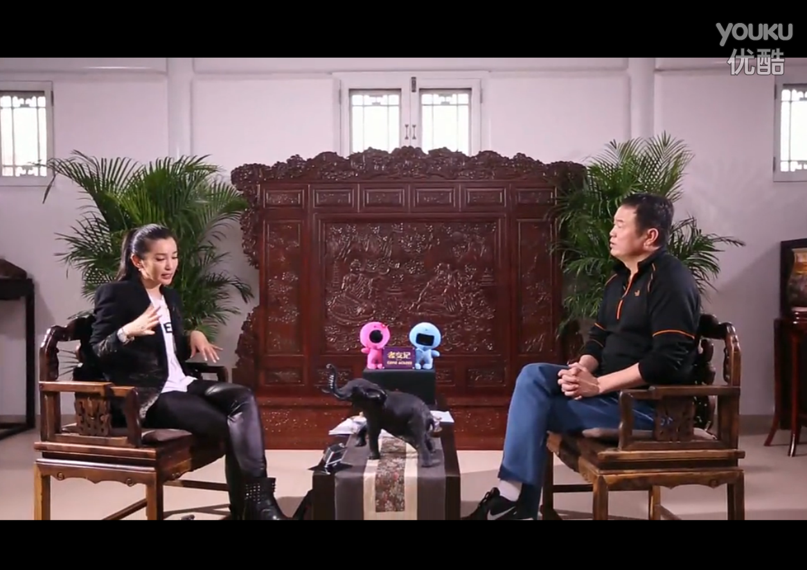

Li Bingbing and Huang Nubo featured in a Youku talk show about ivory: http://v.youku.com/v_show/id_XODkwNTkwNzE2.html

SURVEY
Ivory Survey in China
Published a report summarizing the findings of our October 2014 ivory survey of residents in Beijing, Shanghai, and Guangzhou. The report highlighted an increase in consumer awareness of the ivory trade’s devastating impact on African elephants: 70.6% of participants think elephant poaching is a problem, compared to just 46.6% in 2012, and increase of 51.5%.

