Christmas is already in Juconi
By: Nataly Díaz
Marketing Coordinator
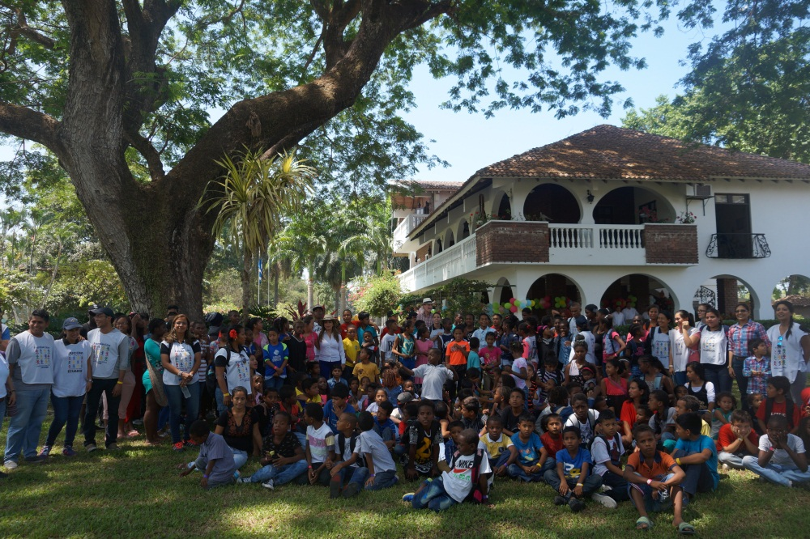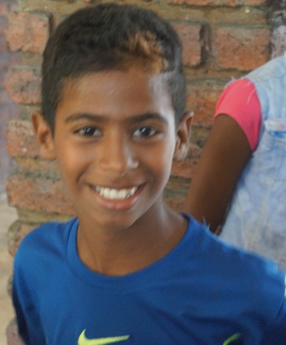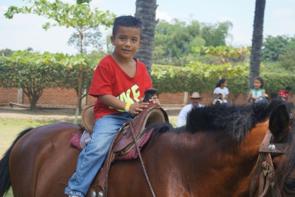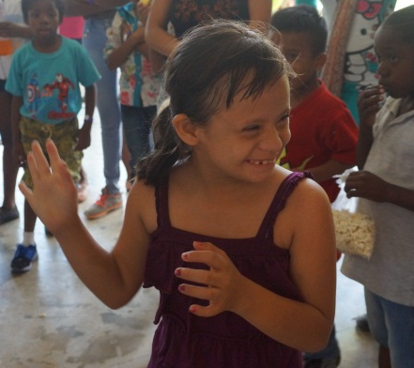
Christmas is one of the most waited season for children who are part of the program. Christmas is synonymous of joy, gifts, friendship, games, fellowship in the spaces created by Juconi for them.
This year is not going to be the exception, the festivities have begun. Last weekend an event was held in a farm on the outskirts of the city of Guayaquil. We arrived at 10:30 am with all the kids, we were greeted with a warm smile by our hosts, among games, contests, nature, fun and many surprises all enjoyed the beautiful evening until 4:30 pm when we returned to Guayaquil.
The children rode horses, played soccer, danced, drew, played in the tree house, painted faces, witnessed typical dances and varied performances during their lunch hour.
Finally came the time of gifts and surprises and share those faces of illusion and happiness.
We are happy and proud to have spent another year with the help of all those who support our cause by providing a new life expectancy for hundreds of children and their families.
Juconi, for a world without violence or child labor.

