Cancer
is spreading rapidly
across India,
but cancer care...

…woefully inadequate

Udhavum ULLANGAL
The thrust area in Cancer Control is Cancer Education, Awareness, Early Detection and Prevention. Join hands with Udhavum Ullangal to strive towards this cause & help make a difference.

  - Cancer Prevention Centre

Contents

Introduction: 2
Message from Dr V. Shanta 3
Support from Harvard Medical School, Boston………………………………………………………………………………......
History so far 5
Our Progress so for 6
Our Competence: 8
Our Investments 9
Particulars 9
Photographs 11
Report by Dr. Krishna Kumar, our Medical Oncologist 14
Biography of Patients treated 15
Treatment Summary of Patients 16

Introduction:

Udhavum Ullangal is a registered Public Charitable trust which was founded in the year 2000 with FCRA & 80G certification. Our key focus area has been Education & Health. Educational aid to the tune of Rs.1.5 Cr benefitting 10000 students so far throughout Tamil Nadu
Over the years Udhavum Ullangal has carried out exclusive projects for the following organizations CAF (Charity Aid Foundation), Cognizant Foundation, Volkart Foundation, Accenture, etc. Rotary International recognized our Service and awarded “Social Responsibility Award” in the year 2010-11.
Udhavum Ullangal has recognized the rampant growth of cancer incidence and has been closely working with Cancer Institute (WIA) Adyar towards creating awareness, education, screening and treatment over a decade
The Cancer Prevention center was inaugurated by Dr.V.Shanta, Chairman, Cancer Institute, Adyar (WIA) on 2nd October 2011 at Tirunelveli.
Under the guidance of Dr.Shantha & her team, Udhavum Ullangal established a low cost cancer care program in Tirunelveli.
The main focus is to educate the public on the fact that cancer is curable if detected early, Cancer is preventable and to dispel myths about cancer among the public.

Message from Dr V. Shanta

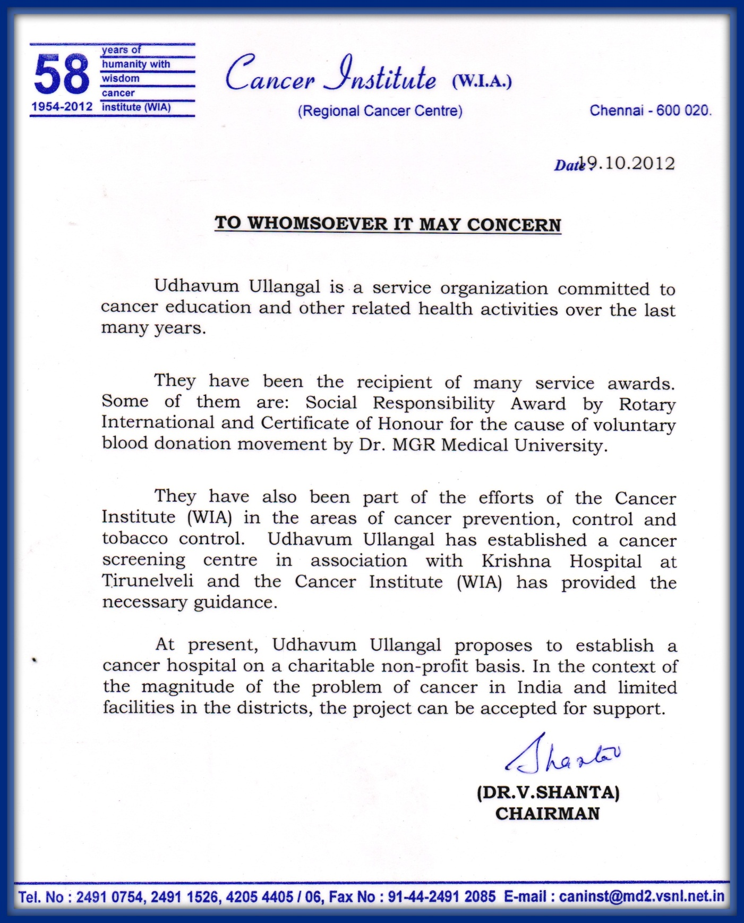

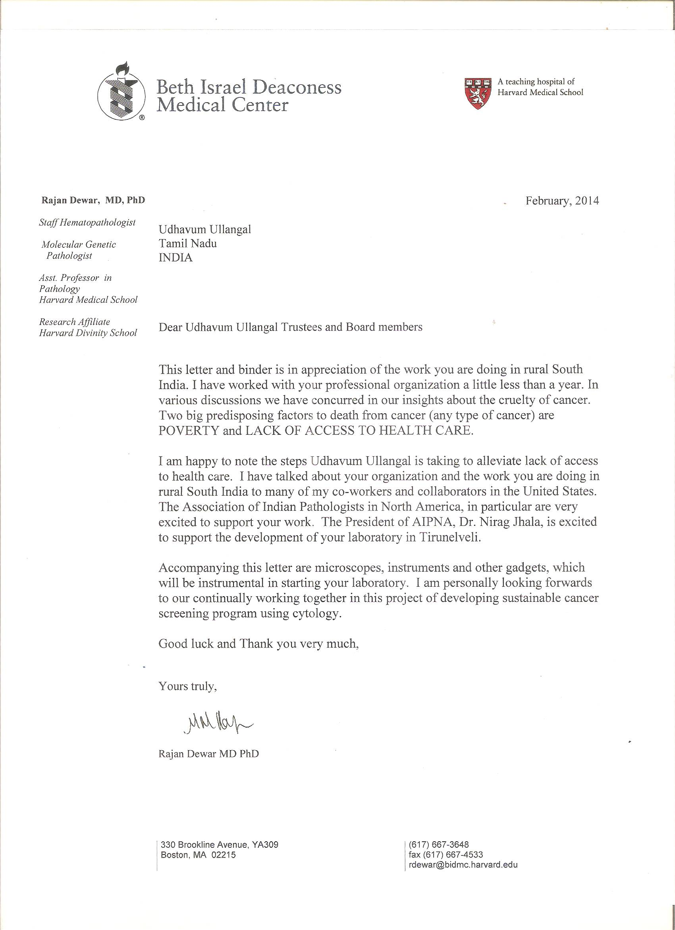

History so far

The plight of the cancer patients and their family members and the extent of their suffering, stimulated Udhavum Ullangal to expand their activities for cancer care, in particular reaching to the rural areas where the care is limited. Therefore, Udhavum Ullangal committed itself to cancer care and started creating awareness on cancer.
Considering the above difficulties, the trust had decided to set up a comprehensive cancer care facility to offer standard treatment and to expand the cancer control activities in the rural areas at an affordable cost.

The Centre currently,
- Has a full-fledged team including a medical officer and a paramedical staff trained by the Cancer Institute (WIA), Adyar.
- Runs a permanent screening center.
- Has a fully equipped Cancer Screening Vehicle supported by Cognizant Foundation
- Conducts camps to create awareness about cancer and the harmful effects of tobacco.
- Organizes screening camps for early detection of cancer.
- Makes necessary arrangements for treatment.
The following procedures are carried out by the project medical officer at the field,
- Visual Inspection with Acetic acid (VIA) (screening for cancer of the cervix).
- Clinical breast examination for breast cancer.
- Oral visual inspection for oral cancer.
In cases where abnormalities are found, further investigations such as colposcopy/USG/Mammogram, biopsies are carried out at Krishna Hospital. As per the MOU with Adyar Cancer Institute, the patients diagnosed with cancer are referred to Cancer Institute for further management.

Our Progress so for

Total Population of Tirunelveli district | 30,72,880
No. of Female (51%) | 15,67,169
No. of Male | 15,05,711
Literacy Rate | 68.44%
Eligible Female Population (30%) | 4,70,151
Number of persons –awareness given | 15200
No. of persons screened | 6120
Tobacco Users | 528 (M- 262; F-140)
Total Camps conducted | 203 camps
Total cancer patients diagnosed | 22
Oral (oral-5, Head & Neck-2) | 7
Breast | 5
Cervix | 10

Our Competence:

Full-fledged guidance & support from Dr.Shantha & her team in our venture
Our Advisory board consists of the most profound professionals namely,
- Dr.V.Shanta, Chairman, is a pioneer in the field of Oncology in India, Ramon Magsay Awardee.
- Mr.T.S.Krishnamurthy, Retd. Chief Election Commissioner of India
- Udhavum Ullangal founder Mr. B Sankar Mahadevan is committed to the cancer project and has taken Voluntary retirement to translate his vision to reality
Our field team consists of
Dr. Krishna Kumar, Consultant Medical Oncologist (Best outgoing student, Cancer Institute, Adyar
Dr. Gandhimathy, Radiation Oncologist
Dr. Pushpa Raju, Gynecologist
Further we have a tie-up with Meenakshi Mission Hospital, Madurai for Radiation treatment.
Entire teams of Doctors & nurses have been trained at Adyar Cancer Institute.
We also have tie-up arrangement with Harvard Medical School Doctors under the leadership of Dr. Rajan Dewar, Pathologist to train our staff in screening periodically. We have plan to setup our own lab in Tirunelveli with their standards and support.
Our Project consists of 3 stages
Stage 1: Awareness Education & screening : This milestone had already been achieved
Stage2: Setting up a Day Care Center and Palliative care Center : Current under process
Stage 3: After achieving the above 2 stages effectively we plan to go for a full-fledged 100Bed Cancer Hospital.

Our Investments

The cost of operations, for one year, which includes salary for the team, infrastructure, transportation, machines, consumables etc. comes up to Rs.34.71 Lacs. The fixed cost of the Screening Vehicle & Equipment amounts to Rs.13.74 lacs which was funded by Cognizant foundation and the recurring costs are now borne by Udhavum Ullangal. We need your support for the running cost of Rs.20.97 lakhs to sustain this project.

Budget - Manpower and salary:
S. No. | Designation | Numbers | Salary per person | Total (Rs)
1 | Coordinator | 1 | 15,000 x 12 months | 1,80,000
2 | Medical Officer Preferably Gynecologist) | 1 | 25000 x 12 months | 3,00,000
3 | Nurses | 2 | 10,000 x 2x 12 months | 2,40,000
4 | FNAs | 3 | 8000 x 3x 12 months | 2,88,000
5 | Driver | 1 | 10000 x 12 months | 1,20,000
Total expenditure for salary (1 year) |  |  |  | 11,28,000

Recurrent costs:
S.No. | Particulars | Unit cost | Months | Total (Rs)
1 | Consumables | Rs. 150/- per person | 12 months (3500 people)* | 5,25,000
2 | Doctor consultation & Diagnostic expenses |  | 12 months (3500 people)* | 2,40,000
3 | Transportation/ fuel & Maintenance | 7,000/-month | 12 months | 84, 000
4 | Rent for satellite clinic | 10000/- month | 12 months | 1,20,000
Total |  |  |  | 9,69, 000

*Travelling Conveyance, Communication Expenses, Office maintenance, Printing & Stationary, Food & Accommodation, Repairs/Computer Maintenance & Programme Awareness

Conclusion
The importance of this project lies in the simple but proven fact that upto 50% of cancers can be totally prevented if they are identified early. This is particularly true for the simpler methods of screening women for the Human Papilloma Virus which causes cervical cancer. This goes hand in hand with the fact that, once a cancer has been allowed to progress beyond the initial stages, the cure cannot be guaranteed and the treatment comes at a much higher cost. Patients also have to undergo much pain and hardship during treatments.
Udhavum Ullangal believes that this screening project will help overcome at least some of the challenges in addressing women's cancers in India including lack of awareness and knowledge about cancer among health workers, lack of surveillance and statistical data as a basis for planning, poor health infrastructure and the concentration of scarce services in urban areas, shortages of skilled personnel, and high costs of drugs and diagnostics, inadequate and inappropriate health care systems, geared to deal with short-term infections rather than long-term chronic diseases.
Udhavum Ullangal looks forward to joining hands with the funders of this project in making a real difference to the population at risk of cancer.

Photographs

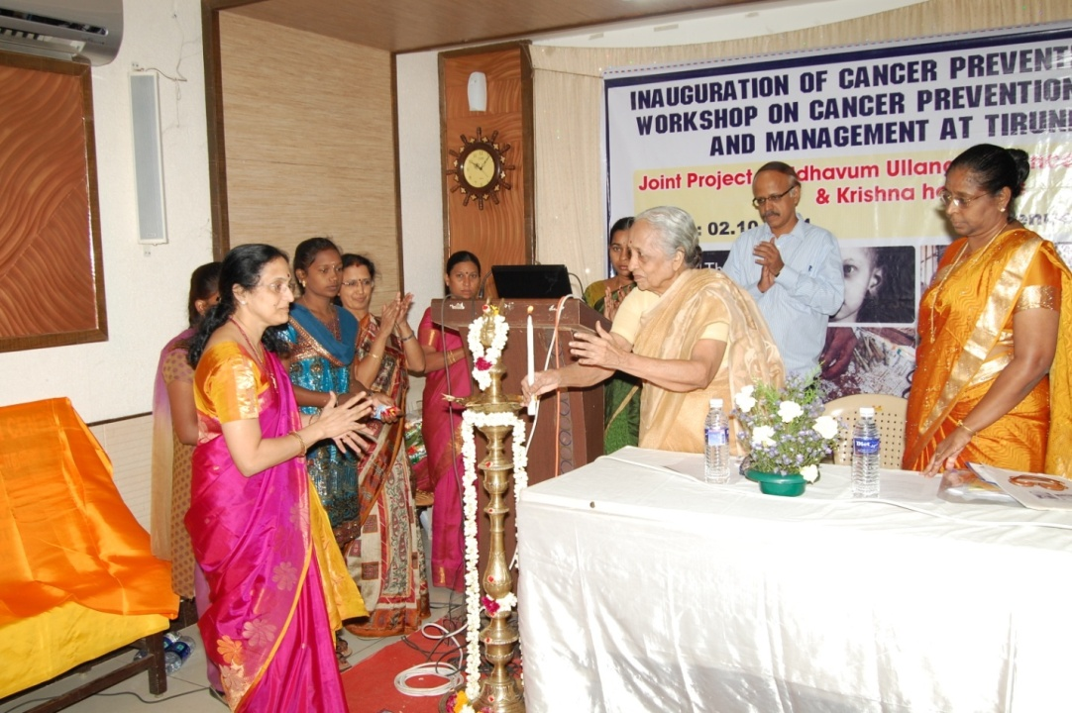

INAUGURATION OF CANCER PREVENTION CENTRE BY
DR.V SHANTA,CHAIRMAN CANCER INSTITUTE (WIA) ADYAR

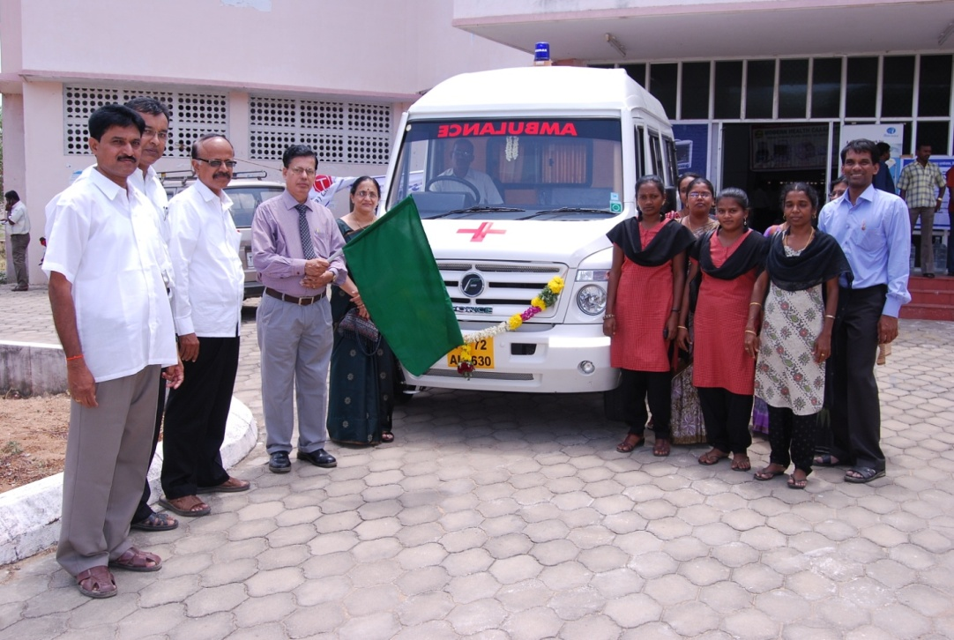

INAUGURATION OF AMBULANCE VAN DONATED BY COGNIZANT FOUNDATION BY
DR.T S SAGAR, DIRECTOR, CANCER INSTITUTE (WIA), ADYAR
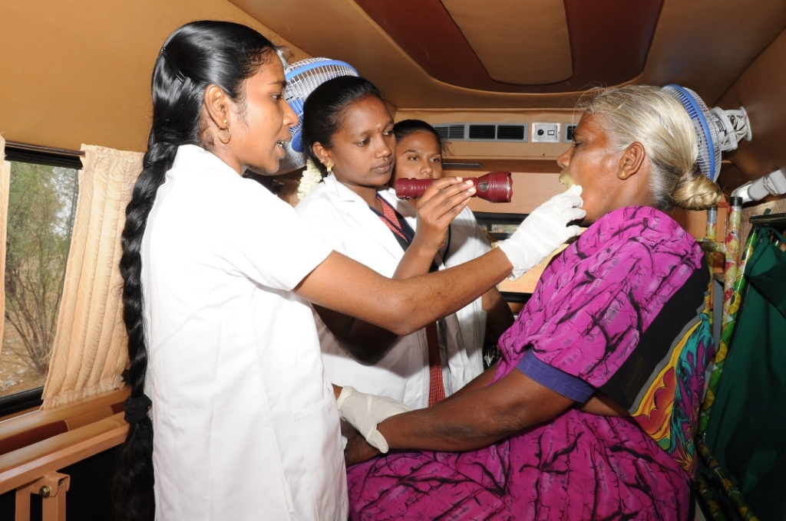

MEDICAL OFFICER EXAMINING THE PATIENTS

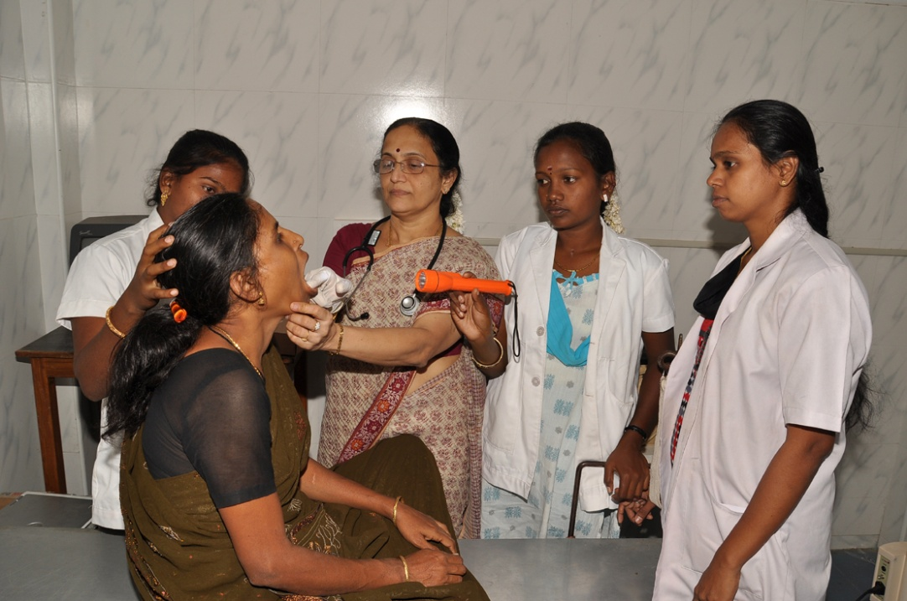

MEDICAL OFFICER SCREENING THE PATIENTS
AWARNESS PROGRAMME
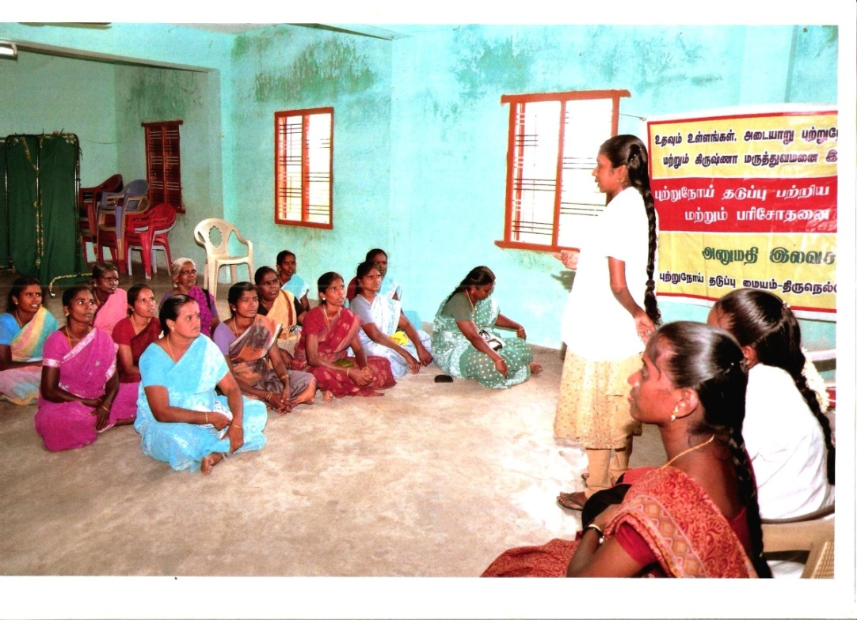

Report by Dr. Krishna Kumar, our Medical Oncologist

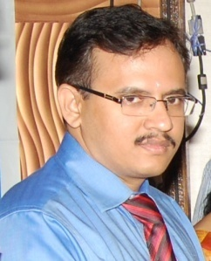

PRINCIPAL MISSION OF UDHAVUM ULLANGAL FOR
CANCER DIAGNOSIS AND TREATMENT

The aim of the Udhavum Ullangal trust is to diagnose cancer in an early stage, provide appropriate treatment without delay and ensuring a close follow up of all the patients after treatment. Cost should not be a barrier to good treatment- this has always been the motto of the trust and with the able guidance from the world renowned Cancer Institute Adyar, Chennai, the trust has arranged for routine cancer screening camps and set up a diagnosing facility at Tirunelveli. In addition to this, the establishment of a comprehensive treatment facility at Tirunelveli, the first of its kind, is under process and will soon be functional.

Biography of Patients treated

With creating awareness among more than 15000 people and more than 6000 cases screened across remote south district of Tirunelveli, Cancer Prevention Centre has proven that it is possible to reduce growing cancer rates through an ample strategy of outreach, public education, support, and other initiatives to establish prevention.

S.No. | Name | Age | Sex | Site | Status
1 | Petchimuthu | 79 | M | Oral
2 | Ms.Gandhimathi | 50 | F | Breast | Treated by Dr. Krishna Kumar
3 | Sornam | 50 | F | Breast | Treated by Dr. Krishna Kumar
4 | Asan Begam | 66 | F | Breast | Treated by Dr. Krishna Kumar
5 | Petchiammal | 45 | F | Cervix | Treated by Dr. Krishna Kumar completed
6 | Indira | 44 | F | Cervix | Under treatment
7 | Syed Ali Fathima | 22 | F | Breast | Treated at Krishna Hospital
8 | Banu | 37 | F | Breast | Treatment completed
9 | Pudiyaval | 65 | F | Cervix | Treated by Dr. Krishna Kumar
10 | Shanmugasundaram | 68 | M | Lungs | Treated by Dr. Krishna Kumar
11 | Ranganathan | 70 | M | Tongue | Expired
12 | Subbiah | 87 | M | Oral | Expired
13 | Chermakani | 62 | F | Thyroid | Treated by Dr. Krishna Kumar
14 | Muthulakshmi | 37 | F | Breast | Treated at Krishna Hospital

Treatment Summary of Patients

DIAGNOSED AT CANCER PREVENTION CENTRE AND TREATED AT MADURAI
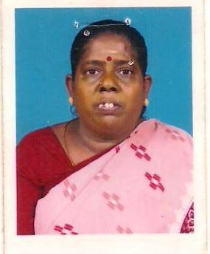
Mrs.Gandhimathi. 50/F Breast cancer survivor
Mrs. Gandhimathi was diagnosed with Ductal Carcinoma of breast by the Cancer prevention Centre, Thirunelveli. She was advised to strictly adhere to the treatment schedule as given by the Specialist doctor and was told that she does not have to worry about the expenses, which were eventually borne by the Centre. She had a mastectomy followed by 6 rounds of Chemotherapy and is now living a healthy lifestyle.

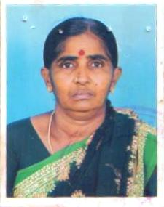
Mrs.Sornam. 50/F Breast cancer survivor
After being diagnosed with breast cancer at 50 and having Ductal carcinoma with Metastasis, Mrs. Sornam had a spread to the axillary node and eventually a life-threatening condition which required emergency chemotherapy and surgery.
"I was in disbelief that this was happening to me and felt so helpless that I abruptly stopped attending my appointments. I can’t imagine anyone having to go through this trauma alone. Since the day I was diagnosed, the Cancer prevention Centre team promised me that they would be with me at every appointment, test, treatment, surgery offering a complete financial back up; and they kept that promise. They sat with me through surgery, so that I wouldn't get scared, and when I cried, they consoled me in every possible way. “From where I stand now as a Cancer survivor I would say every woman deserves to have such care. Therefore, I wish this team venture grows to keep running through every vein of this country. After all they are fighting today, so women will not have to fight in the future”.

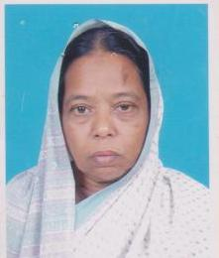
Mrs.Asan begum. 66/F Breast cancer survivor
“After being diagnosed with breast cancer, So many physical and emotional setbacks weighed on me as I had high sugar, hypertension, hypothyroidism and some cardiac complications; however, when my faith, family, friends could only do little, the incredible CPC family were always there for me, reassuring me and offering full monetary support. There was no way I could let them down, so I went through the chemotherapy and completed three cycles. But it was not enough. So I dug a little deeper and went through a Mastectomy in May 2013 and it got better. Now, I can proudly say, I AM A SURVIVOR!"
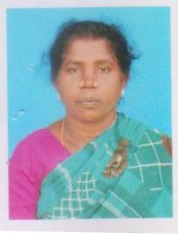
Mrs.Petchiammal 46/F Cervical cancer survivor
When Mrs. Petchiammal got to know about the Cancer Prevention Centre in the nearby city of Tirunelveli, offering free cancer screening, she utilized this opportunity only to realize she had saved herself from the clutches of cancer. She was diagnosed with Invasive cervical cancer of stage II and an immediate ultrasound and biopsy was taken.
“It was never about the money, since CPC bore every cent of it, from screening to radiation. Now it is like a dream as I have recovered from a dreadful Cancer and can challenge the world once again.”

