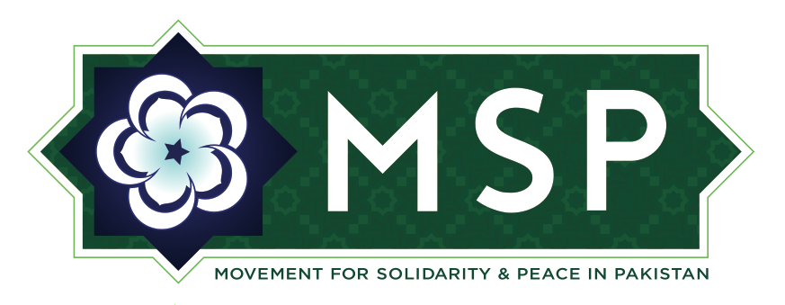
Movement for Solidarity and Peace in Pakistan
7 Times Square, New York, NY 10036
www.msp-pk.org | info@msp-pk.org

Global Giving Report

The Movement For Solidarity & Peace (MSP) In Pakistan submitted “Investigative Report on a Persecuted Community” on August 15th, 2014. Since this date, MSP has raised needed funds from concerned individuals like you. The funds raised are helping us undertake an investigative into the persecution of the Ahmadiyya community of Pakistan. This community, which is currently sized at an estimated 3 – 5 million individuals, has faced discrimination and persecution in various forms since the late 1950’s. However, violence against them has accelerated noticeably in recent decades and years. It is MSP’s objective to draw attention to this increased incidence of violence and violation of human rights against the community.
The funds raised thus far have been dedicated to research of the Ahmadiyya community in the United States and Pakistan. The United States Ahmadiyya community’s cooperation with MSP is essential in the upcoming months. This association is assisting in the disseminating of surveys which will provide quantitative data describing the frequency and nature of persecution against Ahmadis. The statistical results of these surveys are a significant component of an in-depth report. Interviews with Ahmadis in Pakistan and those that have migrated abroad are being conducted as well. These first-hand accounts and experiences will help us offer both qualitative and quantitative insights into the incidence of persecution and human rights violations.
MSP’s report will provide statistical evidence of persecution as well as a historic and contextual analysis of Pakistan’s Ahmadiyya community and emphasize policy recommendations. After the report is completed, it will be disseminated to human rights organizations, various branches of the Pakistani government, and other interested stakeholders. With their help, legal, political, and social campaign platforms will be designed to implement our report’s recommendations. MSP will continue to work with the Ahmadiyya community and other interest stakeholders to encourage coalitions dedicated to helping address human rights. MSP also encourages our donors to share questions or suggestions on how we can work together to attract wider support. Once again, MSP thanks all who have donated to our project and to our efforts. Together, we will promote human rights for all who live in Pakistan. See the attached links below to learn more about MSP’s mission and read our two published reports.

http://www.dawn.com/news/1143388/is-this-ship-sinking

https://twitter.com/movesolpeacepk
https://www.facebook.com/MSP.pakistan
www.msp-pk.org
http://www.globalgiving.org/projects/investigative-report-on-human-rights-in-pakistan/

