Progress Report-4
Education support to 300 slum children of Rayagada
Implementing Organization: Shakti Organization, Rayagada, Odisha, India.
The education standard of our slum children are now improving, they are now the first benchers in their classes. Our programme is helping them with a lot. In our counseling process, we are boosting their moral. Their parents are now feeling the importance of the education and the ability of their children. Our students are doing home works regularly, answering questions in class, getting good marks in their class examinations. In February-2016, they are going to appear their annual examination. We are sure that, most of them will perform better than their examinations. Now, we are running 14 centers and we are in second year of the programme. We are planning to mobilise funding support from well-wishers again for the second year. Now we are supporting 350 children of the under previlised community of the slums of Rayagada Municipality. During last qtr., we supported all children with two note books to each. We As a part of our regular intervention, we are focusing on personal hygienic practice of students; nail cutting and hand wash practice, in addition to educational support.
 | Sl no | Name of Slum, where Education centers functioning | Students Enrolled |  |  | Sl no |  | Name of Slum, where Education centers functioning | Students Enrolled
 |  |  | Girls | Boys | Total |  |  |  | Girls | Boys | Total
 | 01 | Ambaguda | 09 | 16 | 25 | 13 |  | Water Tank area | 08 | 18 | 26
 | 02 | Reli Sahi | 11 | 17 | 28 | 14 |  | Katuru | 13 | 11 | 24
 | 03 | Checkaguda | 06 | 14 | 20 |  |  | New center-Total | 21 | 29 | 50
 | 04 | Forest Colony | 12 | 15 | 27
 | 05 | Bhavani Sahi | 08 | 18 | 26
 | 06 | Harijan Sahi | 13 | 11 | 24
 | 07 | Erakula Sahi | 10 | 16 | 26
 | 08 | Jhodia sahi | 11 | 12 | 23
 | 09 | New Jhodia Sahi | 14 | 10 | 24
 | 10 | Goods Colony | 12 | 14 | 26
 | 11 | Ramchandrapur | 10 | 15 | 25
 | 12 | Sriram Nagar | 09 | 17 | 26
 |  | Total | 125 | 175 | 300
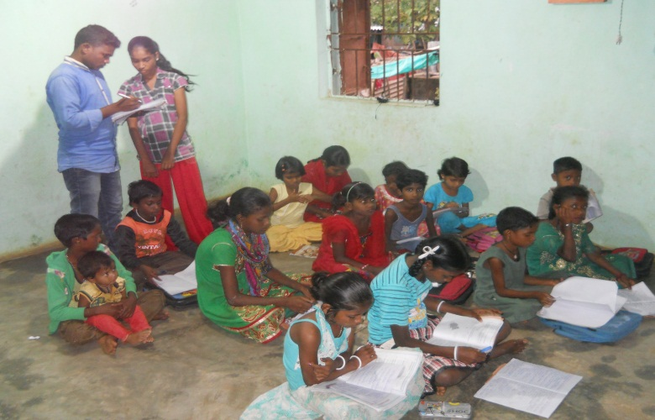 |  |  |  |  |  |  | 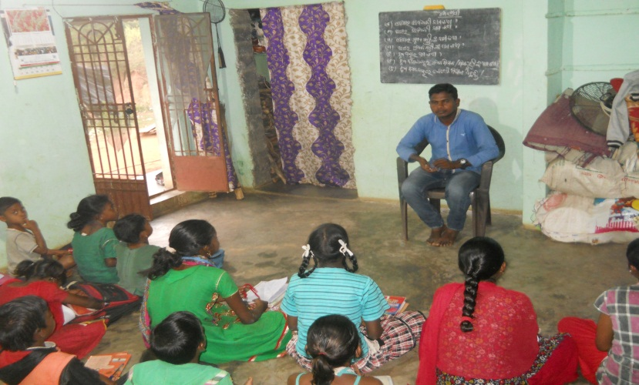
Teacher checking the Home work of students |  |  |  |  |  |  | Teacher busy in teaching

