Progress Report
Education support to 300 slum children of Rayagada
Implementing Organization: Shakti Organization, Rayagada, Odisha, India.

During the last quarter our Programme was running smoothly and has good result, the progress of our students is quite encouraging. We already have covered one year starting the programme. We are planning to continue the pogramme for another year. This year, we are convincing children to share partly the cost of pogramme and hope we will succeed to some extent. We have added two more slums this year from 1st July and started two centers of Education support programme. 50 children are enrolled in those centers from the underprivileged section. Now, all total, we have reached 350 children through this pogramme. The parents are also feeling proud of the education standards of their children. As a part of our regular intervention, we are focusing on personal hygienic practice of students; nail cutting and hand wash practice, in addition to educational support.
Sl no | Name of Slum, where Education centers functioning | Students Enrolled |  |  | Sl no | Name of Slum, where Education centers functioning | Students Enrolled
 |  | Girls | Boys | Total |  |  | Girls | Boys | Total
01 | Ambaguda | 09 | 16 | 25 | 13 | Water Tank area | 08 | 18 | 26
02 | Reli Sahi | 11 | 17 | 28 | 14 | Katuru | 13 | 11 | 24
03 | Checkaguda | 06 | 14 | 20 |  | New center-Total | 21 | 29 | 50
04 | Forest Colony | 12 | 15 | 27
05 | Bhavani Sahi | 08 | 18 | 26
06 | Harijan Sahi | 13 | 11 | 24
07 | Erakula Sahi | 10 | 16 | 26
08 | Jhodia sahi | 11 | 12 | 23
09 | New Jhodia Sahi | 14 | 10 | 24
10 | Goods Colony | 12 | 14 | 26
11 | Ramchandrapur | 10 | 15 | 25
12 | Sriram Nagar | 09 | 17 | 26
 | Total | 125 | 175 | 300

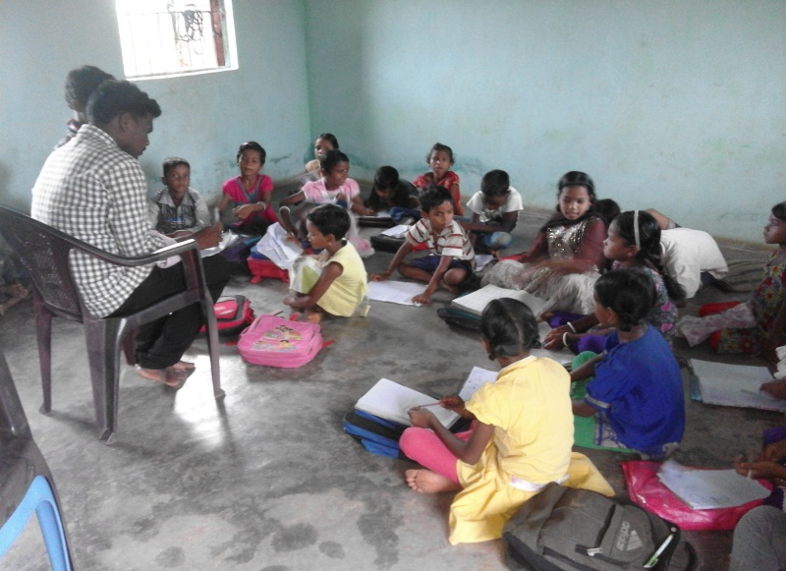 | 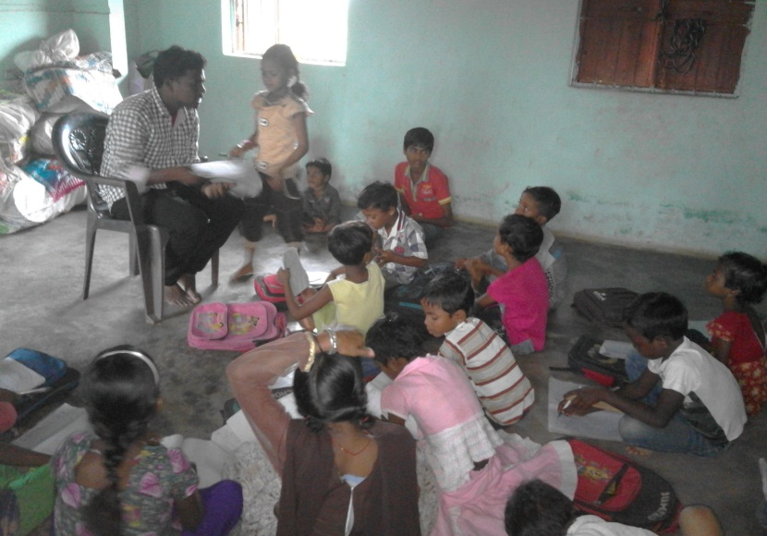
Teacher checking the Home work of students | Teacher busy in teaching

