Quarterly Progress Report
Education support to 300 slum children of Rayagada
Implementing Organization: Shakti Organization, Rayagada, Odisha, India.
12 Education centers in 12 Slums of Rayagada town are functioning since 1st Sept.2014. These centers enrolled 300 children of marginalized community, out of them 125 are girls and 175 are boys. Six months has already passed since the start of the pogramme in Sept.-14. During the last quarter our Programme has shown some good result, all students passed in their annual examination. 23 students stood within the best tenth in their classes, 46 students got position among first 20 good performers in annual exam in their classes. We have conducted 12 nos of parents and teachers meetings to involve the parents to boost the morale of their children and check drop out from coaching classes. All students are regular in their schools and the drop out is checked, but we found 14 dropout from our coaching classes. 206 students have made improvements in their annual examination. In addition to educational focus, we also emphasized on personal hygienic practice of students, nail cutting and hand wash practice. Still we are sort of 423 Dollars and expecting donation.
Sl no | Name of Slum, where Education centers functioning | Students Enrolled
Sl no | Name of Slum, where Education centers functioning | Girls | Boys | Total
01 | Ambaguda | 09 | 16 | 25
02 | Reli Sahi | 11 | 17 | 28
03 | Checkaguda | 06 | 14 | 20
04 | Forest Colony | 12 | 15 | 27
05 | Bhavani Sahi | 08 | 18 | 26
06 | Harijan Sahi | 13 | 11 | 24
07 | Erakula Sahi | 10 | 16 | 26
08 | Jhodia sahi | 11 | 12 | 23
09 | New Jhodia Sahi | 14 | 10 | 24
10 | Goods Colony | 12 | 14 | 26
11 | Ramchandrapur | 10 | 15 | 25
12 | Sriram Nagar | 09 | 17 | 26
 | Total | 125 | 175 | 300

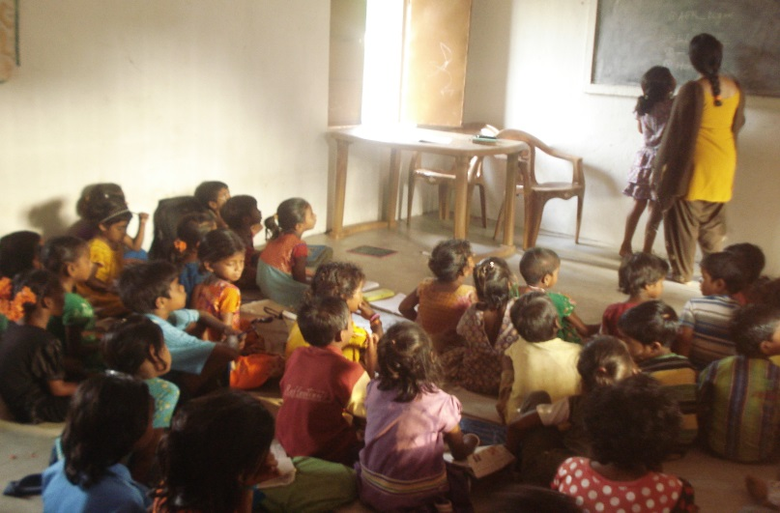 | 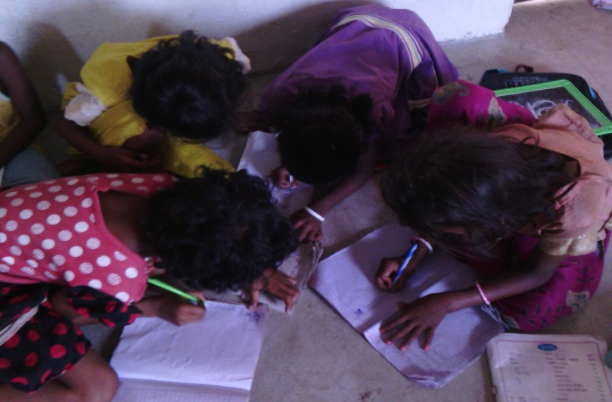
Teacher busy in practicing students in black Board | Students are doing assigned task

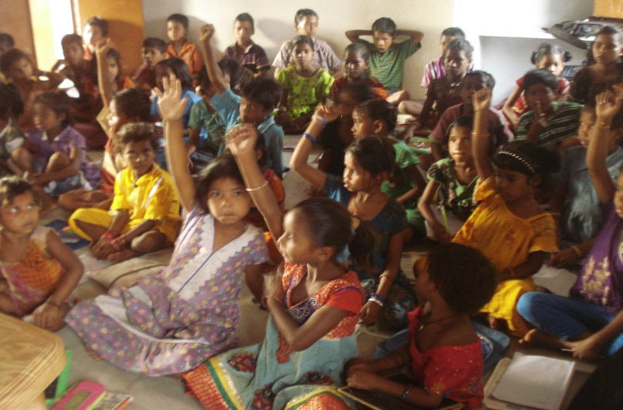 | 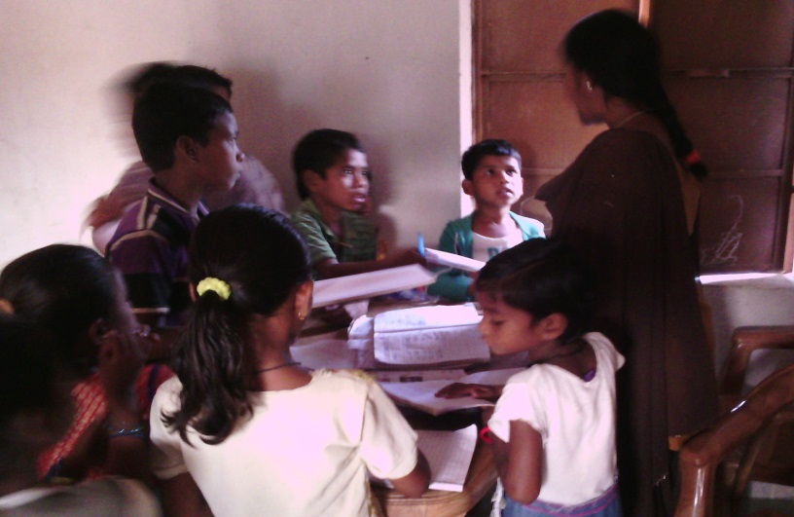
Maximum students raising their hands when Teacher asked GK Question | Teacher checking the Home work of students

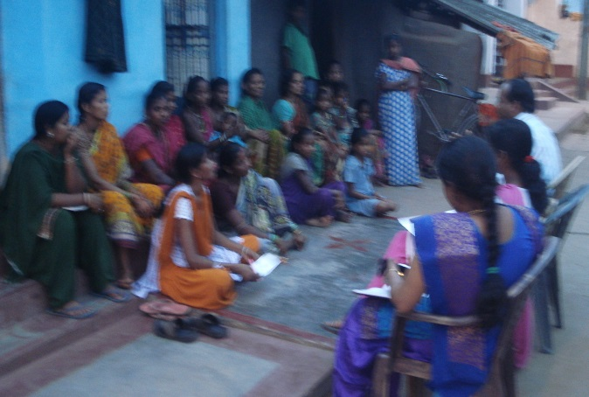
Parents & Teachers meeting

