Student enrollment Position
Education support to 300 slum children of Rayagada
Implementing Organization: Shakti Organization, Rayagada, Odisha, India.
SHAKTI started 12 Education centers in 12 Slums of Rayagada town from 1st Sept.2014. These centers enrolled 300 children of marginalized community, out of them 125 are girls and 175 are boys. During the first quarter our Programme crated enthusiasm for education among 37 school dropout children, who are now regular in school. It is a good impact of this Programme. 185 students have made improvements in their half yearly examination. It's a good start. In addition to educational focus, we also emphasized on hygienic practice of students, nail cutting and hand wash practice initiated. Still we are sort of 868 Dollars and expecting donation.
Sl no | Name of Slum, where Education centers functioning | Students Enrolled
Sl no | Name of Slum, where Education centers functioning | Girls | Boys | Total
01 | Ambaguda | 09 | 16 | 25
02 | Reli Sahi | 11 | 17 | 28
03 | Checkaguda | 06 | 14 | 20
04 | Forest Colony | 12 | 15 | 27
05 | Bhavani Sahi | 08 | 18 | 26
06 | Harijan Sahi | 13 | 11 | 24
07 | Erakula Sahi | 10 | 16 | 26
08 | Jhodia sahi | 11 | 12 | 23
09 | New Jhodia Sahi | 14 | 10 | 24
10 | Goods Colony | 12 | 14 | 26
11 | Ramchandrapur | 10 | 15 | 25
12 | Sriram Nagar | 09 | 17 | 26
 | Total | 125 | 175 | 300

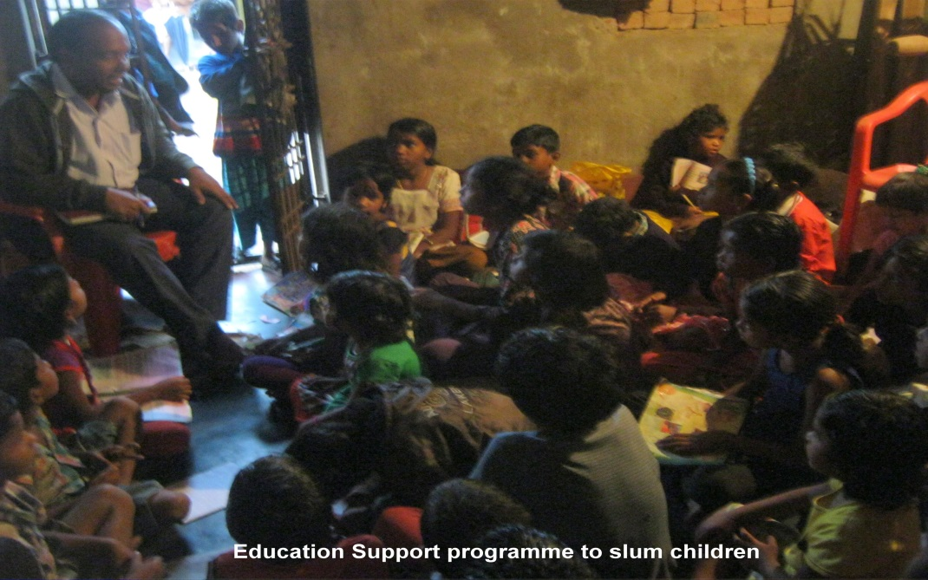
Night Coaching Class going on in SriramNagar Slum of Rayagada Town

