The Julio Otoni Project Update August 2009

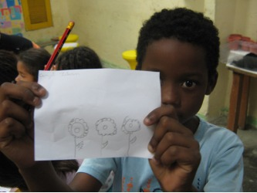
Every day the Community Centre at the Julio Otoni Project is filled with the excited voices of the 50 or so children who benefit from the project. What was once a disused and uninviting space is now a thriving hub of activity and a safe place where the children of the community know there will be people to welcome them and exciting things going on. There are regular classes with both recreational and educational activities such as: Arts and Crafts, Gardening, Sports and Computing as well as extra Literacy and Mathematics classes for those that are behind at school that take place every day, Monday to Saturday.

The more fun classes are scheduled according to what the children in the project enjoy as it is important for them to have something to look forward to and to keep them interested. In April, the children had their first ever Music class – they learnt songs such as Heads, Shoulders, Knees and Toes and then performed them in groups whilst recording themselves. Participating in activities such as this are crucial to these children – a childhood song like this that we take for granted is not something they would have heard of and non-essential classes like Music are not offered as part of the School Curriculum. Aside from being a fun and interactive activity it also builds up their confidence which is important. You can watch the video and see for yourself here: The Julio Otoni Project’s First Music Class!

One big development for the project and for the Community over the last 3 months has been the inauguration of a sports field at the back of the Favela which allows more organised sports to take place. Previously there was no area for this and the children had to travel to a nearby Favela or play at the entrance to the Favela on the main road. Wednesday afternoons are now dedicated to sports and team activities and have rapidly become the most popular day for the project. Playing sports is something we take for granted in developed countries, but it is a luxury for these children and encourages team work and also importantly a fun way to get fit (many of these kids have a very poor diet and no exercise as sport is not offered at school).

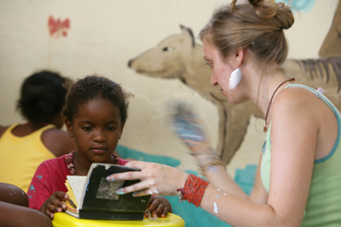
Another big achievement for the project and more importantly the children is the performance and grades that the children who benefit from the project have been achieving at school. The project has seen a 40% reduction in the number of children who need extra literacy and mathematics classes which is great news as this means that these children have now reached the correct educational level for their ages.

There has also been some fun stuff happening too...Charles Siqueira the project leader organised a trip to Cristo Redentor (The famous Rio landmark statue of Christ) on the cog train that runs to the statue through the Tijuca Forest which was a very exciting day out for the children – despite living at the foot of this iconic landmark, many of these childrenhave never had the opportunity to visit the statue and certainly to ride the cog train there and back! You can see the excitement on the childrens faces on the video on You Tube.

All these activities are providing a valuable resource for these children – it expands their knowledge, gives them access to opportunities and experiences they would otherwise never have and most importantly provides an important day to day alternative for these children who would otherwise be left to hang around on the streets of the Favela whilst their parents work, therefore being more likely to become involved with the drug trafficking that is unfortunately the norm.

Please continue your support of this project - without your donations we can’t cover the running costs of this project and if you’ve watched the videos then you will see for yourself what a difference this project makes to the children of the Julio Otoni Community...Thank you!

