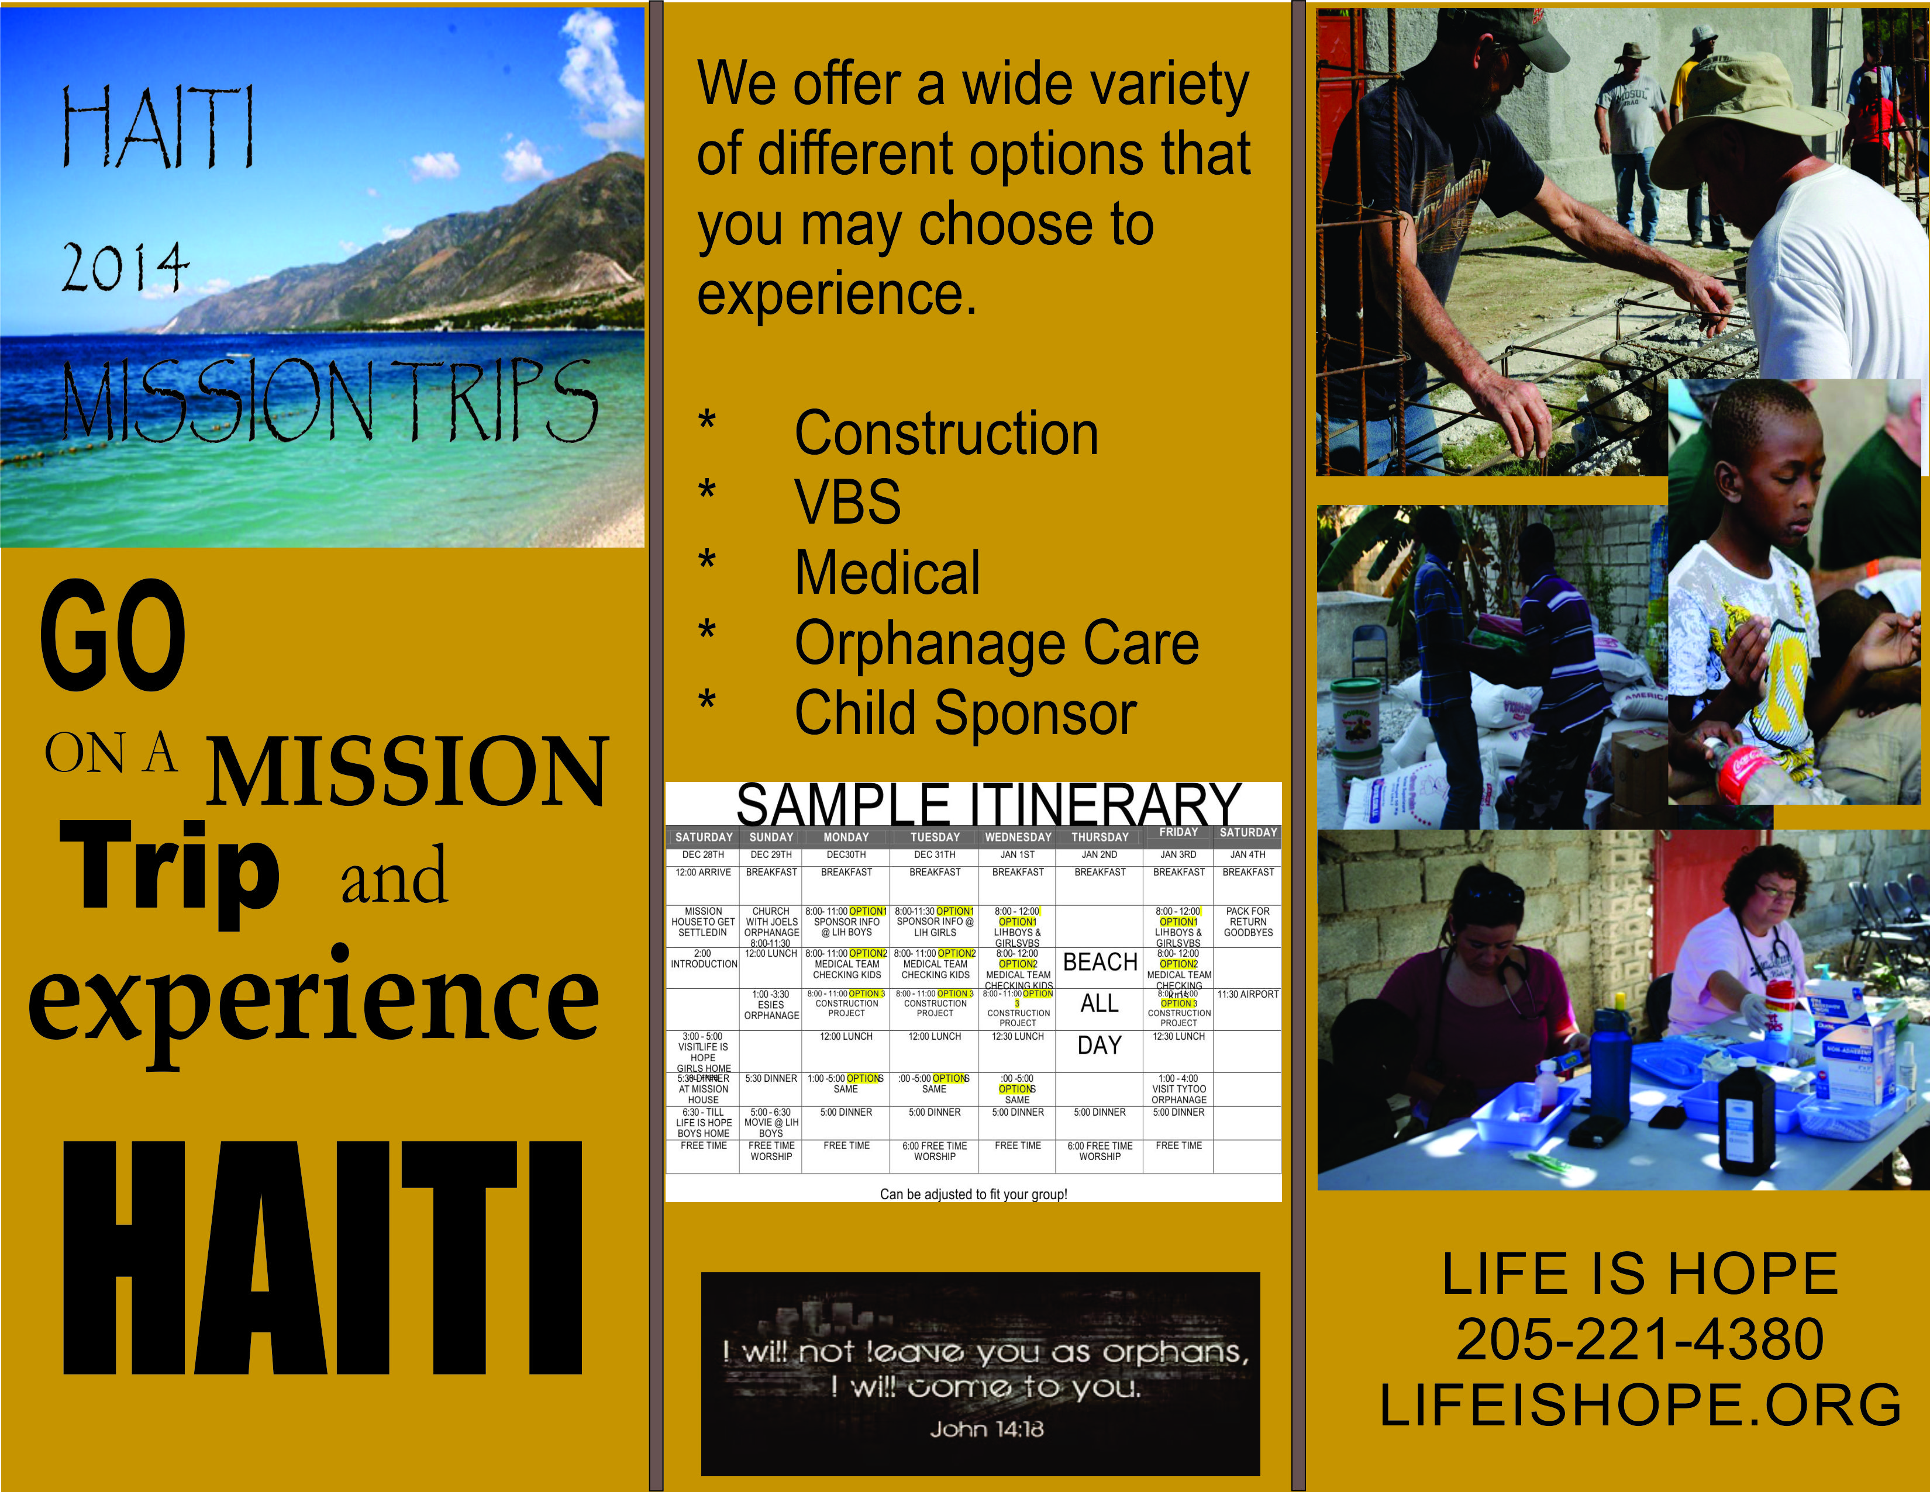
We would like to invite your group to join us on a mission trip to Port-au-Prince Haiti!
Why Haiti?
- Haiti is one of the poorest countries in the world.
- There are approximately 300,000 children that are truly orphans or just abandoned.
- Haiti is approximately a 3 1/2 hour flight from Southern United States.
- Haiti need you.

Why Life is Hope?

- Life is Hope is multi-denomination Christian group that share a love for God and the Haitian children.
- We offer an all inclusive trip with a large variety of options.
- Our mission house with equipped with air condition bedrooms.
- Security Officer at night.
- With your help, we can bring Love, Shelter, Food and Hope to the Orphans in Haiti.
- We support five orphanages in Haiti. We operate almost exclusively by volunteers.

Cost?

- $100 per night per person. Minimum Group 15/Maximum Group 25
- Once you arrive at the airport in Haiti all your expenses are paid (except any souvenirs you wish to purchase) until you are delivered to the airport for your return flight.

