We thank all our supporters for donating towards our campaign to save the lives of malnourished children.
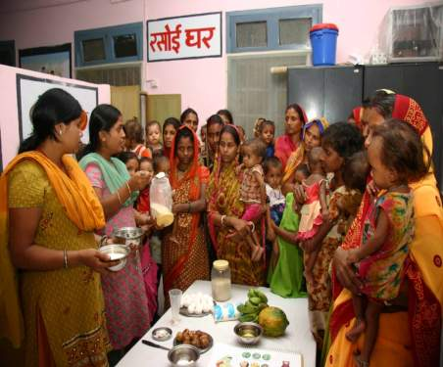
Nidan works to create awareness against malnutrition and also demonstrate through the Nutrition Rehabilitation Centre(NRC) that fighting against malnutrition is not so much a matter of cost but also of mindset. The NRC was able to help 25 children in Aug, another 22 in .Sep and 19 children in Oct. All admitted child come in critical stage with families spending more and more in treatment. Being farming season it has difficult for mother to come to the center. but our volunteers motivated them saying that they were putting the life of their child in danger as the child is severely malnourished. Nidan is now planning to launch a campaign against malnutrition in other districts of Bihar. It plans to train volunteers in ever village who can measure the condition of the child and if the child is severely malnourished then provide training to the mothers to help child in overcoming the situation.
During the three months (1st Aug 2017 to 31th Oct. 2017), 60 malnourished children were admitted (28 Boys and 32 Girls). In this particular period, we have successfully discharged 56 children (26 Boys and 30 Girls).. We make an effort to cure all children who are facing the problem of malnutrition.
The steps to cure a malnourished child:
- Feeding of admitted SAM child (As per protocol); Feed Preparation for admitted mothers; Provision of food to mother;
- Administration of Medication: Albendazole, Vitamin– A, IFA, Zinc, Folic Acid, Magsulf, Potclor; Administration of Medication: Antibiotics, Immunization etc.; Child friendly games and puzzles
- Statistical analysis of: Follow up data extracted from community level. Comparative analysis of target weight status of last batches.
By following these steps, children who have achieved the target weight of 15% when discharged are asked to come for 4 follow ups to check if they are healthy or have they started losing weight.
NRC is also doing capacity building of mothers and family on health, hygiene and nutrition.

Case Study of one child
Name : Rupa Kumari (Fictional name)

Mother’s Name : kumari Devi (Fictional name)
Father’s Name : Hari Paswan (Fictional name)
Village’s Name : Chakfatate
Block : Mahua
Age : 34 months (2 years and 10 months)
Weight : 4.400 kilogram (At the time of admission)
Height : 71 cm
Z scare : < -4SD
MUAC : 7.5 cm

Kumari Devi was from the village Chakfatate with her husband which name is Hari Paswan. She had three children, one boy and two girls. The princess used to cultivate their livelihood and buffalo was also kept. Her husband's income was very low because one of his legs was cut, due to which he could not do much work. kumari Devi said that Rupa had a weight of three kg at the time of her birth and her weight increased from the fourth month. When Rupa was six months old, we started giving him the upper diet. Its development was good for two and a half years. But suddenly, when his stomach got spoiled, he was shown to the doctor, after showing the doctor, his stomach got cured, but after that he started fever and started to vomit and again the stomach got worse. Slowly his hunger ended, whatever he was given, did not eat. Slowly his health became very poor within two to three months. We took him along with a child doctor in Muzaffarpur. But there was no improvement in its condition, after that we also showed it in Hajipur. We showed it to the Ojha but there was no improvement. We were quite frustrated now, and now we have left our child in God's trust. When ASHA didi to know about our situation, she explained to us and told about the NRC Mahua, but I was not feeling confident. One day he insisted on a lot and explained that once you have done what you have done there, anyway, if you have been shown from all over the place, then go there and show it maybe something good. He gave us so much confidence that your child will definitely be fine there. Then we also understood the thing of ASHA didi and came to bring her child to the NRC home, Mahua. When she came home, she weighed only 4 kg 400 grams.

First of all, his hunger was checked in the NRC, it was found that his appetite was not good, he was quite dull and very weak, and he could not even sit with him. After three recruitments in the NRC, his hunger became good, now the weight of Rupa began to increase gradually; as a result she started sitting herself and laughing. Now she had started speaking a little too much. When her grandmother came to meet her after a week, she was happy to see Rupa's condition. Her grandmother speaks to sister that, ‘Do you all have the magic? That my granddaughter gets cured so quickly? We were all very upset about Rupa’s.

When Rupa came, she did not gain weight for the first two days and if the weight increased on the third day she would not have increased on the fourth day, her weight increased steadily from 40 to 50 grams on the fifth day. The targeted weight was completed on the 16th day and it started to stand by itself, on the day of his going, we weighed 5 kg 100 grams.

Discharge details of Rupa Kumari :-
Weight : 5.100 kg
MUAC : 8.0
Z-core : <-4SD
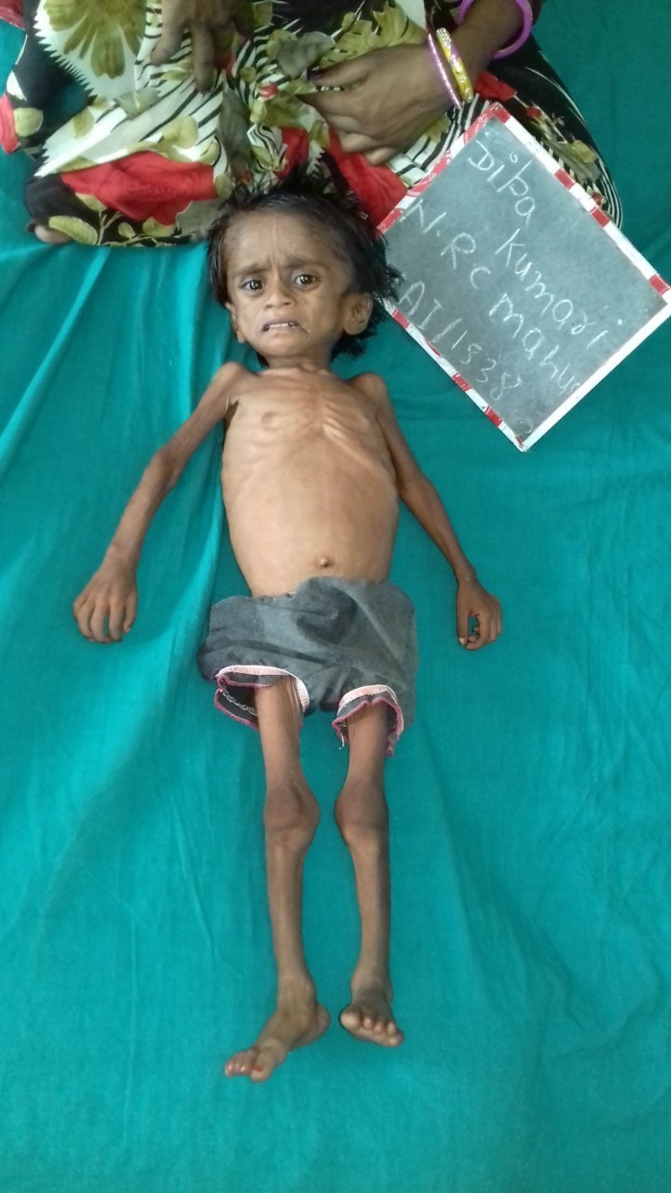
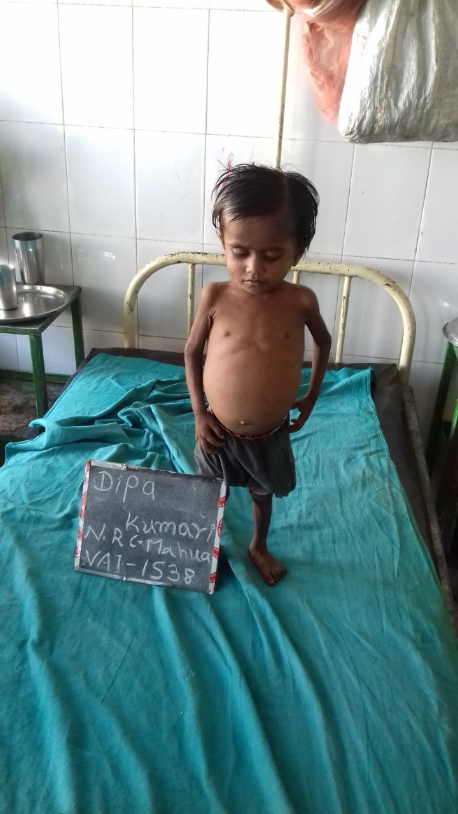
At the time of Admission
At the time of Discharge

