We thank all our supporters for donating towards our campaign to save the lives of malnourished children.
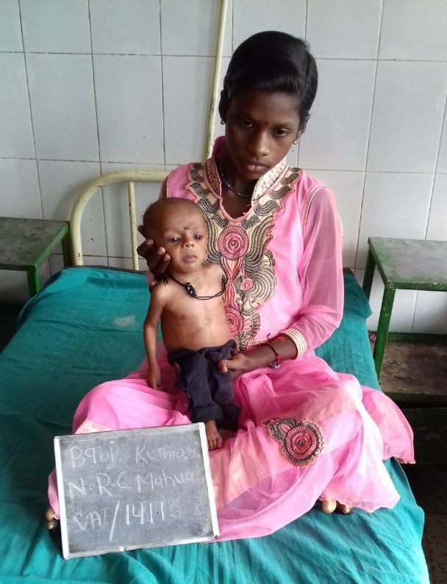
Nidan works to create awareness against malnutrition and also demonstrate through the Nutrition Rehabilitation Centre(NRC) that fighting against malnutrition is not so much a matter of cost but also of mindset. The NRC was able to help 19 children in February, another 20 in March and 27 children in April. All admitted child come in critical stage with families spending more and more in treatment. Being farming season it has difficult for mother to come to the center. but our volunteers motivated them saying that they were putting the life of their child in danger as the child is severely malnourished. Nidan is now planning to launch a campaign against malnutrition in other districts of Bihar. It plans to train volunteers in ever village who can measure the condition of the child and if the child is severely malnourished then provide training to the mothers to help child in overcoming the situation.
During the three months (1st Feb 2017 to 30th April 2017), 66 malnourished children were admitted (32 Boys and 34 Girls). In this particular period, we have successfully discharged 54 children (25 Boys and 29 Girls).. We make an effort to cure all children who are facing the problem of malnutrition.
The steps to cure a malnourished child:
- Feeding of admitted SAM child (As per protocol); Feed Preparation for admitted mothers; Provision of food to mother;
- Administration of Medication: Albendazole, Vitamin– A, IFA, Zinc, Folic Acid, Magsulf, Potclor; Administration of Medication: Antibiotics, Immunization etc.; Child friendly games and puzzles
- Statistical analysis of: Follow up data extracted from community level. Comparative analysis of target weight status of last batches.
By following these steps, children who have achieved the target weight of 15% when discharged are asked to come for 4 follow ups to check if they are healthy or have they started losing weight.
NRC is also doing capacity building of mothers and family on health, hygiene and nutrition.
Impact story of a child
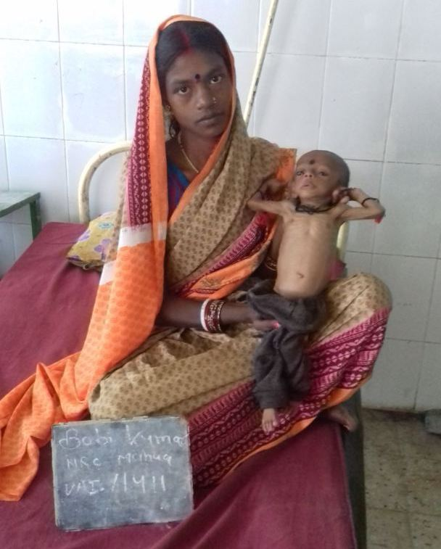
Name of the child – Bobby Kumari
Father’s Name – Sanjay Ram
Mother’s name – Poonam Devi
Village – Kalyanpur
Block - Biddupur
Age- 5 months and 15th days
Poonam Devi was a resident of Kalyanpur village. She has two kids, a girl and a boy. Her husband was not under regular employment. Sometimes he used to go out for work, after regular insistence from her and most of times he used to be at home . As a result the condition of her house was miserable. This poor economic condition forced Poonam devi to stay at her sister house, Since her mother was dead she never visited her mother house when her baby was born he weighed 2.500 gram and did not Cray at the time of birth, the child was kept a newnet. Poonam Devi was unable to feed her new baby. The kid continued to be ill since his birth. He was treated by many doctors of the locality but of no use. This made poonam devi and her sister very much worried, According to poonam devi her child was not able to take in even 50gram of milk. When Asha worker counseled her continuously, she agreed to go to NRC.
When Bobby kumari admitted to NRC her details were:-
Weight – 2.400kg
Z- score -<-4sd
Height- 54 cm
When the child was examined at NRC he was in a very serious condition and her mouth was infected, After getting treatment at NRC for a few days the condition started improving and her weight started growing. On 18th day the child gained the required ideal weight and now she had become very active and started giving response. Her father visited regularly and was happy to see improvement in his child. Bobby also learned to sit and stand in NRC. Poonam was also counseled about how to prepare nutritious diet for children using household grains and about family planning. Booby’s parents were very thankful to NRC and said that if NRC wouldn’t have admitted on time he wouldn’t have survived.

At the day of discharge:-
Weight – 2.800 Kg
Z- score -<-4sd
Height – 54.2 cm

