We thank all our supporters for donating towards our campaign to save the lives of malnourished children.
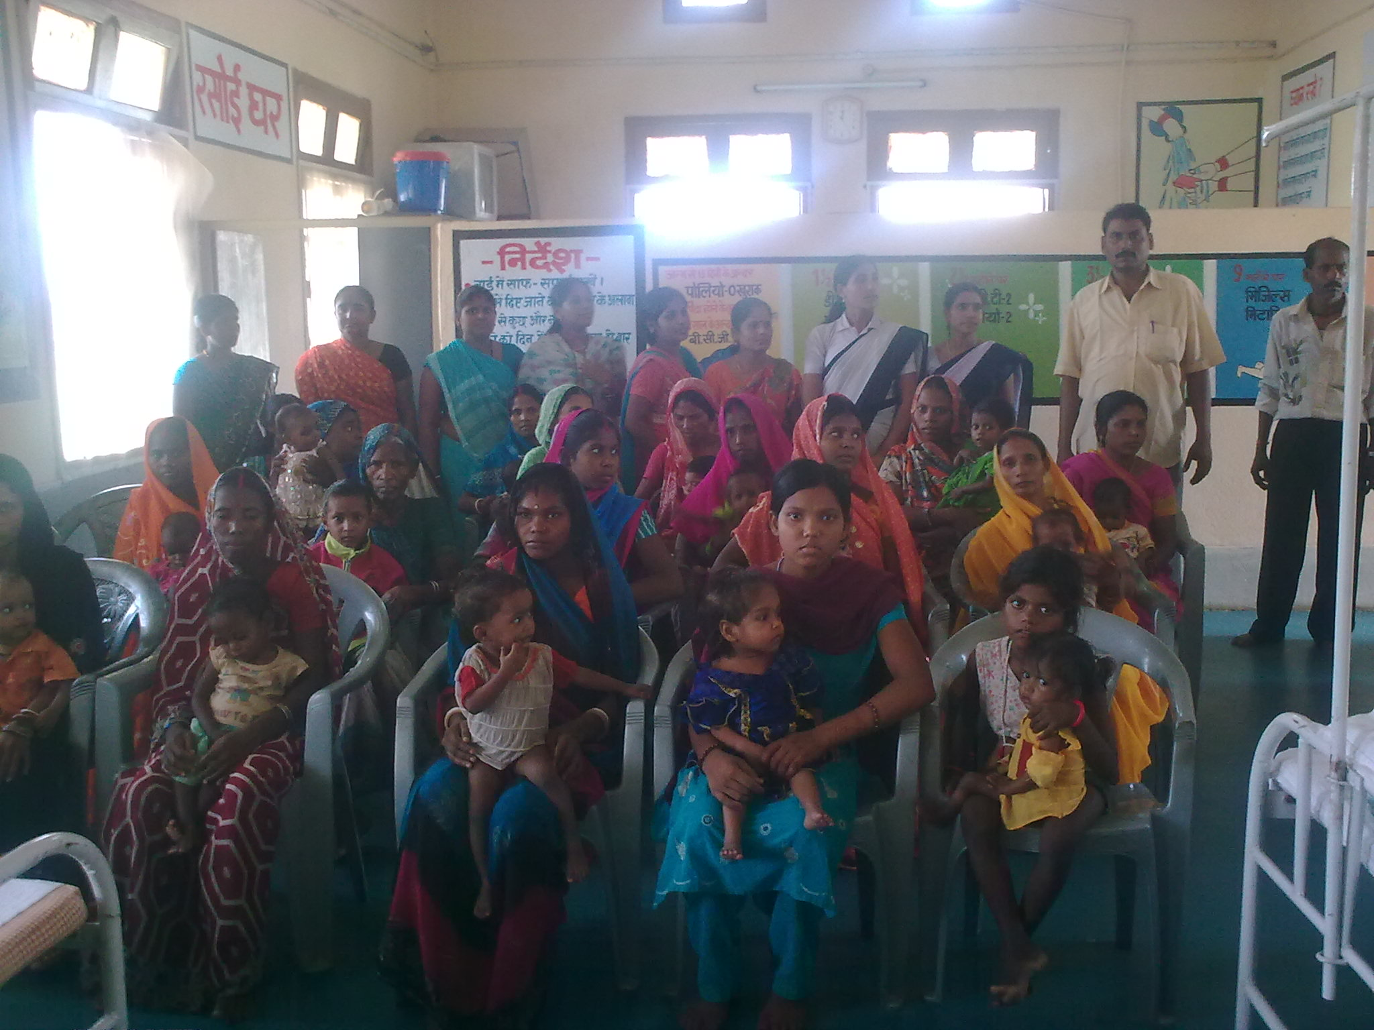
Nidan works to create awareness against malnutrition and also demonstrate through the Nutrition Rehabilitation Centre(NRC) that fighting against malnutrition is not so much a matter of cost but also of mindset. The NRC was able to help 25 children in May, another 22 in June and 19 children in July. All admitted child come in critical stage with families spending more and more in treatment. Being farming season it has difficult for mother to come to the center. but our volunteers motivated them saying that they were putting the life of their child in danger as the child is severely malnourished. Nidan is now planning to launch a campaign against malnutrition in other districts of Bihar. It plans to train volunteers in ever village who can measure the condition of the child and if the child is severely malnourished then provide training to the mothers to help child in overcoming the situation.
During the three months (1st May 2017 to 31th July 2017), 66 malnourished children were admitted (33 Boys and 33 Girls). In this particular period, we have successfully discharged 54 children (25 Boys and 29 Girls).. We make an effort to cure all children who are facing the problem of malnutrition.
The steps to cure a malnourished child:
- Feeding of admitted SAM child (As per protocol); Feed Preparation for admitted mothers; Provision of food to mother;
- Administration of Medication: Albendazole, Vitamin– A, IFA, Zinc, Folic Acid, Magsulf, Potclor; Administration of Medication: Antibiotics, Immunization etc.; Child friendly games and puzzles
- Statistical analysis of: Follow up data extracted from community level. Comparative analysis of target weight status of last batches.
By following these steps, children who have achieved the target weight of 15% when discharged are asked to come for 4 follow ups to check if they are healthy or have they started losing weight.
NRC is also doing capacity building of mothers and family on health, hygiene and nutrition.

