Summary
In this day and age we can see that computer is an important tool in the professional and personal lives of people living in France and other parts of the world. Information technology related knowledge and skills have become very necessary in everyday life. Computer proficiency is indispensable for most job seekers because majority of employment offers are diffused on the internet. The association Femmes Dignes has therefore designed her free computer training and personal development programs, to empower youth and adults with relevant information technology knowledge et skills that would enable them realise their pontential, become productive and self-reliant, as a result contribute towards the development of their communities, which would furthermore enhance national development.

Words of our beneficiaries

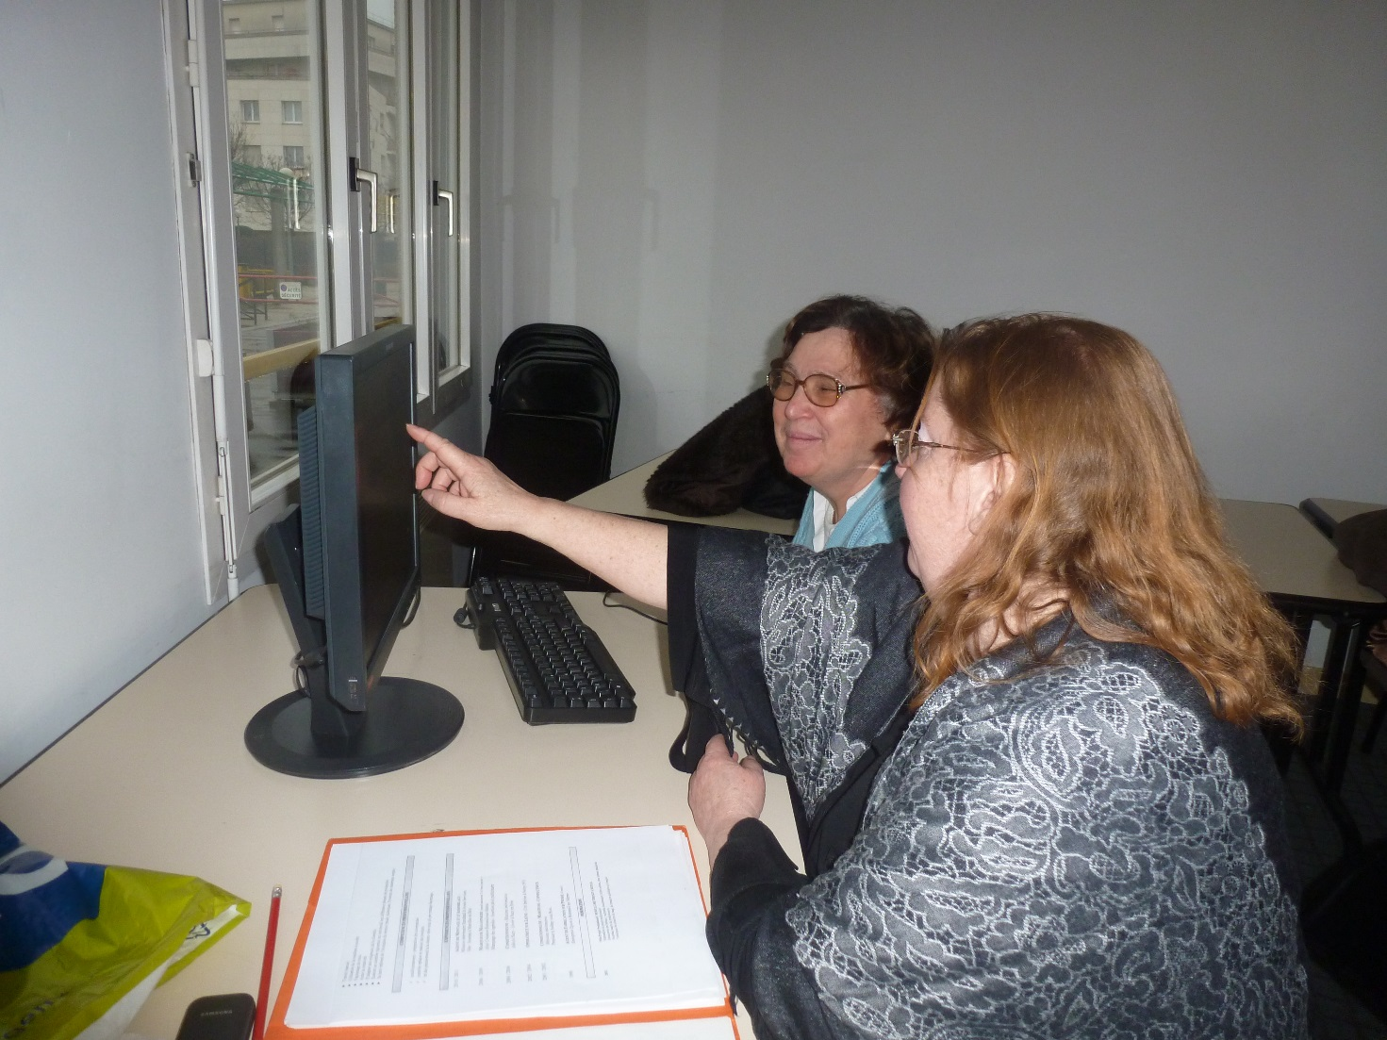

The project of the association Femmes Dignes could not exist without the public or beneficiaries, that is why it places the individual at the heart of her action. The impact of the association in the lives of its beneficiaries urged them to express their gratitude to her :
I attend computer training and personnal development programs set up by the association 'Femmes Dignes'. The first time I came to the association, computer software and hardware were so strange to me, today I am able to work on the computer, I have learnt word processing (microsoft word), browsing on the internet, create an account, send and consult electronic mails, complete administrative procedures online... I will always say a big thank you to Femmes Dignes for giving me a push to develope my career. Maria

The association Femmes Dignes has offered me a lot , my life has changed, I learned a lot from the trainers working with the association . When I arrived at the association I was not sure of what I wanted to do, through the association, I could define my career and I was able go into training, refresher course in secretarial, computer systems, french , mathematics and logic. I am fulfilled in my professional and social life , I am very motivated , I believe in this organization and this is why I investing in the project of Femmes Dignes as a volunteer to help other peoples in need. Every week I spend 4 days at the training center and one day working for the association. I 'm glad that I came in contact with the association Femmes Dignes, thank you for all you have done for me. Claudine

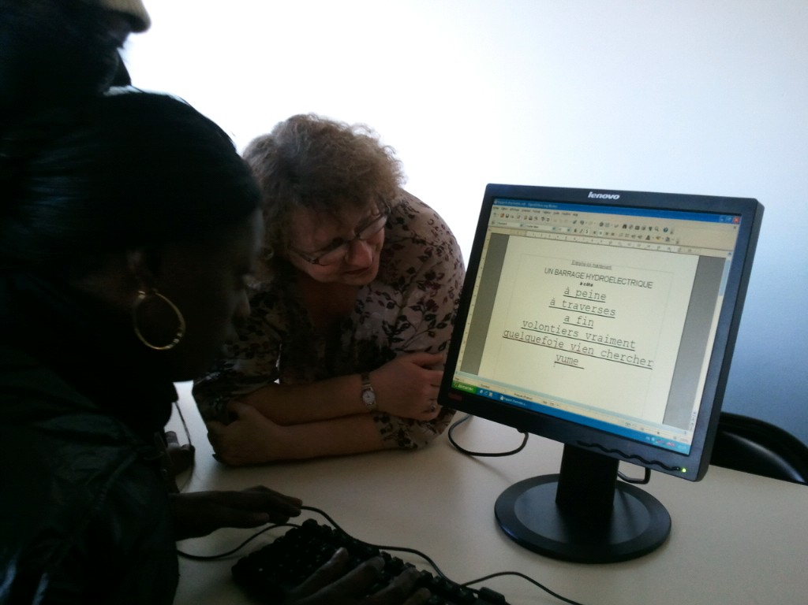

The free computer training programmes of the association Femmes Dignes gave me the opportunity to acquire knowledge and skills that enabled me to intensify my job search on the web sites dedicated to employment offers, consequently I was able get a job as a Receptionist. One of the conditions of this job offer is competence in computer systems. I appreciate the hope that you gave me, courage and self-confidence . I will never forget the support that you accorded me during this period of training. Thank you very much . Fatoumata

