Accessing Education to Refugee Children in Uganda.

Insights from Findings of out of school children in Uganda.

1. Introduction
2. Purpose of the study
3. Objectives
4. Findings
5. Conclusions
6. Recommendations
7. way forward.

1. Introduction.

Aimed at exploring factors responsible for the dropping out of children from school before completing the primary school cycle as well as non-enrolment

As we approach 2015, it is a glaring fact that not ALL children of school going age have been enrolled

The study considered a significant refugee sample in Kampala, Rhino, Nakivale and Kyangwali settlements/sites

Refugee Settlement Areas of the study

District / settlement | Number | Male | Female | Total (%)
Arua (Rhino) | 96 | 22.9 | 77.1 | 21.4
Hoima (Kyangwali) | 87 | 54 | 46 | 19.9
Isingiro (Nakivale) | 107 | 73.8 | 26.2 | 23.8
Kampala (scattered in different localities) | 148 | 53.4 | 46.6 | 34.9
Total | 438 | 51.8 | 48.2 | 100%

Purpose

The purpose of the study was to document reasons why children in various parts of the country do not enroll in school and

why others drop out despite the presence of UPE and other interventions

Objectives of the study

To identify the causes of non-enrolment and dropping out of school
To analyze factors resulting in dropping out from school
To analyze and rank the causes of non-enrolment
To identify push and pull factors
To advise on strategies and make recommendations

Study Design

A Quantitative and Qualitative paradigm
Household survey
Key Informants, Focus group discussions and in-depth interviews

Major Findings
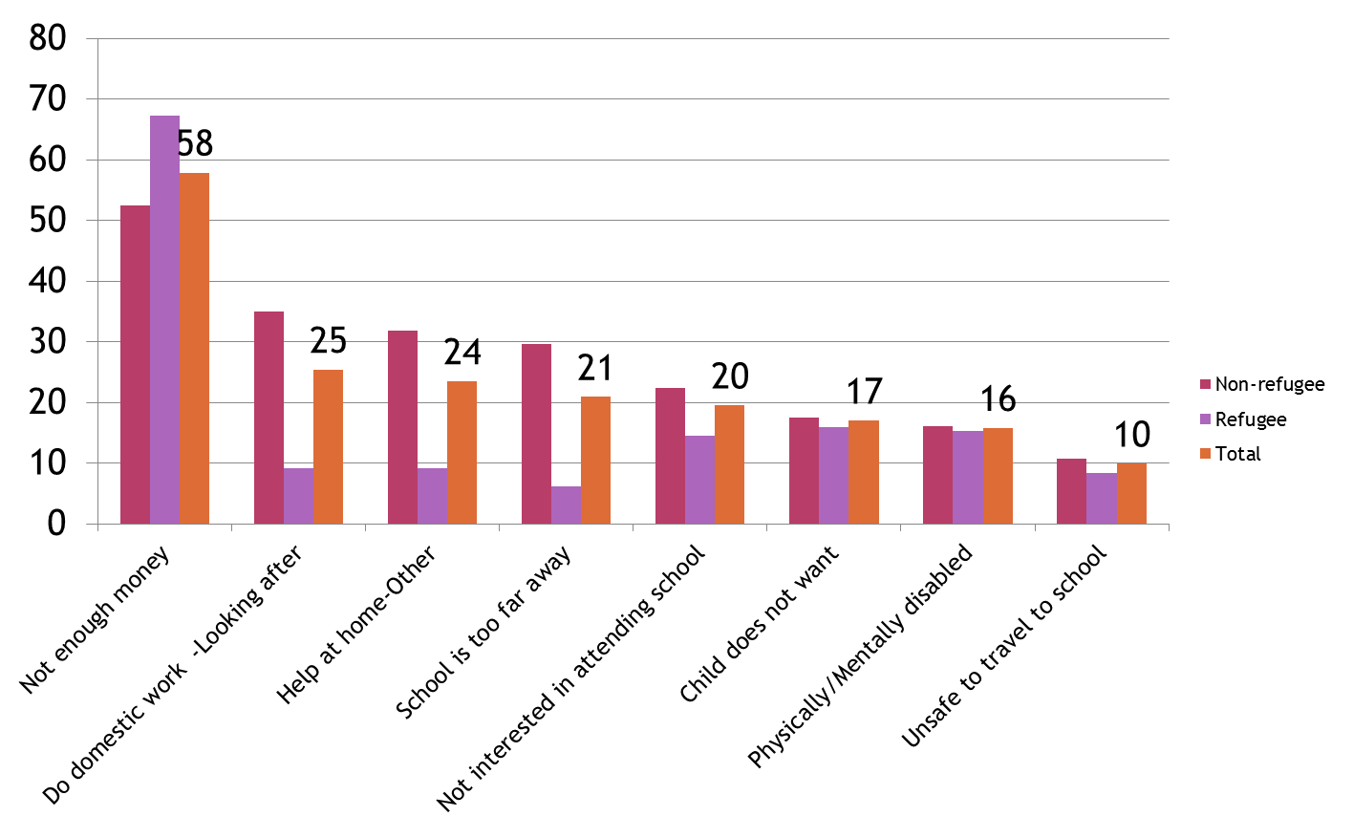

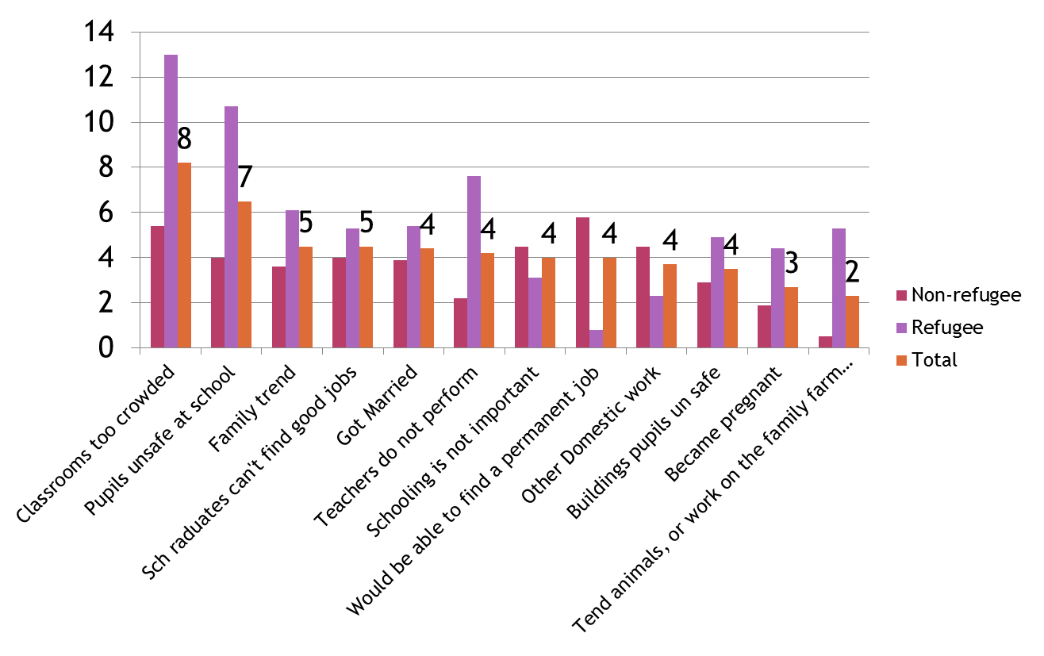

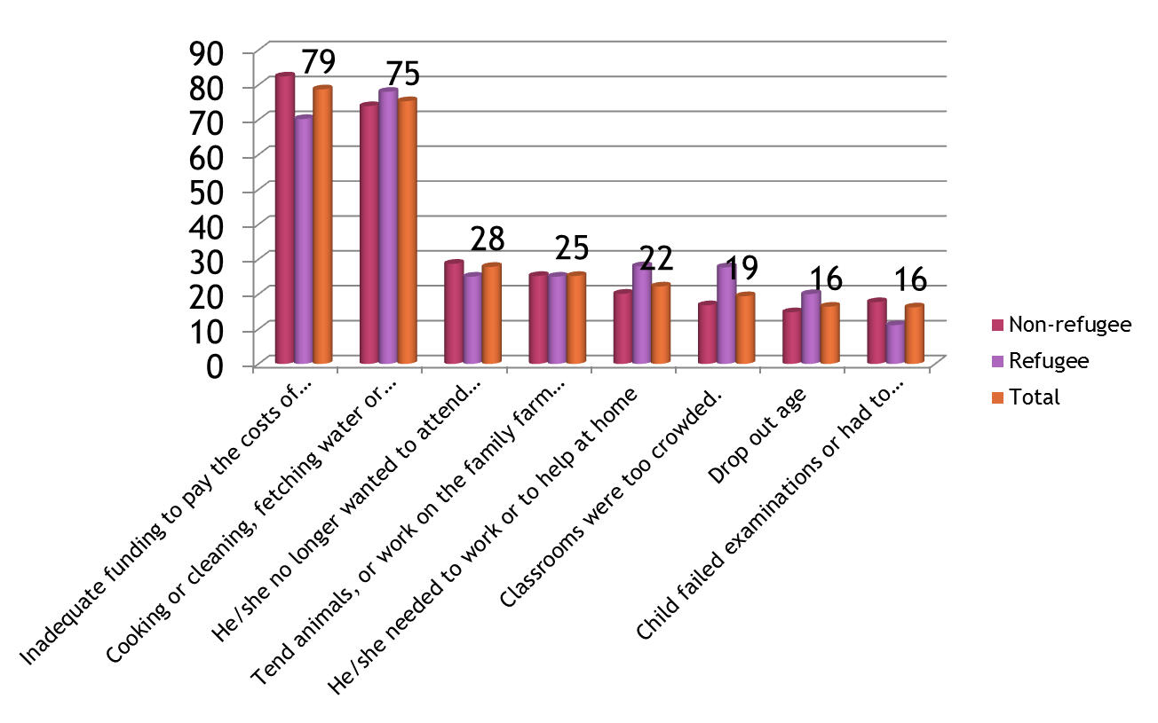

mm

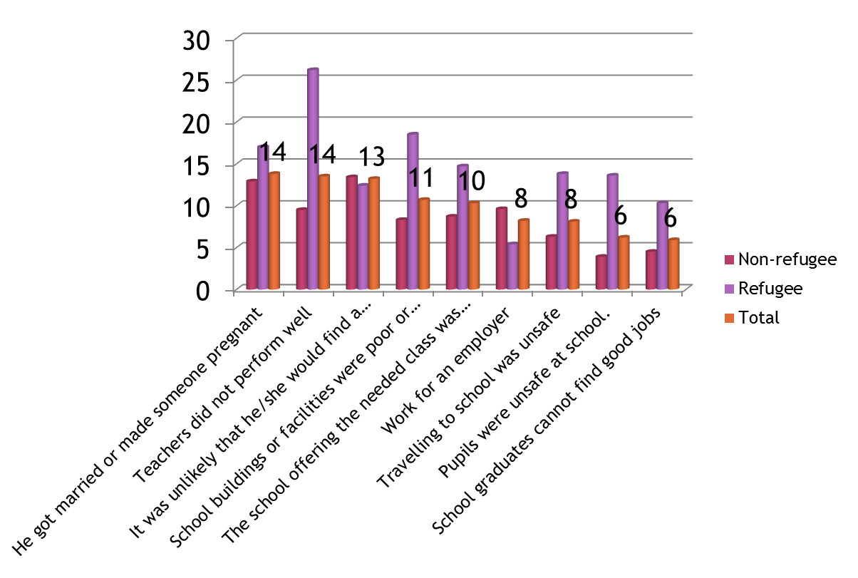

Cause of Non- Unrollement and drop Out

Poverty
Language barrier(refugee population)
Lack of value for education
Parents’ poor attitude (Congolese refugees prefer business/trade to education
Lack of motivation
Disability
Discrimination
Long distances to school
Uncertainty of refugee status and period of stay

Emerging issue

The management of refugee expectations and their adjustment to the education system in the host country
School feeding is a motivator to the learners and service providers (teachers)
Conflict management in the settlements
Resilience in the refugee camps e.g. a lady in Rhino carrying her disabled son daily to school
Feeding children at school
Periodic counseling and engagement with children

Recommendations

School management committees should devise means of engaging parents
Peer-educators should be utilized in motivating learners to stay in school
Regular refresher courses to teachers to address their code of conduct
Hard work and determination of both parents and learners
Reward best performing learners and recognize their parents/guardians
Community leaders should actively re-think and re-address the poverty issue.
Community sensitization should be emphasized in all settlements

Conclusions

How then can education be made more accessible to refugee population?

Address the causes for non enrollment and dropout
Active engagement of parents and children with regard to education
Teachers need to be equipped with the necessary for handling this population

Way foward

Active engagement with the communities on the issues concerning non-enrolment/drop-out

Sensitize parents on the value of education and their role as stakeholders in their children’s future.

