Global Giving
4th Quarter
(October to December 2019)

MOHAN Foundation gets recognition and awards

AWARDS & RECOGNITION
MOHAN Foundation wins at Grand Thornton SABERA
On December 4, 2019, MOHAN Foundation won two subcategory awards at the GRANT THORNTON SABERA (Social and Business Enterprise Responsible Awards). It won the NOT FOR PROFIT YEAR AWARD (below 5 crore) and the INITIATIVE AWARD for its National Organ Donation Toll Free Helpline in the Swasthya Kalyan (Health and well Being) Category.
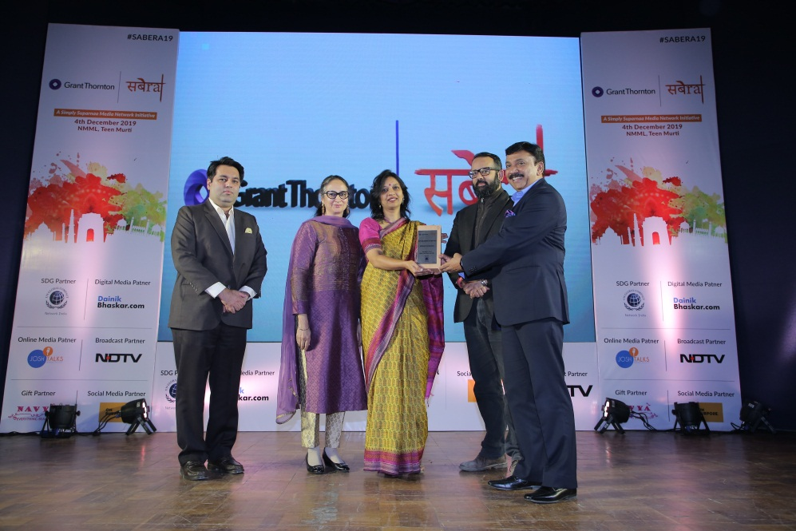

Ms Pallavi Kumar (Executive Director) and Dr. Muneet Kaur Sahi (Programme Manager) of MOHAN Foundation receiving the Award.

MOHAN Foundation receives the NGO Leadership Award at Chennai
On December 16, 2019, MOHAN Foundation received the NGO Leadership Award in the Tamil Nadu Leadership Awards 2019 category instituted by World CSR Day, a for-purpose organization. The award is endorsed by World Federation of CSR Professionals, a not-for-profit that aims to make a real difference to the HR community, business and the economy.
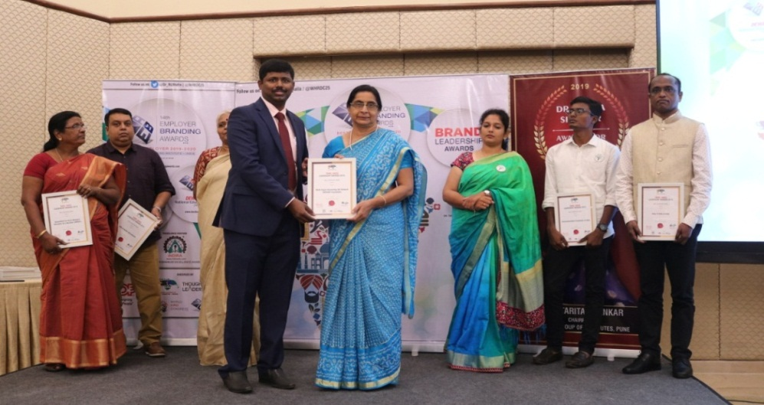

Dr. Hemal Kanvinde from MOHAN Foundation receiving the NGO Leadership Award

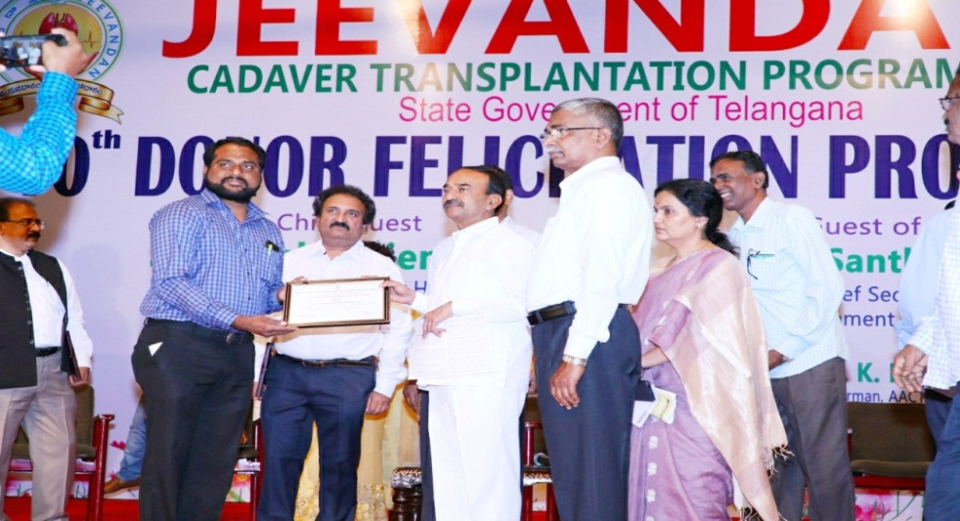

Dr. Bhanu Chandra from MOHAN Foundation receiving the Best Transplant Coordinator Award from the National Organ and Tissue Transplant Organization (NOTTO)

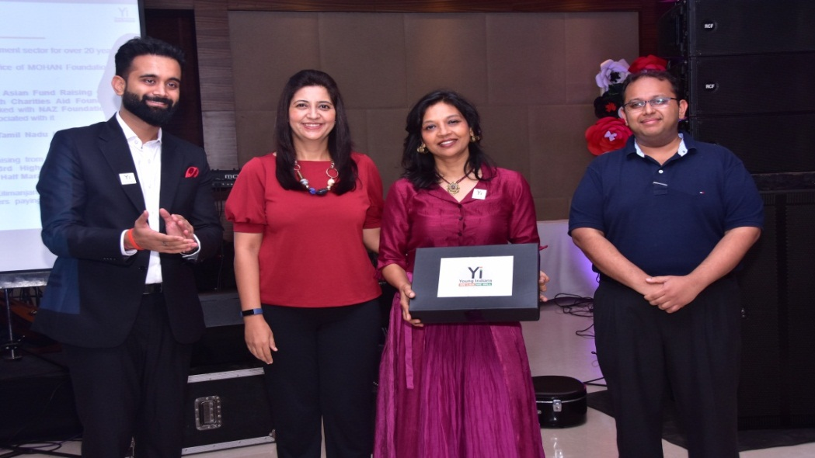

Ms. Pallavi Kumar receiving Honorary Membership of Confederation of Indian Industries (CII) - Young Indians (Yi) Delhi Chapter

MOHAN Foundation represented at International Conferences

Doha International Academy of Organ Donation invites experts from MOHAN Foundation for a three days workshop on Organ Donation, Doha, Qatar
The Doha International Academy of Organ Donation – Hamad Medical Centre, Doha invited Dr. Sunil Shroff, Managing Trustee of MOHAN Foundation and Mrs. Lalitha Raghuram, Country Director of MOHAN Foundation to the 10th year anniversary of the Doha Donation Accord with second activity of ROOTS program which is a collaborative international Qatari initiative aiming to Reach Out for Organ Transplant Self-sufficiency. Several world leaders in organ donation and transplantation were invited as international speakers. The three days workshop which was held from 8th – 10th November 2019 provided a platform for policy makers and ROOTS alliance countries to exchange ideas and raise awareness on ethical organ donation.
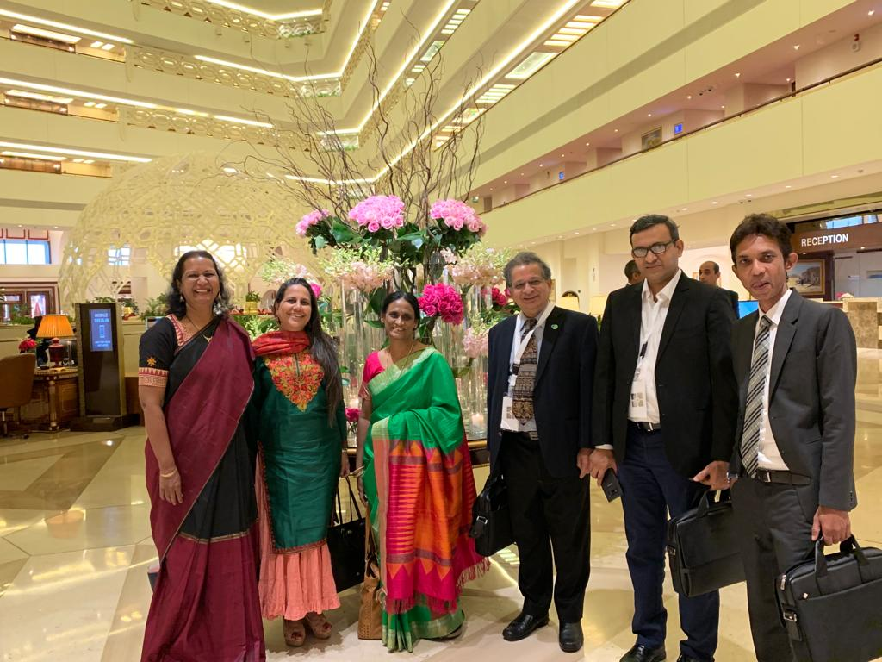

Dr. Sunil Shroff and Mrs. Lalitha Raghuram along with other experts from India

MOHAN Foundation participates in the 15th Congress of ISODP in Dubai
MOHAN Foundation participated and presented at the 15th Congress of the International Society for Organ Donation and Procurement (ISODP) held from November 14-16, 2019 in Dubai, United Arab Emirates and hosted by the Saudi Center for Organ Transplantation and the Emirates Medical Association Nephrology Society. The Congress was attended by Dr. Sunil Shroff (Managing Trustee), Mrs. Lalitha Raghuram (Country Director) and Ms. Pallavi Kumar (Executive Director)
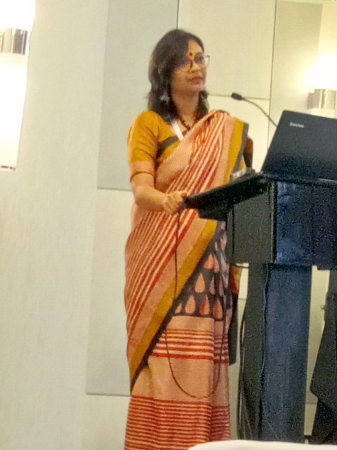
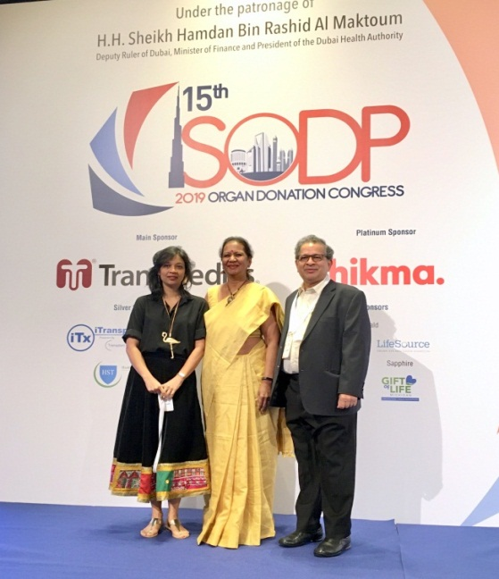

Dr. Sunil Shroff, Mrs. Lalitha Raghuram and Ms Pallavi Kumar representing MOHAN Foundation at ISODP

Ms Pallavi Kumar making a presentation on organ donation by foreign donors in India

12th National Annual Transplant Coordinators’ Conference in association with CMHS held at IIM, Ahmedabad
The Network and Alliance of Transplant Coordinators (NATCO), in association with MOHAN Foundation and the Centre for Management of Health Services (CMHS) - Indian Institute of Management, Ahmedabad organized the 12th National Annual Transplant Coordinators’ Conference at the prestigious IIM Ahmedabad campus on November 30 and December 1, 2019.
The theme of this year’s conference was “Let’s Collaborate,” with a focus on exploring public-private partnership options for organ donation in India. Experts from government, industry, transplant professionals and public health specialists were invited to be part of this focus discussion.
The 12th NATCO conference had close to 150 Transplant Coordinators, working in public and private hospitals, participating from across the country. Faculty included doctors, senior transplant coordinators, NGO heads and representatives, academicians, media professionals, corporate professionals, IAS officers and bureaucrats who shared their ideas and views on a wide range of topics.
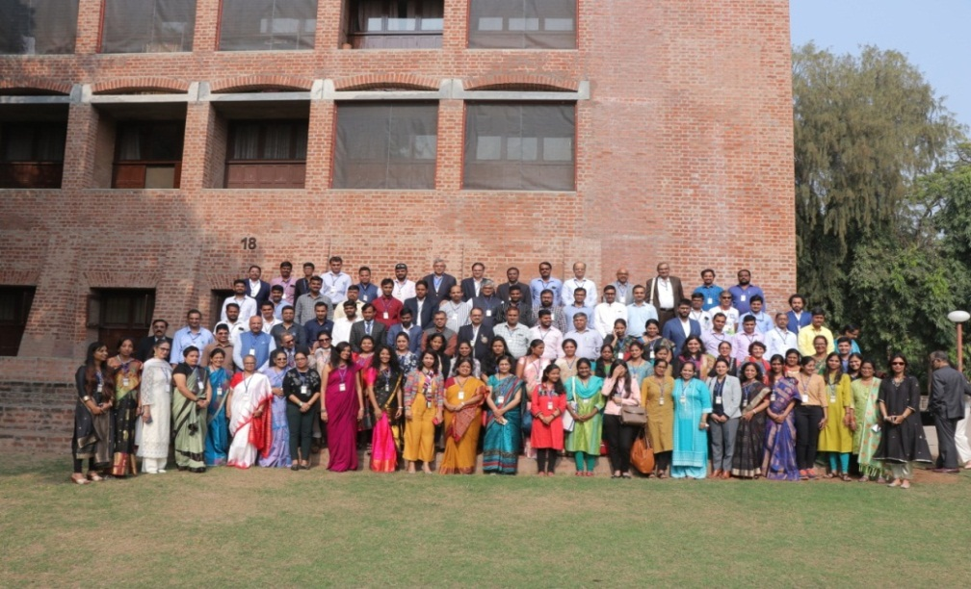

Group photo from the 12th National Annual Transplant Coordinators’ Conference

MOHAN-Edelweiss organ donation drive #NoMoreWaiting culminates in Guinness World Record
On December 5, 2019, MOHAN-Edelweiss organ donation drive #NoMoreWaiting culminated in a press meet at The Oberoi, New Delhi where it was announced that Edelweiss has created a new GUINNESS WORLD RECORD (low case) title for collecting the highest number of pledges for organ donation in a single day, following an impactful drive throughout November. While the awareness drive garnered over 1 lakh pledges during the month, the insurer created history by collecting 54,626 pledges in a single day on November 28, 2019
Earlier on November 5, 2019, Edelweiss Tokio Life Insurance had joined hands with MOHAN Foundation to create awareness on organ donation and to encourage pledging for this important, life-saving cause when this campaign was launched in Mumbai during the meet, During this month long campaign, various activities that included digital media activations, PR, and on-ground educative workshops in educational institutions were undertaken. Talks conducted at IIT Jodhpur & IIT Ahmedabad by MOHAN Foundation were part of this initiative.
Actor-Director Rahul Bose agreed to be the brand ambassador of the campaign.
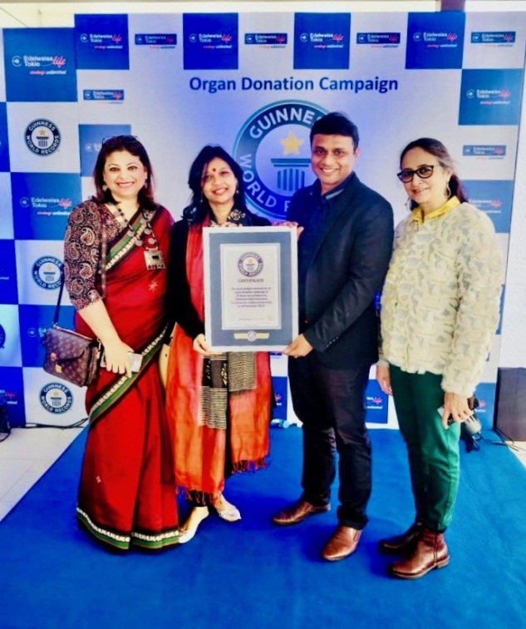
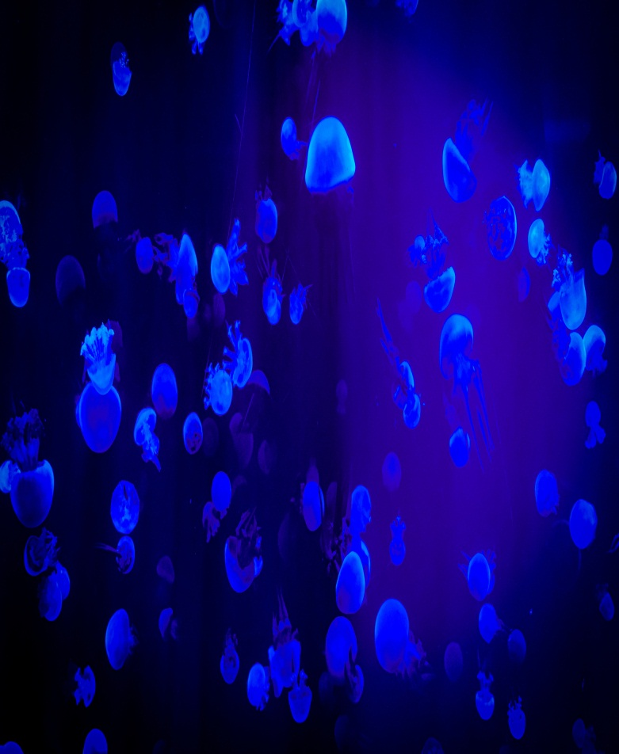

MOHAN-Edelweiss organ donation drive #NoMoreWaiting culminates in Guinness World Record

Ms. Pallavi Kumar summits Mount Kilimanjaro as her tribute to organ donors & their families
On October 03, 2019, Ms Pallavi Kumar, Executive Director, MOHAN Foundation summited Mount Kilimanjaro and unfurled a flag expressing her tribute to organ donors for their selfless act of giving a part of themselves to keep others alive. This is the highest such tribute by any Indian and perhaps from anywhere in the world. Last year, Pallavi summited the Everest Base Camp reaching an altitude of 5380 meters (17600 feet above sea level).This year she climbed higher 5756 meters (18885 feet above sea level) as she feels no tribute is too high for organ donors and their families.
Standing at a height of 5,895 meters, Mount Kilimanjaro is the highest peak of Africa and the tallest freestanding mountain on Earth. Also known as the “Roof of Africa”, this colossal mountain is a part of the seven summits of the world.
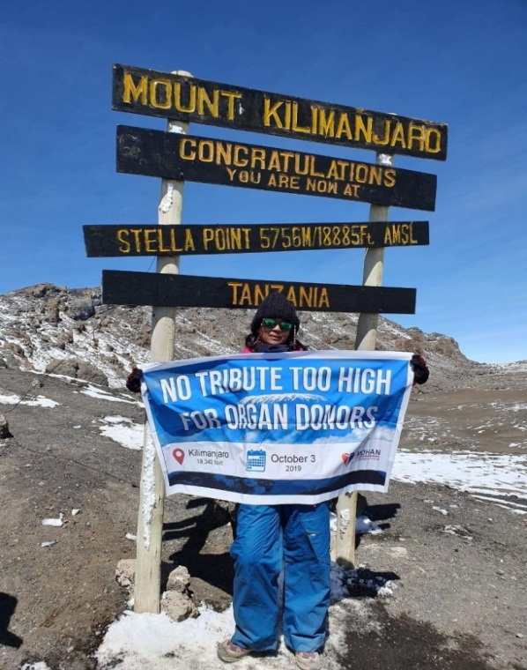

Ms. Pallavi Kumar summits Mount Kilimanjaro as her tribute to organ donors & their families

MOHAN USA:
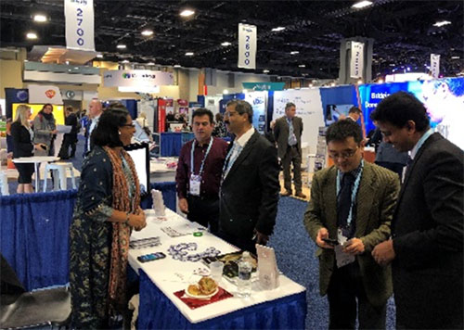

MOHAN USA sets up Information Booth at the Annual Meet of American Society of Nephrology in Washington D.C.

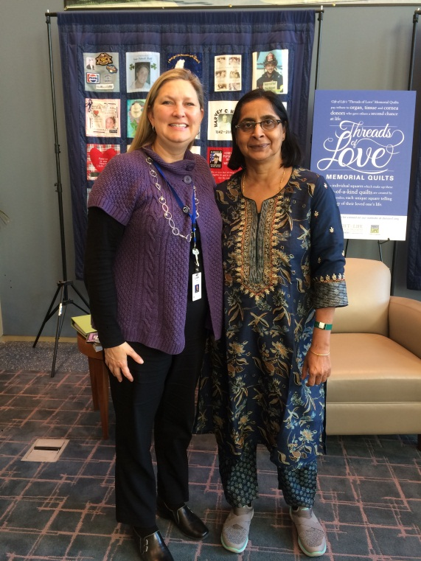

Dr. Hemal Kanvinde, Quality Assurance Officer of MOHAN Foundation underwent Gift of Life Institute’s (GOLI) Mini Fellowship in Organ Donation in Philadelphia, USA

