They are ‘Superstars’ of Aaina:
Welcome to the friend’s zone!!
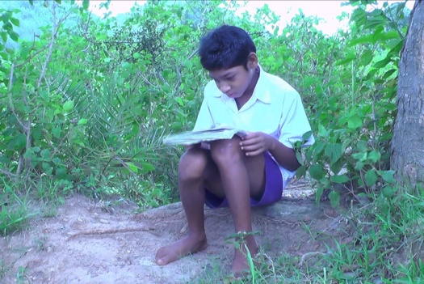
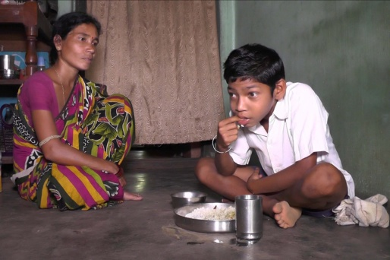
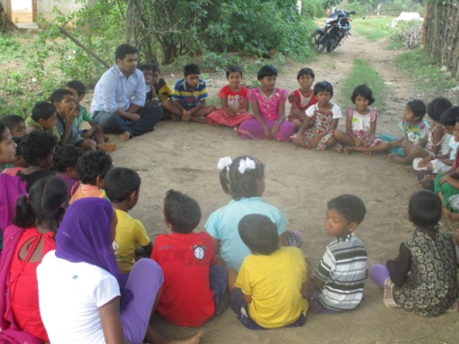
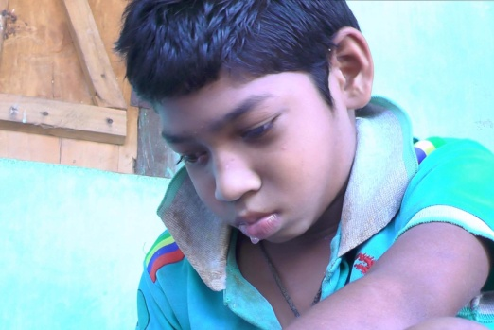
From a life of no friend and solitude to a life of full of friend, school, study and big fun is the journey of Soham. Three years back he was all alone home without any friends, totally dependent on parents for his daily living skills like eating, dressing etc! Soham an eight year old child with cerebral palsy (hemiplegic) from a remoite village of Kandhamal village of Odisha, India. Kandhamal is a scheduled districts having more than 50% tribal population in the district. Due to Cerebral Palsy Soham can not use his right hand and legs properly. His facial muscles also affected to prevent him from speaking things clearly and also not being able to control his drooling. His parents never thought Soham can be in School and can be with other children of his age! The community volunteers identified Soham and spoke to the School teachers and managed to get him admitted in the School. The volunteers not only spoke to the teacher but also prepare the children of that village to get Soham join their children club (promoted by Aaina). The wall of hesitation started breaking and soon they became good friend of Soham. Helping him going to School or even in study all these spheres are full of friends now. “This motivated him to take up his daily chores like dressing, eating independently and moreover reducing his problem behavior like, throwing tantrums”- said Rekha mother of Soham. The volunteers from Aaina also helped him in bridging the study gap with the extra input to put him in class two to which Soham cooperated. Book became his friend and Soham started liking book going to School very much. Now after three years he is in class-5 and doing very well in his study. His slurring speech is no more a point of joke for his friends but there is a competition among friends as to who can understand Soham faster! His parents are happy on his progress.
The Superstars of Aaina are the children those provided a space for Soham and in turn Soham filled in that space to be in mainstream. THANK YOU donors for being so supportive to make us a ‘Superstar’. These small but very important changes in the society only becoming possible for the real ‘Superstars’ in the field like Soham and others…
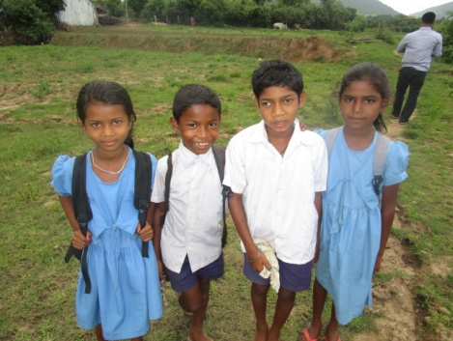
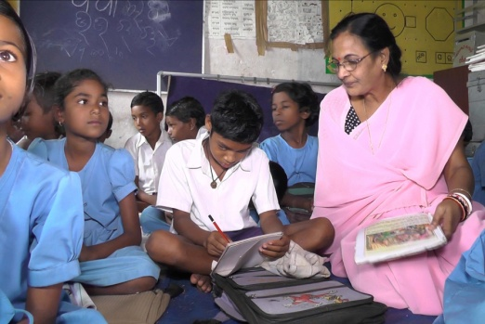
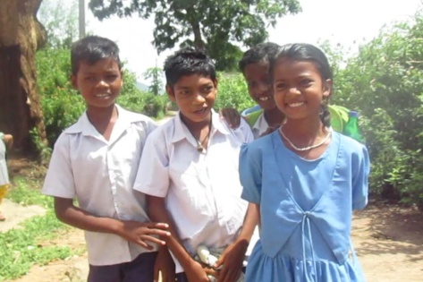
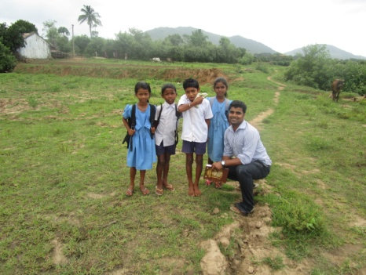
Soham says it all…. I may not be able to walk sown to School but my friends gave me courage. Earlier Basant sir used to come to accompany us to School but slowly it was taken over my friends and I am quite comfortable with them now. Going to School is such a fun…I love my books…love to listen to my teachers teaching the lessons, except English! But I love to be with my friends….Paltu and Ramesh are so funny! Kuni is very helpful; sometimes she carries my bags to School. She advised me to keep a hanky to wipe the drools and I liked it! Earlier the therapist sir told me to do some exercise but I did not want to do it but now I am doing it regularly as I need to keep myself fit enough to go to School and also to be accepted by my friends! I wanted to play football one day like Ramesh, Paltu and others!
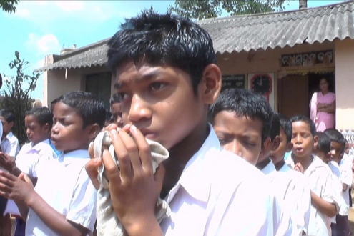
I like my school teacher, she is very helpful and talks to me nicely. I also wanted to participate in prayer so what if I can’t sing the prayer loud and clear but God listens to the silent prayer even as told by my father! I pray God to help me grow so that I can take care of my parents in future…!

