Project Evaluation Report
Latest update : August 6, 2011
Project Title : Practice lessons for 7 disabled kids – Project 1788
Reported by : Calincing Love Rainbow Foundation – Indonesia

Summary
We were still continuing the program with disabled children in Cogreg village. Your donations are very important to us to continue our free educational program in Cogreg village. Below is the detail of program that we have been implemented during May – July 2011. Please continue to support us again so we can help disabled children to do learning activities. Thank you very much for your support.

Reading Comics Contest

The competition was followed by children with special behave like autism. They were asked to read picture books / comics and retell what they read to the teacher. Who can retell it right, and then he is the winner.

In this race, the children feel happy because they can read a story book that has pictures of the beautiful and funny. They read it seriously and try to recall what they have read.

We do this activity as one of the learning materials for children with disabilities who live at Cogreg village, West Java, Indonesia.

Thank you very much for your kind support and donation through Global Giving. Please support us again so we can continue to help our children continue their school and all activities they needed.

Best regards,
Hartoyo Hardjodiwiryo
Team Leader
ypkc_foundation@yahoo.co.id
Photo Library
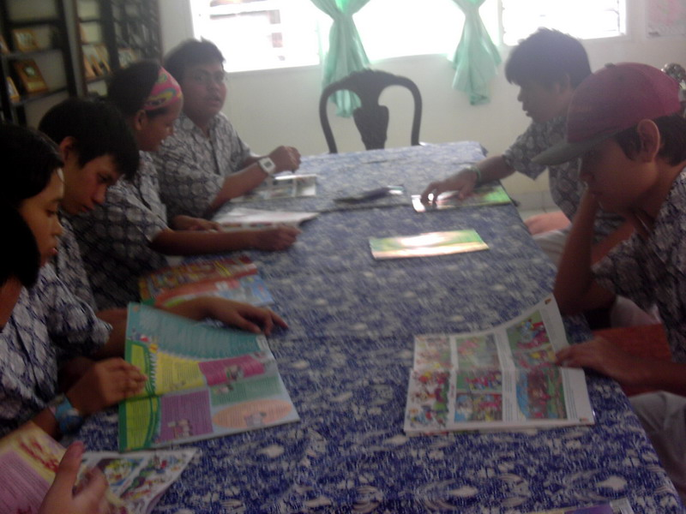
The children were reading picture books in a contest

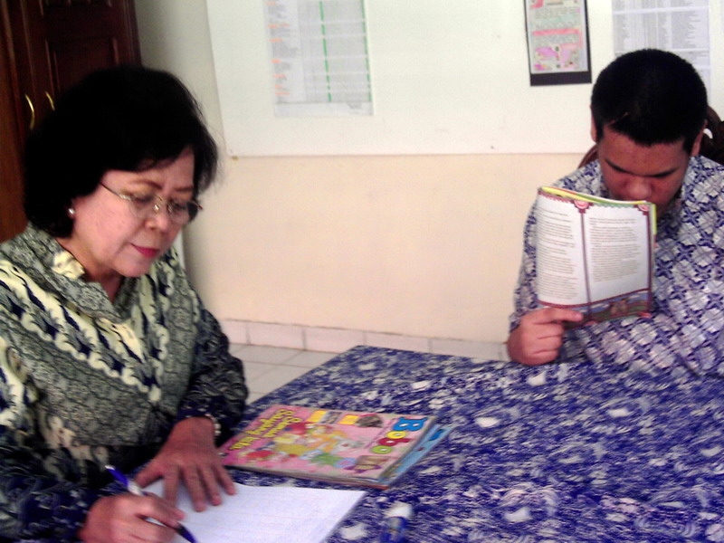
After reading, they are tested to retell what they read
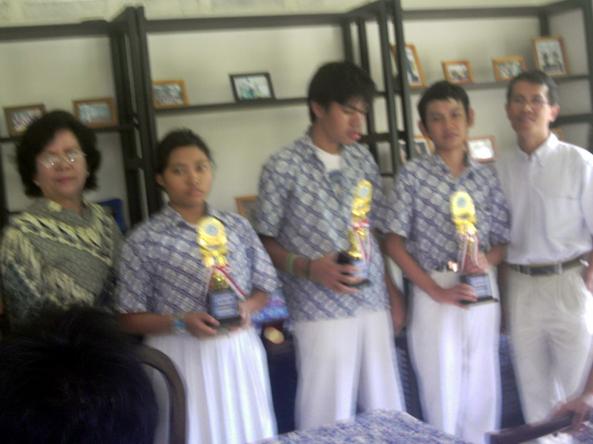
Finally selected three winners of children reading picture books

