QUARTERLY REPORT
Shelter Home for sexually abused teenage girls - CEDRO

In the first quarter of 2015, the girls from our Shelter Home have been towards their school vacations, so the project has focused on three important aspects:
1. Healthy Recreation. This shall be coordinated with various institutions for people to participate in swimming programs, sports and dancing, these institutions offer.
2. Strengthening life skills. The boys and girls have participated in workshops on anger management, expression of feelings, conflict resolution, developed by psychologists program
3. Projection to the community. Shelters have been active in protecting the environment in their community, such as cleaning and planting of green areas in the community of San Juan de Amancaes in Rimac District.
Also, the project has continued with theater and music workshops, which support worked to reinforce these axes.
The holiday quarter has been very helpful for our work, enabling us to increase both personal and social aspects, making good use of their free time.

- Recreation: Dance and Swimming Lessons
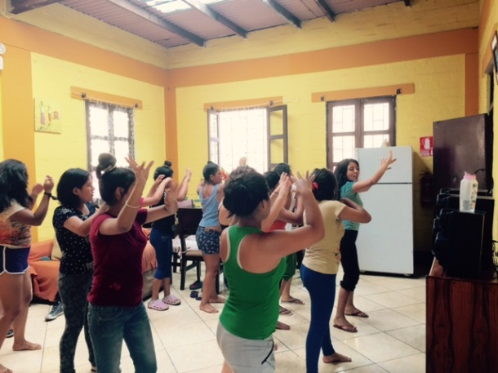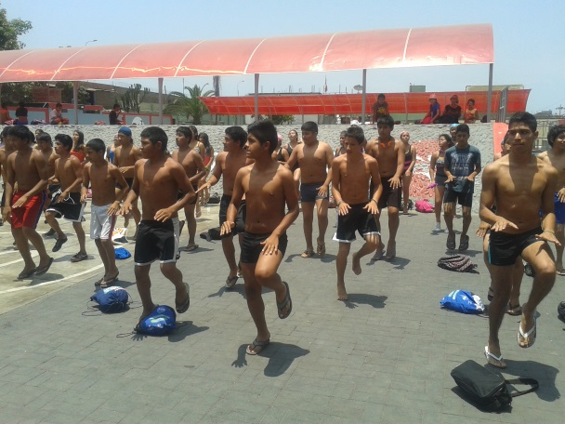
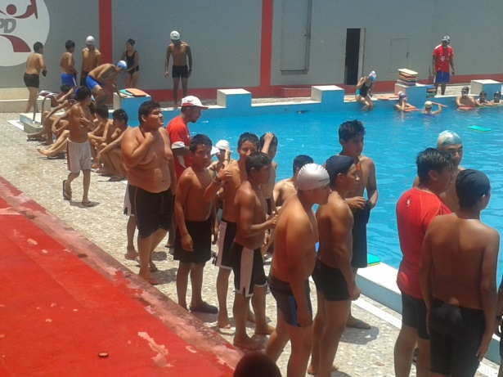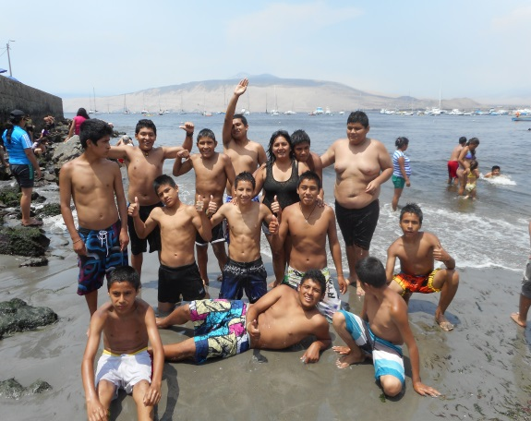

II. Strengthening Life Skills: workshops anger management expression of feelings
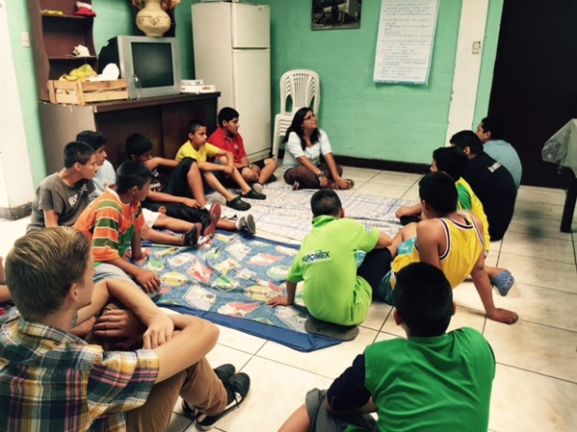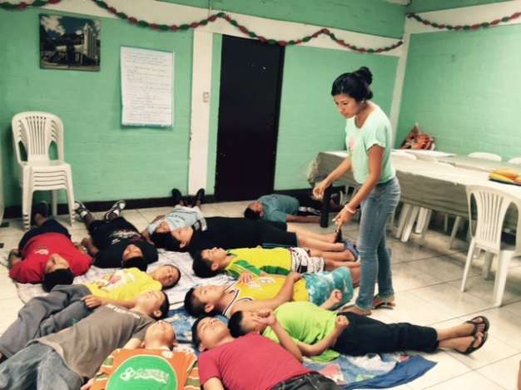
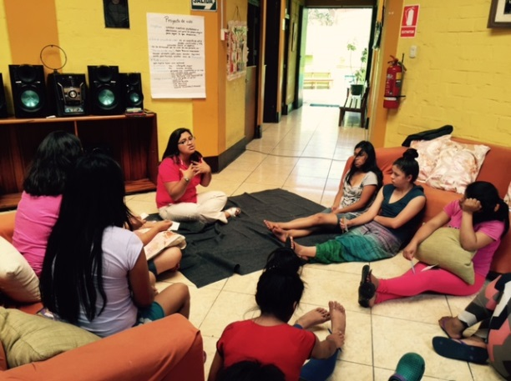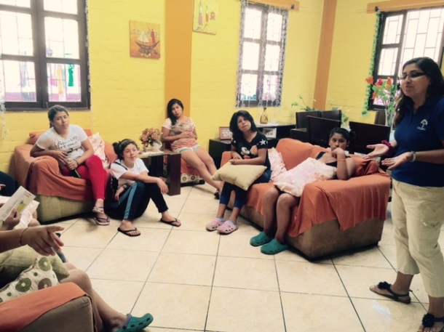
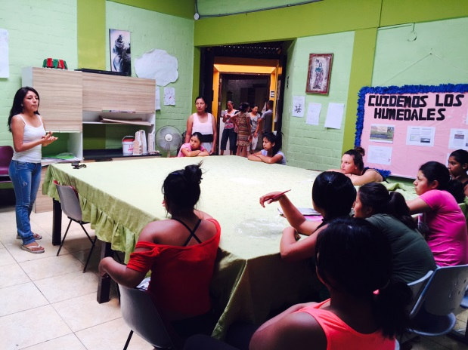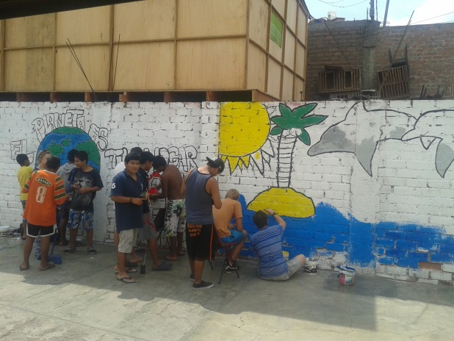
iii. Community Outreach: Cleaning Campaign Amancaes Lomas, Rimac district