ORPHANAGE/SCHOOL REPORT OF ACTIVITY FOR THE MONTH OF SEPTEMBER 2021 THROUGH JANUARY 2022

Dear Donors,
Thank you so much for joining hands with us to score this success in the following areas:

1. EDUCATION
The children successfully resumed classes on 4th September 2022 and 7th December, first-term examination ended mid-December, 17th December 2021 the children went for first term break and came back on the 3rd January 2022

PICTURE
During this month of December was the Christmas festival and the following activities took place:
- Visit to the amusement park –Kumba
- The children were also invited by the Nfon of Kumba to celebrate the day with him at his palace. See PICTURE

2. FEEDING
The center/ school had enough food for the children due to the contribution of some well-wishers, social group, church group and we will not forget
Reach Out who has always been by our side. See PICTURE
Thank you so much our Donors

3. SUPPORT
We also had support from some individuals in the community, church groups, social group associations. Some of the items they brought included foodstuffs, beddings, clothes, beverages, cash, soap. See PICTURE

4. TEACHER SALARY
Reach Out, we say thanks again for not relenting your effort in paying two of our teachers. God bless you more abundantly

5. OUR SUCCESS
First School Result- 2020/2021

NUMBER WROTE % PASSSED REMARK
IDPS 5
ORP 5 98 One
COMM 6 IDPS failed
TOTAL 16

6. ENROLMENT 2022
(List is attached)

7. FIRST SCHOOL REGISTRATION
IDPS 14
ORP 4
COMM 8
TOTAL 26

8. PROJECT
Thank you so much Donors, for joining us to arrive at where we are now, in these great building project for the children to have a conducive learning environment for the children. See PICTURE

9. CHALLENGES ▪ MAIN BUILDING:
The main building needs some renovation like
- Plastering
- Painting
- Pavement
- Building of a kitchen refractory

▪ HEALTH
- An equipped first aid box
- A nurse to attend to the children when they are ill
- A social worker is also needed to help counsel the children in times of problem

CONCLUSION
We are thankful and grateful for your unrelentless effort in this God’s service. let’s continue with the service as God gives us the strength.

God bless you all our Donors

MAH FONIBORG DIANA
Manager

CHILDREN ATTENDANCE LIST FROM OCTOBER 7th 2021 THROUGH

JANUARY 27th 2022

MONTH/DATE | BOYS | GIRLS | TOTAL
07/10/2021 | 110 | 65 | 175
12/10/2021 | 113 | 73 | 186
14/10/2021 | 128 | 86 | 214
20/10/2021 | 123 | 77 | 200
21/10/2021 | 136 | 94 | 230
22/10/2021 | 120 | 73 | 193
29/10/2021  OCTOBER | 127 | 92 | 219
9/11/2021 | 91 | 84 | 175
16/11/2021 | 27 | 16 | 42
17/11/21  NOVEMBER | 49 | 34 | 83
01/12/2021 | 141 | 101 | 242
3/12/2021 | 143 | 103 | 246
7/12/2021 | 140 | 103 | 243
8/12/2021 | 140 | 105 | 245
9/12/2021 | 139 | 104 | 243
10/12/2021  DECEMBER | 136 | 97 | 233
04/01/2022 | 79 | 59 | 138
05/01/2022 | 115 | 88 | 203
13/01/2022 | 146 | 100 | 246
19/01/2022 | 140 | 103 | 243
20/01/2022 | 139 | 99 | 238
21/01/2022 | 138 | 98 | 236
26/01/2022 | 140 | 103 | 243
27/01/2022 | 137 | 103 | 240
28/01/2022  JANUARY | 137 | 100 | 237

ANNEX (photos)

- Education
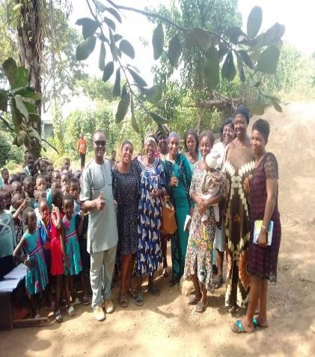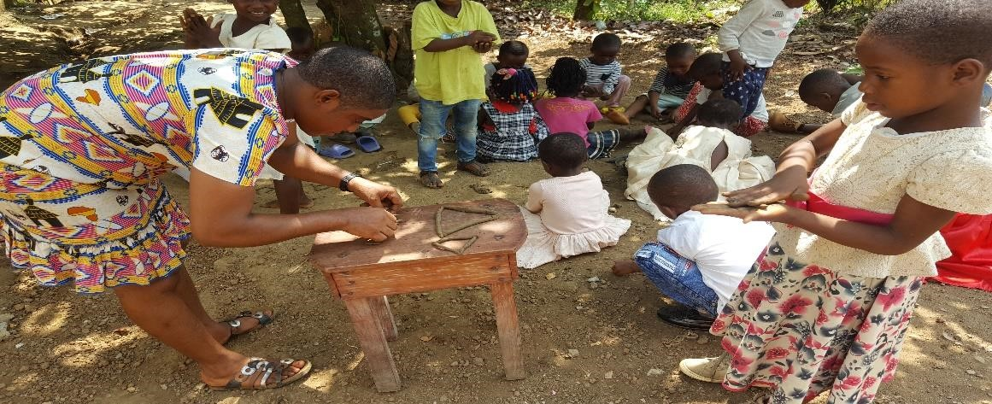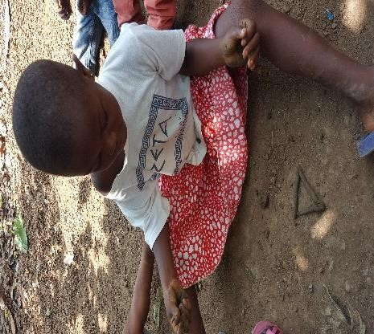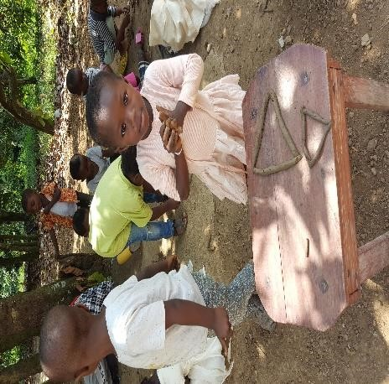

- December/Christmas festival
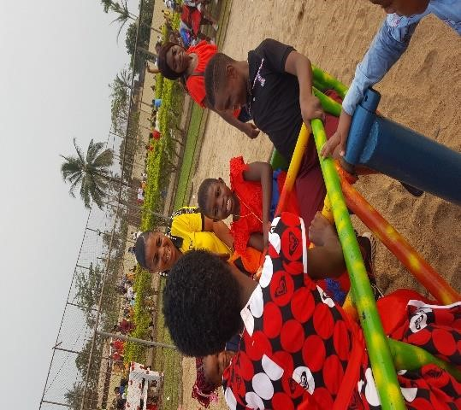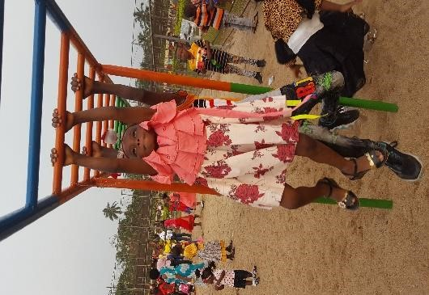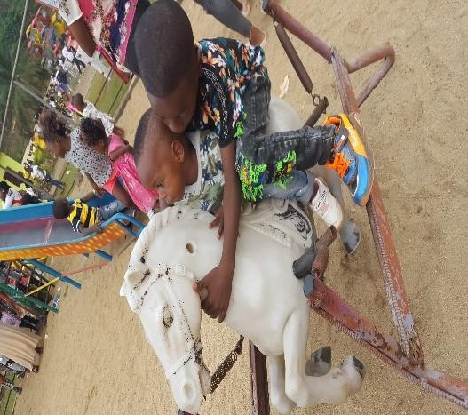

- Feeding/ Support
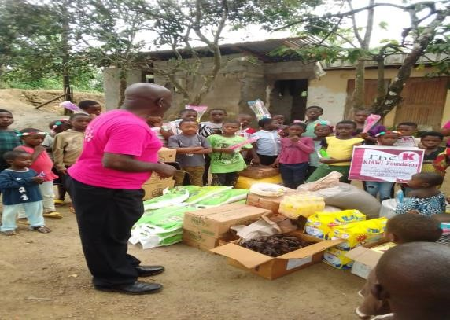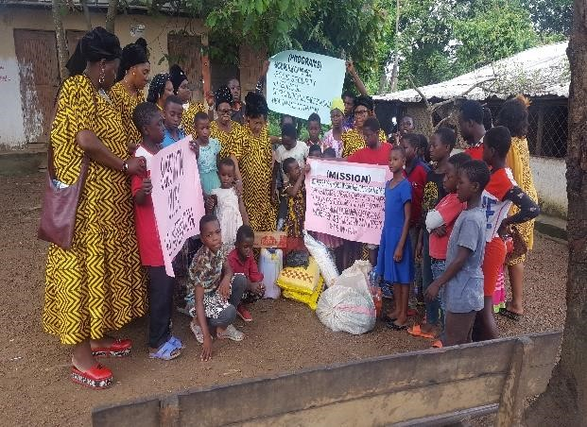

- Project
