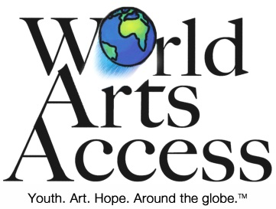
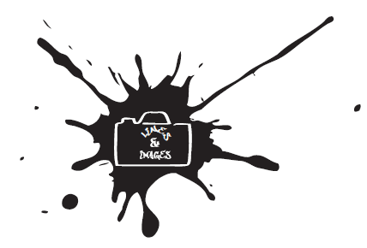
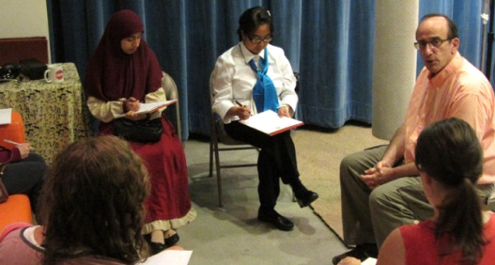
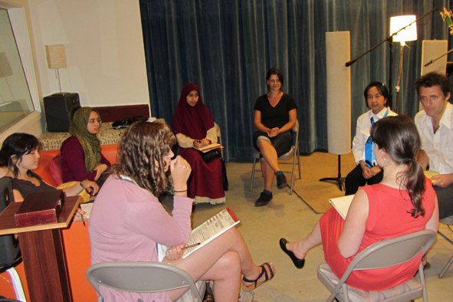
Peace is made one art project at a time.
Lines
And
Images


World Arts Access (WAA) is a registered not-for-profit corporation in Washington State as a charitable organization. and is registered as a 501 (c) (3) with the I.R.S.
Visit us:
www.worldartsaccess.org or
on Facebook www.facebook.com/WorldArtsAccess
And Twitter at: @worldartsaccess

5700 6th Avenue S.
Ste 207
Seattle, WA 98108
Phone: 206.264.5172
admin@worldartsaccess.org
Carla Calvo, Program Supervisor

Follow WAA
Phone: 206.264.5172
admin@worldartsaccess.org

Outcomes:

Participants in our programs learn crucial interpersonal, creative and professional skills that give each person an individual ‘voice’ as well as improve their quality of life and enable them to make meaningful contributions in their communities while also adding to their potential employability.
Our aim is to work with marginalized youth through local communities and partner organizations in order to allow art to be widely accessible. We focus on developing art program leaders and trainers during our projects to allow participants to pass on their skills long after our direct involvement has ended.

Why We Want You As A Partner?
We are looking for youth organizations and organizers that have access to groups that fit our goals.
The preferred youth age is between 16 and 26. We prefer to work with mixed or varied cultural populations. We like to work with established programs that have ongoing activities and would like help with new projects and expanding world views. If your group fits these parameters we are looking to work with you.

Overview:
Lines And Images is a project designed to create a descriptive conversation between two forms of imaginative art, specifically photography and poetry based on an individual’s inspiration for creating a better world. Because everyone sees the world through their own filters, preferences and past experiences, each person’s perception of the world is seen though a different set of lenses. This approach provides a special angle that allows each individual to take someone else’s photograph of community and form a connection transforming the photo into poetic form.

World Arts Access (WAA) strengthens communities around the globe by bringing arts management and training expertise to disenfranchised and underserved youth living in challenging conditions ranging from poverty to violence. Drawing on a variety of art forms including drama, radio, digital media, film, music, and photography, WAA designs and manages inclusive art projects that foster long-term youth empowerment, community involvement, and peace.

Lines and Images Summer 2014

