Public Awareness Campaign
“A DEAL FOR IDEAL INTERACTIONS”
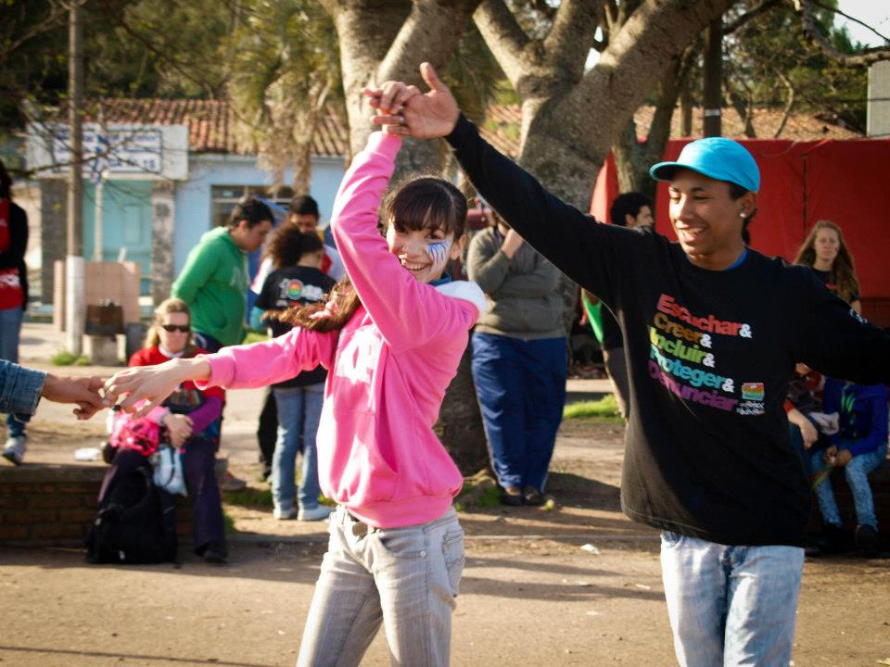
Uruguay 2014

Introduction
Claves works to increase public awareness and to train people to prevent violence against children and adolescents. It seeks to generate understanding, provide teaching tools, and open up spaces for participation, leadership, and sociopolitical change. It develops methodologies that have been applied and recognized in various countries throughout Latin America. Through its various initiatives, Claves works with children, adolescents, families, educators, and professionals.
Without ignoring the structural risk factors of violence, Claves has sought to identify and promote those factors that strengthen and empower the vulnerable in the face of violence. Its conceptual framework includes, among other aspects, the promotion of holistic health, a human rights perspective, an egalitarian vision of gender and age, an eco-systemic framework, resilience, and a preventive approach.
Why is this work necessary?
In their most recent “World Report on Children,” the United Nation reported that maltreatment and sexual violence towards children and adolescents is still a, “massive, daily and underrepresented reality in the Latin American and Caribbean population... Children and adolescents experience violence in the home, in school, in justice systems, in work and in the community.”
Violence against children and adolescents violates their rights, puts their holistic development at risk, and affects the social capital of the country. Relationships that perpetuate maltreatment and sexual violence against children and adolescents in any form - in the public as well as the private sphere- constitute a violation of human rights, in particular the right to a life free of violence, as expressed in multiple articles from the Convention for Children’s Rights.
Through an eco-systemic model of violence, Claves recognizes elements at different levels - expressed through culture, institutions, close-knit networks, like families, and individual characteristics- that act as risk factors for violence against children and adolescents. A resilience-based perspective allows us to identify and develop factors that strengthen children faced with violence. From this perspective, concrete actions can be articulated for the prevention of violence against children.

How do we address these issues?
"A Deal for Ideal Interactions", the symbolic vaccination campaign against maltreatment of children and adolescents, is an effort to promote the respect for and exercise of their inherent right to a life without violence, affirmed and protected by the United Nations “Convention on the Rights of Children”, signed by 194 countries since 1989.
It is a strategy promoting the construction of group unity and citizenship, facilitating inter-generational and inter-institutional spaces, and bringing together people from diverse cultural and economic backgrounds.
The central objective of the campaign is the participation and leadership of young people in raising public awareness regarding the often-invisible problem of violence present in our society. Situations of maltreatment and sexual abuse against young people often involve daily submission and dominance, diminishing their ability to recognize their own rights.
Making these situations visible through a national campaign is the first step in reinforcing adults’ responsibility to protect children and adolescents in our country. The campaign process promotes positive attitudes and behavior among individuals, groups, and the community, strengthening and developing protective factors in children and adolescents, who in turn have a lead role in all aspects of the campaign.
By working together, adolescents feel that they belong to a group and that they are responsible for communicating the message of “ideal treatment” to adults in their communities. They challenge stereotypes, which associate teens with violence and crime, and come to occupy a positive and purposeful place in society.

What is our perspective?
Its fundamental to emphasize the positive and hope giving perspective of the campaign: the issue of abuse and unequal relationships are made visible, just as is the positive perspective of childhood and adolescence, fair and caring interactions, which is made visible through “play”: vaccinations in the streets, bus stations, elementary and high schools, plazas, and stadiums.
The campaign requires a social and culture initiative which promotes positive values in the society and uses playful and festive strategies, incorporating artistic presentations of the children and adolescents involved as well as well-known local artists.
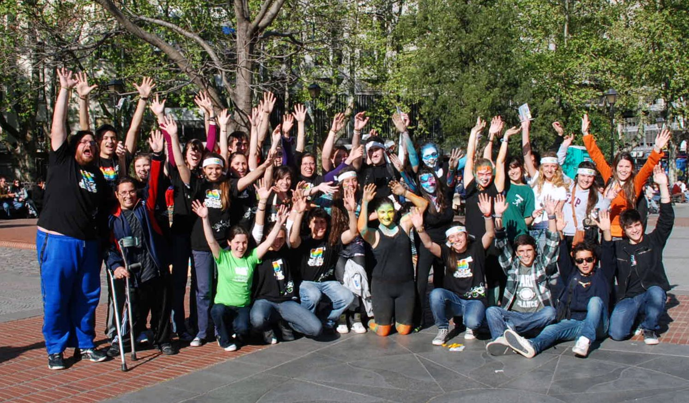
Results from the 2013 Campaign

Qualitative impacts
• Greater awareness of the rights of children and adolescents, specifically the right to not suffer abuse.
• Creation of spaces for citizenship training, promoting creative actions aimed at adults in the community through activities planned, carried out and evaluated by adolescents.
• Support and commitment by various governmental agencies, civil society, and the business world.
• Training in “fair and caring interactions” and abuse. Reflection on gender, peer, and intergenerational power relations.
• Training in techniques for recreational and creative expression, such as music, theater, circus, makeup, etc.
• Inclusion. Bringing together organizations and groups which, on their own, would not likely work together to carry out activities of this nature; encouraging participation, regardless of a person’s social or economic situation; and being open to support from various social spheres to make the campaign happen.

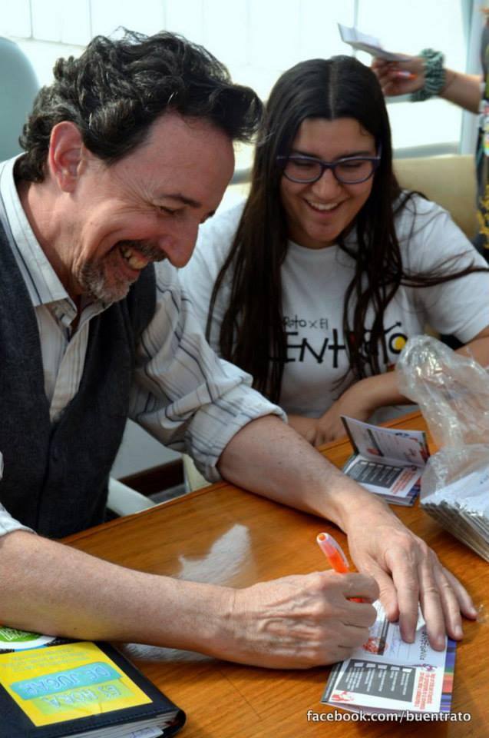
Quantitative impacts
• Direct training given to 1,040 adolescents, who then transmit the strategy to 4,000 more adolescents.
• 65,000 adults symbolically vaccinated, who commit to prevent violence against children and adolescents.
• Trainings in 13 departments throughout Uruguay. 28 workshops, adding up to 168 hours of training with the participation of 1,040 adolescents and 165 public and private institutions.
Main Activities of the 2014 Campaign
The strategies carried out in 2013 gave very positive results and we as the Claves team hope to continue in the same direction in 2014. The main activities corresponding to the campaign that will be carried out in 2014 are as follows:
1. Invitation to participate extended to organizations that work with children and adolescents in diverse settings and perspectives.
2. Training workshops and youth camps with the participation of youth delegates from each organization. The youth delegates share what they have learned with their peers and plan the campaign in their context.
3. Official kick-off of the campaign, “A Deal for Ideal Interactions”. A press conference is held with authorities that support the campaign where the adolescents are the protagonists of the kick-off.
4. Media coverage of the campaign, such as television, radio, social media and billboards.
5. Vaccination month. Each group begins to carry out different public awareness activities including symbolic vaccination of adults.
6. Closing event with a musical component, adolescent march through the city, and an artistic event.
7. Evaluation of the campaign in each participating organization, carried out by the youth delegates.
New Components of the 2014 Campaign
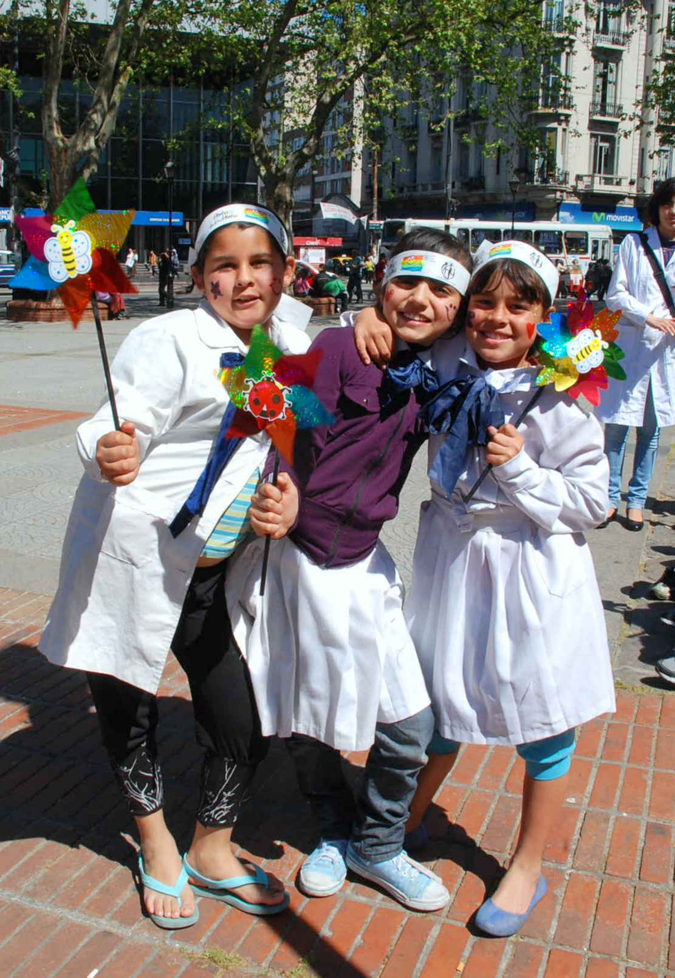
Based on the feedback from organizations and adolescent participants in the 2013 Campaign evaluation, the following new ideas have been proposed:
1. Two-day intensive youth camps where adolescents from different departments come together for training in violence prevention and the promotion of “fair and caring interactions”.
2. Urban actions, as an innovative way to draw public attention during the vaccination month and especially during the closing event.
3. Vaccinations in institutions, businesses, and organizations that are committed to “fair and caring interactions”.

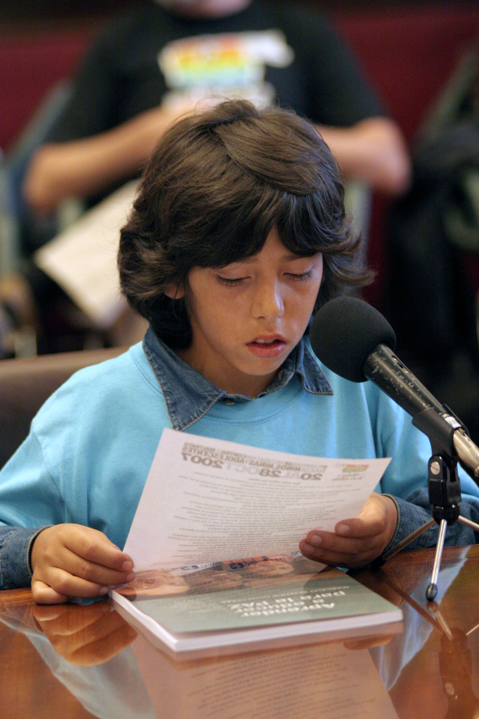
How do our supporting partners participate?
• Supporting the campaign financially through the Global Giving platform.
• Participation of business and organization leaders in the official campaign kick-off in the Presidency of the Republic.
• Develop at least one activity to raise awareness among the businesses or organization’s personnel and clients.
• Campaign promotion through the businesses’ or organization’s website, communication tools, and other spaces.

Contact information:
Campaign Co-Coordinator “A Deal for Ideal Interactions”
Nicolas Iglesias Schneider
Cell phone number: +598 99516021
Email: nicolas@claves.org.uy
Claves Website: www.claves.org.uy
Campaign Website: www.buentrato.org.uy
Facebook: Campaña buentrato UY

World Report on Children. United Nations, 2006.

