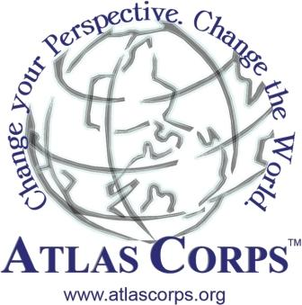

December 15, 2007

Dear Friend,

We did it! One year ago I wrote asking for support for a new idea, a modest proposal for how we could change the world. We dreamed of taking social sector (nonprofit) leaders from overseas to volunteer at U.S. Host organizations, learn best practices, share unique perspectives and then return home to create a global partnership for development. I am writing today to share the good news that we have accomplished our goal and have taken an idea to a viable pilot in less than 18 months – now we need your support to complete the pilot year and double the size of the program.

Atlas Service Corps, Inc. (Atlas Corps) is creating a global partnership for development through an innovative, sustainable, and scalable social sector exchange program. Atlas Corps selects rising leaders to volunteer for one year at U.S. social sector organizations that pay a cost share to benefit from these talented leaders. We launched in 2007 with four Fellows from Colombia and three Fellows from India volunteering at seven organizations in Washington, DC including: AYUDA, Bert Corona Leadership Institute, Free the Slaves, GlobalGiving, Mobilize.org, TechnoServe and Youth Venture/Ashoka. Four hundred applicants applied for these seven positions and the best rose to the top. The Fellows’ average age is 27 years old, they have 3-8 years of social sector experience, they come from five different religious backgrounds, and are all committed to returning to their countries to share what they have learned.
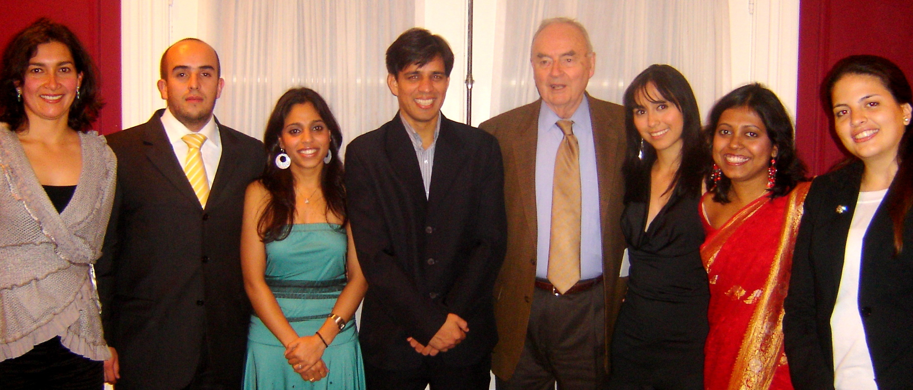
“I salute Atlas Corps’s ‘reverse Peace Corps’ approach towards international development. These leaders are demonstrating how much we can learn from each other and what can be accomplished by working together.” –Senator Harris Wofford, one of the founders of the Peace Corps and member of the Atlas Corps Senior Advisory Board addressing the Atlas Corps Fellows on November 15, 2007 (pictured at right).

A Modest Proposal
Atlas Corps is based on the belief that there is a lack of cooperation and sharing of best practices in the development sector – especially from global south (developing world) leaders to the United States. The challenges we face today, from global warming and poverty, to the spread of HIV/AIDS and the treatment of women, require cooperation on a global scale. Atlas Corps takes talented people with good ideas across borders in order to develop leaders and share good ideas.

Until now, it was almost impossible for global south leaders to volunteer in the U.S. There was a market failure caused by complicated visa restrictions and expensive logistics. This year we received a competitive certification from the U.S. government that allows us to sponsor social sector leaders from anywhere in the world to volunteer in the U.S. – and our first seven Fellows all received their visas and have been at their Host organizations for over three months!
Board of Directors

Scott Beale, Atlas Corps
Julia Cohen, Voxiva, Inc.
Jeff Huening, J.P. Morgan
Gared Jones, Ashoka India
Courtney Beale, U.S. State Dept.
Manmeet Mehta, GlobalGiving
Camila Payan, Georgetown Univ.
Mark Vlasic, White House Fellow
Lincoln Willis, Attorney
Jamie Zembruski, Attorney

We have overcome the high cost of this type of program by charging the Host organizations a cost share that covers almost 40% of the program expenses (average of $17,000 this year). This cost share more than covers our administrative expenses so you can know your donation goes directly to the support and training of social sector leaders. Perhaps more incredible, Atlas Corps has lined up Host organizations for next year who will pay cost shares ranging from $20,000 to $25,000, covering nearly 60% of program expenses. With your help we are ready to double the size of the program!
An Ambitious Plan
We are navigating our way through an exciting yet challenging first year, and we need your support now to keep the momentum going and establish Atlas Corps as not only the first, but the best two-way, international, social sector exchange program. Become a part of this exciting movement advancing global cooperation and support an overseas leader who wants to volunteer in the U.S.

Listen directly to our Fellows: Gargi Saha, a 30-year-old from Bihar, India with six years experience in anti-human trafficking and youth rights said, “Being an Atlas Corps Fellow is a dream come true. I’ve been able to use my experience in India to further Youth Venture’s mission.” Sergio Zuluaga, a 24-year-old youth development leader from Colombia who is volunteering with Mobilize.org said, “I'm learning a million things every day and I cannot wait to go back to Bogotá and start some of these models there. I've been witness to a true dialogue between government, organizations and citizens. This experience is not only life changing for me, but will also help my country and the people of Colombia.”

In four years 75% of our program expenses will be covered by the Host cost share and by our tenth year we will have over 1,000 Fellows from over 20 countries. We are already positioned to bring leaders from anywhere in the world to anywhere in the U.S. and will roll out a new pilot program that will recruit a small number of Americans to volunteer in Bogotá, Colombia. This will be a true exchange of mid career leaders with 3-8 years of experience and a passion for their work who will volunteer overseas to learn, teach and return home to share their experiences. We are setting out to do nothing less than be the largest management development program for social sector leaders around the world and a unique, low-cost capacity building program to strengthen organizations everywhere.
Senior Advisory Board

Ramesh Bajpai, E.D., American Chamber of Commerce, India
Jay Bakshi, Indian Business and Community Foundation
David Bornstein, Author, How to the Change the World
Ambassador William Brownfield,
Three-time U.S. Ambassador
Geri Critchley, Management Systems International (MSI)
Bill Drayton, Founder, Ashoka: Innovators for the Public
Ed Freel, University of Delaware
Dawn Rittenhouse, Director of Sustainable Development, DuPont
Shankar Venkateswaran, E.D., American India Foundation-India
Senator Harris Wofford, Co-Founder, U.S. Peace Corps
Cam Yorkston, District Governor, Rotary International

Please visit www.atlascorps.org/2007.pdf to read our 2007 Annual Report. This eight-page document tells the story of our amazing first year. If you have questions or would like to offer help in other ways, then please contact us at info@atlascorps.org or +1-202-669-4497 or +571-313-0043. We need volunteer help with public relations, accounting, law, real estate, business and other fields. Perhaps you would be willing to host a fundraising dinner, introduce Atlas Corps to potential Host organizations, or donate an old computer? Finally, if you do not receive our monthly email updates, then please subscribe on our website: www.atlascorps.org.

Please consider giving a little extra this holiday season to help us complete the pilot and fuel the expansion. We sincerely appreciate your support for Atlas Corps.


Sincere thanks and Happy Holidays!

Scott Beale, Founder, and the Atlas Corps Team

P.S. We’re looking for social sector organizations in Bogota who would like to learn more about Hosting an American for one year, please contact us if you know organizations that may be interested.
Please mail in section below with your donation:
Make check to Atlas Service Corps and mail to: Atlas Corps, 3217 Connecticut Avenue NW #36, Washington, DC 20008
All donations in the U.S. are tax-deductible, many corporations match donations, and we welcome support of any size!

$5,000 Trustees Participate in Board Meetings and help direct the future of the organization.
$1,000 Ambassadors Be recognized at the Annual Celebration and have dinner with one of the Fellows.
$500 Diplomats Be invited to participate in a Diplomat conference call every three months.
$250 Benefactors Receive written reports every four months on program evaluations and updates.
$100 Supporters Receive a Thank You phone call from one of the Fellows.
$55 Friends Support one day of the Atlas Corps Fellowship and be listed in the Annual Report.
Contact Info: Name: _____________________________Address: _________________________________
City: __________________ State: _____ Zip: ______ Phone: ____________Email: ________________
Credit Card: Name on Card: ______________________________ Amount: _______________________
Credit Card #: ________________________________ Exp Date: _____ /______ Code: ____
You may also donate online at www.atlascorps.org and www.globalgiving.com

2007 Atlas Corps Fellows and Partners
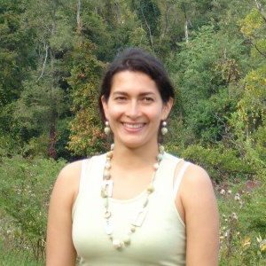 | 
 | 
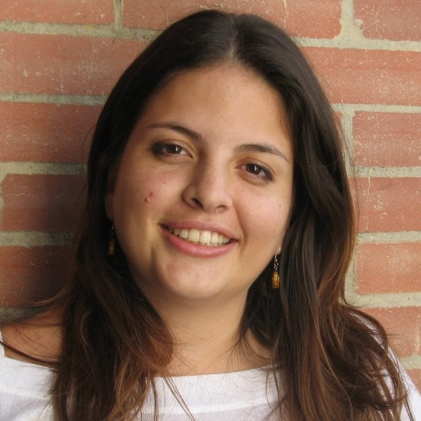 | 
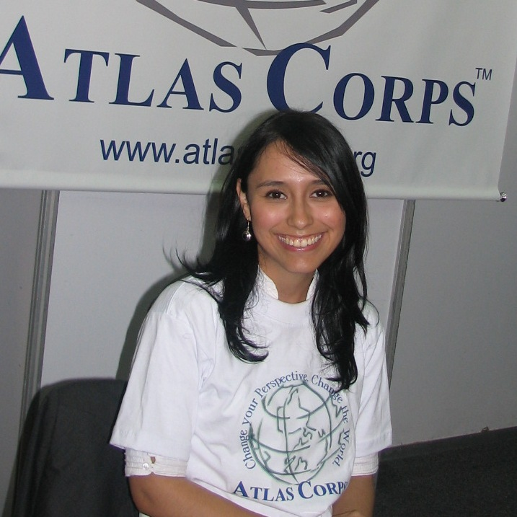 | 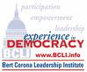
 | 
 | 
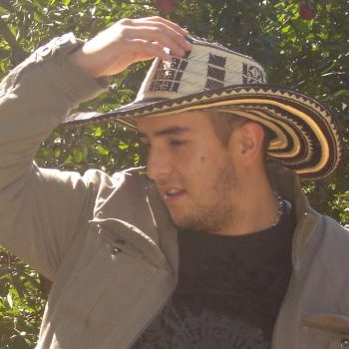 | 
Please go to www.atlascorps.org to learn more!

Maria Angelica Dueñas, 33, Bucaramanga, Colombia (TechnoServe)
Maria has over five years of experience in the public and private sectors. In 2005, Maria co-founded Corporación Educando, a Colombian CSO that works to promote the development of urban and rural communities. Maria earned her MBA from the University of Leicester in the UK and her B.A. from Pontifica Universidad Javeriana in Bogotá.

Gargi Saha, 30, Bihar, India (Youth Venture/Ashoka)
Gargi has more than six years experience in anti-human trafficking. She was a senior program coordinator at CHILDLINE India Foundation. Gargi also assisted in the arrest and prosecution of traffickers, for which she has posed as a decoy client and rescued 15 minors through police raids. She was selected as one of the “50 Dynamic Women” by the U.S. Ambassador in India. Gargi earned her B.A. and M.A. in history from the University of Delhi.

Emily Tangarife, 27, Cali-Valle, Colombia (AYUDA)
Emily has six years experience in marketing and international business in the public and private sectors. She used to work with a local government institution which seeks to promote the sustainable development of Valle del Cauca. Emily obtained her B.A. in marketing and international business at the Universidad Autónoma de Occidente in Cali, Colombia.

Alejandra Tapia, 23, Arauca, Colombia (Bert Corona Leadership Institute)
Alejandra has four years experience working in government, public policy and human rights. Previously, she worked in the Arauca Governor’s Office where she developed a study about citizen security and culture. Alejandra holds a B.S. in political science from the National University of Colombia in Bogotá.

Vithika Yadav, 26, Alwar, India (Free the Slaves)
Vithika worked in the anti-human trafficking field for four years. She worked at STOP (Stop Trafficking and Oppression of Children and Women) and with UNODC (United Nations Office on Drugs and Crime) on a project to strengthen law enforcement response to trafficking. Vithika received her B.A. and M.A. in history from the University of New Delhi.

Syed Mohd Yunus, 27, Kanpur, India (GlobalGiving)
Yunus has four years of experience on youth participation and anti-human trafficking. Most recently, he was an activist with Bachpan Bachao Andolan, an Indian NGO campaigning against child labor that represents individual members and more than 700 NGOs. Yunus earned his B.A. and M.A. in social work from Jamia Millia Islamia Central University in New Delhi.

Sergio Zuluaga, 24, Bogotá-Cundinamarca, Colombia (Mobilize.org)
Sergio has worked in both the public and private sectors for over three years. In 2005, he joined the Salesian Society to work in the Juan Bosco Obrero Center as a business development coordinator for the Office of Entrepreneurship. Sergio holds a B.A. in international relations from the Universidad del Rosario in Bogotá.
Atlas Corps Partners include large international organizations like TechnoServe, YouthVenture/Ashoka and GlobalGiving that have multi-million dollar budgets; medium-sized organizations like Free the Slaves; and smaller organizations like AYUDA, BCLI, and Mobilize.org that are more U.S.-focused and have fewer than six staff members. Each Host organization pays a cost share (about $17,000) and receives a Fellow for one year.

We embrace the term social (or citizen) sector because we prefer to define ourselves by what we are, and not by what we are not. Legally, Atlas Corps is a U.S. 501(c)3 nonprofit organization that may receive tax deductible donations in the U.S. and through our partner, iVolunteer, in India.

