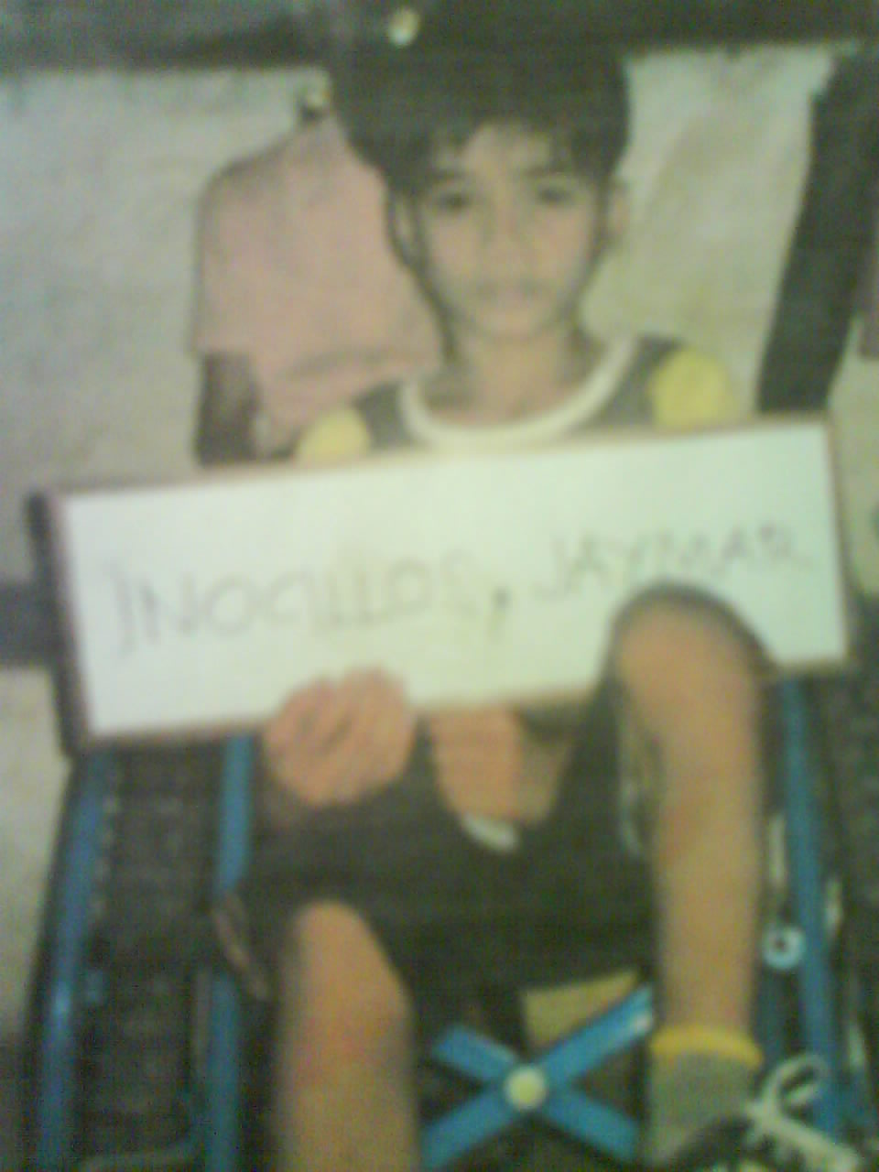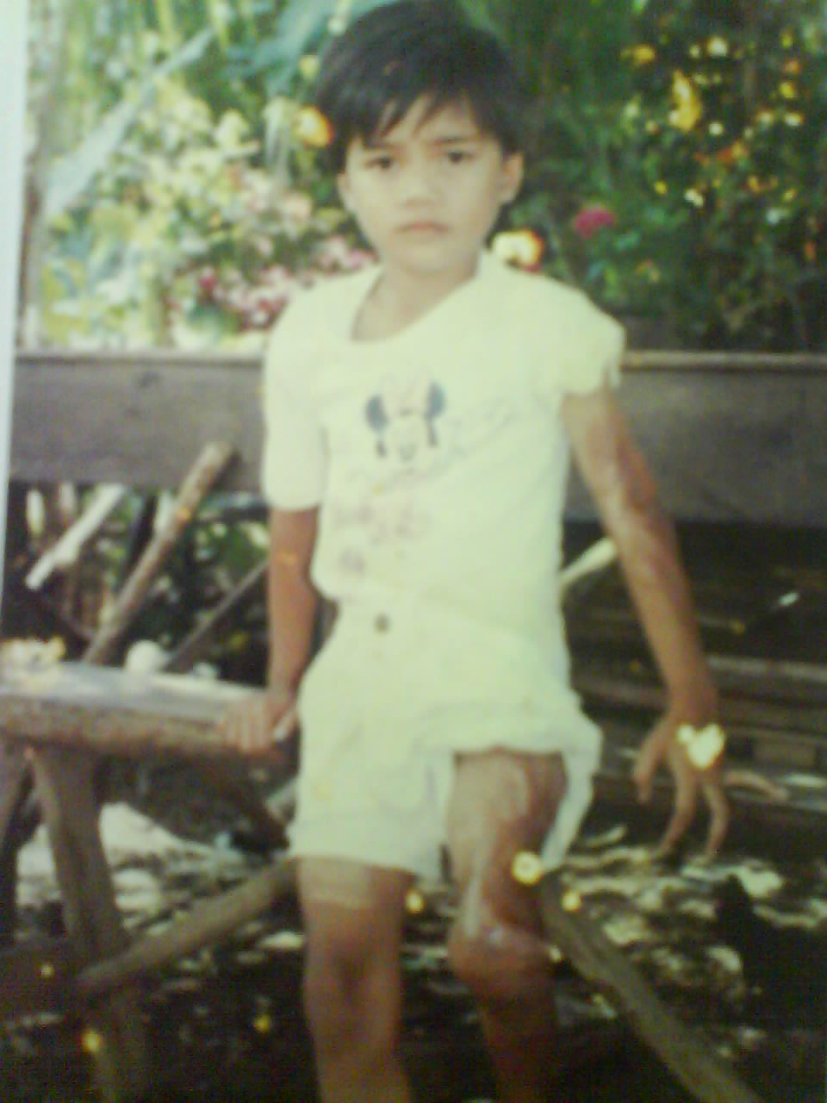

JAYMAR INOCILLOS IN HIS CUSTOMIZED WHEELCHAIR

JAYMAR INOCILLOS - BEFORE

BEFORE