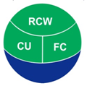

SENDFiNGO
Microfinance with Credit Unions

5 Year Business Plan

Prepared by Clay O’Brien
AYANI Inclusive Financial Sector Consultants

For SENDFiNGO

21 June 2012
TABLE OF CONTENTS

EXECUTIVE SUMMARY 3
I. BACKGROUND 5
A. Activities Prior to 2010 5
B. Financial Performance from 2010 7
II. GOALS AND OBJECTIVES 9
A. Original Program and Impact 9
B. Revised Goals 14
C. Credit Union Association and other Alliances 15
III. MARKET BACKGROUND 17
A. MacroEconomic and Political Situation 17
B. Regulatory Environment 19
C. Microfinance Sector 20
IV. BUSINESS APPROACH 21
A. Corporate Ethos 21
B. Target Clients 22
C. Products and Services 24
D. Competitive Landscape 29
E. Marketing 30
F. Detail on Locations 32
G. Branch and Head Office Operations 38
H. Human Resources Development 41
I. Information Technology 43
V. ORGANIZATIONAL STRUCTURE 44
A. Key Personnel 44
B. Performance Monitoring Plan 45
C. Governance 46
VI. FINANCIALS AND INVESTMENT REQUIRED 47
A. Financial Targets 47
B. Investment Required 48
C. Development Budget 49
Appendices 50
Appendix A: Business Plan Balance Sheet 51
Appendix B: Business Plan Income Statement 52
Appendix C: Business Plan Cash Flow Statements 53
Appendix D: Business Plan Ratio Analysis 54
Appendix E: Development and Total Budget 55
Appendix F: Total Financing Table…………………………………………………………………………57
Appendix G: Organisational and Senior Management Structure 57

EXECUTIVE SUMMARY

SEND-Ghana pioneered the use of credit unions to expand microcredit in order to promote sustainable livelihood security in the north of Ghana, one of the poorest parts of the country. It provided these loans through a relationship it built with credit unions, under which it offers funding and technical support to the credit unions.

In 2009 a Three Year Business Plan was prepared for the consolidation of the existing credit unions into a new entity called SENDFiNGO, which would strive for institutional and financial sustainability, as well as to scale up in new districts and communities. SENDFiNGO has achieved a result better than budgeted for 2011 in regard to nearly all of the indicators. An overall growth in SENDFiNGO clients of 116% was achieved in 2011 over the 2010 figure. By 31 December 2011 the program had grown from 1,314 members in December 2009 to a total of 5,057, ahead of the forecast total of 4,896 members.

Studies have shown the widespread positive impact of the project on the clients, some of which are summarised below:
• 49% of women expanded their business;
• The women saving money increased from 24% to 40%;
• The women contributing to their household expenditure increased from 12% to 45%;
• The women contributing to household decisions increased from 36% to 54%;
• The women with business skills increased from 42% to 56%; and
• The women involved in leadership matters increased from 20% to 46%.

This Business Plan sets out the plans that SENDFiNGO has devised for the next exciting stages of its development. It will strive for institutional and financial sustainability for its ten existing branches, as well as to scale up in as many as four new districts and communities. The aim remains to allow poor women in the relevant districts to graduate to the stage where they can afford to become members of the credit unions and access all of the other available financial services.

SENDFiNGO will employ just nine of its own staff who will work with the credit unions in the existing areas and those “animated” in up to five new areas. At the same time, SENDFiNGO will support the Loan Officers at the credit unions who offer the microfinance products, as well as credit union services, in return for receiving all of the interest on the microfinance loans. The Loan Officers, whose numbers are forecast to grow to 44 by the end of Year 3, would be working wholly for the credit unions but would be paid and supervised by SENDFiNGO.

A financial model has been prepared that produces the following summary outcomes.

Year  Indicator (GHc) | 2013 | 2014 | 2015 | 2016 | 2017
No. of Active Loans* | 7,450 | 9,318 | 10,957 | 12,888 | 15,846
Net Loan Portfolio | 823,160 | 1,355,936 | 1,512,085 | 2,221,078 | 2,875,534
Net Income pre-Grants | -64,467 | 130,177 | 270,193 | 439,269 | 610,705
Total Assets | 1,031,162 | 1,419,219 | 1,864,909 | 2,353,213 | 2,976,265
Total Equity | 1,026,888 | 1,414,945 | 1,860,635 | 2,348,939 | 2,971,991
OSS (%) | 84.1% | 132.7% | 158.3% | 183.5% | 196.0%

Under the modelling, SENDFiNGO will increase its outreach, through the associated credit unions, to more than 15,000 active borrowing clients by December 2017. As indicated, the SENDFiNGO operation will be sustainable by Year 2 and reach Operational Sustainability of 196% by Year 5. The return on assets will increase to nearly 14% by 2017 and the Operating Cost ratio will fall to less than 24% over the same period.

The funding required over the three years is assumed to be provided through unrestricted grants totalling GHc961,000 with no excess cash held on the SENDFiNGO balance sheet.

BACKGROUND

Activities Prior to 2010

SEND Foundation of West Africa first began work in the Eastern Corridor of Ghana by conducting a needs assessment in four peri-urban communities (Salaga, Kpandai, Bimbilla and Kete-Krachi), which culminated in the development in 2000 of the Eastern Corridor Livelihood Security Promotion Program (ECLSPP). The ECLSPP operates on a model of bringing microfinance into credit union development as a means of broadening access to financial services by members of these communities. Donors including the Canadian Co-operative Association (CCA) and CORDAID from the Netherlands have provided grants.

As a key component of using micro-credit to promote sustainable livelihood security, SEND has adopted the credit union model which emphasises savings as a precondition for accessing credit. To develop the credit union model, SEND entered into partnership with the Credit Union Association of Ghana (CUA), to provide technical assistance to SEND in order to animate credit union development as part of ECLSPP. In 2002 a Community Based Credit Union (CBCU) was opened in Kpandai and Bimbilla, and one year later another one was initiated in Kete Krachi. The Chamba and Banda CBCUs both started operations in 2005.

Due to the fact that many women were unable to raise adequate funds to purchase Shares in the credit unions and open accounts, SEND and its principal donor CORDAID established the micro-finance scheme with the Rural Commercial Womens Associations (RCWA) members as the principals. Under this scheme the credit unions in Kpandai, Bimbilla and Kete-Krachi were allocated microcredit funds for the RCWA members who were organised into savings and loans associations. Each association had to open an account with the credit union in order for its members to qualify for access to the loans while each loan beneficiary also had to open a sub-account as a member. The program began operating in 2005.

The program consolidated over the next two years and SEND undertook a feasibility study in 2008 to identify suitable communities in the northern part of the eastern corridor for the replication of the credit union with microfinance (CU-MF) orientation model. The survey recommended five peri-urban communities in the northern region. In addition SEND consulted with CUA for the possibility of extending the model to existing credit unions. CUA management agreed to have CUA member credit unions in the Northern, Upper East and Upper Regions develop microfinance services targeting women in these communities.

In 2009 a Three Year Business Plan was prepared for the consolidation of the existing credit unions into a new entity called SENDFiNGO, which would strive for institutional and financial sustainability, as well as to scale up in new districts and communities. Targets for clients and all financial indicators were set for the three years to December 2012. Amendments were made to the original Business Plan, which were agreed between SENDFiNGO and primary donor CORDAID, as shown in Table 1.

Table 1: Revised Summary SENDFiNGO Financial Performance
Item | Year 2010 |  |  | %age revision of targets
Item | B-plan Target | Revised Target | Variance | %age revision of targets
Number of Active Clients | 3,200 | 2,240 | 960 | 70%
Net Loan Portfolio Balance Gh¢ | 145,556 | 109,167 | 36,389 | 75%
Net Income pre-grants | (97,080) | (72,810) | (24,270) | 75%
Financial Income Gh¢ | 48,462 | 29,077 | 19,385 | 60%
Total Assets | 208,133 | 156,100 | 52,033 | 75%
Loan loss reserve | 3,721 | 2,791 | 930 | 75%
PAR greater than 30 days | 2.5% | 2.5% | - | 100%
Total Equity | 136,133 | 102,100 | 30,303 | 75%
Operating Self-sufficiency (OSS) | 35% | 26% | 9% | 75%
Item | Year 2011 |  |  | %age revision of targets
Item | B-plan Target | Revised Target | Variance | %age revision of targets
Number of Active Clients | 6,800 | 4,896 | 1,904 | 72%
Net Loan Portfolio Balance Gh¢ | 377,552 | 302,042 | 75,510 | 80%
Net Income pre-grants | (52,158) | (41,726) | (10,432) | 80%
Financial Income Gh¢ | 132,326 | 92,628 | 39,698 | 70%
Total Assets | 421,025 | 336,820 | 84,205 | 80%
Loan loss reserve | 9,614 | 7,691 | 1,923 | 80%
PAR greater than 30 days | 2.5% | 2.5% | - | 100%
Total Equity | 349,025 | 279,220 | 69,805 | 80%
Operating Self-sufficiency (OSS) | 72% | 58% | 14% | 80%
Item | Year 2012 |  |  | %age revision of targets
Item | B-plan Target | Revised Target | Variance | %age revision of targets
Number of Active Clients | 10,050 | 7,538 | 2,513 | 75%
Net Loan Portfolio Balance Gh¢ | 730,546 | 606,353 | 124,193 | 83%
Net Income pre-grants | 40,256 | 33,412 | 6,844 | 83%
Financial Income Gh¢ | 295,812 | 221,859 | 73,953 | 75%
Total Assets | 764,916 | 634,880 | 130,036 | 83%
Loan loss reserve | 18,666 | 15,493 | 3,173 | 83%
PAR greater than 30 days | 2.5% | 2.5% | - | 100%
Total Equity | 692,916 | 575,120 | 117,796 | 83%
Operating Self-sufficiency (OSS) | 116% | 104% | 12% | 90%

The revised forecast for each CU are set out in Table 2 below.

Table 2: Revised Client Forecasts by Branch

Clients Forecast for 2011 and 2012
Credit Union | Solidarity Clients 2011 | Farmers Loan 2011 | Total Clients 2011 | New Solidarity Clients 2012 | New Farmers Loan 2012 | Total Solidarity Clients 2012 | Total Farmers Loan 2012 | Total Clients 2012
Salaga | 175 | 190 | 365 | 182 | 73 | 357 | 263 | 620
Kpandai | 571 | 209 | 780 | 182 | 59 | 753 | 268 | 1,021
Bimbilla | 737 | 70 | 807 | 182 | 40 | 919 | 110 | 1,029
Chamba | 322 | 365 | 687 | 187 | 63 | 509 | 428 | 937
Banda | 370 | - | 370 | 182 | - | 552 | - | 552
Kete Krachi | 484 | - | 484 | 146 | - | 630 | - | 630
Tamale | 265 | - | 265 | 146 | - | 411 | - | 411
Chereponi | 338 | - | 338 | 345 | - | 683 | - | 683
Tatale | 400 | - | 400 | 408 | 20 | 808 | 20 | 828
Nalerigu | 400 | - | 400 | 408 | 20 | 808 | 20 | 828
Totals | 4,062 | 834 | 4,896 | 2,367 | 274 | 6,429 | 1,108 | 7,538

Financial Performance from 2010

A summary of the major financial outcomes for the year to 31 December 2011, compared to the revised annual targets, is set out in Table 3 below.

Table 3: Summary SENDFiNGO Financial Performance in 2011

Annual performance Summary (January 2011 to December 2011)
No. | Indicators | Denomination | Annual Actual Output (January to December 2011) | Revised Annual Target in Business plan (Jan. to Dec 2011) | Percentage Achieved
1 | Number of Active Clients | Number | 5,057 | 4,896 | 103%
2 | Net Loan Portfolio Balance Gh¢ | GHC | 363,597 | 302,042 | 120%
3 | Net Income pre-grants | GHC | (39,581) | (41,726) | 95%
4 | Financial Income Gh¢ | GHC | 63,052 | 92,628 | 68%
5 | Total Assets | GHC | 466,634 | 336,820 | 139%
6 | Loan loss reserve | GHC | 3,412 | 7,691 | 44%
7 | PAR greater than 30 days | %age | 2.2% | 2.5% | 88%
8 | Total Equity | GHC | 451,964 | 279,220 | 162%
9 | Operating Self-sufficiency (OSS) |  | 61% | 58% | 106%

SENDFiNGO achieved a result better than budgeted for all of the indicators in the above table other than the quantum of financial income. An overall growth in SENDFiNGO clients of 116% was achieved in 2011 over the 2010 figure. The women solidarity loans grew by 145% whilst farmers loans also increased by 27%. In total 2,715 new clients consisting of 2,558 solidarity women and 157 farmers benefited from the loans during the year.

As a result of the above changes, by 31 December 2011 the program had grown from 1,314 members in December 2009 to a total of 5,057, ahead of the forecast total of 4,896 members.

In terms of branches, SENDFiNGO has expanded in three ways:

(a) Consolidated and strengthened the Credit Unions existing at the beginning of the Business Plan in the six communities of Kpandai, Bimbilla, Kete-Krachi, Salaga, Chamba and Banda as follows:
• Salaga: from 285 members to 297, with the original Solidarity Loans been transferred to Bimbilla;
• Kpandai: 206 members to 543;
• Bimbilla: 314 members to 725;
• Kete-Krachi: 187 members to 484;
• Banda: 140 members to 355; and
• Chamba: from 182 members to 652;

(b) Partnered with the Tamale Community Cooperative Credit Union and there were 591 microfinance loans by the end of 2011; and

(c) Expanded in 2010 into three additional communities in the more remote areas of Nalerigu, Tatale and Chereponi by “animating” new Credit Unions and reaching the following clients by the end of last year:
• Tatale: 525 members;
• Chereponi: 350 members; and
• Nalerigu: 535 members.

Comparing the above numbers with the detailed revised forecasts for 2011 in Table 2, the client numbers achieved for Salaga, Kpandai, Bimbilla, Chamba and Banda are behind those forecast but the other CUs were either in line (Kete-Krachi) or ahead of the expectation for the 2011 year end. The three new CUs have performed particularly well, both in terms of numbers achieved and general development and institutional progress.

As part of this expansion, three mobilization centres (facilitated by SENDFiNGO) were opened by: Bimbilla CU in Wulensi; Chamba CU in Bincheretanga and Kete-krachi CU in Chindri. SENDFiNGO has also worked with the credit union in Borae but it has not yet made any loans funded by SENDFiNGO.

This Business Plan sets out the plans that SENDFiNGO has devised for its next exciting stages of its development.

The financial model used in this Business Plan assumes, for convenience, a January 2013 start date, as this coincides with the end of the current funding from CORDAID and others.

II. GOALS AND OBJECTIVES

Original Program and Impact

The success achieved in the early years of implementation of a credit union with microfinance orientation by SEND-Ghana was one fundamental reason for the establishment of SENDFiNGO, in order to scale up and consolidate the model which combines the unique characteristics of a credit union and a microfinance institution. The model involves, first, the mobilisation of community people to establish a community based credit union. The model requires the ‘promoter’ to provide infrastructure, human resources and technical assistance to the community people in the infant days of the credit union. The community makes savings from which they make loans to themselves after usually a period of six months. The use of exclusive internally generated funds for loans instils among the people the culture of savings as they are aware that the promoter is not bringing in external funds to be given to them.

However, the growth of a credit union through its traditional products and services may not ensure absolute equity in wealth distribution and the development of the individual. Therefore, it is important to identify members of the community who genuinely cannot meet the initial entry and loan qualifying requirements of the average credit union. The promoter then takes additional steps to facilitate the organisation and orientation of that class of the community that can be identified as productive poor into solidarity groups and then associations with a common interest. These solidarity groups of 5 to 7 are formed through a self-selection process. Between 5 and 7 of such groups (averaging 35 persons) make up an association, each with a name and a nominated meeting place, day and time. The association goes through an incubation process of about 4 weeks during which they are educated on the scheme that would provide them with credit and assist them to graduate over time into membership of their community credit union. The period is also used to elect executives and develop relevant by-laws for the group.

The promoter at this stage introduces the external funds exclusively for this class of persons whose collateral is the solidarity group to which they belong. Loan repayments are made on a weekly basis and are completed in four months. As the savings base of the local credit union grows, the Board of Directors is encouraged to inject some of their internally generated funds into the microfinance scheme, since the interest rate is usually higher than that paid by the credit union to its own members.

The clients of the microfinance scheme who are able to grow their businesses well and demand higher loan amounts graduate into the credit union through their individual savings which they mobilise while they were members of the group. The synergy here is that the credit union funds a micro-loan to people who are not members in order to grow their businesses and, thereafter, such persons attain the qualification needed, join the credit union to make bigger savings and take larger loans.

The specific objectives of SENDFiNGO as laid out in the original 2009 Business Plan included to:
(i) Expand client numbers so that SENDFiNGO can become sustainable and self-funding;
(ii) Strengthen the human resource capacity of all credit unions;
(iii) Improve the management information systems (MIS) of the credit unions for effective monitoring of performance;
(iv) Improve physical and administrative infrastructure;
(v) Strengthen the governance structures and working committees of each credit union; and
(vi) Grow the working capital base of each credit union.

All of these objectives have been achieved over the first two and half years and the objectives will be further monitored until the end of 2012.

In addition, certain social indicators for SENDFiNGO were devised and set down in the Initial Monitoring Report of 2010 in the light of certain objectives. After some initial issues with the collection process, in 2011 and 2012 a total of 1,754 initial and second interviews obtained in order to compile meaningful longitudinal data. Some of the second interviews were conducted one cycle (4 months) after the original interview; others two cycles or 8 months later. All but three of the CUs participated to supply a meaningful number of two interviews.

The data received was entered into a spreadsheet and an external expert retained to process the data using the widely accredited SPSS system. Some of the key impacts over the period analysed by the survey are summarised below:

• 49% of women expanded their business

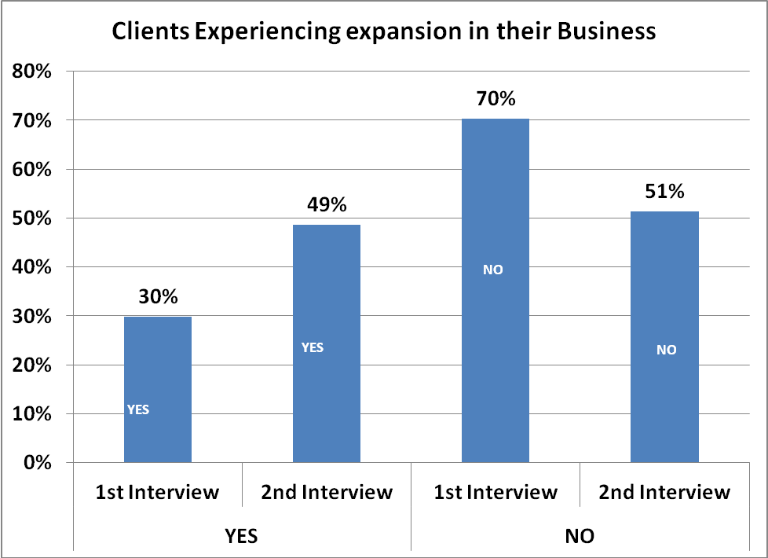

• The women saving money increased from 24% to 40%

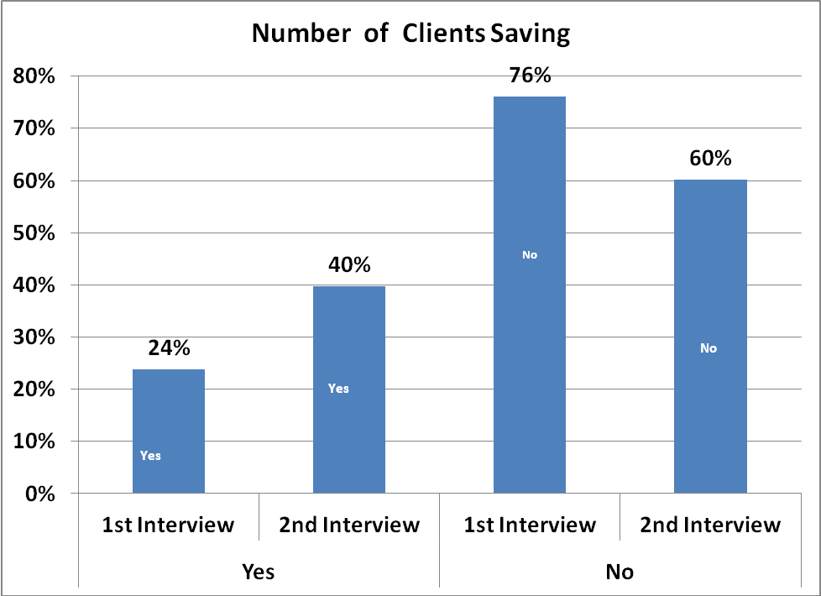

The women contributing to their household expenditure increased from 12% to 45%

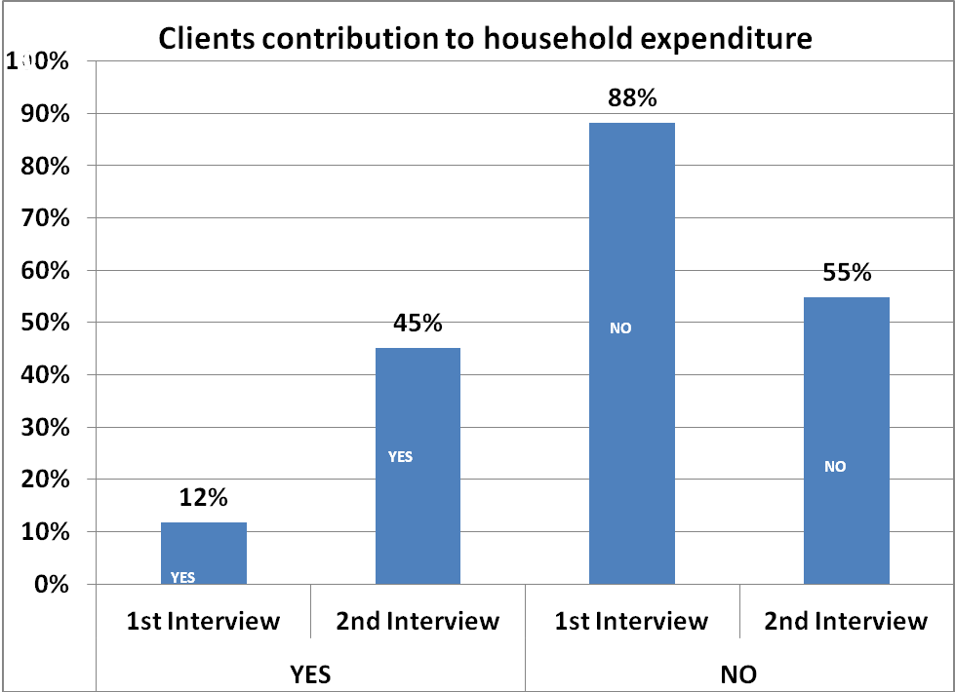

• The women contributing to household decisions increased from 36% to 54%

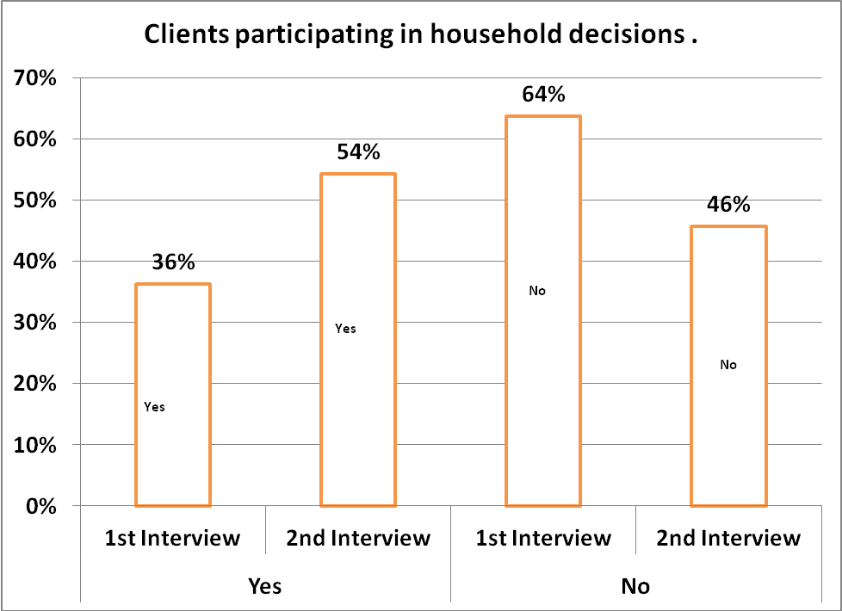

• The women with business skills increased from 42% to 56%

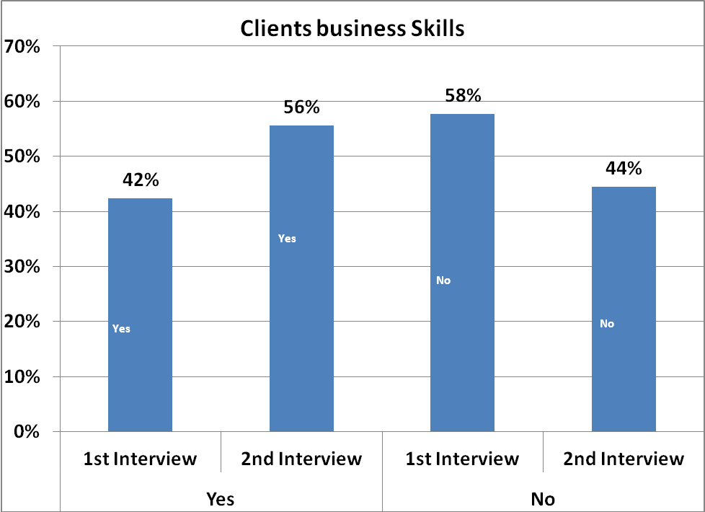

• The women involved in leadership matters increased from 20% to 46%

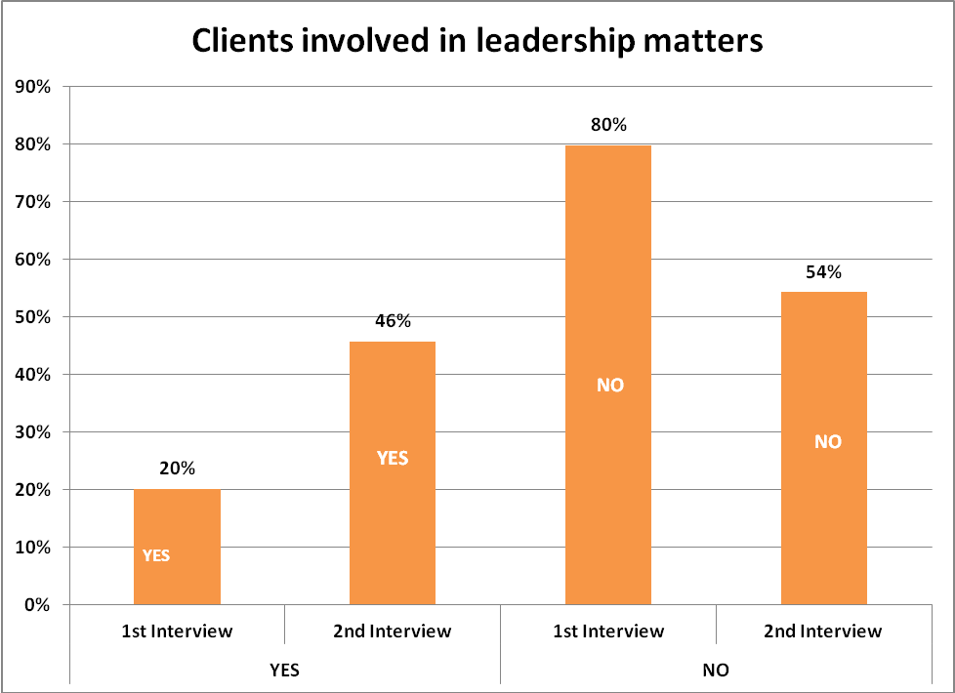

B. Revised Goals

Building on the above achievements, the goals for SENDFiNGO over the next three to five years are to:
- Strengthen the institutional and organizational capacity of the three new credit unions to accelerate their growth towards operational and financial sustainability to cover their cost of operation;
- Increase client numbers by extending the microfinance service to an additional 5000 new women in the communities;
- Improve the institutional and organizational capacity of the older credit unions to solidify their institutional and financial sustainability;
- Strengthen social performance management systems of the credit unions;
- Establish four new Community Co-operative Credit unions in four districts; and
- Conduct feasibility studies for replication of the project in other communities.

The expected results of the extension include:
1. Increased human resources capacity.
2. Increased depth of outreach of financial inclusion.
3. Networking and strengthening of Credit unions relationship among one another.
4. Improved knowledge management.
5. Increased sustainability of the credit unions and SENDFiNGO.
6. Increased commitment to social performance management.
7. Increased quality of service delivery.
8. Improved monitoring and documentation of the client’s graduation systems in place.

The gains made in the first three years would be consolidated by adopting appropriate methodologies to address the challenges and weaknesses identified. For example, with 6 months to the end of the first phase of the project, the three new credit unions have not reached the threshold of 100% of operational sustainability. Some of the existing credit unions have also experienced unstable savings which affected their ability to create new income earning assets. The quality of loans granted to credit union members other than those granted to microfinance clients is also a challenge in some credit unions. The absence of an internal auditor/M&E officer is another issue that SENDFiNGO would address.

More detail is contained in following sections.

C. Credit Union Association and other Alliances

SENDFiNGO recognizes the importance of relationships with potential partners, such as credit unions, other microfinance institutions, local and foreign companies, banks, donors and other business development implementers. They can lead to a better understanding of local markets and more effective operations.

Most importantly, the credit union with microfinance orientation must involve credit unions. SENDFiNGO has strategic partnerships with each of the ten community credit unions and it provides vital start-up infrastructure and capacity building training for the Boards of Directors (BOD) and committees as well as for the staff. As it expands, SENDFiNGO will also work with new credit unions to be established in new districts.

A detailed MOU has been negotiated with the credit unions covering the following elements:
- The arrangement with respect to the payment of Loan Officers;
- Revenue sharing with respect to the microfinance loans;
- The nature of other support provided by SENDFiNGO to the credit unions;
- Agreement on the terms of the microfinance loans;
- The marketing, promotion, disbursement and collection of the products;
- Reporting by the credit unions to SENDFiNGO; and
- Other key matters relating to the partnership.

All of the above and other matters key to the relationship between SENDFiNGO and the credit unions will be dealt with in detail elsewhere in this Business Plan.

In addition to SEND, SENDFiNGO has built relationships with other parties such as CORDAID, CCA, Irish League of Credit Unions Foundation, and it has conducted recent discussions with other donors including ACDI/VOCA. A relationship with the CUA will continue to be important. In all of SENDFiNGO’s arrangements with credit unions, CUA as an umbrella organisation has been called upon to help facilitate the educational processes (see section IV, C below). CUA, as the apex industry body, has previously agreed to execute certain functions in support of credit unions, such as:
- Annual audits and preparation of reports for the credit union’s Annual General Assembly;
- Training for the various credit union committees at least once a year;
- To ensure that the credit union policies and practices are in line with CUA’s guidelines for operation of primary societies;
- To update each year the business plans of the respective credit unions;
- To raise funds to support the position of Accounts Officer in weak or newly established credit union; and
- To regularly conduct quality control checks of the financial management control systems to ensure that they are operating in line with CUA’s standards.

More recently, SENDFiNGO and CUA have entered into discussion on their relationship, which is timely in the lead up to the next funding stage. Cementing the relationship with CUA will also indicate to the credit unions that SENDFiNGO is not engaging with them on its own. In the meantime, CUA is providing the support envisaged, for example through a German consultant from GIZ working with the CUs.

Thirdly, SENDFiNGO is receiving some support from the Canadian Co-operative Association (CCA) for the strengthening of the three weak credit unions (ie Banda, Borae and Salaga) in the Eastern Corridor through the ECLSPP. SENDFiNGO’s operations in that area currently receive support through a 3 year CCA sustainability project. The continuation of that support to SENDFiNGO after the current program ends in 2013 is being discussed between SEND and the CCA.

Finally, the SENDFiNGO achievements to date could not have occurred without the support of its generous donor, CORDAID. It is hoped that CORDAID will be prepared to continue to support SENDFiNGO. However, additional donors will also be sought.

III. MARKET BACKGROUND

A. MacroEconomic and Political Situation

1. Poverty and Agriculture

The 2010 Census has not been released as yet but preliminary numbers indicate a total population of 24.2 million. Based on the Ghana Living Standards Survey data, 29% of the total Ghanaian population in 2006 was classified as poor. While this represents a significant decrease from the rate of 52% in 1992, the latest figure masks much higher poverty in some areas, especially the north of the country. In 2006, 52% of people in the Northern Region were still living in poverty.

Ghana's economy has been strengthened by a quarter century of relatively sound management, a competitive business environment, and sustained reductions in poverty levels. The services sector accounts for a third of GDP and industry about 27%. Ghana is well endowed with natural resources such as gold. Oil production at Ghana's offshore Jubilee field began in mid-December, 2010, and is expected to boost economic growth. Individual remittances are major sources of foreign exchange.

Agriculture accounts for roughly 30% of GDP and employs more than half of the workforce, mainly small landholders. Agriculture also contributes about 60% of export earnings, and it provides the main source of livelihood for about 60% of the population. Agriculture is predominantly smallholder, traditional and rain-fed with some 2.7 million farms, averaging 1.2 ha in size, accounting for 80% of agricultural production. The main food crops are roots and tubers (cassava, yam), cereals (maize, rice, sorghum, millet) and pulses (cowpea and groundnut).

In terms of economic activity, poverty is by far highest among food crop farmers, almost 60% of whom live below the poverty line, followed by export farmers (37%) and non-farm self-employed people (30%). Private formal employees are best off (with only around 11% living in poverty).

Financing of agriculture remains problematic given the high risks and costs involved and the lack of proven instruments for mitigating production and credit risk, as well as the paucity of financial instruments that are adapted to the needs of smallholder farmers. Credit flow to the agricultural sector (including forestry and fishing) as of March 31, 2007 (Bank of Ghana 2008) was only 4.6 percent of total bank credit, marginally up 2.3 percent from the same period in 2006. Within this credit to agriculture, food crops and fruits, vegetables and nut seeds dominate with 62.6 percent (GH¢ 89.2 million) of total outstanding credit to the agriculture sector (Bank of Ghana 2008).

For the above reasons, SENDFiNGO has been focused on women living in the rural communities of the Northern Region and will continue to do so.

2. Other MacroEconomic and Political Factors

Key indicators for Ghana are set out in the following table, starting with the figures at the time the previous Business Plan was prepared.

Table 4: Key economic statistics for Ghana

Macro Economic Indicator | 15 June 2009 | December 2009 | December 2010 | December 2011 | May 2012
Exchange Rate* (GHc/US$) | 1.45 | 1.42 | 1.48 | 1.62 | 1.84
Exchange Rate*  (GHc/Euro) | 1.99 | 2.03 | 1.96 | 2.09 | 2.43
Annual Inflation Rate (%) | 20.6  (year to April) | 16.0 | 8.6 | 8.7 | 9.6  (2012 est.)
12 Month T-Bill Rate (%)* | 25.8 | 20.0 | 12.7 | 10.5 | 15.5
Real GDP Growth (%) | 6.3  (2008) | 4.0 | 7.7 | 14.4 | 8.8  (2012 est.)
*: End of period
Source: World Bank, Bank of Ghana, IMF

Economic growth has been strong over recent years, particularly in 2011, and inflation has been reduced to less than 10%. Nonetheless, the Ghanaian cedi has lost value over the last 3 years.
Real gross domestic product (GDP) growth in Ghana for the year 2012 is projected to be 8.8% by the International Monetary Fund (IMF) in its April 2012 World Economic Outlook. But GDP growth will ease to 7.4% in 2013, according to the Fund. The IMF projects that inflation will be around 9.6% and 8.9% in 2012 and 2013, respectively.

Assumption for Financial Model: Annual inflation rate of 10%.

The other key aspect of the Ghanaian economy is infrastructure, the generally poor condition of which seriously constrains economic growth and poverty reduction. Power shortages are the most critical constraint facing small and medium enterprises (SMEs) in Ghana. Other concerns include the current transport system, which makes many parts of the country very difficult to reach, and water and waste treatment.

Ghana is an emerging democracy. A new Government was elected in late 2008, headed by the President, Professor John Atta Mills, from the National Democratic Congress. Despite the defeat of the ruling New Patriotic Party, whose leader John Kufuor was obliged by the Constitution to retire after two terms, in a closely fought battle, the result was generally accepted and a peaceful handover of power took place.

More details on the specific districts in which SENDFiNGO will operate are set out in section IV, G below.

Regulatory Environment

The banking sector as a whole is regulated by the Bank of Ghana (BoG) under the Banking Law of 1989.

Savings & Loan companies (S&Ls) and Credit Unions are covered by the Financial Institutions (Non-Banking) law of 1993. However, credit unions are not regulated by the BoG but by CUA, which acts as a self-regulatory apex body. The BoG will formally delegate responsibility for regulating CUs to CUA in the near future.

As a financial NGO, SENDFiNGO was not subject to regulation at the time of the original Business Plan and did not require a licence as a financial institution. However, since then, the Government has issued certain regulations under the Non-bank Financial Institutions Act, 2008 (Act 774). After discussions with the Bank of Ghana, it would appear that SENDFiNGO is regarded as a Non-deposit taking Financial Non-Governmental Organization (FNGO) under Tier 3. As such, it must register with the Bank of Ghana and report regularly. SENDFiNGO has already commenced the relevant process, including by having joined the Association of Financial NGOs.

A financial NGO is a non-profit making institution that seeks to address the needs of the disadvantaged through the provision of one or more demand-driven financial services. Such services may involve:
- The provision of micro-credits or micro-loans;
- Facilitating access to credit and perhaps the encouragement of savings among members;
- Intermediation of credit funds;
- Guarantees;
- Group lending;
- Village banking; and
- Credit with education.

SENDFiNGO would not be able to take deposits. However, a financial NGO may also facilitate its clients to institute a Village Savings and Loans scheme or other means by which the groups can mobilise savings for themselves. But SENDFiNGO would not be able to access those savings that have to be deposited with the respective credit unions.

C. Microfinance Sector

The larger banks in Ghana do not generally make small business loans. The ability of potential borrowers to meet bank’s requirements are inhibited by certain problems of formalization, involving:
- Land registration and titling;
- Registration of businesses; and
- Farmer-based organizations (FBOs) not largely being accepted as registered intermediaries by bankers.

As a result, the banks tend to focus on larger businesses and foreign corporations in the major cities rather than the rural areas.

According to the MixMarket, the five largest MFIs (including two Opportunity International MFIs and some Rural Banks) operating within Ghana have 275,000 clients, with a gross loan portfolio of GHc 70 million. In addition, there are another 57 MFIs, mainly small NGOs, Rural Banks, Community Banks and some Savings & Loan Institutions (S&Ls) with microfinance activities in certain districts.

There are 19 S&Ls and also over 250 Credit Unions. In 2005, the latter were estimated to be serving 174,000 members with a deposit base of $47m and an asset base (mainly loans) of $56m. There is also an array of susu collectors, moneylenders, traders and ROSCAs.

The microfinance sector is relatively well-developed in Ghana compared to other countries in the region, but there is still considerable room for growth. Notably, the access to financial resources remains inadequate in Northern Ghana. There are great opportunities for an aggressive expansion of microfinance and credit unions in terms of membership and savings due to the existence of many communities that are not served by any financial institution.

IV. BUSINESS APPROACH

A. Corporate Ethos

1. Mission Statement

The mission statement of SENDFiNGO is to: Improve the socio-economic wellbeing of the resourceful poor men and women in Ghana by developing credit unions with microfinance orientation.

2. Legal Status

SENDFiNGO is an established independent entity, separate from SEND-Ghana.

The name “SENDFiNGO” was reserved in 2010 and a logo (see front cover) was adopted. The registration as a company limited by guarantee was completed on 3 June 2011. Whilst a company limited by guarantee does not have shareholders, SEND-Ghana, the CUs, CUA and the Council of the Credit Unions (a body proposed by SENDFiNGO as the platform for knowledge sharing among the CUs) are recognised as the effective ‘owners’ through the Board structure and other matters.

The Memorandum & Articles of Association have been registered. Sappor Agyekwena, Chartered Accountants, have been appointed the external Auditors of SENDFiNGO. SENDFiNGO was also granted a Certificate to Commence Business.

Apart from local regulatory requirements (see section III, B above), SENDFiNGO also conducts its activities in accordance with standards set by international microfinance monitoring bodies such as The MIX Market (Microfinance Information eXchange - http://www.mixmarket.org/) and CGAP (Consultative Group to Assist the Poor – www.cgap.org).

B. Target Clients

SENDFiNGO has been successful for the last two and half years – and is on target to meet its goals for 2012 - in working through credit unions to provide financial services to poor women in the designated rural areas in Northern Ghana. This will continue to be the basic approach under the next phase.

The credit unions employ Loan Officers who will offer the microfinance products and services (see Section C below) as well as performing other credit union functions. SENDFiNGO will provide the credit unions with funding for the microfinance loans and the salaries for the Loan Officers. In return, SENDFiNGO will receive the interest paid on these loans. More detail on the arrangements between SENDFiNGO and the credit unions, which has been utilised up to now, is provided in later sections.

As mentioned in Section I, SENDFiNGO’s CU-MF scheme has been successfully implemented in ten communities in the Eastern Corridor. In order to arrive at forecasts for future client growth, an analysis was conducted of the surrounding towns (within a distance of 15 kilometres) that could be reached by the SENDFiNGO model in each community.

The population figures are shown in the following table. Whilst a new census was conducted in 2010 the results are not yet known and the release has been postponed. Therefore, the 2000 Census has been used, with figures inflated at the growth rate that has been disclosed as part of the preliminary release of data from the 2010 Census.

Table 5: Population of Towns currently benefiting from SENDFiNGO Program

Town | Population in 2000 (based on Census) | 2012 Forecast  (2.9%pa Growth) | Estimate for surrounding towns | TOTAL
Kpandai | 7,714 | 10,871 | 24,371 | 35,242
Kete-Krachi | 9,285 | 13,085 | 12,439 | 25,524
Borae | 4,601 | 5,786 | 29,994 | 35,781
Chamba | 3,973 | 5,599 | 26,085 | 31,684
Bimbilla | 21,016 | 29,617 | 16,697 | 46,313
Banda | 6,730 | 9,484 | 9,720 | 19,204
Salaga | 16,196 | 22,824 | 23,837 | 46,661
Tamale | 202,317 | 285,113 | 49,323 | 334,436
Nalerigu | 10,698 | 15,076 | 39,274 | 54,350
Chereponi | 6,241 | 8,795 | 18,378 | 27,173
Tatale | 5,555 | 7,828 | 27,807 | 35,635

In addition, a feasibility study was conducted to critically evaluate a group of other communities within a proposed area of expansion and to recommend which ones are best suited for the credit union with microfinance orientation model. This built on earlier detailed work conducted in April 2008 with regard to three of the towns.

Four communities were analyzed during the study, namely Wulensi, Zabzugu, Bunkprugu and Sang, and all but the latter had been assessed in 2008. They were all evaluated in terms of their economic viability and their social relevance, and they were filtered based on the specific conditions required for an effective and sustainable program implementation, namely:

- Sufficient Potential Users: Adequate population base and expansion capacity, and meaningful economic activity and infrastructure;
- High Social Relevance: Low social infrastructure and NGO presence, and inadequate financial services supply; and
- Conducive environment: Significant strengths and opportunities, a few and manageable weaknesses and threats.

The study recommended expansion into the four towns. The next table shows the population figures for these four communities and the surrounding towns.

Table 6: Total Population of Four Selected Communities

Town | Population in 2000 (based on Census) | 2012 Forecast  (2.9%pa Growth) | Estimate for surrounding towns | TOTAL
Wulensi | 7,616 | 10,733 | 22,862 | 33,595
Sang | 5,194 | 7,320 | 14,745 | 22,064
Zabzugu | 11,269 | 15,881 | 13,423 | 29,304
Bunkprugu | 6,447 | 9,085 | 12,283 | 21,368

For both the existing (Table 5) and new (Table 6) districts, approximately 5% of the population is regarded as the maximum potential client base. This would amount to one-quarter of the families (assuming each household comprises five people) in each area. Such a cap is consistent with similar ‘rules of thumb’ utilised by the microfinance industry in other countries.

More detail on all 15 towns is contained in section F below.

C. Products and Services

1. Strategy

Lending by the credit unions funded by SENDFiNGO will be governed by the following principles:

- Customer Service - responding positively, transparently and professionally to the needs of existing and potential creditworthy clients, in terms of the client friendly loan products and other services;
- Client Outreach - actively seeking new clients, all of whom are women (except for some of the farmers provided with loans), on a selective and planned basis, in accordance with the target client criteria;
- Profitability - recognizing the need to strive for sustainability whilst retaining the mission of improving the socio-economic wellbeing of the target communities by offering affordable products;
- Market Orientation - providing focused, demand-led services, with an awareness of competitor products;
- Sound Credit Risk Management - maximizing outreach, profitability and customer service levels while making sound credit decisions based on existing procedures and the necessary data;
- Credit Union Alignment - help improve the client’s enterprise so that the client can build the resources necessary to subscribe to the traditional credit union scheme.

A robust product management process will be incorporated into SENDFiNGO’s operations to continually ensure it is offering a product range appropriate to the customers’ needs.

2. Products and Services

Loan Products

Based on the above strategy, SENDFiNGO has been funding two products being provided by the credit unions, both in local currency. The interest payments are calculated on the loan amount. There will be a grace period on the farmers loans only, with no repayments required until the fifth month.

A summary of the key terms of the loan products is in the following table.

Table 7: Loan Products

Loan Product | Solidarity | Farmers
Target Clients | Women, in self-selected loan groups of 5 to 7 members, which are then clustered into Credit & Savings Associations (CSA) of a maximum of 35 members, based on affinity | Individual rice, vegetable and fruit farmers; pig and chicken farms; producers (the latter have a different product, involving a sharing of the sale price, but it is effectively the same) via cooperatives of 10 to 40 members
Drawdown | All at beginning of term | All at beginning of term
Average Loan Owing (GHc) by cycle* | 1st: 100; 2nd: 120;  3rd: 150; 4th: 180;  5th and later: 200 | 1st: 250; 2nd: 300;  3rd: 350; 4th and later: 400
Loan Term (by cycle) | 4 months | 9 months
Principal and interest payments | Weekly | Weekly from beginning of 7th month
Interest rates | 10% on loan amount for 4 months, ie 30% pa | 22.5% on loan amount for 9  months, ie 30% pa
Administrative and other fees (initial and ongoing) | An optional levy of 1% which is held by the group and minor charges (GHc58 per group), which is discounted in the modelling | Same as for Solidarity Loan
Collateral | The loan groups within each CSA apply for loans as individuals but they co-guarantee each other | Same as for Solidarity Loan

*: All increasing each year by the annual inflation rate (10%): see section III.A.1

There has been only one major change to the two loan products offered over the original Business Plan, regarding the size of the Loans, with larger amounts now being offered in each cycle. The Farmers Loan also incorporates a ‘rest period’ of 3 months, to reflect the fact that clients borrow at the same time each year (around May to July) and complete repayments 9 months later. A rest period of one month has also been allowed with regard to the Solidarity Loans, as clients do not normally move immediately from one cycle to the next.

SENDFiNGO recognizes the importance of loan pricing to achieving its overall profitability objectives. Loan pricing will ensure that the objective of improved profitability receives resolute attention on a continuous basis. The pricing of products or services will be directly related to the:

- Customer’s business relationship with SENDFiNGO;
- The level of risk associated with that relationship; and
- Client profitability targets.

As SENDFiNGO gains a better understanding of each customer’s business and deepens the customer relationship, it will offer improved pricing structures. The advancement of this objective must be pursued with sensitivity to safeguard relationships and to avoid loss of good business. SENDFiNGO will: ensure its clients are made fully aware of the true cost of borrowing; provide adequate disclosure of pricing principles; and promote improved financial services understanding among its clients.

Other products have been considered by SENDFiNGO. Firstly, three of the CUs are providing an inventory credit product. Next to the branch offices in Kpandai, Salaga and Chamba storage silos have been built in the last year by SEND with funding from CIDA and CCA. These silos are in the process of offering warehouse facilities for clients to store grain, nuts and other produce. There is also the opportunity for the CUs (with SENDFiNGO funding) to provide short term (around 3 months) term loans, secured against the produce stored, to allow the farmers to hold the produce until market supply falls and prices rise.

Secondly, SENDFiNGO is considering a pilot project to improve the limited access that farmers have to, and the increasing cost of, tractor services for land preparation. The project would involve access to adequate agricultural credit in cash and in kind and the provision of the on-time supply of inputs and technical services to households engaged in agricultural activities. Various options are being considered and separate funding will be sought for the pilot.

No new products have been included in the modelling for this Business Plan. However, SENDFINGO will monitor the above two potential loan products and others, with the aim of incorporating the new items in its client offering whenever appropriate through a joint initiative with SEND’s ECLLPS project especially the proposed project to finance farmers access to on-time tractor ploughing services.

Savings

SENDFiNGO will target women and farmers as borrowers. However, access to dependable savings services is also essential for the poor for the following reasons:
- Savings is a source of funds, helping in case of emergencies, to expand businesses or just providing security for long-term social factors like retirement, ill health or disability;
- Provides security for loans and increases the chance of obtaining a loan;
- Enables self empowerment and self financing and flexibility;
- Generates income rather than sitting idle or deflating;
- Builds financial discipline, management skills and fosters long-term planning;
- Channels funds into productive activities rather than being used for consumption; and
- Helps to ascertain food security.

While the entrepreneurial poor lack viable credit options, the majority of families living near or below the poverty line lack access to safe savings mechanisms. Therefore, whilst SENDFiNGO’s licensing status as a Financial NGO does not allow it to take savings, it will work with the credit unions to provide access to savings, in both the existing districts and in new rural areas into which SENDFiNGO will expand.

Other Services

As indicated in its original Business Plan, SENDFiNGO Loan Officers have been providing some non-financial services to its clients and their families, including:

- Reproductive Health and HIV/AIDS Education: These education programs are being delivered by the SENDFiNGO supported staff during some group meetings, particularly at Chamba, Kpandai, Bimbilla and Salaga. The women are also being encouraged to register for the national insurance scheme at many CUs.
- Enterprise Development and Mentoring Support: As a prelude to granting any loans, all groups receive basic enterprise development training, under which prospective loan clients are assisted to make simple projections of their business’ potential upon which they would be able to determine a reasonable estimate of their loan requirements. In addition, Loan Officers are giving occasional business mentoring support to some of the women through the CUs at Nalerigu, Tatale, Salaga and Kpandai.

However, training has been “put on hold” at some CUs. Other CUs, indicated that there are social problems increasing the training, eg the women do not want to extend the meetings or need to hold them early in the day so that they can travel to markets at other towns.

In general, the CUs have not expanded their non-financial services to the extent expected as the new CUs consolidate their operations. Over the period of this Business Plan, SENDFiNGO will expand these non-financial services through its relationship with SEND-EC as the two move forward together in their respective areas of operation. Alliances will also be formed with other organizations with an interest in such areas. Because this advice is provided free, it comes at a cost to SENDFiNGO, through the funding and training of the Loan Officers. However, it is considered justified on the basis that it increases client satisfaction and improves loan repayment rates.

SENDFiNGO will examine how its relationship with certain partners, such as SEND and CUA, can be of assistance in providing these services and training, thereby reducing the costs to SENDFiNGO and/or the credit unions. Other third parties, such as the Commission on Human Rights and Administrative Justice (CHRAJ), the National Civic Education body and health sector officers, may also be willing and able to offer relevant training to SENDFiNGO clients.

3. Demand

Growth in the loan has been based on the populations set out in Tables 2 and 3, with the assumption being that only the operations in the existing districts will expand outside the towns. Whilst four towns are targeted in the new districts, in order to be conservative, it is likely that only two might successfully “animate” into a credit union.

The following table summarises the growth of the loan portfolio over the 5 year model.

Table 8: Loan Portfolio Growth

 |  | Initial  (2012) | 2013 | 2014 | 2015 | 2016 | 2017
Active Loan Client Breakdown
Solidarity: number |  | 6,429 | 7,931 | 9,730 | 11,631 | 13,555 | 15,331
percentage |  | 85.3% | 84.7% | 84.3% | 84.2% | 83.7% | 83.2%
Farmers: number |  | 1,108 | 1,437 | 1,813 | 2,189 | 2,637 | 3,085
percentage |  | 14.7% | 15.3% | 15.7% | 15.8% | 16.3% | 16.8%
Total Active Clients |  | 7,537 | 9,368 | 11,543 | 13,820 | 16,193 | 18,416
Portfolio Breakdown
Solidarity: GHc |  | 475,542 | 525,497 | 922,780 | 913,455 | 1,442,467 | 1,884,222
percentage |  | 82.5% | 61.4% | 65.8% | 58.0% | 62.7% | 63.3%
Farmers: GHc |  | 100,885 | 330,642 | 480,302 | 661,508 | 858,411 | 1,093,267
percentage |  | 17.5% | 38.6% | 34.2% | 42.0% | 37.3% | 36.7%
Total Portfolio Outstanding |  | 576,428 | 856,139 | 1,403,082 | 1,574,963 | 2,300,877 | 2,977,489

The total number of loan client at the end of 2012 will be around 17,000. Assuming that no client has more than one loan, this amounts to less than 4% of the current total population of the catchment areas (even excluding Tamale).

4. Provisioning and Loan Losses

SENDFiNGO will aim to ensure a consistently prudent provisioning policy for loan losses. The Provisioning Policy is designed to sufficiently absorb losses inherent to lending operations.

The current PAR (over 30 days) for the externally funded credit union microfinance loan portfolio is 2.2%. To be conservative, as slightly higher Reserve Ratio has been utilized.

Assumptions for Financial Model:
1. Write off ratios: zero.
2. Reserve ratio: 2.5% for Solidarity Loans and 5.0% for Farmers Loans.
3. Opening loan loss reserve: zero.

D. Competitive Landscape

The competition faced by SENDFiNGO affiliated CUs has increased further to be as follows:

- Bimbilla: Ghana Commercial Bank (GCB), Grameen, AGGREDS, General Mutual Fund, Global Investments S&L, Sinapi Aba and Masloc (the government sponsored plan).
- Krete-Krachi: GCB, Masloc and Asubonten.
- Kpandai: Atebubuman, with possible entry of GBC now less likely.
- Chamba: Recent entrant Mawunyo S&L and Grameen (in a neighbouring village).
- Banda: Mawunyo S&L plus recent entrants Sinapi and Matantudu.
- Salaga: GCB, Salaga Farmers Credit Union, Sinapi, Mawunyo S&L and Masloc.
- Tamale: The CU was not aware of the situation; last year we estimated there were 13 commercial and rural banks as well as over 18 microfinance programs.
- Nalerigu: Rural Empowerment and Development (PARED), Bessfa Rural Bank and the East Mamprusi Community Rural Bank.
- Tatale: World Vision, Grameen, plus Sunyani Youth Association which is now calling itself “Tatale CU”.
- Chereponi: Mawunyo S&L, with Masloc not having starting lending yet.

A major issue for some of the CUs (notably Bimbilla, Kpandai and Chamba) was the closure of CARE Vision branches last year. This institution offered unsustainable rates on deposits and many CU clients withdrew their funds in order to open an account with the new institution. This caused some liquidity issues and, in order to help stabilize the situation, SENDFINGO acceded to CU requests to borrow funds. Having provided the funding, SENDFiNGO advised the CUs to slow down disbursements. It is anticipated that the amounts lent will be repaid to SENDFiNGO this year.

CARE Vision has since closed all its branches and many people have lost their savings. There may be an ongoing impact in the three communities with regard to the willingness of people to deposit their savings. However, the ownership structure of CUs means that they are best placed to distinguish themselves from operators such as CARE Vision.

Whilst competition has increased over the last 3 years, it is still generally low. This means that there are few instances of clients obtaining loans from more than one institution.

The retention rate with current clients is high, based on an analysis of the numbers of members per group by cycle, which is reflected in the assumed rate for the modelling.

Assumptions for Financial Model:
1. Rest period between loans: zero for Solidarity Loans and 3 months for Farmers Loans
2. Retention rate: 95% for Solidarity Loans and 90% for Farmers Loans

E. Marketing

SENDFiNGO is the first of its kind, at least in Northern Ghana, to partner with credit unions and the CUA in promoting microfinance services within the credit union movement. After proving the model works, SENDFiNGO now has an exciting opportunity to expand the services to other communities in Northern Ghana that are interested in reaching out to prospective members who are unable to meet the requirements of credit union membership.

Loan Officers will be the main point of contact with SENDFiNGO clients and, therefore, they are the main marketing source. They come from these communities and live among them. Loan Officers will actively seek to identify qualified potential clients in four ways:
- Most importantly, through the relationship with the Credit Unions (see above sections);
- In addition, SENDFiNGO will seek referrals from, and larger relationships with, their existing clients;
- Some direct marketing through approaches to businesses or by setting up stalls in appropriate gathering places, such as markets; and
- Advertising, possibly in newspapers but more likely with pamphlets (see below).

The first step towards getting acceptance of the scheme in new communities is through intensive education that sets out in practical terms how the scheme works. Emphasis is given to the steps it takes to join a group, the dynamics of managing groups and typical behaviour to expect from group members. SENDFiNGO has visited many communities to promote the services of SENDFiNGO.

One key incentive to attract clientele to the scheme will be to bring the product and services as close to them as possible. The use of local people as both Loan Officers and the credit union Boards of Directors, who play an active part in marketing for some CUs, establish an atmosphere of inclusion and make the people trust the scheme.

An additional incentive for customers and members is the use of the forum provided by the meeting sessions to provide vital reproductive health and HIV/AIDS educational messages (see Section C above). Issues like the national health insurance scheme are emphasised to ensure that every member of the microfinance group is registered in order to reduce the overall cost of health care to members.

Another key component of the marketing strategy is establishing and maintaining productive relationships with representatives of relevant local government institutions, associations, public organizations, churches, business groups and the associations operating local markets. The specialisation of SENDFiNGO in microfinance and credit unions make it appealing to any development organisation that works towards alleviating poverty among women groups.

The high illiteracy rate in the communities and the absence of community radio stations present a challenge for the use of mass media for publicity purposes, although Kete-Krachi has done some work in this area. In the old communities, the use of SEND facilitated drama groups was very effective during public gatherings, by enacting plays to highlight the importance of savings. In the new communities, efforts would be made to find any existing drama groups who could be used during public gatherings to stage dramas around the subject of savings and paying back loans.

Notice boards are used in the centre of the towns to advertise the services offered by the credit union and the microfinance program. Educational outreach programs are also organised to ensure that there is regular face-to-face interaction with the people, to offer instant explanations to pertinent questions.

SENDFiNGO has also devised public marketing literature, including a corporate brochure with the new logo, which spells out all that one needs to know about the scheme and how to become a member, as well as answering some of the frequently asked questions about credit unions and microfinance.

Finally, where Farmers Loans are offered, local cooperatives are often used, with help from SEND.

F. Detail on Locations

Most of the proposed branch locations are shown in the map below.

Map 1: Northern and surrounding regions of Ghana

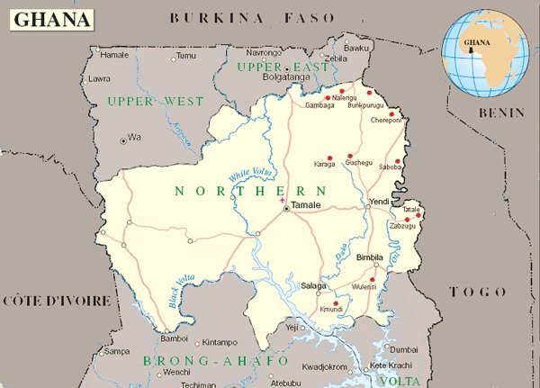

1. Initial Locations

SENDFiNGO has already built relationships with credit unions in eleven locations and is funding microfinance loans from all but one of them:
- Kete-Krachi: This town is the Krachi West district capital in the Volta region and serves as a major connecting point and nerve centre for over 15 villages. Kete-Krachi exceeded the initial business projections, with most of the surrounding communities along the Volta River utilising the services of the credit union. However, it has now reached the stage where the CU can operate independently of SENDFiNGO and it will not expand the CU’s microfinance program beyond the current activities (estimated to be 630 clients at year end).
- Borae: At the same time, SENDFiNGO will begin funding this Credit Union. It is in a town near to Kete-Krachi, in the new Nchumbrun district, with huge potential. After a period being mentored by Kete-Krachi, it is now registered as an individual credit union. The proposal is currently to link with the mobilisation centre established by Kete-Krachi in Chindri, which makes more sense to be linked with Borae that lies between the two towns. The combined catchment population for Borae and Chindri is approximately 35,000.
- Kpandai: Kpandai is the capital town of the new Kpandai District which was carved out of the East Gonja District. As a commercial centre, Kpandai, with a population estimated to be over 10,000, has over 20 communities quite close to one another and to the credit union office. Combined with other communities that can be reached by motorbike or bicycle, there would be up to 7,000 potential members and clients (being 20% of the combined population).
- Banda: This town is under the new Nchumbrun district, recently carved out of Krachi West District. It was originally close enough to Kpandai for many people in Banda to saving with the Kpandai Credit Union. However, as another major commercial centre comparable to Kpandai, an independent credit union was established by the community after originally constituting a study group in 2004. Adding surrounding towns, the total catchment population is approximately 19,000.
- Bimbilla: The capital of the Nanumba north district, Bimbilla has a total population of estimated now to be close to 30,000. It is estimated that 85% of this population is dependent on agriculture, with the remainder being either salaried workers or businessmen and women. Early predictions that the credit union in Bimbilla had the greatest potential for growth have come through with the expectation that it will have the largest number of SENDFiNGO clients by year end. It potential remains, as it has the largest market in the area and many outlining towns and villages, bringing the total catchment population to approximately 46,000.
- Chamba: This is the fastest growing town in the Nanumba north district, predominantly peopled by farmers. The town has a big market, which attracts traders from all over the country. Whilst trading is not as brisk as in Bimbilla, its large neighbour, it still has great potential with a total catchment population of 32,000.
- Salaga: The capital of the East Gonja District, Salaga is an ancient town with a population of 23,000 inhabitants. Trading in farm produce is the primary occupation of the people with a few actually engaged in farming. The Credit Union has not grown as fast as the other five original locations. However, it has good growth prospects, with neighbouring towns doubling its catchment to 46,000.
- Tamale: The Tamale metropolis has a population of approximately 335,000 inhabitants, with over 200,000 in the centre. Despite being a regional capital, there are many very poor suburbs where some of the living conditions are much worse than those in the known rural communities. The Tamale community cooperative credit union (TCCCU) is the only community based credit union in the city open to the general public. For the above reasons, SENDFiNGO partnered with TCCCU two years ago.
- Nalerigu: Nalerigu is the second biggest town in the East Mamprusi district of the Northern Region. The town has a population of approximately 15,000 inhabitants of which about 80% are farmers. Apart from farming, the people are engaged in a variety of economic activities ranging from food processing to ‘petty’ trading in basic manufactured consumable goods. The credit union has been embraced by the community (with a total catchment of 54,000) and its growth prospects are the best of the three most recently created CUs.
- Tatale: This is the largest town in and the capital of the new Tatale district of the northern region with a population of about 8,000 people and a total catchment of 36,000. It is a border town with the Republic of Togo. Whilst it is a concern that people who take loans could move across the border into Togo, the location provides the advantage of a vibrant trading environment. Even though food-crop farming is the main business activity, in the past few years trading in household consumable items has picked up.
- Chereponi: This is the capital of the new Chereponi district, previously combined with Saboba. With a population of nearly 9,000 inhabitants, the town is a predominantly farming community with about three-quarters of the people so engaged. Petty trading is a dominant activity in the town for women. The total population including surrounding areas is 27,000.

SENDFiNGO has set up a head office within the Bimbilla credit union premises (rather than Salaga as originally proposed) to oversee the microfinance lending. In 2013, it will add a new location at Chereponi, with some staff there (see section G.3 below) in order to better serve those CUs already in the North and to be established there.

Assumption for business model: Total rent for the Bimbilla head office and the location in Chereponi of GHc 495 per month.

Map 2:
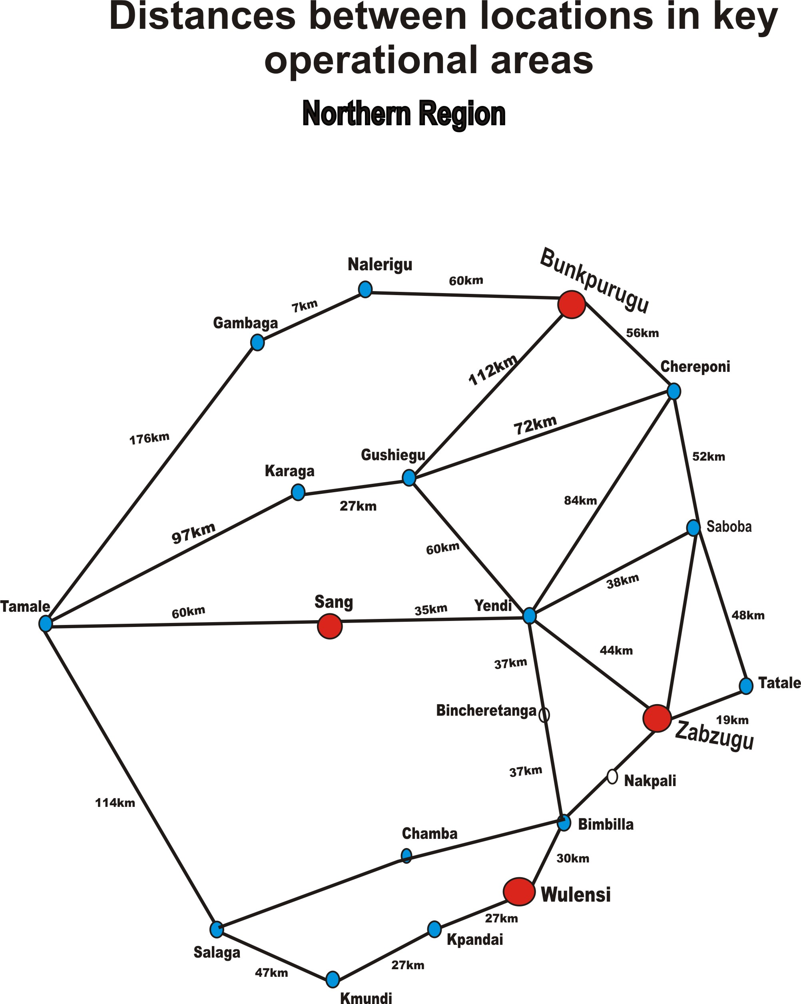

2. Expansion

As mentioned in section IV.C, SENDFiNGO will expand in Year 1 (2013). An ambitious plan has been hatched for four credit unions to be successfully “animated”.

Information on the four potential credit union affiliations is set out below:

- Wulensi: Wulensi is the second biggest town in the Nanumba district of the Northern Region. The town has a population of more than 10,000 inhabitants of which the main livelihood activities revolve around farming (yam, maize, guinea corn and groundnut) and animal rearing. There is a market here every 6th day, attended by some 600 women, and there are about 65-70 enterprises in the main street. NGOs in the area include IDC (Integrated Development Centre) and DIDO (Dinkugari Integrated Development Organization) but there are no financial institutions. CARE Vision targeted the town and as many as 100 people may have lost savings; the effect can be seen in the slowing down of the activities of the mobilisation centre that the Bimbilla CU started in Wulensi. MASLOC visit on occasions but have had limited impact. The town is enthusiastic about having a credit union, with a total catchment of 34,000, and an interim Board has already been established.

- Sang: This was formerly the second largest town in the Yendi district, with a population of about 7,500 people, but is now the capital of a new district. It is on the main road from Yendi to Tamale, being about 35km from the former and 60km from the latter, and is a major stop for buses and other modes of transport. There is a market here every 6th day, attracting traders from Yendi, Tamale and surrounding villages. The main crops are maize, yam and groundnut (in that order). It is the only one of the four towns that was not surveyed in 2008. However, it appears a suitable location, given the total catchment of about 22,000 people and the lack of current financial services. Some small foundation offices were observed there but there are no lending agencies currently operating; some people save with banks in Yendi or Tamale.

- Zabzugu: This is the largest town in, and administrative capital of, the new Zabzugu district, located 19km from Tatale along a relatively good road. With a population of 16,000 inhabitants (and another 13,000 people in surrounding areas), the town is a predominantly farming community with as many as 95% of the people so engaged. The main crops harvested are yam, corn, millet, groundnut, guinea corn, cassava, soy beans and rice. There is a market every 6th day and there are approximately 140 enterprises in this core of the town; many are small food stands, tea stalls and chop bars generally operated by women. A large quantity of NGO’s are currently working in Zabzugu, although ICA has ceased to operate. The only one offering credit is Grameen Ghana; however, some of the challenges in the area, eg the time and resources needed to educate the community, has seen their activity reduce. There is also a rural bank but it only grants loans for paid workers.

- Bunkpurugu: This is the capital of the Bunkpurugu-Yunyoo district. The town has a population of approximately 9,000 inhabitants (and a total catchment estimated at 21,000) and is located roughly halfway between Nalerigu and Chereponi, and close to the Togo border. Since the 2008 research, the town has been connected to the national grid. There is a market here every third day. Most of the people in the Bunkpurugu area practice subsistence farming, the main crops being, in order of importance, maize, groundnut and millet. The communities within the district are served by Bessfa Rural Bank (with headquarters in Garu-Upper East Region, but with a branch in Nakpanduri-East Mamprusi) and the East Mamprusi Community Bank (with headquarters in Gambaga-East Mamprusi). Both banks provide mobile banking services in Bunkpurugu town only on market days, with services including deposits, withdrawals, savings and very limited credit.

The membership drive would be pursued through:
- an educational campaign in all the communities in the vicinity of the credit union location;
- the provision of effective, customer-driven door-to-door services through the use of community based Loan Officers and CU accounts officers; and
- building awareness of what people can gain from the membership of the scheme.

Some of the avenues to be used to support these tactics are:
- churches and mosques for educational sessions;
- seeking the full consent and support of opinion leaders and chiefs for new communities;
- systematising the processing of loan application processes and the incubation of new groups in an orderly manner;
- offering counselling to members before loans are granted;
- organizing the women groups in every community under the umbrella of the RCWAs; and
- use of mobile educational van with audio-visual aids.

G. Branch and Head Office Operations

1. Approach to Plan

SENDFiNGO’s key strategy has been, and remains, to build a client base to the stage where it can generate sufficient income to meet its operational expenses and finance growth through internally generated cash-flow. The membership growth achieved to date and forecast for 2013, would see SENDFiNGO with over 100% operational sustainability by the end of 2013.

The credit unions open for business for a maximum of 8 hours from Monday to Friday each week. In the new communities, where credit unions are being introduced for the first time, the office will be run by a full-time Accounts Officer, Cashier and Loans Officer. There would also be an Organisational Development (OD) Officer. The Accounts Officer, the OD Officer and the credit union Board and committees would be engaged mainly in educating people about the value of credit unions to the individual, the family and the community. A security person will also be engaged in due course.

Where a start-up credit union is established, there would be no microfinance loans until after the first six months in the first year. The first six months of the first year would be used to incubate the solidarity groups. A meeting would be held once a week for each women association during which the principles and practices associated with the scheme would be fully explained to the women. The women would also use the period to enact their by-laws and elect their executives. Delivery of the educational messages by the credit union staff would also start during this period.

2. Credit Union Branches

Under the existing arrangements with the credit unions, SENDFiNGO pays the salaries of the microfinance Loan Officers. The credit unions would be responsible for all the other costs of the Loan Officers, such as equipment (eg laptops), transportation, accommodation and office furniture, although SENDFINGO will make some contributions in this regard.

All loan officers will be recruited by the credit unions, although SENDFiNGO will provide some assistance with initial training. It is assumed that the existing credit unions will have one Loan Officer who can commence immediately at full capacity. The maximum case-load will be 400 clients per loan officer for both Solidarity Group loans and Farmers Loans. For new Loan Officers, the case-load will build up gradually, with full capacity reached progressively over the first year as follows: 50% for the first four months; 75% for the next four months; and 100% from month nine onwards. Loan Officer turnover may occur but it is assumed that employees leaving are replaced with people with the same degree of capacity.

3. Head Office

The management structure for SENDFiNGO comprises five current staff with the following specific functions:

- The General Manager, Mr. Haruna Habib;
- The Organisational Development Officer (ODO), Reverend Moses Bakar;
- The Microfinance Officer (MFO), Mr Iddrisu Fusheini;
- Administrative Officer, Ms. Catherine Awini; and
- The Driver, Mr. Mumin Adongo.

The three key officers estimate that their time was spent in 2011 as shown below, together with an estimate of their time allocations for 2012.

Table 9: Time Allocation of Senior Executive Time

Activity (%) | 2011 Actual |  |  |  | 2012 Forecast
Activity (%) | Mr. Habib | Rev. Bakar | Mr. Fusheini | Average % | Mr. Habib | Rev. Bakar | Mr. Fusheini | Average %
Portfolio Management | 20 | 11 | 48 | 26 | 19 | 5 | 56 | 27
Internal Audit and Financial Management | 17 | 0 | 21 | 13 | 10 | 8 | 13 | 10
Product Development (new CU Development) | 15 | 60 | 8 | 28 | 13 | 56 | 5 | 25
Human Resources Support | 15 | 9 | 5 | 10 | 10 | 11 | 8 | 10
Training | 17 | 12 | 18 | 16 | 10 | 12 | 11 | 11
CUA Relationship | 4 | 8 | 0 | 4 | 8 | 8 | 0 | 5
Fundraising | 12 | 0 | 0 | 4 | 30 | 0 | 7 | 12
TOTAL | 100 | 100 | 100 | 100 | 100 | 100 | 100 | 100

As explained in section F.1, in order to better serve the expanding CU network, a small office will be set up in Chereponi, under the ODO, and four new staff will be taken on:

- An assistant MFO;
- A second driver;
- An Internal Auditor; and
- An Office Assistant.

The first two will be based in Chereponi with the ODO, and the last two at the Head office in Bimbilla. In order to fund the expansion through the four new branches (see section F.2 above), 80% of the ODO costs will be allocated to a proposed development budget and the driver’s costs will be split between SENDFiNGO and the development budget (see section IV.C).

Assumptions for Financial Model:
1. Maximum client load for loan officers by product: 400 for Solidarity Loans and for Farmers Loans.
2. Equipment prerequisites for credit union-based employees: For account of credit unions.
3. Fixed assets and expenses at branches: For account of credit unions.
4. Equipment and fixed assets for Head Office employees: The major items are one existing motor vehicle, with a second vehicle taken in year 1 (2013), one existing motor bike, laptops for the senior executives and other normal items.

The four potential new credit unions would require the most support, in order to approach operational self sufficiency as soon as possible.

H. Human Resources Development

1. Staffing Projections

SENDFiNGO has five current employees and four more will be added in Year 1 (2013). The numbers of new Loan Officers will be determined by the growth in the client numbers and the client load for loan officers by product (see above) and their salaries in the SENDFiNGO expenses.

Anticipated staffing levels in 2012 (the year end estimate) and the five years to 2017 are set out below.

Table 10: Staff paid by SENDFiNGO

 | 2012 | Year 1 (2013) | Year 2  (2014) | Year 3  (2015) | Year 4  (2016) | Year 5 (2017)
Head Office Staff | 5 | 9 | 9 | 9 | 9 | 9
Branch Staff:
Loan Officers | 18 | 24 | 24 | 34 | 34 | 44
TOTAL STAFF | 23 | 33 | 33 | 43 | 43 | 53

Over the five years of the Plan, total employee numbers will grow to around 53 staff.

2. Management Strategy and Team Training

The management strategy of SENDFiNGO is focused on combining community participation with strict professionalism of its staff, consistent with the past experience from SEND-Ghana’s activities, where community ownership is the key driver. SENDFiNGO will continue to explore other innovative ways of implementing microfinance in the rural areas of Northern Ghana.

SENDFiNGO strives towards consensus building with the local BODs of the credit unions on administrative issues without compromising standards that ensure success. As mentioned above, the relationship between the credit unions and SENDFiNGO will continue to be based on the current arrangement, under which the Loan Officers would be working wholly for the credit unions, administering both the CU loans and the microfinance loans, but would be paid and professionally supervised and trained by SENDFiNGO.

SENDFiNGO pays for Loan Officers based on a formula of one LO for every 400 Farmers Loans and Solidarity Loans. In return, SENDFiNGO keeps the interest on the microfinance loans. In the annual monitoring of SENDFiNGO, the CU BoDs expressed general satisfaction that the above cost sharing is appropriate, as they agree they need the assistance that SENDFiNGO provides. However, in response to the concerns of the Managers and Accounts Officers of the CUs, SENDFiNGO currently proposes to absorb 20% of their monthly salary cost. This equals GHc240 and GHc170 per month for the Manager and Accounts Officers, respectively, starting from 2013, with annual increment of 10% on both figures. By December 2012, it is estimated that there will be one CU manager and one Accounts Officers per branch, ie 11 increasing to 15 if the proposed CU expansion takes place. The arrangement will be reviewed over the period of the Business Plan and the cost to SENDFiNGO has not been included in the financials for this document.

As shown in Table 9 above, approximately one-quarter of the time of the three SENDFiNGO senior managers is spent on HR and Loan Officer training. Training focuses on two particular areas:
- Skills: Included in this aspect are matters such as understanding lending, risk management, financial literacy, including the use of computers; and
- Competency: Management, communications and inter-personal aspects will be improved, in a program tailored to each person’s seniority.

In addition to the above areas, these initial sessions will also focus on the mission, vision and values of both SENDFiNGO and the credit unions.

Originally, new LOs were trained in a workshop initially before going to the field. However, with the number of experienced LOs at each CU and the difficulty of arranging the trainings before every LO commences, it was decided that the LOs could go straight to the CU where they receive on the job training from experienced officers. Now, SENDFiNGO holds sessions in Bimbilla every four months or so, where all new LOs are brought for training together with experienced LOs.

Ongoing training is also provided. A key area for this is in regard to the MIS and ICT more generally.

In terms of efficiency, the average number of loans per LO was 361 in December 2011, a significant improvement from 260 a year earlier and now well ahead of the original Business Plan, with its assumption of 258 clients per LO.

3. Salaries and Incentives

The salaries will be based on comparable rates in the marketplace. Ghana’s available human resources are considered high quality. Regular assessments of market salary levels will be undertaken to ensure the credit unions are competitive.

Loan Officers commence on a base salary of GHc158 per month, which increases after the first six month (probationary) period to GHc189 and another 36% on becoming a senior Loan Officer (with full client capacity) at the end of 12 months.

SENDFiNGO has also put in place an incentive scheme for Loan Officers. They receive 50% of the standard loan loss provision rate of 2.5% if the loan is completely recovered within the repayment period.

Assumptions for Financial Model:
1. Salaries for all employees: Based on comparable employee
2. Incentives for Loan Officers: See above
3. No other allowances or fees for the account of SENDFiNGO
4. Annual increases (after first 12 months): Inflation (10%) plus 5%.

The nature of microfinance means that loan officers are vital to the success of the company. SENDFiNGO does not have its own Human Resource policies and procedures, for its small staff but this will be discussed at the next Board meeting. However, for the last two years it has worked with the credit unions to recruit and retain the best employees and to develop their HR policies.

Loan officers for the credit unions will be required to have at least a high school education. Small business experience or a 2 to 3 year general work history is preferred. Specialization in areas such as agriculture, rural activities or general sales will be sought.

I. Information Technology

The CUs employ an accounting system called Easybook as their main accounting system. For the SENDFiNGO loan portfolio both the CUs and SENDFiNGO use an MIS called Datalink. The accounting system is adequate and was rolled out into each CU in 2011.

The MIS was also installed in 2011 but some branches still use hand written reporting rather than the MIS. SENDFiNGO is continuing to provide training to improve the situation, particularly among the longer established CUs, such as Kpandai and Kete-Krachi.

V. ORGANIZATIONAL STRUCTURE

A. Key Personnel

The senior management structure of SENDFiNGO is explained in Section IV, G. A diagram in contained in Appendix G.

The management of SENDFiNGO is headed by the General Manager (GM). He is responsible for the over-all institutional management and general administration of the company, subject to the policies set by the Board of Directors. The duties of the GM, working with the Organisational Development Officer, include among others the following:
- Over-all management of SENDFiNGO;
- Planning and monitoring of operations, including credit union supervision;
- Developing new products;
- Consulting with the credit unions, particularly on the selection and supervision of Loan Officers;
- Managing the microfinance loan portfolio;
- Training of Loan Officers;
- Hiring and training, if needed, of the other Head Office staff;
- Preparation of the annual budgets for SENDFiNGO;
- Providing other input to the credit unions;
- Expansion of the credit union relationships;
- Fund sourcing and negotiating with banks, investors and other parties;
- Reporting to the Board;
- Liaising with the CUA; and
- Representing SENDFiNGO in other contracts, negotiations and meetings.

The GM will also be critically needed in the implementation of this Business Plan. As mentioned, he will be assisted on much of the above work by the Organisational Director. The MFO and the Administrative Officer will also have key roles to play.

Technical support will also be made available as necessary by SEND. Such support would cover among others:
- Financial management training;
- Accounting preparation and audit; and
- Development of policies and procedures.

B. Performance Monitoring Plan

SENDFiNGO regularly monitors progress reports from the credit unions that are responsible for submitting correct and timely information to SENDFiNGO. Each credit union is monitored regularly through site visits. In the case of a credit union that is not performing as planned, the monitoring frequency will be higher; whilst in the case of a healthy credit union, the monitoring frequency may be less.

The SENDFiNGO monitoring includes the following:
- Review the performance of directors and credit union committees;
- Review the performance of loan officers and also the other credit union management and staff;
- Ensure that operational targets, eg members, interest income, expenses etc, are met;
- Draw attention to lapses/weaknesses which need remedies;
- Provide skills training on simple matters that need prompt redress;
- Monitor the attainment of milestones and targets within plans;
- Ensure that management and the BOD implement the strategies within plans;
- Assess the overall performance of the credit union;
- Make sure that the monitoring and evaluation framework are consistently used by both management and the Board of the credit union; and
- Follow up on previous findings to ensure that any problems have been remedied.

SENDFiNGO has also conducted social performance monitoring through client impact assessments (see section II.A).

Since the original Business Plan was prepared in 2009, SENDFiNGO has undergone a detailed annual Monitoring and Evaluation (M&E) exercise conducted by an external expert from the independent consulting firm AYANI that also prepared the original plan and this Business Plan.

The budget for the five years of this Plan does not include such an external review but it includes expenses for internal monitoring, commencing at GHc8,400 per annum. In addition, from 2013 SENDFiNGO will improve its M&E function through the recruitment of an Internal Auditor.

C. Governance

SENDFiNGO has its own Board of Directors, comprising three parties representing the indicated stakeholders and two independent experts:

- SEND: Mr Siapha Kamara, Chairman;
- CUA: Mr Emmanuel Oduro Darko;
- a joint CU representative: Ms Margaret Afua Kudzo;
- an independent microfinance expert: Mr Francis Beinpuo; and
- an independent lawyer: Ms Justina Anglaaere from SEND is filling this role until a suitable person can be found.

The General Manager, Mr Habib Haruna, also sits on the Board.

The Board works in conjunction with the GM to:
- Provide strategic and fiduciary governance;
- Hold management accountable for meeting operating objectives and fiduciary responsibilities;
- Establish adequate systems of internal control, audit and risk management;
- Make most senior appointments;
- Establish business plans;
- Take decisions regarding material contracts or transactions which significantly impact on SENDFiNGO’s financial results;
- Support the organization in developing and nurturing relationships, both local, eg CUA, and international, eg donors, for operating, regulatory, and capital-raising success; and
- Ensure that management of the institution respects the clear lines of authority.

More generally, the Board is responsible for ensuring that SENDFiNGO’s business is conducted under sound principles and remains in compliance with regulatory requirements and its own internal policies.

Members serve a maximum of two terms, of 3 to 4 years each, and the the BoD meets twice a year, with the ability to meet more often if needed. In addition, Board members have asked to receive updates every quarter. At this stage, it has not proven necessary for any Board committees to be constituted.

VI. FINANCIALS AND INVESTMENT REQUIRED

A. Financial Targets

The financial model prepared by Clay O’Brien at AYANI and confirmed by SENDFiNGO management produces the following summary outcomes, shown in the first table for the year end and in the second table as at 30 June for each year.

Table 11: Forecast Performance

Year to 31 December  Indicator (GHc) | 2013 | 2014 | 2015 | 2016 | 2017
No. of Active Loans* | 7,450 | 9,318 | 10,957 | 12,888 | 15,846
Net Loan Portfolio | 823,160 | 1,355,936 | 1,512,085 | 2,221,078 | 2,875,534
Net Income pre-Grants | -64,467 | 130,177 | 270,193 | 439,269 | 610,705
Total Assets | 1,031,162 | 1,419,219 | 1,864,909 | 2,353,213 | 2,976,265
Total Equity | 1,026,888 | 1,414,945 | 1,860,635 | 2,348,939 | 2,971,991
OSS (%) | 84.1% | 132.7% | 158.3% | 183.5% | 196.0%

30 June  Indicator (GHc) | 2013 | 2014 | 2015 | 2016 | 2017
No. of Active Loans* | 6,367 | 8,019 | 11,163 | 11,643 | 13,740
Net Loan Portfolio | 489,122 | 1,046,792 | 1,541,698 | 1,823,724 | 2,594,632
Total Assets | 770,018 | 1,152,751 | 1,604,086 | 2,058,641 | 2,638,724
Total Equity | 765,744 | 1,148,477 | 1,599,812 | 2,054,367 | 2,634,450
OSS (%) | 93% | 134% | 165% | 182% | 185%

*: Less than client numbers due to resting (see section IV.C.2)

More detailed figures are shown in Appendices A to D.

In order to achieve the above targets, SENDFiNGO will accomplish the following:

- Increase breadth of client outreach: SENDFiNGO will increase its outreach, through the associated credit unions, to more than 15,000 active borrowing clients by December 2017. To do so, it will operate through up to 15 credit unions, four of which it will be instrumental in creating in 2013, to penetrate rural areas.
- Provide financial services to the rural poor: SENDFiNGO’s approach is to provide access to financial services in the deprived communities within the areas of operation, mainly being rural and peri-urban, for businesses and households that engage in viable economic activities.
- Strengthen credit union institutional capacity: SENDFiNGO will work to strengthen institutional capacity at the associated credit unions by funding and training staff, developing management skills, providing internal audit and financial management and helping develop products. In areas where SENDFiNGO cannot help, it will link credit union staff with training and development programs provided by CUA and other third parties.
- Develop standalone management and staff: SENDFiNGO will also strengthen its own regional management as part of setting up an independent institution. Total staff, both internal and at the credit unions, will be 53 by the end of 2017.
- Reach sustainability: The SENDFiNGO operation will be sustainable by Year 2.

More detailed financial forecasts are contained in Appendices A, B, C and D.

B. Investment Required

There is now a minimum capital requirement imposed by the Ghana Government on SENDFiNGO as a Non-deposit taking Financial Non-Governmental Organization in Ghana. The amount is just GHc60,000 of paid up capital. However, there are no other current requirements governing an institution such as SENDFiNGO with respect to liquidity and capital adequacy reserves, as compared to the controls that exist for banks.

It has been decided that all funding for SENDFiNGO would be in the form of unrestricted grants. This and other relevant assumptions are set out below.

Assumptions for Financial Model:
1. Sources of funding: All contributed as unrestricted grants.
2. Interest rates on loans: Not applicable.
3. Liquidity requirements: Nil.
4. Interest rates on cash or investments held: 10%.
5. Taxation: Nil.

Subject to the approval of SENDFiNGO, in conjunction with SENDFiNGO Board support, the funding in 2013 to 2017 is assumed to be sourced as follows:

Table 12: Funding Sources

 | 2013 | 2014 | 2015 | 2016 | 2017
Equity | - | - | -
Unrestricted Grants: GHc | 466,618 | 257,881 | 175,496 | 49,035 | 12,348
Loans | - | - | - | - | -

The total additional funding required for microfinance expansion aside of the amount required for the development of credit unions, over the five years of the modelling is GHc961,000, with no excess cash held on the SENDFiNGO balance sheet.

Table 13 shows the breakdown of the funding into major categories.
Table 13: Funding Uses

GHc | 2013 | 2014 | 2015 | 2016 | 2017 | TOTAL
Investments (Capacity) | -91,612 | -13,025 | -14,700 | -16,570 | -3,760 | -148,257
Loan Funds | -279,711 | -546,943 | -171,881 | -725,915 | -676,612 | -2,401,062
Operating (Subsidy) / Surplus | -95,295 | 302,087 | 11,085 | 693,450 | 668,024 | 1,579,351
TOTAL | 466,618 | 257,881 | 175,496 | 49,035 | 12,348 | -961,378

Development Budget

AYANI has also been asked to consider the costs of establishing and operationalising the four new credit unions and institutional strengthening and consolidation of the new credit unions established in 2010, mentioned in section II.F.2. A table showing these costs, with an allocation of the major areas of expenditure, is included in Appendix E. As indicated in section II.G.3, the costs of funding the expansion through the four new branches will include 80% of the ODO costs and 50% of the second driver’s costs. The total amount of GHc 621,815 (appendix E) increases the total funding requirement to GHc 1,582,000, as shown in the second part of Appendix F.

Appendices

A. Business Plan Balance Sheet
B. Business Plan Income Statement
C: Business Plan Cash Flow Statements
D. Business Plan Ratio Analysis
E. Development and Total Budget
F. Total Financing Table
G. Organisational and Senior Management Structure

Appendix A: Business Plan Balance Sheet

ASSETS * | 2012 | 2013 |  | 2014 | 2015 | 2016 | 2017
Cash in Bank and Near Cash | 15,090 |  | 0 | 0 | 0 | 0 | 0
Net Portfolio Outstanding | 576,366 |  | 823,160 | 1,355,936 | 1,512,085 | 2,221,078 | 2,875,534
Short-term Inv. & other curr ass | 17,000 |  | 122,377 | 0 | 306,030 | 99,961 | 95,987
Net Fixed Assets | 20,554 |  | 85,624 | 63,284 | 46,794 | 32,173 | 4,743
Long-term Invest. & other LT assets | 0 |  | 0 | 0 | 0 | 0 | 0
TOTAL ASSETS | 629,010 |  | 1,031,162 | 1,419,219 | 1,864,909 | 2,353,213 | 2,976,265
LIABILITIES *
Savings deposits | 0 |  | 0 | 0 | 0 | 0 | 0
Concessional Loans | 0 |  | 0 | 0 | 0 | 0 | 0
Commercial Loans | 0 |  | 0 | 0 | 0 | 0 | 0
Other liabilities | 4,274 |  | 4,274 | 4,274 | 4,274 | 4,274 | 4,274
TOTAL LIABILITIES | 4,274 |  | 4,274 | 4,274 | 4,274 | 4,274 | 4,274
EQUITY *
Accum. Donated equity, prev. periods | 719,273 |  | 719,273 | 1,185,891 | 1,443,772 | 1,619,268 | 1,668,303
Donated equity, current period | 0 |  | 466,618 | 257,881 | 175,496 | 49,035 | 12,348
Accumulated net surplus | -94,537 |  | -159,004 | -28,827 | 241,367 | 680,635 | 1,291,340
Equity Reserves | 0 |  | 0 | 0 | 0 | 0 | 0
TOTAL EQUITY | 624,736 |  | 1,026,888 | 1,414,945 | 1,860,635 | 2,348,939 | 2,971,991
TOTAL LIABILITIES AND EQUITY | 629,010 |  | 1,031,162 | 1,419,219 | 1,864,909 | 2,353,213 | 2,976,265

ASSETS *
Current Assets | 30 June 2013 | 30 June 2014 | 3 June 2015 | 30 June 2016 | 30 June 2017
Cash in Bank and Near Cash | 0 | 0 | 0 | 0 | 0
Net Portfolio Outstanding | 489,122 | 1,046,792 | 1,541,698 | 1,823,724 | 2,594,632
Short-term Investments | 181,651 | 29,108 | 0 | 191,149 | 23,753
Net Fixed Assets | 99,246 | 76,851 | 62,389 | 43,768 | 20,338
TOTAL ASSETS | 770,018 | 1,152,751 | 1,604,086 | 2,058,641 | 2,638,724
TOTAL LIABILITIES | 4,274 | 4,274 | 4,274 | 4,274 | 4,274
EQUITY *
Accum. Donated equity, prev. periods | 719,273 | 1,185,891 | 1,443,772 | 1,619,268 | 1,668,303
Donated equity, current period | 217,196 | 80,551 | 71,342 | 0 | 12,348
Accum. Net Surplus (Deficit), prev. periods | -94,537 | -159,004 | -28,827 | 241,367 | 680,635
Net Surplus (Deficit), current period | -76,188 | 41,039 | 113,524 | 193,732 | 273,163
TOTAL EQUITY | 765,744 | 1,148,477 | 1,599,812 | 2,054,367 | 2,634,450

Appendix B: Business Plan Income Statement

2013 | 2014 | 2015 2016 | 2017

Financial Income | 306,848 | 528,073 | 733,952 | 965,466 | 1,246,667
Financial Expense | 0 | 0 | 0 | 0 | 0
Net Financial Income | 306,848 | 528,073 | 733,952 | 965,466 | 1,246,667
Provision for loan losses | 32,917 | 14,167 | 15,732 | 16,921 | 22,156
Net Financial Margin | 273,931 | 513,905 | 718,220 | 948,545 | 1,224,512
Program Operating Exp | 61,545 | 83,242 | 118,250 | 155,993 | 202,440
Administrative Operating Exp | 270,353 | 300,487 | 329,777 | 353,283 | 411,367
Net Operating Income | -57,967 | 130,177 | 270,193 | 439,269 | 610,705
Net Non-Operating Income/(Exp) | -6,500 | 0 | 0 | 0 | 0
Net Income (before taxes and donations) | -64,467 | 130,177 | 270,193 | 439,269 | 610,705
Amount of taxes paid | 0 | 0 | 0 | 0 | 0
Net income (after taxes and before donations) | -64,467 | 130,177 | 270,193 | 439,269 | 610,705
Grant Income | 466,618 | 257,881 | 175,496 | 49,035 | 12,348
Net Income (after taxes and donations) | 402,152 | 388,058 | 445,689 | 488,304 | 623,052
Adjustments to Operating Margin | 67,970 | 107,201 | 148,171 | 194,710 | 251,222

 | 30 June 2013 | 30 June 2014 | 3 June 2015 | 30 June 2016 | 30 June 2017
Financial Income | 115,883 | 240,758 | 340,097 | 452,725 | 585,647
Financial Expense | 0 | 0 | 0 | 0 | 0
Net Financial Income | 115,883 | 240,758 | 340,097 | 452,725 | 585,647
Provision for loan losses | 22,382 | 3,828 | 4,801 | 5,267 | 9,576
Net Financial Margin | 93,502 | 236,930 | 335,296 | 447,458 | 576,070
Branch Expenses | 28,069 | 40,682 | 56,883 | 77,084 | 97,224
Head Office Expenses | 135,121 | 155,209 | 164,888 | 176,641 | 205,683
Net Operating Income | -69,688 | 41,039 | 113,524 | 193,732 | 273,163
Net Non-Operating Income/(Exp) | -6,500 | 0 | 0 | 0 | 0
Net Income (before taxes and donations) | -76,188 | 41,039 | 113,524 | 193,732 | 273,163
Amount of taxes paid | 0 | 0 | 0 | 0 | 0
Net income (after taxes and before donations) | -76,188 | 41,039 | 113,524 | 193,732 | 273,163
Unrestricted Donations | 217,196 | 80,551 | 71,342 | 0 | 12,348
Net Income (after taxes and donations) | 141,008 | 121,590 | 184,867 | 193,732 | 285,511

Appendix C: Business Plan Cash Flow Statements

Cash Flows from Operating Activities
Net Operating Income | -27,023 | -16,823 | -12,312 | -8,045 | -3,461
+ Depreciation and amortization | 2,918 | 2,918 | 2,918 | 2,918 | 2,918
+ Loan loss provisions | 11,918 | 2,432 | 1,883 | 2,017 | 2,398
- Cash Paid for Taxes | 0 | 0 | 0 | 0 | 0
- Net change in acrrued interest | 0 | 0 | 0 | 0 | 0
+ Loan repayments received | 211,483 | 183,874 | 203,709 | 223,571 | 241,423
- Loan disbursements | -22,600 | -271,730 | -272,080 | -306,930 | -304,880
+ Minus Increase in Line-of-Credit Portfolio | 0 | 0 | 0 | 0 | 0
Increase/(Decrease) in credit insurance reserves | 0 | 0 | 0 | 0 | 0
(Increase)/Decrease in short-term invest. | -165,383 | 81,356 | 68,371 | 32,657 | 0
Increase/(Decrease) in savings deposits | 0 | 0 | 0 | 0 | 0
(Increase)/Decrease in other current assets | 0 | 0 | 0 | 0 | 0
Increase/(Decrease) in accrued/(pre-paid) expenses | 0 | 0 | 0 | 0 | 0
Increase/(Decrease) in other current liabilities | 0 | 0 | 0 | 0 | 0
Increase/(Decrease) in other long-term liab. | 0 | 0 | 0 | 0 | 0
Net Cash from Operating Activities | 11,314 | -17,972 | -7,511 | -53,813 | -61,602
Cash Flows from Investing Activities
(Increase)/Decrease in long-term invest. | 0 | 0 | 0 | 0 | 0
(Increase)/Decrease in other assets | -96,202 | 0 | 0 | 0 | 0
Net Cash from Investing Activities | -96,202 | 0 | 0 | 0 | 0
Cash Flows from Financing Activities
Increase/(Decrease) in borrowed funds | 0 | 0 | 0 | 0 | 0
Increase/(Decrease) in Stock | 0 | 0 | 0 | 0 | 0
(Dividend payments) | 0 | 0 | 0 | 0 | 0
Donated Equity | 76,299 | 17,972 | 7,511 | 53,813 | 61,602
Net Cash from Financing Activities | 76,299 | 17,972 | 7,511 | 53,813 | 61,602
Net Cash (received)/paid for non-oper. activities | -6,500 | 0 | 0 | 0 | 0
Net change in cash and due from banks | -15,090 | 0 | -0 | 0 | -0
Cash and Due from Banks, Beginning of the Period | 15,090 | 0 | 0 | 0 | 0
Appendix D: Business Plan Ratio Analysis

 | 2013 | 2014 | 2015 | 2016 | 2017
  Portfolio Quality
Reserve Ratio | 3.8% | 3.4% | 4.0% | 3.5% | 3.4%
Annualized Loan Write-off Ratio | 0.0% | 0.0% | 0.0% | 0.0% | 0.0%
Profitability
Adj. Pre-tax Return on Performing Assets * | -17.6% | 2.1% | 8.0% | 12.1% | 13.8%
Solvency
Equity Multiplier * | 1.00 | 1.00 | 1.00 | 1.00 | 1.00
Efficiency and Productivity
Operating Cost Ratio * | 49.5% | 35.2% | 29.8% | 25.7% | 23.7%
Borrowers per Loan Officer * | 310 | 388 | 322 | 379 | 360
Overhead percentage * | 81.5% | 78.3% | 73.6% | 69.4% | 67.0%
Loan Officers as % of total staff" * | 72.7% | 72.7% | 79.1% | 79.1% | 83.0%
Growth and Outreach
Total Loan Portfolio * | 856,139 | 1,403,082 | 1,574,963 | 2,300,877 | 2,977,489
Overall growth in portfolio | 49% | 64% | 12% | 46% | 29%
Number of active loans * | 7,450 | 9,318 | 10,957 | 12,888 | 15,846
Overall growth in loans | -1% | 25% | 18% | 18% | 23%

Portfolio Quality | 30 June 2013 | 30 June 2014 | 3 June 2015 | 30 June 2016 | 30 June 2017
Reserve Ratio | 4.4% | 3.4% | 3.3% | 3.6% | 3.3%
Annualized Loan Write-off Ratio | 0.0% | 0.0% | 0.0% | 0.0% | 0.0%
Profitability
Adj. Pre-tax Return on Performing Assets * | -13.1% | 2.3% | 10.1% | 11.5% | 12.2%
Solvency
Equity Multiplier * | 1.01 | 1.00 | 1.00 | 1.00 | 1.00
Efficiency and Productivity
Operating Cost Ratio * | 56.0% | 36.8% | 28.6% | 28.2% | 23.3%
Borrowers per Loan Officer * | 265 | 334 | 349 | 342 | 362
Overhead percentage * | 80.4% | 77.3% | 73.7% | 69.2% | 67.7%
Loan Officers as % of total staff" * | 73% | 73% | 78% | 79.1% | 80.9%
Growth and Outreach
Total Loan Portfolio * | 511,565 | 1,083,599 | 1,593,645 | 1,891,869 | 2,684,008
Overall growth in portfolio | -25.9% | 13.1% | 3.3% | 9.3% | 5.9%
Number of active loans * | 6,367 | 8,019 | 11,163 | 11,643 | 13,740
Overall growth in loans | -18.1% | 2.2% | 14.0% | 1.6% | 2.8%

Appendix E: Development and Total Budget

Budgetary Activities | 2013 | 2014 | 2015 | 2016 | 2017 | Total
Budgetary Activities | GHC | GHC | GHC | GHC | GHC | GHC
Institutional Strengthening of Existing 3 new Credit Unions:  Consolidating and Strengthening of the Current Existing three Newly Established Credit unions into financially viable co-operatives. | 87,373 | 73,736 | 46,514 | - | - | 207,623
Infrastructure & logistics Support for Old Credit Unions:  Contribution towards Construction of Tamale Comm. Co-op. Credit Union Office Building | 30,000 | - | - | - | - | 30,000
Expanding Access to Financial Services:  Establishment & Development of 4 New Community based Credit Unions in 4 Rural-urban Communities. | 156,952 | 131,244 | 95,997 | - | - | 384,192
Totals | 274,325 | 204,980 | 142,510 | - | - | 621,815
Euro € | 115,248 | 86,115 | 59,871 | - | - | 261,234
USD $ | 148,372 | 110,866 | 77,078 | - | - | 336,316
Exchange rate used 14th May 2012
GH₵2.3803=EUR €1.00
GH₵1.8489=USD $1.00

F. Total Financing Table

TOTAL FINANCING REQUIREMENT FOR SENDFINGO (2013 TO 2017)
FINANCING REQUIRED: | Year1 | Year2 | Year3 | Year4 | Year5
SENDFiNGO | 2013 | 2014 | 2015 | 2016 | 2017 | Total
Investment ( Capacity) | -91,612 | -13,025 | -14,700 | -16,570 | -3,760 | (139,667.00)
Loan Fund | -279,711 | -546,943 | -171,881 | -725,915 | -676,612 | (2,401,062.00)
Operating Subsidy/Inflow | -95,295 | 302,087 | 11,085 | 693,450 | 668,024 | 1,579,351.00
Previous Funds | -523,000 | 0 | 0 | 0 | 0 | -523,000
Sub-total Including Previously approved Funds | (989,618.00) | (257,881.00) | (175,496.00) | (49,035.00) | (12,348.00) | (1,484,378.00)
LESS Previously Approved & Accumulated Funds | 523,000.00 | - | - | - | - | 523,000.00
Funding Requirement for SENDFiNGO in GH₵ | 466,618.00 | 257,881.00 | 175,496.00 | 49,035.00 | 12,348.00 | 961,378.00
FINANCING REQUIRED FOR DEVELOPMENT OF CREDIT UNIONS: | 2013 | 2014 | 2015 | 2016 | 2017
BUDGETARY ACTIVITIES : | Year1 | Year2 | Year3 | Year4 | Year5 | Total
Institutional Strengthening of Existing 3 new Credit Unions | 87,372 | 73,736 | 46,514 | - | - | 207,622
Infrastructure & logistics Support for Old Credit Unions: | 30,000 | - | - | - | - | 30,000
Expanding Access to Financial Services: | 156,952 | 131,244 | 95,997 | - | - | 384,193
Total for Development of Credit Unions (GH₵) | 274,324.00 | 204,980.00 | 142,511.00 | - | - | 621,815
GRAND TOTAL (GH₵) | 740,942.00 | 462,861.00 | 318,007.00 | 49,035.00 | 12,348.00 | 1,583,193
GRAND TOTAL EURO € | €311,280.93 | €194,454.90 | €133,599.55 | €20,600.34 | €5,187.58 | €665,123
Exchange rate used 14th May 2012
GH₵2.3803=EUR €1.00

Appendix G: Organisational and Senior Management Structure

SENDFiNGO BOARD
OF
DIRECTORS
General Manager
Branch Managers
(Credit Unions)
Manager:
Organizational Development & Programmes
Manager:
Technical service

Loan Coordinators
Credit Union Accounts Officers
Accounts/Adm Office:
Accounts/HRM
Manager:
Microfinance Fund
Cashiers
ORGANOGRAM OF SENDFiNGO
Council of Credit Unions Boards ofsDirectors
Local Credit unions Board of Directors
Women solidarity group loan officers
Agric-credit loan officers
Women solidarity loan fund
Internal Audit & monitoring team
Office Assistant/HRM
Drivers
Accounts Officer HRM
Mentoring & Coaching of Credit Union Boards, staff & Committees
Programme Promotion & marketing Team
Research & Development team
Social performance management
Establishment & development of new credit unions
Agri-business loan fund

Training & Development of Microfinance Team
Technical Dev’t of CU staff
Ass. MFO

In this case SEND-Ghana is the promoter and facilitator of the process with special technical assistance from CUA through an MOU.
CIA, The World Fact Book at https://www.cia.gov/library/publications/the-world-factbook/geos/gh.html
www.mixmarket.org as at 16 June 2009
http://www.microfinanceregulationcenter.org/resource_centers/reg_sup/micro_reg/country/17/
CUA is rolling out its own MIS, called CUsoft, but it has not been adopted by any of the SENDFiNGO associated CUs, because of the cost and operating issues.

