Annual Report

2013-2014

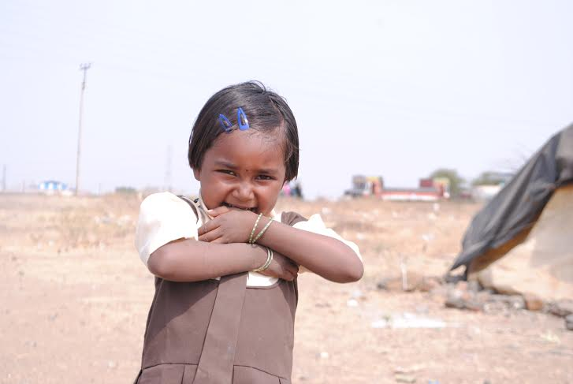

AJIT FOUNDATION
Office: Wani Plot, Agalgaon Road, A/P/T-Barshi-413 401 Dist-Sholapur
Tel: 02184-220103 Fax: 02184-220203 Mobile: 09822897382
E-mail: srujanonline@gmail.com Website: www.ajitfoundation.com

PRESIDENT’S DESK…

We have not wings we cannot soar; but, we have feet to scale and climb, by slow degrees, by more and more, the summits of our time”. H. W. Longfellow  I believed strongly in Longfellow’s poem about man’s ability to survive...Today, I believe in it more because of our organization with the AF which is now a full six years old.  During the year 2013 AF in its own modest way has surged ahead in its endeavour to act as an agent of social change in areas of critical concern like underprivileged children Education, public health, women's empowerment, non-formal education, community development, etc. with focus on the urban as well as the rural poor.  The organization itself becomes a prime example of sustainable development! Beginning with a very limited way (forming SHG’s and organizing women) in 3 villages of Barshi Block the developmental interventions of the organization has now expanded into well over 100 villages of 4 Blocks in two districts (Solapur & Osmanabad).  As the organization passed through each phase, the challenges, issues it involved in became manifold which called for different sets of strategies, interventions and program. During the year under review the developmental | interventions/ programs which the organization implemented/involved in included: formation and strengthening of SHG’s, Income generation trainings, Goat rearing program for SHG women, promotion of women’s leadership, propagation of Panchayatiraj, Educational development programs like balwadis, support classes, strengthening of village education committees, advocacy and lobbying- highlighting the plight of government hostels for adivasi, tribal and backward students, Sevalaya Centre for orphan and one parent children, and the initiatives on “liberating women from violence”. Starting with a report on this new outreach program of the organization (Liberating women from violence), this annual report provides a glimpse on the activities/ program/ interventions by the organization during the year and some of its outputs /impacts.  We are venturing more and more into the world of online fundraising and we are very grateful to ICICI Bank. Global Giving for introducing us to a new world of opportunities.  We look forward to visits of our friends, well-wishers, donors and volunteers to Ajit Foundation. See how we have grown and help us to grow further.  Yours sincerely,  Mahesh Nimbalkar  President  Date : 31st March, 2014

SUMMARY OF ACTIVITIES

Migrant & Street children Education Program:  - Akshar Initiative -Non formal education Center:  This research project was conducted in the 8 centers located on Barshi– Latur road in block Barshi , district Soalur and Nijam-Jawala in block- Paranda Dist-Osmanabad. The ten centers are located in the following eight areas in Barshi and Paranda blocks. The research was carried out in order to see the magnitude of educational deprivation of migratory children.  The migrants with whom we work are mainly migrated from the Banjara, Marwadi communities. The main occupation of the community is to make sculptures/ Statues of God/ Goddesses. The entire family is involved in making of these sculptures. After making it the adults in the family wander in the surrounding villages to sell these statues made of Plaster of Paris and other similar materials. When parents are away selling these statues, the older children look after the household chores and their younger siblings. Migration may take considerable time for a migrant family to get assimilated into the new village/urban society into which it moves. The migrant families, especially long-distance migrant families, live in constant fear of insecurity of life. Moreover, it may be hard for a migrant family to claim equal access to common property resources  through formal and non formal learning and also by creating conducive environment in family and communities.  Major Project Activities:  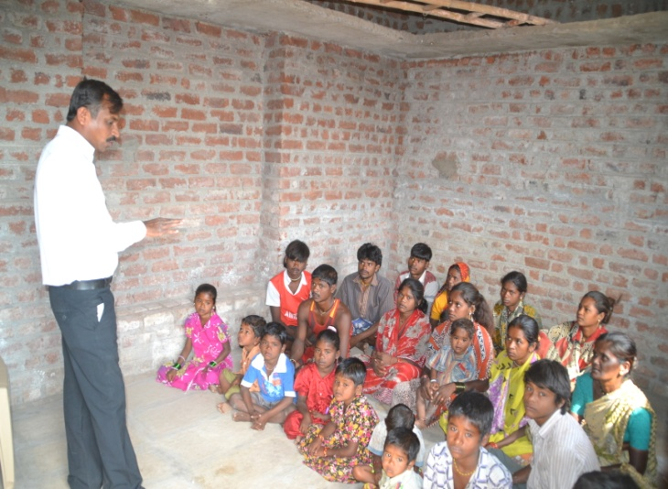  We take 4 parent’s meetings in October & November. At that time for we had 48 parents attend this meeting. In meeting we more focus on children regularity & parent’s continuous visit to school.  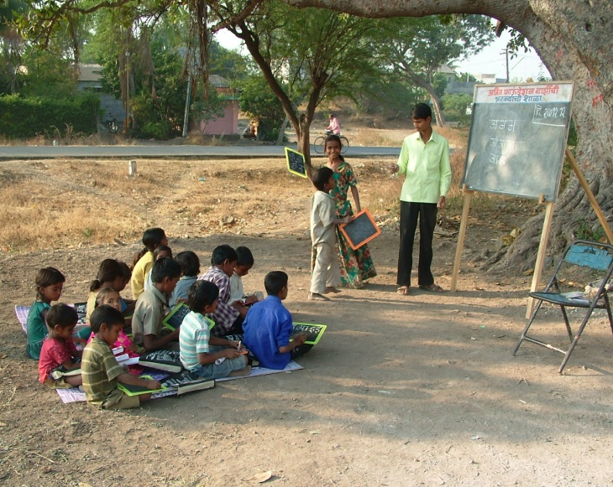  Parents are not ready to send children in regular school. So we decided to start a school in area where they live. We started  Hobby classes for children  Hobby/support classes continued to be conducted at every target vasti/tanda. Ms. Sayara Mulla supervises these classes from 4.30 p.m to 5.30 p.m at one  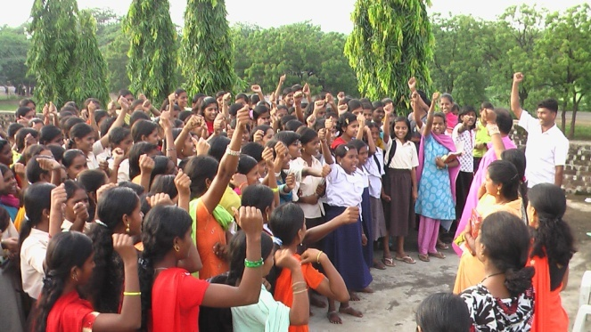  AF organized Melawa of Hobby class students  vasti/tanda each day. Apart from helping the first generation learners to stay focused on academic studies, it also helps in their character formation and also to be aware of their social responsibilities. As a result, the incidents of Child labour and children dropping out from school have come down to almost nil in the 10 target tandas. A motivating factor for the children and parents alike these classes have made for regular attendance and improved overall performance.  Liberating women from violence  This Program Liberating Women from violence, - which became operational during the reporting period is a multi dimensional approach to provide aid, support, prevention and eradication of all types of violence meetings, reporting and planning of the project programmes. Below is mentioned about the activities during the year as part of this program.  Sevalaya– Home for HIV infected children:  Proper care, mingled with love and affection, systematic learning geared to a rigorous time-table focused on the integral growth of the children is the preferred mode at Sevalaya where a total of 100 orphan/one parent children are being brought up to take up the responsibilities of their personal, vocational and future life.  The project year 2010 – 11 marks the fifth year of the Sevalaya project. After the initial struggle for want of a proper and regular place to accommodate the children, a small structure have been built as a permanent shelter for the Sevalaya children in last year  Sr. No Class/Standard No of children  1 XIIth Std. 11  2 Xth Std. 12  3 IXth Std. 36  4 VIIth Std. 5  5 VIth Std. 8  6 Vth Std. 9  7 IVth Std. 7  8 IIIrd Std 4  9 IIrd Std 25  Total 100  Women impacted through SHG’s  Total No. of SHG’s 100  Total members 1200  Total Savings Rs. 35 Lacks  Total bank loans received by the Self Help Groups Rs. 15 Lacks /-  Total women involved in various income generation activities 500  Total number of girls & women trained 150  Research and collection of data on VAW  Armed with the training and understanding of the project we conducted survey and focus group discussions in 100 programme villages in the month of May. We collected data on the women and girl population, cases of female infanticide, child marriage, sexual abuse, rape, child prostitution, wife battering, abuse and murder for want of dowry etc. The data was collected with the help of Sarpanchs and women leaders etc. Table I  We also applied to Superintend of Police, Osmanabad seeking information (under RTI) on VAW cases (registered cases) in the Osmanabad district filed under it. The S.P Office gave detailed information on this issue. (See Table I). This information was very vital since we knew that, only a fraction of the VAW cases are filed and action is taken.  - cruelty etc.  - Crime’s related to women’s body – rape, Fundamental rights and their applications in daily life.  - Rights of women as per various personal laws.  - Women’s right to maintenance, Outrage of modesty, abduction, trafficking, domestic violence etc.  - Fundamental Rights………………… etc  Trainings on VAW and Legal Remedies  - With a view to gain the confidence of the people, mainly the civil society actors – we organized a total of 6 training programmes in the 4 talukas during the project period. This included meetings/discussions, classes etc on VAW, legal remedies, project programmes (initiatives by the organization) role of civil society etc. The participants included journalists, government officers, prominent members of the society, advocates, Police personnel etc. A total of 59 people participated in these programmes. These training helped us to gain the confidence of people and we were able to launch the project programmes with the backing of the prominent persons from the society.  Gram savitries:  We also have selected a total of 31 women as “Gram Savitries “to act as the “eyes and ears” of the organization at village level. They were given basic training in identifying VAW cases, basic laws, women’s rights etc. They assisted the organization in taking up the causes of VAW victims, in finding  believed that a healthy mind dwells in healthy life. In order to enable the people to manage their livelihood comfortably and to be able to create wealth that comes with good health, AF has taken many initiatives, such as, health check up, RCH program along with some health awareness programs including CBD centers.  Health Care through Community Based Drug Distribution Centers (CBDs): Health activities are being carried out by AF to check prevailing health disorders and generate awareness on healthy living, hygiene and sanitary practices. The Community Based Drug Distribution Centers (CBDs) are established in the villages having SGHs promoted by AF and selected members are provided with necessary training on health grounds to run the CBD.  Awareness on Cancer: Several formal and informal programs at Barshi head office level are usually organized on cancer awareness. Technical staff and social worker of AF are trained by premier research organization of country to support advice and serve people with this dreaded disease at different stage.  HIV/AIDS Prevention: HIV / AIDS have been the burning issue for the globe. Barshi Block has been suffering from this dreaded invincible disease for last so many decades. AF has been targeting this disease to prevent and restrict its spread by focusing the District, where migration of labour and trafficking is high. Thus on regular basis AF could conduct 15 programs on HIV/AIDS Prevention at block and district level.  people targeted under this project will devalue the process and underutilize the infrastructure that defeats the whole objective.  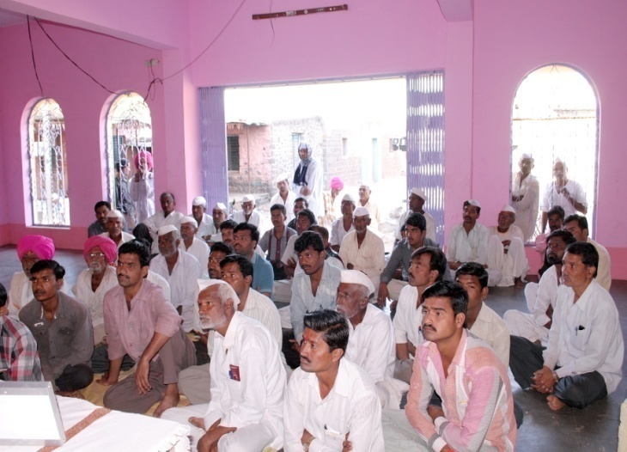  Awareness on total sanitation  The Ajit Foundation advised and tried on following approaches to address the issue:  - Checking of reckless over-consumption and misuse.  - Restrict pollution of natural water.  - Restrict pollution of underground water.  - Check depletion of underground water level.  This could help to enhance the knowledge for conservation of fresh water which is a great necessity human survival.  National Environment Awareness Campaign (NEAC): The National Environment Awareness Campaign (NEAC-2013-14) was supported by Ministry of Environment and Forests, Govt. of India. The program aim to mobilizing the people on environment related issues for eliciting people’s support towards future  Minority Empowerment  Constitution of India has bestowed the fundamental rights to its people to live with peace and harmony keeping in view the Secularism of the country. Since the inception of Indian Constitution “Unity in diversity” has been the mantra in Indian context of Secularism. But, a large number of communities, so called ‘minority groups’ are still ignored and begin isolated in major affairs of national issues and in some cases forced behind in getting similar opportunities to live as a citizen.  People of the minority Muslim community are under extreme hardship in almost all ways of life. Lack of proper livelihood support is the main cause behind this hardship. The Ajit Foundation has initiated a program for the community under NPF program in Solapur and Osamanabad. These two districts have a Muslim population of 23% and 21% respectively. In Osamanabad district with 68% Muslim population, get special attention.  Ajit Foundation established a Muslim cell at Barshi in Solapur and formed fifteen SHGs with an aim to empower the women there. The members of these groups get vocational training to improve their economic status by enhancing various livelihood opportunities.  Ajit Foundation has always shown interest in the betterment of the minority community and qualitative improvement of education of | and infrastructural facilities created by the local administration in the new location. This could also be one of the reasons why the children from these migrated families do not attend school. Children of a migrant family are likely to face problems in the process of socialization. These problems/risks are probably known to the heads of families and hence they are not very motivated to send their children in the local schools.  Solapur & Osmanabad districts, where Ajit Foundation is working a most backward, under developed district of the state and is well known as a drought prone zone of the region. olapur, which has the highest number of 28 sugar factories in the district, will have 20 additional new sugar factories. So labors are come from Beed, Parbhani in those factories to get job immediately. The cheap labor was made available through laborers who are migrated from various parts of the Marathwada. There sugar factories are operative for 6 to 8 months in a year i.e. from Sept to March or before onset of the monsoon. The workers migrate to these sugar factories along with their families and of course children.  Targeted beneficiaries: 150  Project objectives: People from all cast and creeds residing in 17 communities of Aurangabad region will demonstrate understanding responsibility and support for working together for completing education and overall development of their children.  Akshar Initiative. We made total SC, ST & NT list of 0 to 16 age child for our record & we used this list for children’s regular attendance and their progress.  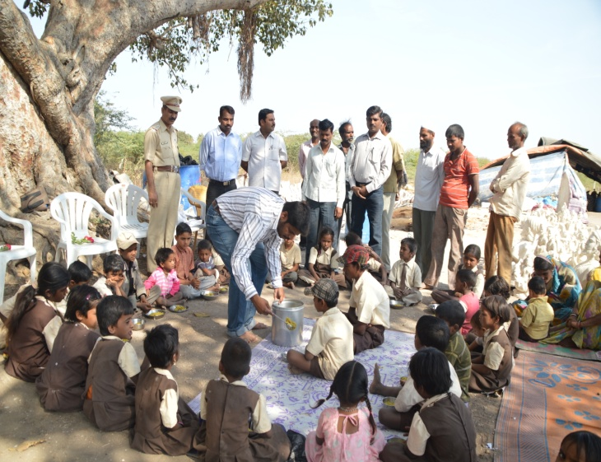  We were start a mid day meal to every center with the help of Municipal School of BNP Ghodade Plot, Barshi for that we regular touch up with Panchayat samiti, Barshi.  Child labourers  In order to create awareness on “Child labour” a children’s rally was organized in Barshi city on August 13. Hours before its announcement project persons visited the city shops – hotels and roadside eateries and took pictures of children being employed in odd jobs at these places. The shop keepers and owners of hotels etc were counseled. About the negative implications of child labour its criminal aspect and warning given of possible legal action in future. As a result, these hoteliers, shop owners etc. send the children to their homes and stopped the practice of employing children in their establishments.  against women. It also envisages accountability of perpetrators who indulge in violence against women. The project is being implemented in three Blocks of Soalpur & Osmanabad district, viz. Barshi, Paranda, and Tuljapur, M. S., INDIA.  In this first year of the project, we have made some important breakthroughs, viz. research and collection of data on different types and instances of Violence Against Women (VAW), Printing hand bills and copies of various Acts/laws etc. Training programs, providing legal aid to needy women, conducting street plays and Nari adalats etc. One of the most important and encouraging change happening at the village level is that, of the gradual change in the attitude of the people – people are positively inclined to support every effort of the activists and thereby ensuring the success of the program. In most of the target villages, there is considerable improvement in the level of awareness on VAW, Basic Laws, and Nari Adalats etc. The women’s self help groups (Micro-credit Groups) are actively and openly supporting the initiatives of the organization. A lot of people are visiting the office of our organization seeking guidance/assistance or support.  The project staff has also become experts in implementing the various project programs, organizing and ensuring the support of the people etc. The new found confidence and enthusiasm of the project staff is reflected during the monthly  Livelihood Promotion & Social Security  The activities of women’s empowerment includes, Socio-economic, political and educational development of women in the target area. Self help Groups (SHG) acts as the back born of women’s empowerment initiatives. Details of shg’s – see the table.  Entrepreneurship awareness and skill trainings have provided small business options and promoted self-reliance amongst the SGH women and adolescent girls.  Women have participated in anti-alcoholic drives, protests against social injustice and violence against women…. Over 150 women are members of the Village Education Committees. Women from the two Blocks of Solapur district viz. Barshi, Madha, and Indapur in Pune district where AF works have been helped through the Legal Aid Cell of AF. Recently due to the effort of SVS, over 12,000 women’s names were registered as co-owners of the family property under Section-8A of Succession Act.  The formation of Sabala Mahila Kendra’s branches in 21 villages are providing a decisive edge to the women in fighting atrocities, promoting women’s rights, assistance to widows and destiutes, and establishing women’s leadership. Sabala Mahila Kendra is gradually becoming a movement and a platform for making the women’s voice heard, fight against oppression.  TABLE 1  Sr No Types of Crimes (VAW) 2011 2012 Upto Aug. 13  1 Dowry murder 5 3 6  2 Dowry harassment 2 6 6  3 Suicide due to harassment for Dowry 44 41 18  4 Rape 22 21 20  5 Abduction 19 15 14  6 Domestic violence 184 148 107  7 Sexual harassment 80 64 49  8 Eve-teasing 8 9 7  Total 364 307 227  Printing Handbills, copies of Acts/laws etc.  We have been exhorting the general public to join us in our fight against VAW. Handbills and stickers on the issue was prepared and distributed amongst SHG women and general public, students, schools etc. stickers have been stuck in front of the houses by women. Public awareness and consciousness that women are the fellow being is being created amongst the general public through this kind of awareness drive.  We also published a booklet titled – “Ladai Stree Asmitachi” (Fight for women’s dignity) detailing the various Acts/laws pertaining to:  - Women’s right to property and inheritance  - Laws related to marriage, child marriage, bigamy, adultery, forced abortion,  solutions, or solving the issues at local level. These volunteers also helped the organization in identifying potential woman leaders, and training them on the whole issue of VAW. A total of 459 women with leadership qualities were identified and were given training.  Legal Aid Cell:  During the first half of the project duration itself we had opened “Women’s Legal Aid Cell’s” at four Blocks – Barshi, Paranda, Bhoom and Tuljapur. Through these cells, we were able to reach out to the victims of violence - abuses, cruelty, marital discord etc.  The Legal Aid cells’ in effect acted as a platform to provide “first Aids” to the victims, collected information and datas on atrocities and referred serious matters to the organization Office which in turn took up these and tried to find solutions. A large number of cases have been handled by these cells.  During the period under review, a total of 98 cases have s been registered in these legal aid cells at the four Blocks. A majority of these cases were of marital discord. Some of the cases/matters which could not be resolved through the legal aid Cells were referred to Nari Adalats which are gradually becoming active in the project target areas.  Health and Nutrition  Health and Nutrition occupies an important part in human life and for overall development of the society. It is generally  On-going Reproductive Child Health Program (RCH): In the Barshi Block of Solapur district one RCH project of AF in two sub-centers. There are 11 villages being benefited. This project aims for the development of health of the pregnant mothers and infants. This is also working for the psychological and physical development of the adolescent boys and girls.  - During this reporting year AF has organized 25 ANC/ PNC camps, 15 immunization camps, 5 adolescent health check-up camps, 4 PRI meeting, 4 Health melas.  Water and Sanitation  Total Sanitation Campaign Project: Promoting sanitation is an integral component of AF’s social sector strategy. AF approach is based on an integrated water resource perspective that ensures- social, economic, environmental and technical dimensions those are take into account in the management and development of water resources. Effective water resource management program can improve water supply for irrigation and household, provide power, mitigate floods and help manage the complex web water uses. They can also play an important role in climate change-as a tool to help countries adapt to evolving hydrologic conditions and to reduce fossil fuel consumption.  Awareness Campaign on Water & Sanitation: It is well proved that without the awareness on implications of sanitation, on social changes and human development,  interventions. The programs were conducted with active participation from community leaders, youth club members, SGH members.  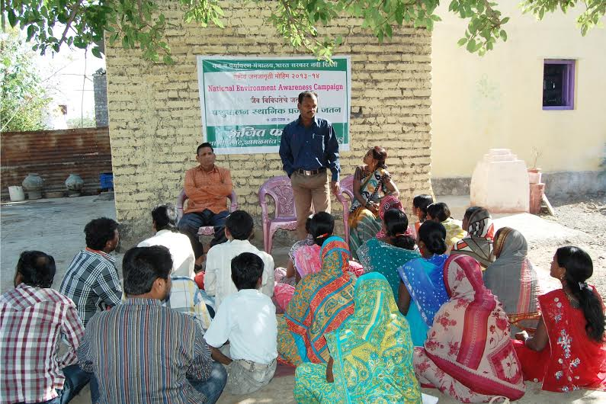  National Environment Awareness Campaign at Alipur,Barshi Block  Relief & Disaster Management  Disasters are as old as humanity and used to occur even much earlier. Natural and manmade disasters are on the rise in almost all parts of the world. Maharashtra has been regularly suffering from natural disaster such as cyclone and sun stroke.  Taking serious note of different disasters in the coastal and tribal belts of Osmanabad during past, AF has undertaken a number of activities in enabling the people to overcome such untoward events through disaster management, preparedness and mitigation activities.  Some awareness programs have also been carried out to create a sense of responsibility and accountability to solve the problems at community level.  the children in this community as they are the least cared for.  It has revealed from the experience of Anglo- Urdu high school in Barshi and observation of Ajit Foundation coordinators says that children from the minority community in Barshi were neither interested to go to school nor attracted by provision of food, recreation and health care. But, now the scenario is altered and keeping in view to all these affairs of child education Ajit Foundation is planning for other ambitious plans for them.  -----------------------

Administration

• AJIT FOUNDATION is registered as a not-for-profit trust under The Indian Societies Registration Act 1860 (Reg No.: MH/1318/2006)
• AJIT FOUNDATION is registered U/S 12A of the Income Tax Act, 1961 and under section 80G (5) (VI) No.: PN/CIT-IV/The/80G/AF/4/2012-13/180. Permanent Validity.
• FCRA Permanent Permission under Section 6 (1) (a) of FCRA Act, 1976.
FCRA No. 083980083
• Registered Address: Wani Plot, Agalgaon Road, A/P/T-Barshi-413401 Dist-Sholapur.

Fundraising and Communications
AJIT FOUNDATION is fortunate to enjoy the financial support of many institutions, employee groups and individuals from Barshi, across India and beyond.

Financial support comes through direct donations, support of annual fundraising events and through program grants. All donors can be sure that they truly having a positive impact on the lives of vulnerable children and we endeavour to provide timely and thorough updates on the use of all donations.

A special thank you to the following institutional and corporate donors whose ongoing support for our programs and operations is greatly appreciated:

Grant Agencies: Smile Foundation, Goonj, Mananjyot Public Charitable Trust, Sadbhav Foundation, S.N. Baldota Trust.
Resource Partners: Global Giving, Ammado, ICICI Bank payment gateway.
ONLINE SUPPORT- A Click away

Now you can donate to AJIT FOUNDATION online, just click on http://www.ajitfoundation.com/Donation.aspx we have tied up with ICICI Bank.

ICICI Bank | : | http://www.ajitfoundation.com/Donation.aspx
Global Giving | : | http://goto.gg/16606
Ammado | : | https://www.ammado.com/nonprofit/141598

Come join this journey of empowerment and change with us!

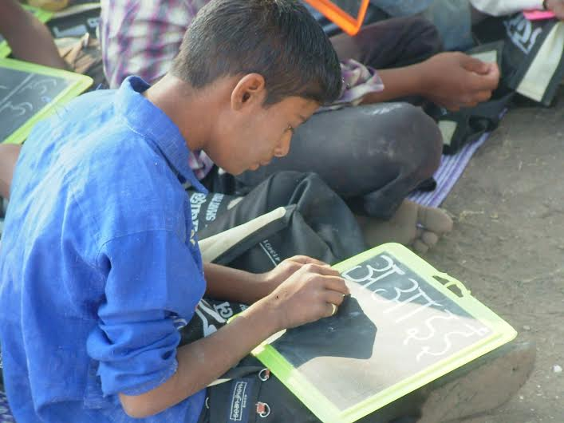

Visit or write to us at
AJIT FOUNDATION
Office: Wani Plot, Agalgaon Road, Barshi-413 401
Taluka- Barshi Dist-Sholapur, Maharashtra.
Mobile: 09822897382 / 09405024613
E-mail: srujanonline@gmail.com
Website: www.ajitfoundation.com

