
Darfur Crisis: A Report from Sudan
From Fatima Ahmed, Director of Zenab for Women in Development
April 2007
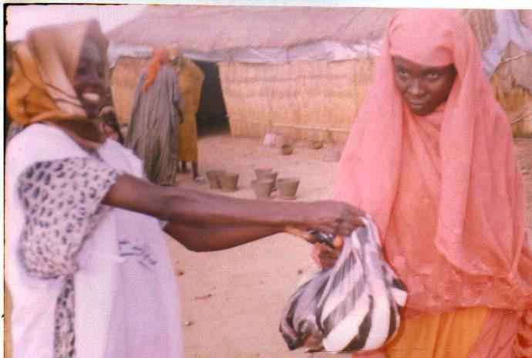
With the help of GlobalGiving supporters, MADRE and Zenab have been able to provide much-needed aid to hundreds of people in the refugee camps at Autach, Gereida, and El Sireaf and surrounding villages. We have constructed private latrines in two of the camps so far, and distributed sugar, dates, onions, oil, millet, and sorghum to hundreds of people. These items were especially important during Ramadan, in October of last year.
© Zenab
Women and young children who have been traumatized by displacement and war have benefited from the services of a local counselor, who travels to each camp to conduct day-long sessions. The sessions are not regarded as psychological counseling, which people in the camps are not familiar or comfortable with, but are offered in a way that encourages people to share their experiences and regain a sense of trust and community. Another activity that has been very successful in this regard is a new creative project, designed to empower women by supplying them with raw materials they can use to produce different types of artisanal products, to help generate income. The women we’re working with have found this to be a very useful type of support, and we were happy to hear how much they enjoyed it too. Together with four other local women’s organizations, we have formed the Darfur Network for Creative Women, in order to arrange cultural and musical events.

Our biggest success so far was participating at the Annual International Exhibition in Khartoum, the capital of Sudan. We traveled with 30 women and a group of musicians from the camps, and rented a tent for them to display their art. The musical group performed every night in front of our tent, and we received many local and international visitors to what came to be known as the Darfurian Women’s Creativity Tent. In fact, ours became a famous venue at the exhibition, and we were able to sell many of the women’s wares.

Our plan is to continue our work in Darfur, and expand our distribution of food and aid to the south of Sudan. We understand that one of the latest reports states that food aid has decreased by 64%, and we see the tremendous need this has caused in the camps. Because of this, and so many other factors, the public health situation is also rapidly deteriorating, as the World Health Organization has documented.

In the coming months, we hope to buy milk and rice, in addition to other food items, to distribute to women and their children, and to particularly channel aid to pregnant women who are very vulnerable. Non-food aid will include clothing, sheets, blankets, and bed nets to prevent the transmission of malaria, one of our most pressing health concerns.

Thank you so much for supporting the women of Sudan with your resources and support. The relief and joy that comes from knowing that we are not alone, that we are not suffering in anonymity, is immeasurable. The world is full of injustice, and we can’t fix it all at once, but your gestures from the other side of the world make a big difference.

