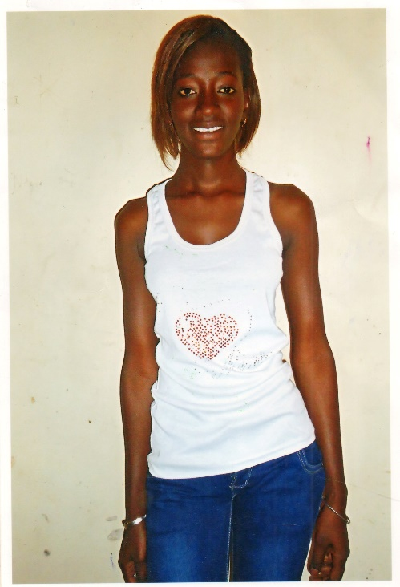
Penda Diop struggled through primary school. Her father died when she was very young and left her mother as a poor housewife with a heavy load to bear. Her mother then passed away when she was in grade 3. She found herself alone, but was able to continue her studies through the generosity of a caretaker in the community.
She proved herself a very willing and clever student and passed the entrance exam to further her education at junior high school. However, the nearest school was many miles down the road and she would have to find somewhere to stay in the new community. Having no financial resources to pay the school fees and no family to stay with, she had to drop out of school.
Penda now must fend for herself and has gotten a very low-paying job as a maid in a nearby city. She has almost no hope of going back to school and very limited opportunity to get a better job and improve her situation.
There are many students like Penda in the town of Mbouma who have the capability and willingness to succeed in school if given the chance. If Penda and her friends had a school in their town, she would not have had to drop out and leave the village. There are many children like Penda who can have hope for a better future if we are able to help them build the school they deserve.

Mbouma is a small road town located about 40km south of Kaolack, Senegal, with a population of approximately 1400. The town currently has a primary school with 250 students in attendance. There are no local educational options after that. If local children wish to continue their education, they need to go to the neighboring town of Keur Soce about ten km away. Some children do this, if they can find someone to board with, or if they can afford the transport back and forth each day. Most children, especially girls, drop out after primary school.

The village elders have petitioned the government for a junior high school and have been deeded land by the community to build on. The government has sent a few teachers but it is left up to the community to build classrooms. This is a community of farmers with almost no resources, but they are very committed to doing what they can to have a junior high school for their children, so they have built several makeshift classrooms from millet stalks. The temperature in this region often reaches 120 degrees and the desert winds blow through these makeshift rooms making for a very challenging learning environment. In addition, these classrooms have been rebuilt several times because they have burned to the ground due to the dry conditions.

Andando has partnered with the community leaders of Mbouma and have agreed that working within this budget is achievable. Much of the labor to build the school will be done by folks in the village to keep costs down and to ensure investment and buy-in from the community, both of which are large components of sustainability. Further budgetary figures can be provided upon request.

Foundation | $2700(USD)
Walls (including security doors and windows) | $7250
Electricity (to hold adult classes in evenings) | $250
Roofing | $1250
Painting | $550
Total | $12000

