Education and sensitization campaign against breast ironing of young girls in the Littoral Region of Cameroon (Central Africa).

Context

- For many decades, it has been common practice in many communities living in the Littoral Region of Cameroon to practice breast ironing to young girls at the age of 10 to 17 years old. The United Nations Population Fund (UNFPA) estimates it affects 1 in 4 girls in Cameroon.
- This practice results from a local and traditional perception that when the young girls evolve from childhood into an adult, her breasts increase in volume. Therefore it is generally admitted that as far as the young girl of that age will have an important breast development, it is necessarily to curb this physical development of the breast, by practicing regular massage with hot crushed stone use in the kitchen or other similar materials.
- The belief that lies behind this practice is that massaging or ironing the breasts will reduce the risk of sexual assault and teenage pregnancy (US State Department Human Rights Report, 2011), but according to the UNFPA, one third of unwanted pregnancies occur between the ages of 13 and 25, with more than half falling pregnant after their first sexual encounter.
- The practice is part of the “sexual mutilation” practices, recorded in some traditional societies in West Africa which consists on the removal of the some significant parts of the sexual organs of female persons. These practices have been generally condemned and recognized as genital mutilation and an offence to the rights of female individuals.
- It has been observed that this practice, instead of providing a harmonious growth to the girls, has years after, provoke the occurrence of many diseases such as skin burnt, and other breast problems.

What the project seeks to achieve:

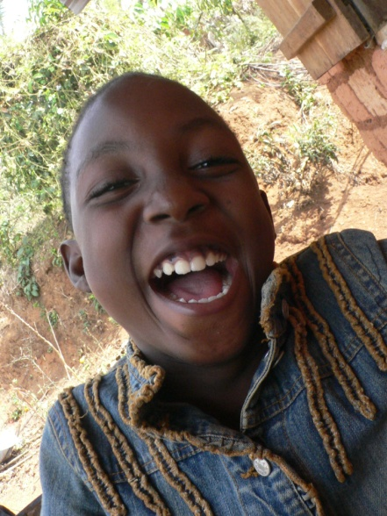
Estelle is a jovial and very young Cameroonian girl living in the Mungo division (Littoral Region of Cameroon). She is just 12 years and has just been successful in school this year. Her mother is amongst those who are aware of the negative effects of traditional breast ironing, and has prevented her daughter from being mutilated in this way. This project seeks to ensure every young girl has the same life chances as Estelle.

The main objectives of this project are to:
- Deepen our understanding why this practice continues in the target communities of the Littoral Region in Cameroon;
- Inform the community about the negative effects of practising breast ironing done to the young girls of the area;
- Educate young girls, community leaders, women, traditional rulers and other interest groups about the consequences of such practices;
- Advocate for a change of the current practice at the national level.

The beneficiaries

Beneficiaries of the project are:
a) 500 young girls of the project area, aged between 10 to 17 years old and potential victims of this harmful traditional practice;
b) Female elders (mothers, aunts, grandmothers, etc) who are the parents and traditional practitioners;
c) The Loum community (c.150,000 people) including local traditional leaders, health authority, schools, parents, etc. all of whom have an interest in ending this practice.

Activities

Five main activities are targeted for this project:
- Participatory survey and knowledge sharing on the motivation and how the practice is undertaken;
- Creation of a documentary on the situation faced by young girls and testimonies from the victims, which can be used to disseminate information and key messages;
- Clinical support from a psychologist to help 150 affected girls;
- Organization of a Workshop to inform, sensitize and educate 50 people drawn from various stakeholders (including 10 from outside the region) involved in the breast ironing practice as well as health authorities, traditional rulers and local authorities about the practices, it impacts, etc…
- Advocacy activities at the national level targeting policymakers and other various stakeholders – including collaborative activities with other NGOs and CBOs active on these issues.

Budget

Items | unit | Unit cost (£) | Total (£)
Participatory survey
Survey (honorarium and expenses) | 1 | 410.5 | 410.5
Background research | 1 | 100 | 100
Sub total 1 |  |  | £510.50
Realisation of the documentary
Honorarium for cameraman and other field expenses | 1 | 1200 | 1200
Sub total 2 |  |  | £1,200
Clinical support
This clinical support will be undertaken by physician working in public hospitals a number of 150 girls at this pilot phase. | 150 | 5 | 750
Sub total 3 |  |  | £750
Transport, lodging, food and incidentals
Reimbursement transport fees for outside participants | 10 | 12.15 | 121.5
Lodging for outside participants | 10 | 9.5 | 95
Food and incidentals (for outside participants) | 10 | 10 | 100
Lunch and tea for workshop participants (50 lunchX2 days) | 50 | 14 | 700
Sub Total 4 |  |  | £1,016.5
Logistics for the meeting
Venue hire | 2 | 36.5 | 73
Equipment hire | 2 | 31 | 62
Workshop facilitation | 2 | 61 | 122
Workshop materials (pen, files, writing pad, etc) | 50 | 1.25 | 62.5
Workshop banner | 1 | 31 | 31
Sub total 5 |  |  | £350.5
Follow up activities
Compilation of participatory survey and workshop reports | 1 | 100 | 100
Printing of overview reports in French and English | 500 | 1.5 | 750
Report distribution and advocacy activities |  | 250 | 250
Sub total 6 |  |  | £1,100
TOTAL 1+2+3+4+5+6 |  |  | £4,927.5
Unforeseen (5%) |  |  | £246.3
GRAND TOTAL |  |  | £5,173.8

