Volunteer voices in Ruaraka
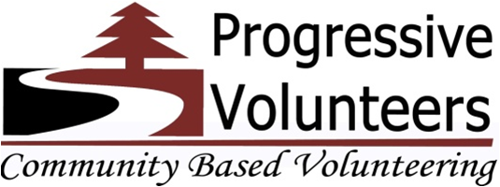

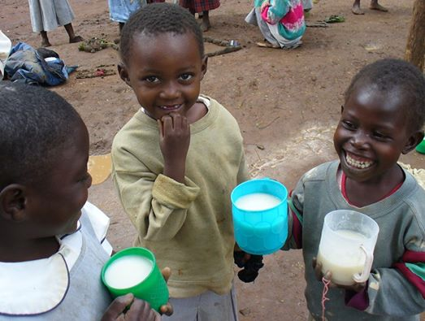
Creating a platform for partnerships between the North and the South to build a participatory and people-centered development.

Dear Friends of Progressive Volunteers,

I am delighted to send you the second report of our project, in which we will share with you the results already achieved and our future plans.

The first success of PV is that we have created a partnership of friends ready to actively participate in the projects and help with donations and build people-centered participatory development.

Thanks to your individual donations, our local contributions and the donations of institutional donors, we raised USD 3,200 out of the target of USD 9,500. This has enabled us to start the process of achieving our project goal.

So far, we;
- Recruited 10 volunteer teachers, mentors and change makers in the five informal partner schools.
- Purchased school kits and classroom essentials for 250 children.
- Established reading and mentorship clubs in all the five informal schools.

Dear friends, I am happy to inform you that with your support, PV is contributing towards the achievement of the UN’s Millennium Development Goal (MDG) number two, which is to “Achieve universal primary education”.

I salute you for being part of this noble development initiative and I hope you will remain involved and committed in Progressive Volunteers activities to contribute to a fairer world.

Thank you.

Jeremiah Mzee
PV-Chairman Board of Management
jeremiah@progressivevolunteers.or.ke
Definition of VOLUNTEERISM according to Ruaraka residents:
“Volunteerism is a reliance on volunteers to support an institution or achieve an end”. Mr. Kennedy Aroko, Head teacher at Emmaus Education Centre
‘’Volunteerism is when one offers any service out of their own free will without expecting any pay or compensation in exchange for the time and skills given.” Mr. George Odolo, Programme Director at Progressive Volunteers.
“Volunteerism is when a nation or a society actively engages volunteers in the day to day efforts to develop.” Mr. Paul Chandoek, local administrator- Chief Ruaraka.
“Volunteering does go far beyond giving up your time without expecting pay. It has far reaching positive impacts on the economic and social lives of people. Therefore, to bring this word to life, all patriotic citizens should volunteer their skills, knowledge and time at one point in their lives, to move the country forward. The value and importance of volunteering cannot be taken for granted. It needs to be recognized, facilitated and promoted.” Ms Khadija Thabit, Board of Management member

“Volunteerism is a free job.” Melline Akoth, 10, student at Lucy Education Centre.

“Sustainable development requires people’s engagement. People are development actors and not only recipients. Concepts of inclusion, participation and ownership leading to real capacity building and social capital come to mind. Volunteers are very important if these are to be achieved.” Simon Lewis, volunteer with VSO Jitolee seconded to PV for 2years.
“Volunteers don't get paid, not because they're worthless, but because they're priceless. “ Mr. Joseph Areba, the volunteer teacher.

“Volunteering is the ultimate exercise in determining the kind of community you want to live in.” Author Unknown

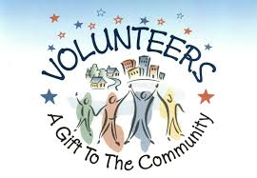
Kindly share with us your own understanding of volunteerism.
Email: volunteers.p@gmail.com

VOLUNTEER TEACHER’S EXPERIENCE

By Christabel Were.
My African name is Awuor literally meaning the greedy one, I had always wanted to do something to give back to the community but my excuse had always been that volunteerism was for the jobless. However, thanks to Progressive Volunteers which cultivated the spirit of volunteerism in me, my volunteer journey began in January 2014.
One of the experiences I still hold very dear was a visit to the Lucy Education Centre, a community school in the heart of Korogocho slums to do a need assessment for PVs volunteer teachers program. We found life of pupils in that school difficult, the school lacked basic amenities, the classrooms were tiny, the pupils had no books and so basic learning was a tall order.
Despite the fact that the pupils came to school with no basic learning materials, torn shoes and uniforms, they greeted us with giant smiles, had big dreams written all over their faces and most of them wanted to become doctors, teachers and pilots.
PV initiated and partnered with the school and since then I have engaged with the school as a volunteer teacher and mentor.
As a volunteer teacher in the school, I spend four days in a week teaching English and Science in classes 4-6 and a day for mentorship.
So my reward and motivation in the volunteer teachers/mentors program has been at Lucy Education Centre. I plan to continue helping the pupils until end of 2015.

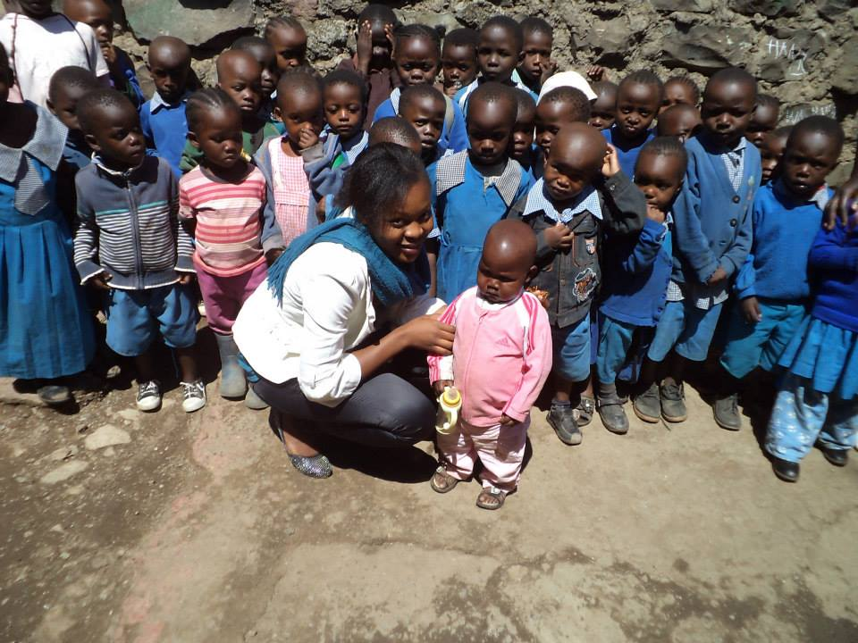
Above Christabel with standard 1 pupils, below teaching standard 5 pupils at Lucy Education
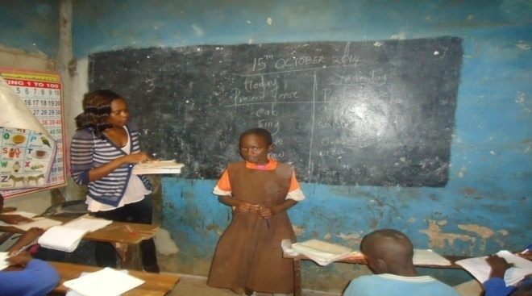

PROTECTING FUTURES THROUGH CHILD MENTORSHIP. By Eric Ochieng.
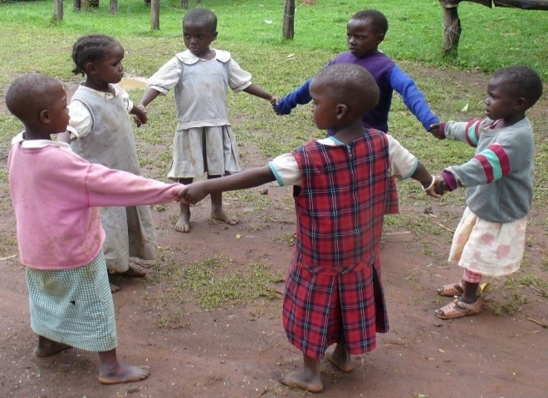A school in Korogocho one of the slums in Nairobi where Progressive Volunteers work.
Every child has a right to education. Education is life; it helps equip one with the necessary tools to face life’s challenges. Education also opens doors to opportunities that would have otherwise been impossible.
The children, who attend the Informal schools in the slums of Nairobi, face many challenges in trying to get education. These schools are severely under-resourced and under staffed. The teacher student ratio is 1:40. Most of these teachers are high school graduates who are looking for something to do as they wait to join colleges/university. This ratio shows that although the children have access to an education, it is substandard. It is not an odd thing to find 3-4 students sharing a desk. These classes are very overcrowded. You will find a room partitioned into 4 classes whereby you have classes 1-4 all having a class at the same time. You can only imagine the confusion that occurs when the classes are on. The students also miss classes because the supervision at the schools is very minimal. This is because the schools rarely cater for the upper primary classes of classes 6, 7 and 8.The schools also lack adequate facilities such as toilets and water for washing hands. This makes personal hygiene a very big issue. Most of the pupils see school as a chore and this has brought about a high drop-out rate especially at the beginning and at the end of the school term. Progressive Volunteers saw the challenges that these pupils faced and came in to offer helping hand. With the help from partners such as Global Giving Foundation and individual donors, The Government of Kenya through the local administration, parents, community leaders and other CBOs, PV came up with a mentorship programme that uses volunteer teachers and mentors who act as “big brothers and sisters” with the aim of guiding these pupils towards a constructive life.
The programme is structured in such a way that volunteer teachers and mentors from PV goes to five of the informal schools and holds sessions on different topics every day.
The topics include; career and character education, personal hygiene, effects of early pregnancies, self empowerment, drugs and alcohol abuse, self-esteem and awareness issues among others.
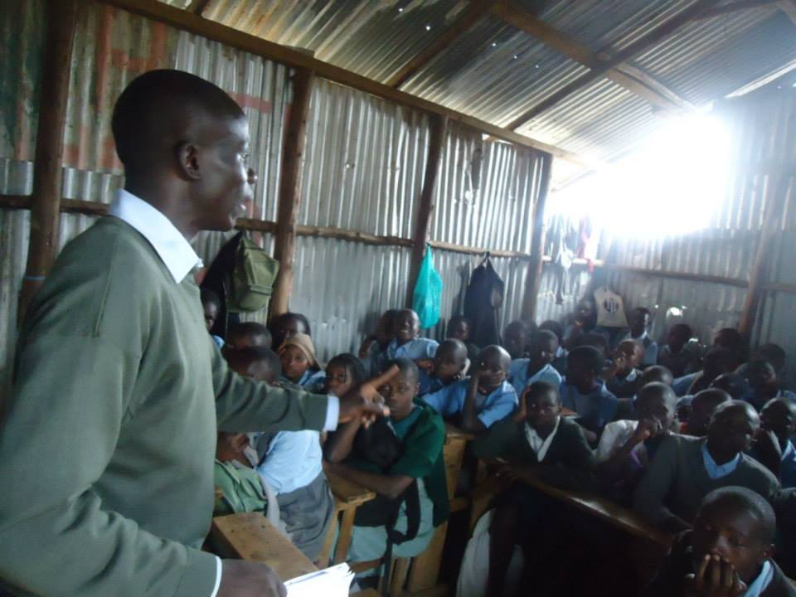Eric a volunteer from PV mentors students at Emmaus Educational Centre in Lucky summer Area in Nairobi.

PARTNER SCHOOLS
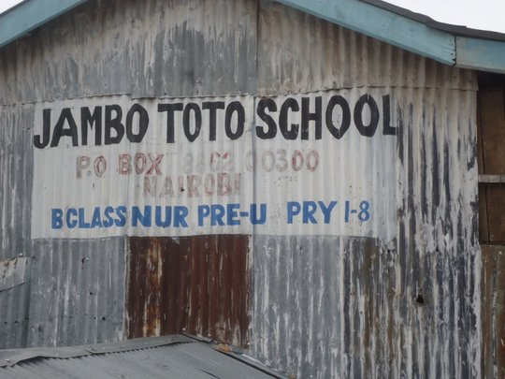

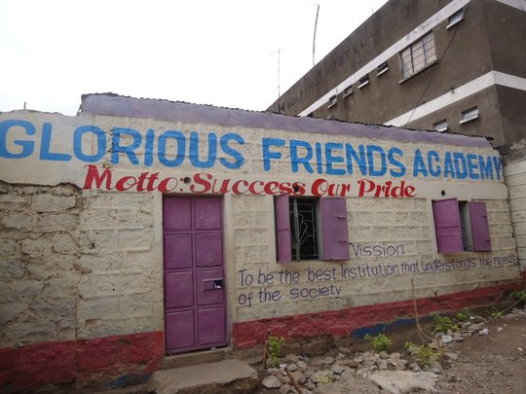

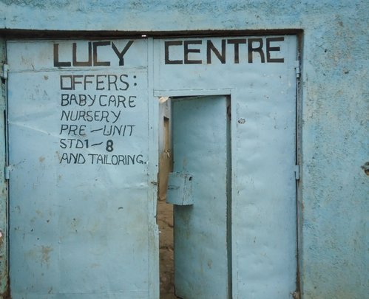

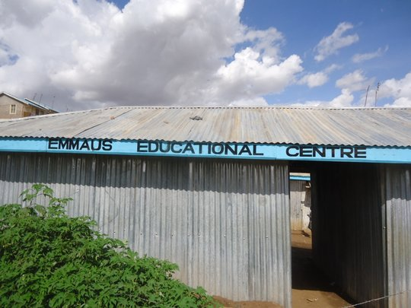

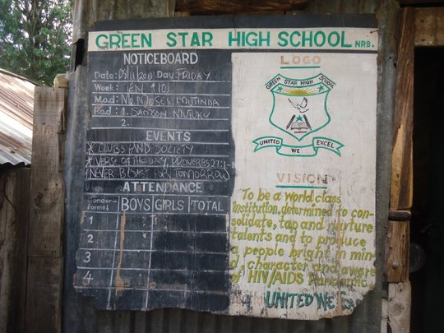

School | Population  Of students | No of Teachers
Jambo Toto | 239 | 6
Glorious Friends High | 287 | 7
Lucy Centre | 123 | 3
Emmaus Centre | 462 | 12
Green Star High | 254 | 8

PICTURES OF VOLUNTEERS IN ACTION
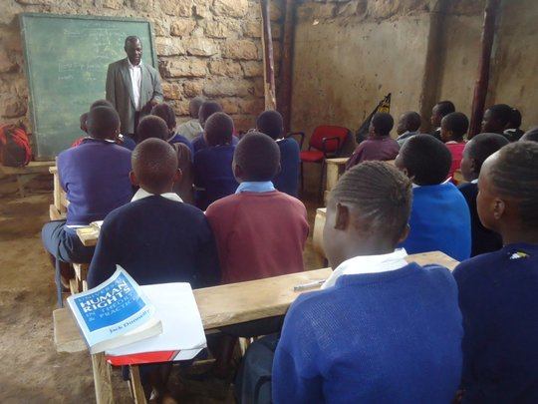George, volunteer mentor during a session at Jambo Toto School
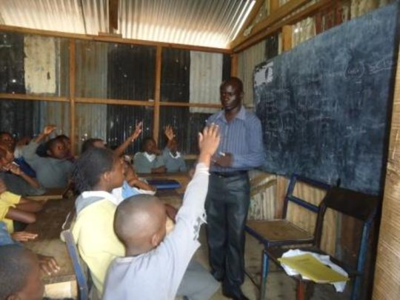Eric, volunteer teacher in action at Emmaus Education Centre
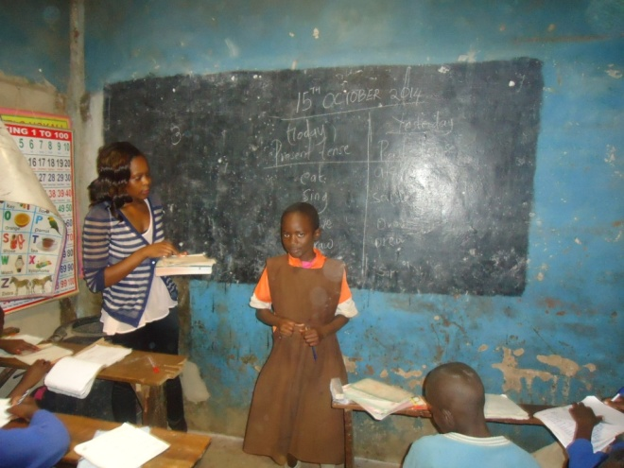Christabel, volunteer teacher in action at Lucy Education Centre

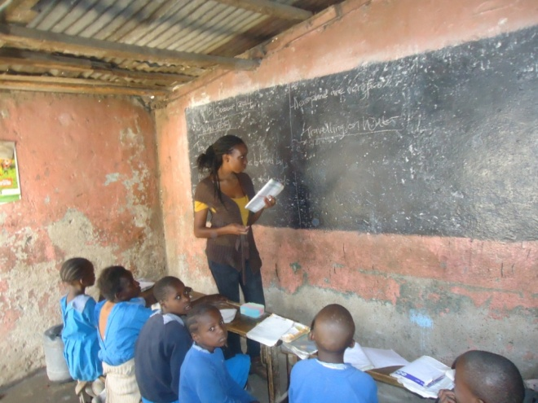Christine, volunteer teacher at Lucy Education Centre
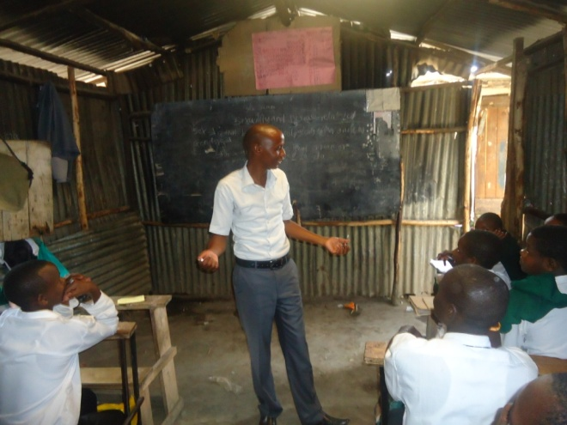
Joseph, volunteer teacher/mentor in action at Green Star High School
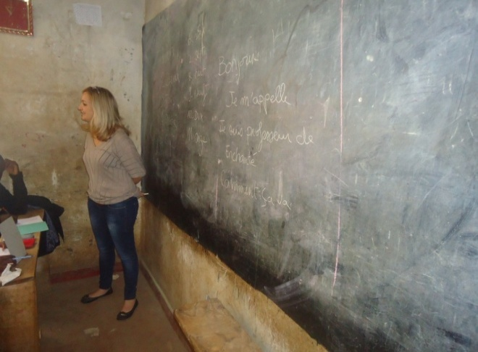
Claudia, French teacher at Emmaus Education Centre and Glorious Friends High School.
FUTURE PLANS

Dear friends, our project needs to grow. To this end we want to organize our activities in such as way that we can work in the best interests of our members, our partners and, above all, of the beneficiaries of our projects. So we need helpers who, on a voluntary basis and in keeping with our philosophy, are willing to take an active part and contribute to the growth of Progressive Volunteers.

The following are the future plans
- Fundraising: Mobilize more project funds in the month of November/December 2014 for the next project phase beginning January 2015.
- Targets: Implement the second phase of the project involving 7 more schools to make the total number of schools 12 with target of 600 pupils and 24 volunteer teachers/mentors.
- Youth out of school: Organize life skill trainings for the youth out of schools.
- Community Library: Stock Ruaraka community library with more local curriculum books to be lent to over 12 informal schools.

Currently the project can be supported through GlobalGiving Foundation;
Project Name: Educate slum child in Kenya.
Link to project: http://www.globalgiving.org/projects/educate-250-slum-children-in-kenya/
Shorter url of the project for Twitter, SMS, or Facebook : http://goto.gg/17170
Dear friends, it is good news that our project is eligible to receive donations not only on GlobalGiving, but also on corporate portals such as:
- Eli Lilly & Co.
- Hilton Honors
- Your Cause

For direct bank payment, below are the Progressive Volunteers account details

Account Name: Progressive Volunteers
Account Number: 1464886
Bank Name: Barclays Bank of Kenya
Bank Code: 03
Branch Name: Moi Avenue Nairobi.
Branch Code: 075
Swift Code: BARCKENX

THANK YOU

