ASSISTING TEACHERS AND STUDENTS COMPLETE SYLLABUS

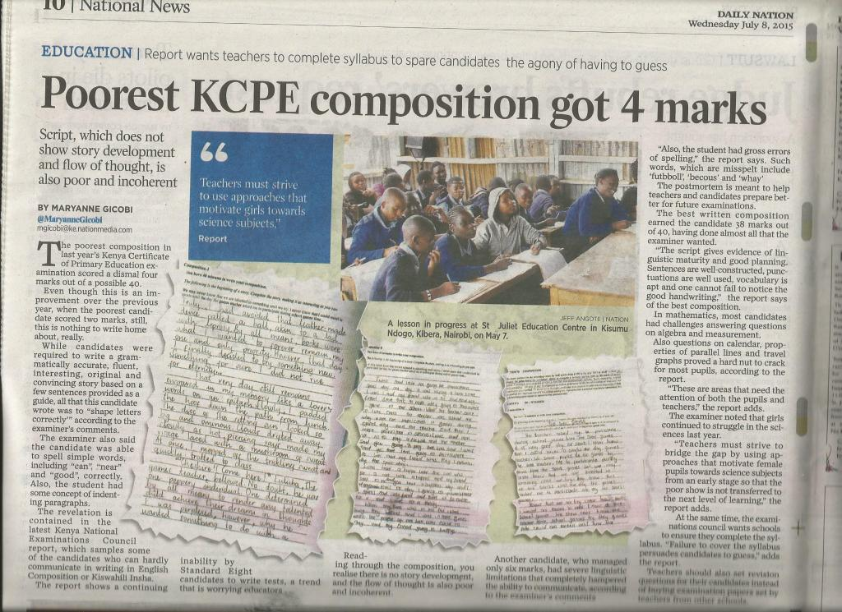
The latest report released by Kenya National Examination Council indicates that informal schools, especially in the urban slums continued to perform poorly in English and Mathematics in the national exams. With your help, we started small to change this rating by enabling children from these informal schools have improved performance in languages and mathematics.
During the second term period, which is coming to an end on the 7th of August 2015, our team of volunteers assisted class teachers completes the teaching syllabus and this in turn will help students perform better in the examinations. This meets our goal of educating slum kids to finish school with a high level of literacy.
Our assessment of reading materials in the schools revealed that the schools are ill equipped with learning materials. Our call for support is therefore to help these 8 non formal schools acquire reading and learning materials enough for the 250 students who are in dire need.

