Easy R Equine Rescue received a call from the owner of a horse in need. Little did they know, when going to pick her up, how much need she was in. Maysie's frail body and weary spirit told a story of neglect, and she was only weeks from perishing. But the odds were on her side, thanks to the saving grace of the rescue.
Fortunately, Maysie landed with Easy R in August 2024. Her healing journey began that day! She started with slow feeds to bring her body weight and condition back to normal. Everyone was determined—including Maysie—to be healthy once again and to live a life of safety, comfort, and stability. One can only imagine what was going through her mind as she fought to stay alive each day, hoping for someone to help.
There were rough days ahead, with her liver enzymes rising to dangerous levels. But veterinarians were right there to help her. With her will to live, Easy R's will to help her, and veterinarians administering excellent medical care, she continued to improve slowly but surely.
Over the following months, her transformation was nothing short of miraculous. While she was very thin, a slow feeding regimen was the only way to bring a horse back to health, requiring patience and knowing this was the right way. It’s difficult to watch the slow weight gain. It’s normal to want to feed her everything she wants immediately, but it's very dangerous for a horse that isn’t used to eating all they want. So, it's a slow process that requires knowledgeable hands at the helm to make this happen. With all the experience that Easy R has in this area, Maysie was on a path to guaranteed success.
By January, Maysie had reached a normal weight, and so many changes had taken place. Her coat was a completely different color—a normal color—and Maysie turned into the most beautiful horse one could lay eyes on. Her two different colored eyes now have a light that shines in them, filled with thankfulness for those who were determined to save her. Her disposition is so sweet, and she loves being with other horses in her new foster home.
Welcome back to life, Maysie! Easy R is determined to make sure your life continues to thrive with good food, good people, and good pasture companions.
Maysie's journey is a testament to the profound impact of kindness and generosity from donors who give selflessly, foster homes that provide a place of shelter and love, and a rescue organization determined to save horses in need. She now enjoys the company of other horses in her foster home and continues to flourish, embodying the spirit of resilience and hope.
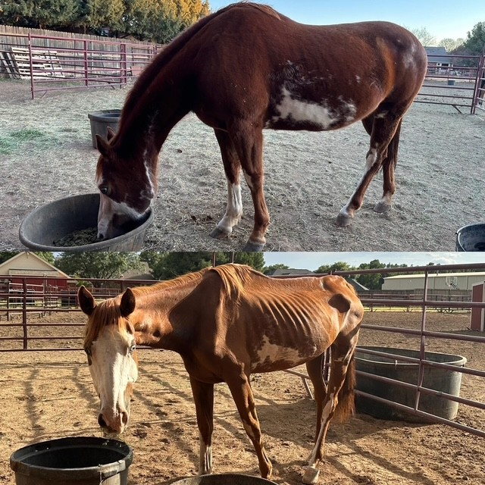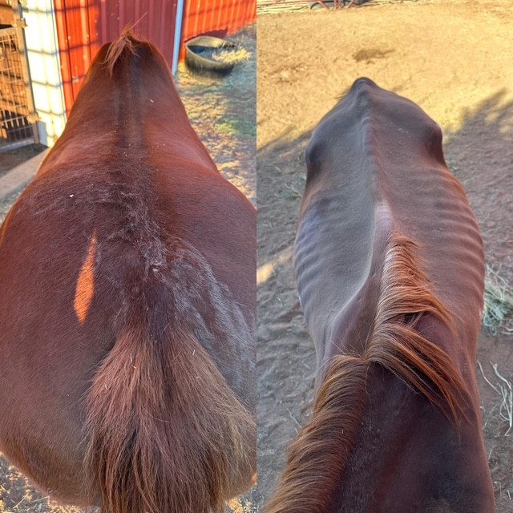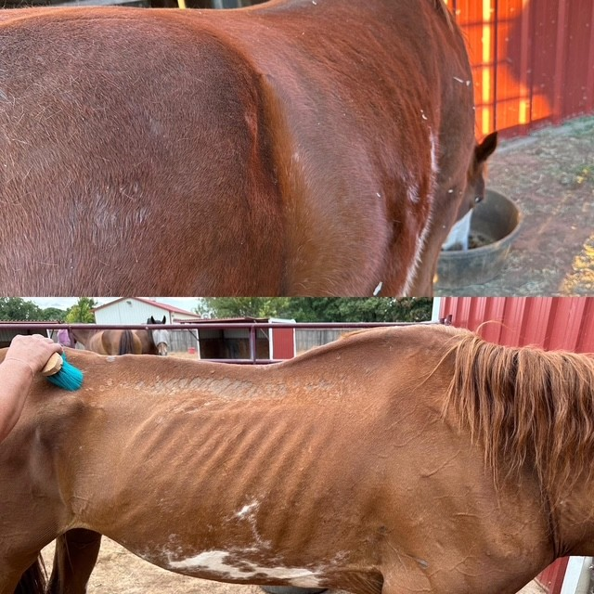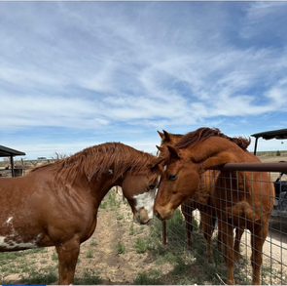
Before and after.
She looks so different!
Maysie meeting her new friends in her new foster home. She is stunningly beautiful!
Life after rescue! ❤️

