Our Mission: Fountains of Hope (FoH) serves God’s people by providing safe, life-giving water. FoH leads mission teams installing reliable and sustainable water “oasis” purification systems around the world. We help literally thousands of people in need/disaster situations. Our simple purification system disinfects 3,600 gallons of water per hour using a cup of table salt, water and a 12-volt battery. Chlorine gas is made from the table salt through electrolysis and injected into the water killing bacteria such as cholera, typhoid, e-coli and micro-organisms causing diarrhea. FoH developed a simple solution that provides safe, life-giving water to a thirsty world.
Our “Hall of Fame” Project: FoH partnered with OrthoIndy to install our largest water purifier system in La Digue Mattheux, Haiti. It provides 4,600 gallons of safe, filtered & purified water for a community of 10,000 people including 8,500 children in local schools and orphanages. The upper purifier tank purifies 1,000 gallons in just 20 minutes. Afterwards, the water is moved by gravity through a manifold system to one of three 1,000-gallon tanks below where the chlorine is allowed to evaporate prior to distribution. (See photo) Our purifier system is easily adaptable and sustainable for use worldwide in churches, schools, orphanages and medical clinics.
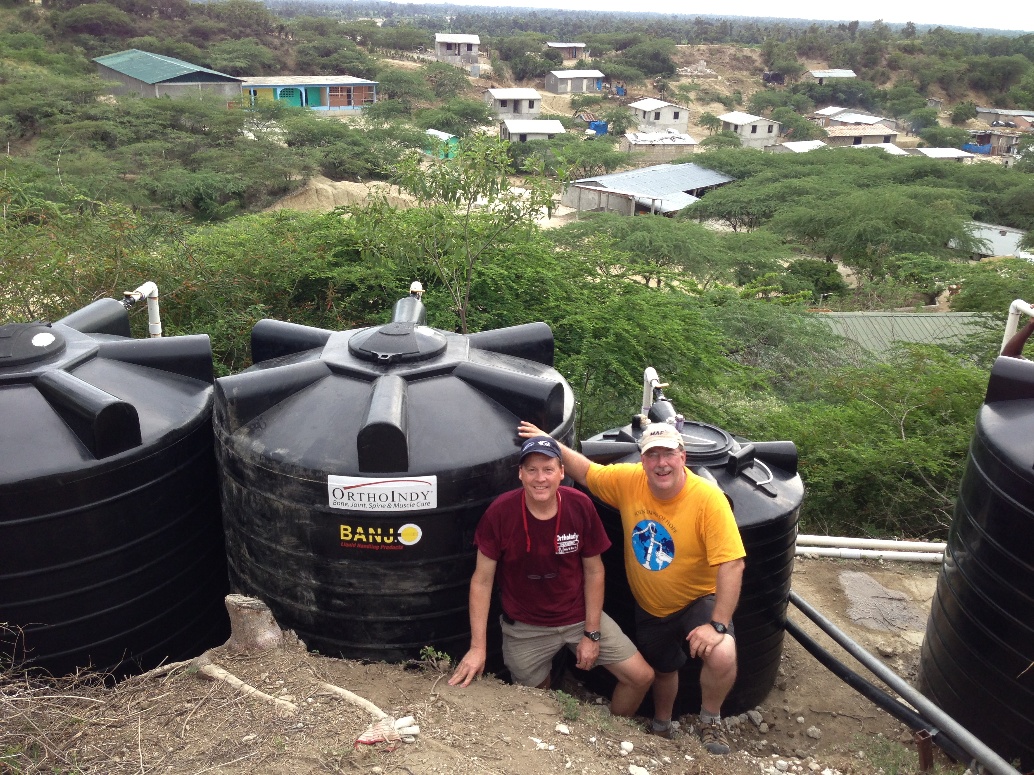
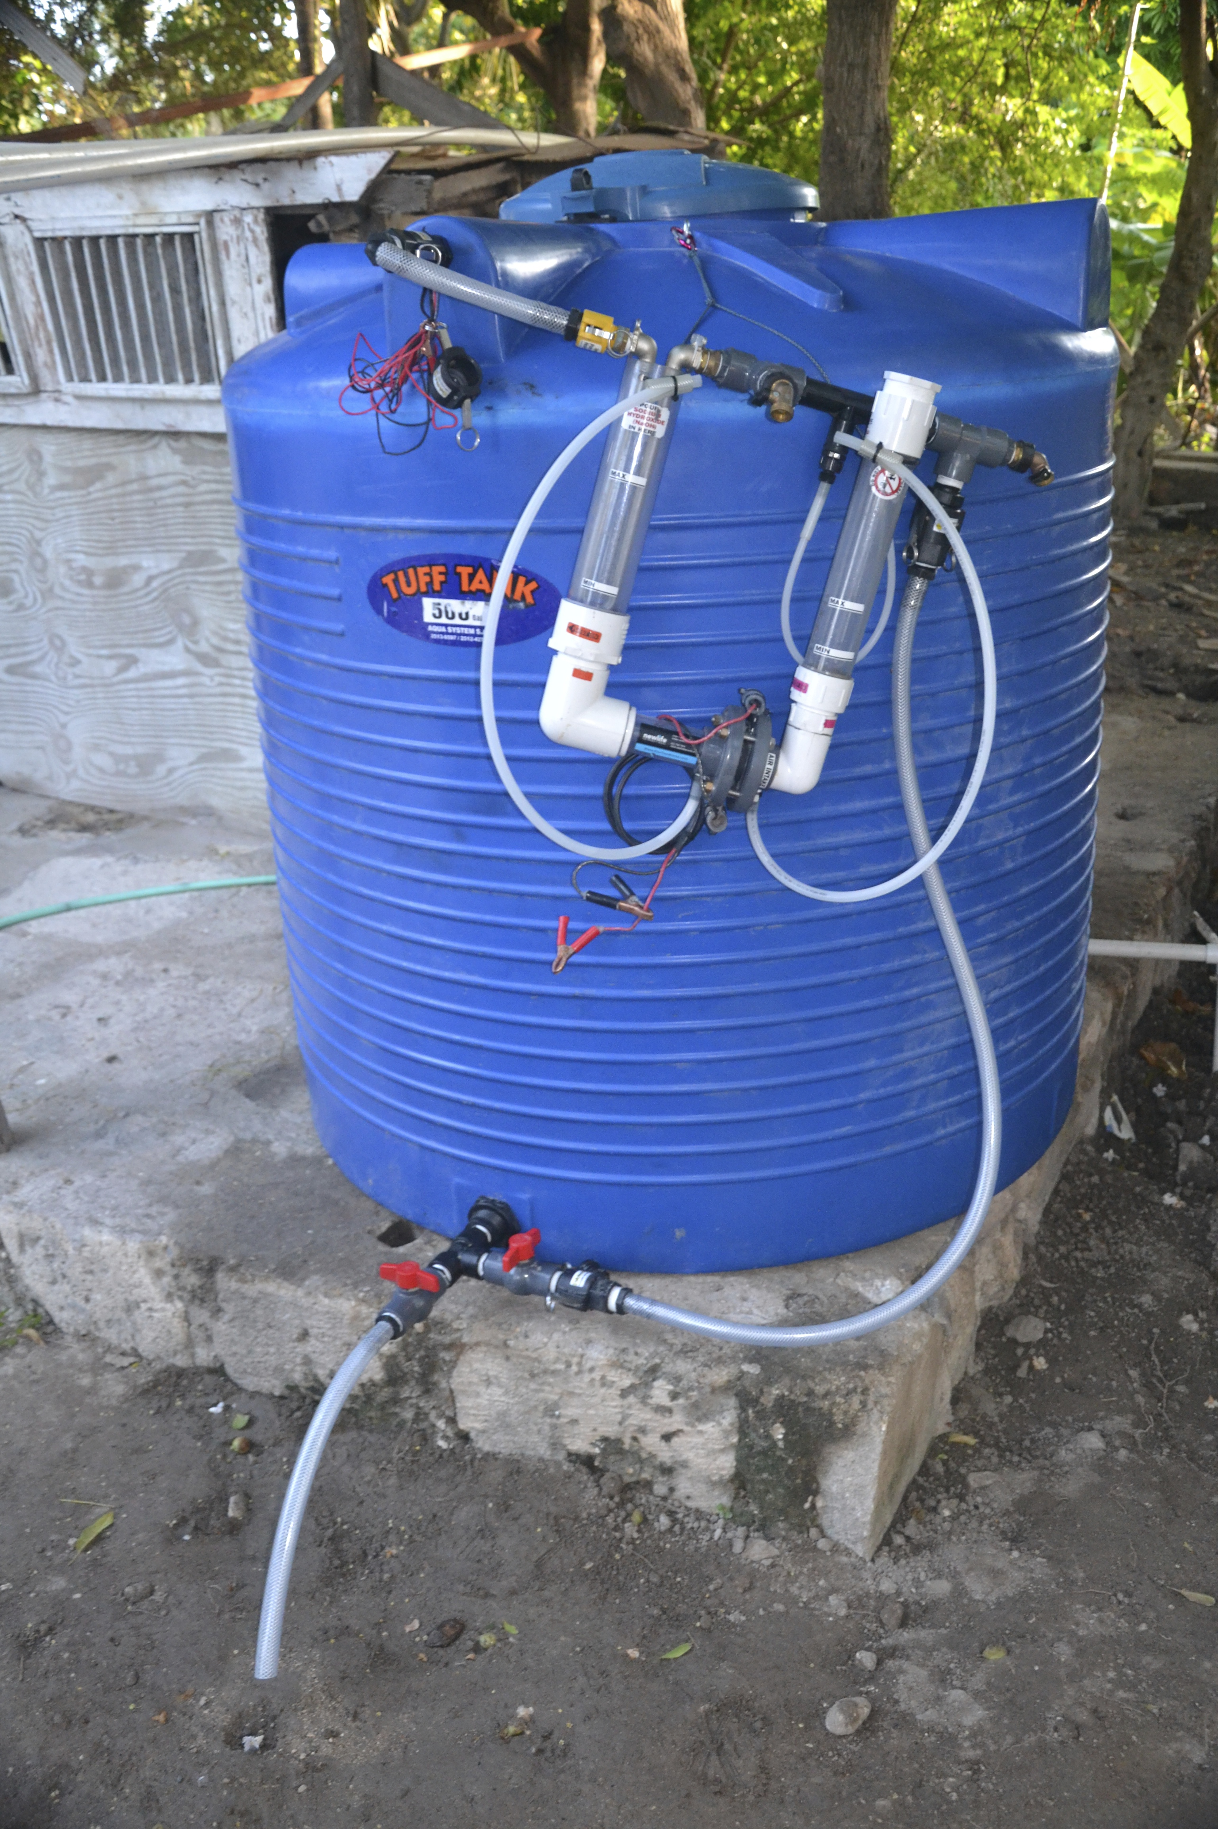
Fountains of Hope International
FountainsOfHope.org
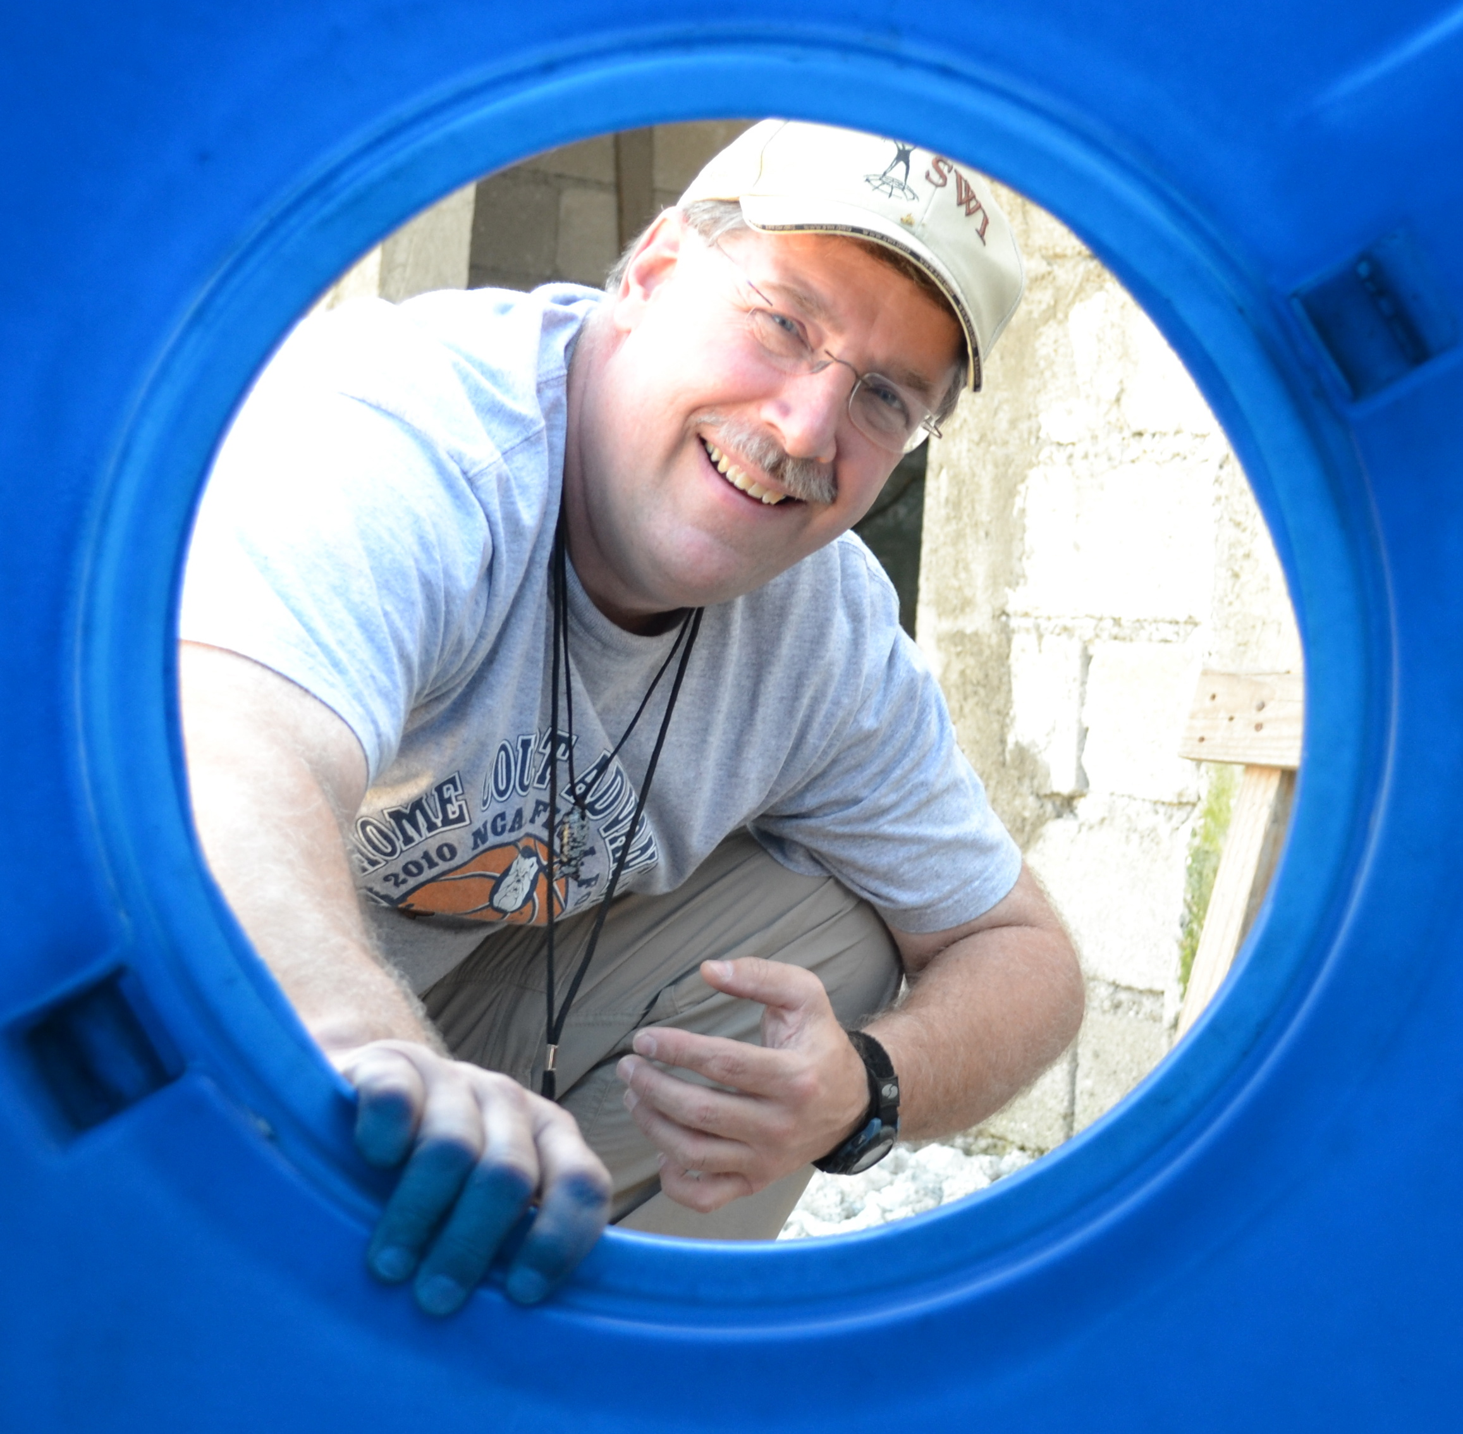
Bill Farrar
Executive Director

How YOU Can Help:
Pray! – That FoH will continue growing in all areas so that we can help end the world’s water crisis.
GO! – On a life-changing mission trip with FoH. Take your church or family on a FoH Trip. You will all be changed!
Volunteer! – FoH needs help at our warehouse assembling water purifier systems. Families, youth or small groups can help. Volunteers are also needed in our office, and to head up our FoH Banquet & Golf Outing.
Fund a FoH Water Oasis! Churches, individuals and businesses can get more bangs for your buck by partnering with FoH. One FoH purifier system can be an oasis of water for an entire village or community and is the very best use of your finances. All gifts, small or large, are greatly appreciated!

Fountains of Hope International
8731 Americana Boulevard
Indianapolis, Indiana, 46268 USA
Phone: (317) 289-9170
E-mail: Bill@FountainsOfHope.org
Web Site: http://FountainsOfHope.org

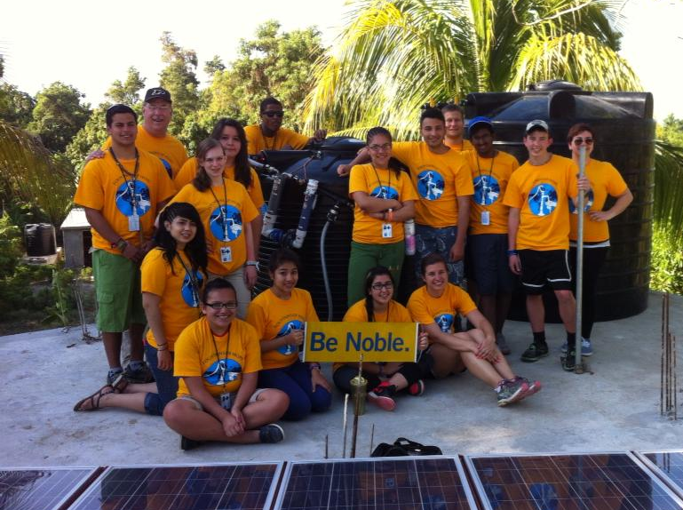
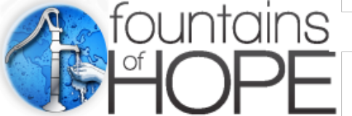Transforming Lives Through Safe Water

Project Budget - Petit Bois Village School & Hattee Marree School, Haiti
For nine Indy MET Students, two Indy MET teachers and two adults
Equipment:
Water Purification System $3,200 x2 $6,400
Tool Kit $ 80 x2 $ 160
600 Gallon Tanks (2 at $700 Each) $1,400 x2 $2,800
12 Volt Deep Cycle Battery $ 300 x2 $ 600
Water Testing Kit $ 20 x2 $ 40
Health and Hygiene Materials/Manual $ 500 x2 $1,000
Shipping $ 200 x2 $ 400
Customs Fees on Equipment $ 300 x2 $ 600
$6,000 $12,000

Travel (Covered by a grant by Goodwill Industries plus donations Indy MET HOPE students raised):
Airfare $10,200
Room, Board, Transportation, Interpreter $ 8,640
Insurance $ 560
Shots $ 1,800
Passports $ 1,620
3rd Water Purifier System (Goodwill Sponsored) $ 6,000
$28,820

Total Expenses $40,820
Donations $28,820
Amount requested from GlobalGiving $12,000

