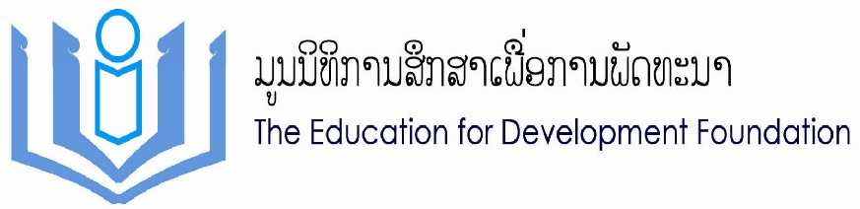

**Project Proposal**

For

Book to School

(BToS)

Academic Year 2014-2015

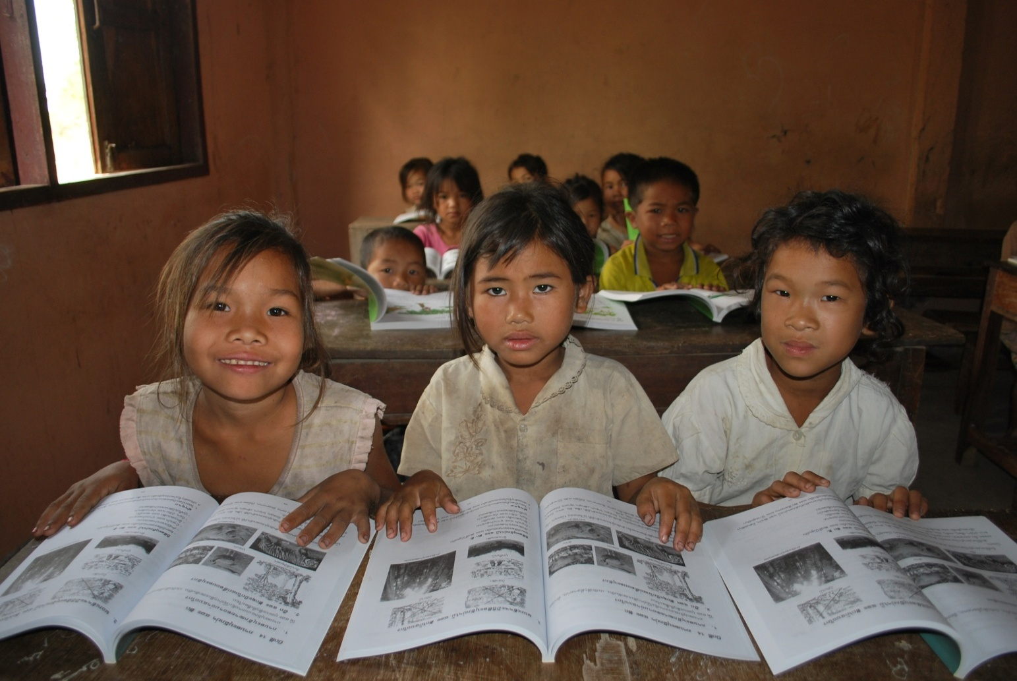

​

By: The Education for Development Foundation (EDF-Lao)

And

​Research Institute for Educational Sciences (RIES)

April 2014

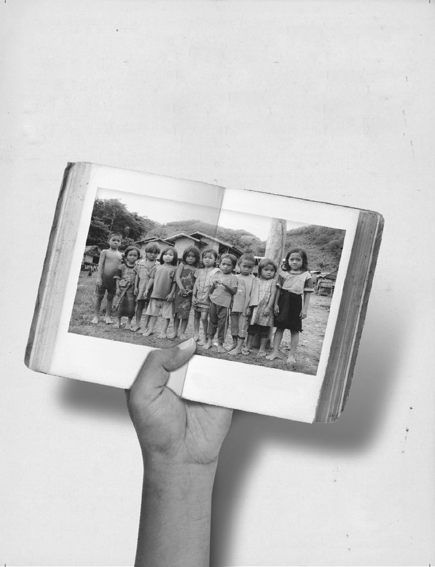**Contents**

1. Project Summary
2. Background and Mission of EDF-Lao
3. Project Proposal​
4. EDF Lao Profile
5. Message from the President

**I. Project Summary**

|  |  |
| --- | --- |
| Project Name | “Teaching and Learning Quality Improvement in Primary Education” |
| Campaign Name | “Book to School” |
| Project Executor | 1) Research Institute for Education and Science (RIES), Ministry of Education and Sport in Laos (MOES)  2) The Education for Development Foundation (EDF-Lao) |
| Office Location | 1) The Education for Development Foundation (EDF-Lao)  Hatsady Tai Village, Chanthabouly District, Lane-Xang Avenue  ANZ Building, 3rd Floor, Room No. 5  Telephone 021-222720, 021-240300  Fax: 021-222720  2) Research Institute for Education and Science (RIES)  Mohosod Road, Chanthabouly District, Lane-xang Avenue  Tel/Fax 021-213161 |
| Project Activity | Providing textbooks for Primary Schools |
| Target Areas | Lamam, Thateng, Kaleum and Dakjeung Districts in Sekong Province |
| Activities and Agenda | * Campaign: Between April to Aug of 2014 * Book Distribution: September to October of 2014 * Report to donors: December 2014 – January 2015 |
| Amount | 60,000 Kip per set |
| Project Implementation Committees | * Research Institute for Education and Science (RIES) * Primary and Pre-School Education Department * Provincial Education and Sport Service (PESS) * District Education and Sport Bureau (DEB) * Representative from each schools * Village Education Development Committee (VEDC) * EDF-Lao Staff members |

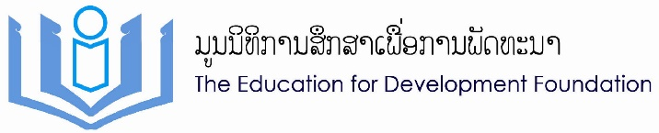**II. Background and Mission of EDF-Lao**

EDF-Lao was founded and began operations in 1997 with the aim of providing educational opportunities to local underprivileged children in Laos. EDF-Lao works to progressively reduce poverty and to improve the education system through cooperation with both the government and local public sectors. EDF-Lao is working together with the Ministry of Education, Provincial Education Sport and Services as well as District Education Bureau and Sport (DEBS) in each currently operated provinces, Khammouane, Savannakhet, Saravan and Sekong.

EDF-Lao aim to enrich the basic education environment and work towards the elimination of poverty in Laos through education. Our mission is that:

*“EDF-Lao works toward ending the cycle of poverty by providing equal access to the disadvantage children in Laos and improving quality education in order for the children to reach their fullest potential.”*

With Education, we believe, is the key in lasting and effective way we can help children and their families to escape from the cycle of poverty. It is an investment in their future and our society. We strongly believe that developing children through quality education will be a significant pathway to break the chronic poverty cycle in Laos. This will help Laos achieve the goal of “Education for All” and will serve as a noteworthy taskforce to drive community development in perpetuity.

**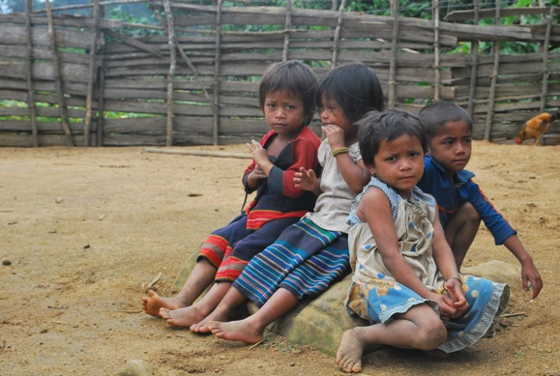**

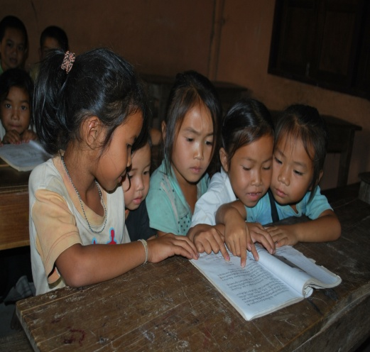**III. Project Proposal**

**3.1 Project Name:**

“Book to School”

**3.2 Project Campaign**

Give them books, give them future

**3.3 Introduction**

The textbook situation in Lao PDR is of great concern for the country’s educators at all levels. Textbook supply has depended on government and foreign fundings; its current availability however does not meet national demand. As a result, text books are insufficient and are given collectively to some schools, some students, for multi-year use rather than individually to every student each year. This is not conducive to encouraging students to cultivate a reading or studying habit at home or at school. In class, challenges remain for students as it is not often that a student gets to have one-on-one time with their borrowed textbooks. These widespread insufficiencies have made learning and teaching in rural classrooms in Lao PDR, extra difficult. The Ministry of Education and Sport **(MOEs)** of Lao PDR together with **EDF-Lao** has established Book to School Project on 12 January of 2011 to improve the quality of learning through sustainable supplying textbooks to primary education level nationwide.

**3.4 About Book to School**

In the academic school year 2014-2015 marks Book to School’s 4th year. In the initial years, Sekong Province is our campaign area of priority. Sekong has 4 districts; Lamam and, Thateang Districts are flat lands and Dakcheung and Kaleum Districts are rocky, rugged and hilly remote areas. These two districts are very difficult to access during raining season.

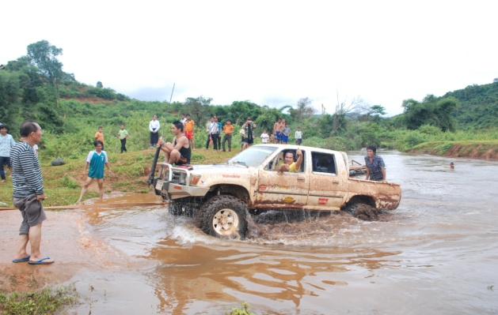 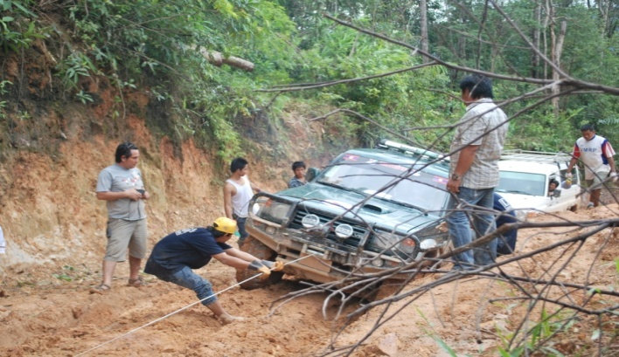

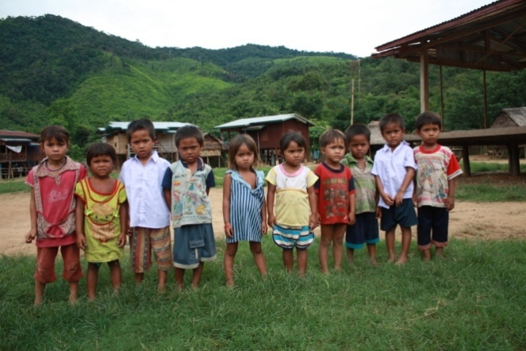 There are about 100,000 inhabitants with low literacy rate. According to the Education for All Global Monitoring Report 2010, the southern part of Lao PDR is noted to be suffering the highest rate of extreme education poverty in the country. Out of the 4 Southern Provinces, Sekong is the most textbook-deprived province; 1 in every 4 schools doesn’t have textbooks for their students and thus have to share books (Annual Education Development Report, MOE, 2008/9). As much as over 50% of the households in Sekong Province are defined as poor by the national standard thus parents can hardly afford to buy textbooks. Due to the high demand and insufficient of textbooks at Sekong Province Sekong will still be our target area to provide textbooks to the disadvantage children.

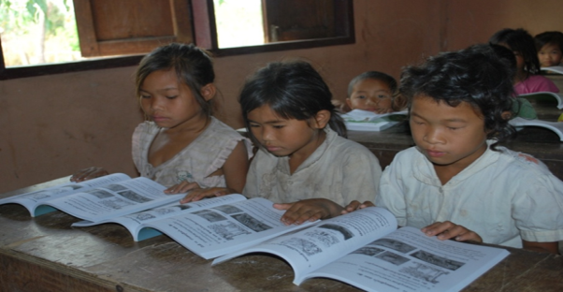Based on a national statistics, approximately 8,500 students in Sekong province, most of whom are ethnic minorities, are enrolled in primary school in 2008/9. Although, the number of primary school students has been recorded to increase year after year, the usage of the books has been an issue. "Book to School" aims to supply textbooks to meet the needs of the students, each student each textbooks is our goal.

In previous years we provided 6,214 textbook set to grade P1, P2 and P3. For this School year 2014-2015 EDF-Lao is targeting to provide textbooks to the students in Sekong who are in grade P4.

**3.5 How ‘Book to School’ makes a difference**

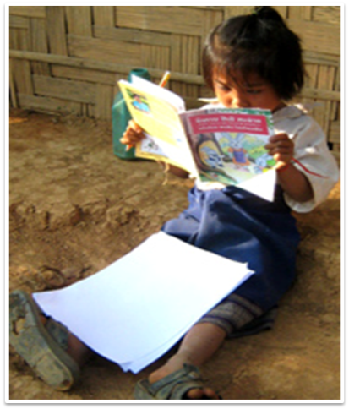

With ‘Book to School’, students will have their own textbooks to help them study more effectively in class and gain a long-overdue chance to develop self-discipline and studying habit. Students having their own text books will not hinder them from being absent from school as now they have studying materials so they can concentrate in school better and have a brighter future.

The feedbacks were unanimous and positive; both teachers and students reported an improvement in classroom learning. Students commented that they found it easier to follow and understand lessons and particular enjoyed being able to study at home to support the work they do in class.

**3.6 Set of Textbook for Students**

The Textbook set for student is 3 books for one package which consist of 3 subjects as:

1. Lao language textbook
2. Mathematics textbook
3. Moral Education and World Around Us textbook

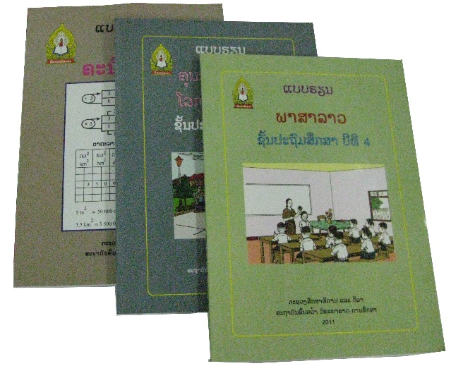

**3.7 Cost of Project**

**With 60,000 Kip donation to Book to School...**

**3.8 Why ‘Book to School’ require multiple partners?**

‘Education’ is the important key for Lao people to break away from poverty and become a more develope country. Along with socio-economic development, education development builds quality human resources for the nation which consume huge investment and times. Today, globalisation is moving fast, especially in Science and technologies, therefore it requires faster and more effective investment on human resources which cannot rely solely on the government. Therefore, education need cooperation and supports from multiple organization as partners. ‘Book to School’ requires multiple partners to work together with the Ministry of Educatio to supply sufficient textbooks and improve teaching and leanring quality standards together with the Research Institute for Educational Sciences (RIES).

**3.9 Benefit returns to your company**

1) Promoting your name or your business and company through:

-Sticking a logo of your name and business on every supported textbooks

-Promoting on EDF-Lao’s website and social media

-Company and Business logo will be put on banner for BtoS events

2) Your contribution to society will be known

**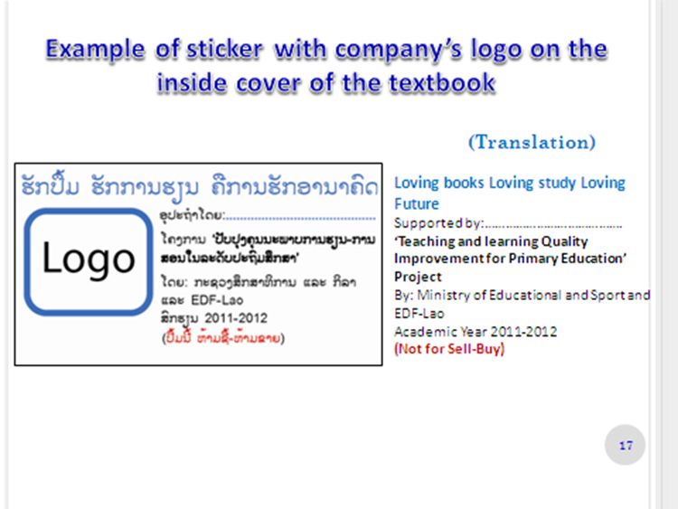**

***(Donor’s name is placed on each book with a motto to encourage self learning:***

***‘Loving book, Loving study, Loving future’)***

**3.10 Project Achievement**

|  |  |  |
| --- | --- | --- |
| C:\Users\iTcorner\Desktop\BTOS 2014 photo\2-028-1.JPG | C:\Users\iTcorner\Desktop\BTOS 2014 photo\2-003-2.JPG | C:\Users\iTcorner\Desktop\BTOS 2014 photo\1-009.JPG |
| C:\Users\iTcorner\Desktop\BTOS 2014 photo\1-031.JPG | C:\Users\iTcorner\Desktop\BTOS 2014 photo\1-016.JPG | C:\Users\iTcorner\Desktop\BTOS 2014 photo\1-019.JPG |
|  | C:\Users\iTcorner\Desktop\BTOS 2014 photo\2-049-1.JPG | C:\Users\iTcorner\Desktop\BTOS 2014 photo\2-001-2.JPG |
| C:\Users\iTcorner\Desktop\BTOS 2014 photo\1-041-2.JPG | C:\Users\iTcorner\Desktop\BTOS 2014 photo\2-031-1.JPG | C:\Users\iTcorner\Desktop\BTOS 2014 photo\2-016-2.JPG |

**IV. EDF Lao’s Profile**

EDF-Lao has implemented many different projects which 100% aim to develop Lao’s Education. Having been working closely with government agencies since 1997, the Book to School program and development projects run by [The Education for Development Fund, EDF-Lao](http://www.edflao.org), are well-recognized and highly acclaimed by the Ministry of Education of Lao PDR.

|  |  |  |  |
| --- | --- | --- | --- |
| **No** | **Programmes** | | **Recently achivement** |
| 1 | M:\Photos SLS\DSCF1644_0.JPG**Scholarship Project** | Cloth | The Project has been launched to alleviate poverty and promote both primary and secondary education in needy rural areas. Scholarships are provided to underprivileged children so they can continue their studies.  Approximately 70,000 scholars benefitted from this program |
| 2 | **C:\Documents and Settings\Degkorat\Desktop\annual meeting 2011\1.Kato\Pics\2.JPG Construction Project** | **C:\Documents and Settings\Degkorat\Desktop\annual meeting 2011\1.Kato\Pics\3.JPG** | The School Construction Project is a school-building project; It is the construction of unique, environmental friendly and fully furnished 6-room primary school buildings    35 schools were constructed since project started in 1997 |
| 3 | DSC_1952**Teacher Training Master Degree Projet** | C:\Users\iTcorner\Desktop\TTM 2014 report photo\1512467_689672171066088_1286485577_n.jpg | TTM, initiated in 2004, aims to strengthen Lao’s teaching force by providing higher education opportunities at a Master Degree level for teachers and professional educators.  27 teachers were provided scholarship and those teachers will be part of SOP and Book to School project to develop teaching methods and material such as textbooks and teacher guidance books |
| 4 | **Rural Ethnic Teacher Training Project**  DSC03715 | P3 class | Quality of education in the rural area is a main concern. RET project provides ethnic minority students in secondary school scholarships to study at Teachers' Training Schools. After graduation, these new teachers return to their communities in remote areas to teach and help better their village  Since 2004, 114 scholars graduated, became teachers and returned to their village to teach and help their village to grow and prosper |
| 5 | G:\Yangkham_Library\SAM_2247.JPG**Library Project** | IMG_8057 | Lacking of reading books in primary and secondary schools are still an obstacle for education development. Library Project builds library rooms to serve as a Learning Center as well as provide library boxes for schools and classrooms that does not have space as space is very limited  Overall 892 library services were provided which includes library boxes, library rooms and furnished library centers. |
| 6 | **pic%2019[1] Lunch Project** | SDC12753 | This is a 3 year project and the mission of this project is to promote small scale agriculture production in order to supply lunches for students and alleviate poverty in long term. The project aims to respond to malnutrition problems in children as well as encourage children to attend school  In its piloting stage, this project is currently in Khamouane district providing a program to 3 different schools and servicing 610 students. |
| 7 | **Present Set Project** |  | This project is intended for donors; Donors have a chance to purchase a present set for their scholars on special occasion or any occasion. The objectives are to 1) promote friendship between donors, scholars and schools, 2) support scholars in another aspect other than scholarship and most importantly 3) encourage scholars with their education.  The project has provided 179 present sets, 19 sport sets and 48 school supply sets for students, teachers and schools since 2013 |

**V. Message from the President**

*“Having Education leads to Health and Wealth,” Therefore, EDF-Lao exists to serve the people in need of opportunity for education, especially basic education. In providing books to students and improving quality education those children will have their life foundation-education, in order to stand on their feet and to further serve their family, community and society. Those children then are more likely to educate their children and their children are more likely to educate their children, so forth and in hope, end the cycle of poverty one generation at a time.*

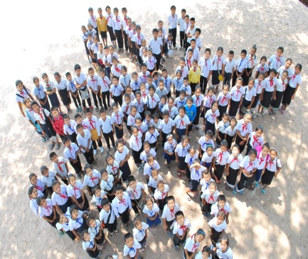*Education is the important key for Lao people to end poverty and be a more developed country. Along with socio-economic development, education development is to build quality human resources for the nation which consume huge investment and time. We hope to get support internally and abroad so EDF Lao can continue its role in education and develop its work efficiently.*

Mr. Khamhiane Inthava

President of EDF-Laos