ManavyaReport for empowering 50 HIV+ orphan children through education

***Introduction:***

***The start of the quarter was delightful as it started on an auspicious occasion of Gudipadva with a traditional celebration. Overall the quarter was a perfect blend of hard work, dedication and rigorous efforts that children had invested in their academics as they had all of their final assignments, submissions, important tasks and annual examinations followed by the results and summer vacation which was welcomed with enthusiasm and zeal backed with summer events and activities as well as a one day picnic to Hadshi.***

***Academic Flagship:***

***It was a quarter of great rejoicing and excitement as Manavya family was excited to know the results of our children appeared for 10th and 12th standard. This quarter was of immense importance to us as eleven of our children appeared for SSC final examination and a two of children appeared for HSC final examination. Proving our trust, all of the children cleared these examinations with satisfactory grades. All the SSC students are now in an ongoing process of deciding their area of interest, most of whom are being enrolled for vocational training programs in order to make them independent and self-sufficient. The ones, who are proven to be good at academics and have shown interest in pursuing college and have the capacity to pursue college education, are being enrolled in the colleges. Out of the two children who appeared for HSC examination, one will be enrolled for vocational training program while the other will resume college. Eight children cleared their primary schooling from our residential school and have catapult to another level where they have been enrolled at the community school to pursue their high school education. Children are adjusting to their new schools, colleges and training institutes and are back to their routine after a refreshing summer vacation.***

***Career Choices to help them achieve their dreams:***

***10th and 12th being milestone these qualifications concretize the basis of every career plan. These exams are like litmus test that gives our children a clear indication as to where they stand. Before the examination the children were exposed to number of career guidance sessions and counselling session, for making them contented with the choices they have made. In this Manavya family stood by their children helping them overcome every hurdle that comes their way it may in selection of a particular course to admission process.***

***Choosing your future begins with self-analysis; and we do mean SELF that’s the actual aim of our counseling session done by MANAVYA Staff. Traditional thinking seems to limit choices to science, mathematics, commerce and humanities – but that’s no longer the case at Manavya .Careers are now best based on children’s natural skills and talents – whether for writing or for sports or for any interest dear to you. This has proved significant in a metamorphosis in the way Manavya perceives the growth of the children where this year our management took a crucial decision of admitting them in program which will upgrade skills of every individual child. We have introduced them to professional courses rather than going into conventional educational system.***

***Introducing earns and learn scheme:***

***Moving out of the comfort zone of Manavya:***

***Vigyan Ashram Pabal***

***Manavya decided to involve the 4 children who have successfully completed their S.S.C examination to VigyanAshram,Pabal. The course is only for these students who are not interesting in regular education system ,but want to do something creative or want to be a industrialist. Vigyan Ashram residential institute who provides education in sector of science & technology since more than 25 years with object of “Rural Development through Education.Vigyan Ashram located in Pabal village district,Pune.It is a technology resource centre of CAPART of ministry of rural development. Vigyan Ashram provides“2 years residential plus apprenticeship non-formal education program i.e Diploma in Basic Rural Technology,which includes education in following areas :***

* ***Engineering- (Fabrication & construction& Basic Carpentry, Engineering Drawing & Costing )***
* ***Energy & Environment - (Electrical, Motor rewinding, survey techniques, solar / biogas etc.)***
* ***Home and Health (Sewing, food processing and rural lab)***
* ***Agriculture and Animal Husbandry (polyhouse, poultry, goat farming, dairy nursery techniques)***
* ***Beside this computer, meditation, sports, Adventure etc. are parts of the program.***
* ***Fab Lab for digital fabrication including 3D printing.***

***The course contains not only theoretical knowledge but also a practical experience to our children. Our two children also getting stipend of Rs. 200/- under earn & learned scheme at Pabal to give ordinary people around the world the technology to design and make their own stuff.Learning while doing it’s a natural process of learning. It’s not only vocational teaching; rather it’s a process of encouraging or boosting to make them self independent. That is why we put a step ahead & give opportunity to four of our children to take admission in Vigyan Ashram. Manavya now emphasizing on introducing children to professional courses rather than going into conventional education system i.e regular graduation .Manavya thinks that all such professional courses will help children to make them self independent in all respect.***

***Kohinoor Technical Institute (KTI)***

***Manavya recently took a decision to involve 10th passed children to various vocational trainings in all the technical areas.KTI*** e***stablished in 1967, it is a pioneer in vocational training for technical courses.***

***KTI provides various technical educations that is focused on employment and livelihood.***

***Manavya involved 10th passed 7th children for vocational training at KTI. According to Manavya children’s must have full freedom of choose their carrier as per their own interest & capacity.KTI provides technical education to our 7 children who have passed 10th examination are taking education in following areas.***

* ***Electricals Computer Software***
* ***A.C & Refrigeration Automobile***
* ***Mobile Repairing Mechanical***

***KTI arrange campus interviews for their students after completion of their course. It helps students to get placement in various renowned companies. It will help to our children to brighten their future & to stand on their own legs confidently.***

***This will also help the children for acceptance in social community.***

***Felicitation of 10th passed children***

***For this academic year 5 children were appeared for S.S.C examination. It was a proud movement for Manavya that they successfully completed 10th examination with first class.***

***Manavya has organised the felicitation program for honouring our children on foundation day 21st June 2016. Manavya has gifted them a nice multi used Jerkin as a token of appreciation from the hands of our honourable guest for their success.***

**Hadshi Photographs**

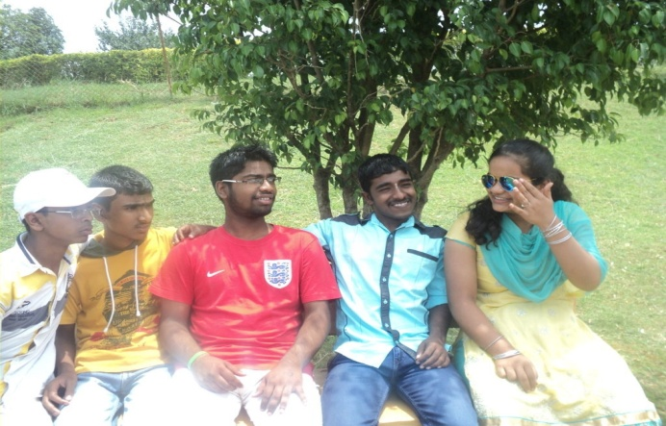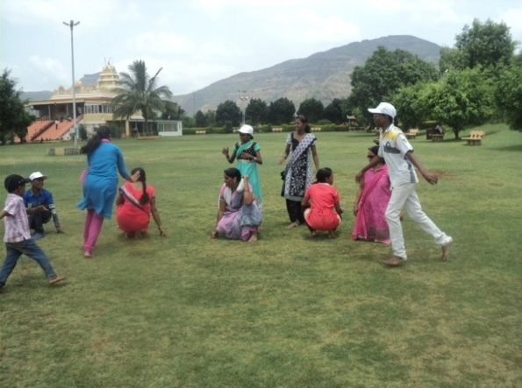

Pabal Photographs (Tree Planting)

