SNEHALAYA

 Project Monthly Report

Reporting period : June 2015

Name of Project : Rehabilitation center

Name of reporting person : Mr.Vaijnath Lohar

1. **Project Performance:**

|  |  |  |  |
| --- | --- | --- | --- |
| **Sr. No.** | **Performance Parameter** | **Target** | **Achievement** |
|  | School attendance | 100% | 98% |
|  | Timely Food Serving | 100% | 90 % |
|  | IPD ( 2 ) | 100% | 100 % |
|  | OPD (67) | 100% | 100 % |
|  | ART Follow-up (102/102) | 100% | 100 % |
|  | CD-4 Testing (25/25) | 100% | 100 % |
|  | Physical Checkup ( 10/10 ) | 100% | 100 % |
|  | Counseling ( 17/17) | 100% | 100 % |
|  | Execution of Extra Curriculum Activity ( 2 ) | 100% | 100 % |
|  | Study Class Attendance | 100% | Summer Vacation |
|  | Coaching C lass Attendance | 100% | NA ( Started from 1 July 2015) |
|  | Cleaning & Hygienic Dormitory | 100% | 92.65 % |
|  | Maintenance Complaints (14/7) | 100% | 50 % |
|  | Timely Material Distribution | 100% | 100 % |
|  | Departmental Review | 100% | 100 % |

1. **Statistical Report:**
2. **Beneficiary Status :**

|  |  |  |  |  |
| --- | --- | --- | --- | --- |
| **Sr.No** | **Name of Balgruh** | **Girls** | **Boys** | **Total** |
| **1** | Sneh-Asha Special Balgruh  (for HIV/AIDS Children) | **63** | **86** | **149** |
| **2** | Sneh-Balgruh | **43** | **29** | **72** |
| **3** | Sneh-Balsadan | **15** | **08** | **23** |
| **4** | GKN Rehabilitation center  (After care unit) | **00** | **03** | **03** |
| **5** | Snehalaya | **02** | **12** | **14** |
| **Total** | | **123** | **138** | **261** |

1. **Services being provided**:-

|  |  |  |  |  |
| --- | --- | --- | --- | --- |
| **Services** | **No.s of beneficiaries availing the services** | | | **Total** |
| **Snehasha Balgruh** | **Sneh Balgruh** | **Sneh Balsadan** |
| Food | 149 | 73 | 23 | **245** |
| Education | 144 | 70 | 23 | **245** |
| Shelter | 149 | 73 | 23 | **245** |
| Clothing | 149 | 73 | 23 | **245** |
| Health/Medical | 149 | 73 | 23 | **245** |
| Civilisation | 0 | 0 | 0 | **0** |
| Short Stay | 0 | 0 | 0 | **0** |
| Counselling | 12 | 05 | 00 | **17** |
| Legal Aid | 0 | 0 | 0 | **0** |
| Vocational Training | 0 | 0 | 0 | **0** |
| Referral | 2 | 0 | 0 | **2** |
| Rehabilitation | 0 | 0 | 0 | **0** |
| Adoption | 0 | 0 | 0 | **0** |
| Other | 0 | 0 | 0 | **0** |

1. **Major Highlights :**

**Snehalaya HSC students secure 100% & SSC students post 88% results**

We are feeling very happy and proud to share our HSC and SSC student’s results of the academic year 2014-15. Snehalaya is running several projects including Rehabilitation Center for children in red light areas and HIV postive kids and Balbahvan for slum children. This year 6 students for HSC and 34 studetns for SSC from Rehab. Center were appeared at the same time 44 students for HSC and 71 students for SSC from Balbhavan were appeared. All out of 155 , 135 students have posted highly impressive results.

It is noteworthy that the students with HIV/AIDs & having very poor economic background of their family who had appeared for the HSC and SSC exam this year have secured first class by overcoming all their problems in day today life.

Our students had special support and guidance from all the teaching and non-teaching and care giving staff.

The toppers are as follows:

|  |  |  |  |
| --- | --- | --- | --- |
| Project Name | Grade | Name of student | Mark Obtained % |
| Rehab Center | HSC | Pooja Shinde | 72 |
| Rushikesh Sagarale | 68 |
| Manisha Aher | 65 |
| SSC | Priyanka Shendage | 77 |
| Anita Gaikwad | 71 |
| Savita Rothe | 70 |

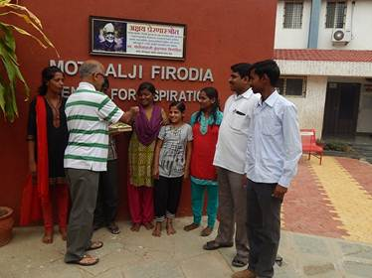

NAME OF PROGRAM: Career Counseling

VENUE: Alliance Hall

TIME: 10:00 A.M

DATE: 28 JUNE 2015

RESOURCES USED: Sound system, white board marker and duster.

PARTICIPANTS: 44 Students and 3 Teachers

PROGRAM DESCRIPTION: In this training we had Mansi Madam and Sneha Madam from "Saarthi" Mumbai as career counselors for our 10th and above students and they guided them well with proper points such as what studies are like..., why the students lacking their interests from studies and why marks are important and what it assures, how marks are important or not and what is important to survive a good living life and they addressed our students with proper living examples as per students interests. Students were taken part actively and respond them with positive attitudes. In this way we had career guidance training on Sunday with MansiAmdekar Madam and her friend Sneha Madam successfully.

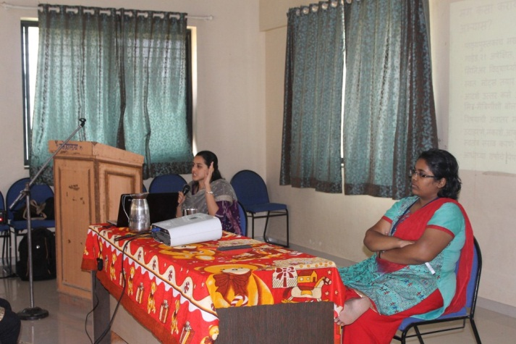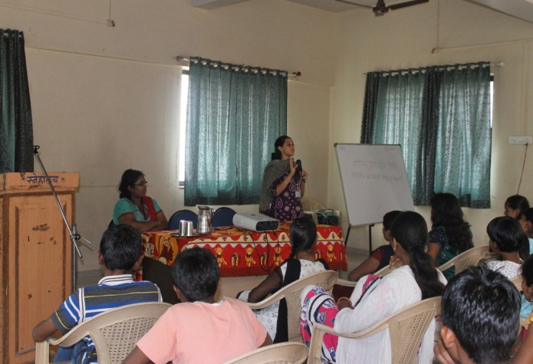

**Snehalaya’s Rehabilitation Center**

Student Admission in various schools and colleges for the educational year 2015-2016



1. **Staff Details:**

|  |  |  |  |  |  |
| --- | --- | --- | --- | --- | --- |
| **Sr. no** | **Designation** | **Filled Position** | **Vacant** | **Total** | **Remark** |
| 1 | Project Manager | 1 | 0 | **1** |  |
| 2 | Office Assistance | 1 | 0 | **1** |  |
| 3 | Section Head | 3 | 0 | **3** |  |
| 4 | Asst. Supriendendant | 1 | 1 | **2** |  |
| 5 | Care Taker | 8 | 2 | **10** |  |
| 6 | House mother | 2 | 8 | **10** |  |
| 7 | Counsellor | 0 | 2 | **2** |  |
| 8 | Part Time Teacher | 2 | 1 | **3** |  |
| 9 | Education Head | 0 | 1 | **1** |  |
| 10 | Store In charge | 1 | 0 | **1** |  |
| 11 | Asst. Store In charge | 0 | 1 | **1** |  |
| 12 | Driver | 3 | 0 | **3** |  |
| 13 | Cook | 1 | 0 | **1** |  |
| 14 | Asst. Cook | 1 | 0 | **1** |  |
| 15 | Kitchen Supervisor | 1 | 0 | **1** |  |
| 16 | Gardner | 1 | 0 | **1** |  |
| 17 | Washing machine In charge | 1 | 0 | **1** |  |
| Total | | 27 | 16 | **43** |  |

1. **Expenditure Report**

|  |  |  |  |  |  |
| --- | --- | --- | --- | --- | --- |
| **Sr.No** | **Account Head** | **Snehasha** | **Balgruha** | **Balsadan** | **Amount** |
| 1 | Bank Charges | 0 | 0 | 0 | 0 |
| 2 | Cloths Exp | 0 | 199 | 0 | 199 |
| 3 | Consumable Store | 0 | 0 | 0 | 0 |
| 4 | Cleaning Exp | 5139 | 2665 | 623 | 8427 |
| 5 | Cosmetics Oil & Soap | 3749 | 4917 | 596 | 9262 |
| 6 | Education Exp | 90524 | 53583 | 13926 | 158033 |
| 7 | Food grains & Milk Exp | 119288 | 81774 | 100015 | 301077 |
| 8 | Foot ware Exp | 21015 | 10115 | 2410 | 33540 |
| 9 | Fuel & Gas Exp | 12597 | 6725 | 10699 | 30021 |
| 10 | Hair Cutting Exp | 0 | 0 | 0 | 0 |
| 11 | Medical & Hospitals | 24940 | 1449 | 372 | 26761 |
| 12 | Misc Exp | 2040 | 390 | 0 | 2430 |
| 13 | Funeral | 0 | 0 | 0 | 0 |
| 14 | Printing & Stationary | 1559 | 0 | 4350 | 5909 |
| 15 | Salary Exp | 49587 | 50484 | 19800 | 119871 |
| 16 | Transport Exp | 730 | 500 | 645 | 1875 |
| 17 | Travelling, Lodging & Lacal Expans | 1503 | 780 | 0 | 2283 |
| 18 | Vegitable Exp | 21041 | 11192 | 15060 | 47293 |
| 19 | Water Exp | 8850 | 6100 | 4650 | 19600 |
| 20 | Entertainment Exp | 0 | 0 | 0 | 0 |
| 21 | Program & Functions | 0 | 0 | 0 | 0 |
| 22 | Telephone & Postage Exp | 40 | 0 | 0 | 40 |
| 23 | Repair & Maintenance | 500 | 120 | 0 | 620 |
| 24 | Photo Exp | 40 | 0 | 0 | 40 |
| 24 | Training Fee | 0 | 0 | 0 | 0 |
| 24 | Foodgrain Grinding Charges | 0 | 0 | 0 | 0 |
| 24 | Educational Fee | 0 | 0 | 0 | 0 |
| 25 | Honorarium | 20610 | 9030 | 0 | 29640 |
| 26 | News Paper & Periodicals | 1204 | 551 | 874 | 2629 |
| 27 | Grinding | 3395 | 0 | 0 | 3395 |
|  | **Total** | **388351** | **240574** | **174020** | **802945** |

**Co-Ordinater / Project Manager**

**Mr.Vaijnath Lohar**