Centre for Women's Development and Research

Skill Training for 250 Tsunami Affected Women

Updates Report April 2007

It is really astonishing to see Tsunami affected villages returning to normal life within a period of two years, particularly comparing to the devastation. Fishing is going on as usual of course there are complaints that now the catch is reduced. The major change happened in the process of rehabilitation work is women from fishing community got visibility and importance in their community. They have been consulted by NGOs and Government, they were meeting often to discuss about their issues and development of the community. Women themselves have proven that they have an important role in disaster management and rebuilding families. We are happy that we are part of this process of rebuilding with your support. Still there is a long way to achieve women’s equality in the fishing community, but definitely the process is initiated. On behalf of the women and our organization our sincere Thanks to Globalgiving for helping us in our attempt to rebuild the lives of fishing community and in the process empowering women. In India in the Vedic teachings there is a saying in Sanskrit “Vasudhaiv Ktumbikam” that means the world is one family. In this conflict ridden world only during Tsunami rehabilitation work through the help we received from different corners of the world we felt that the world is one family. We thank each and every individual who supported us through Globalgiving.

Nearly 3000 children and 500 women directly benefited from our rehabilitation activities supported by Globalgiving. Initially we started our work with providing supplementary nutrition and health services to children and adolescent girls, and then we provided skill trainings for women to rebuild their livelihood sources. Being a women’s organization we have also organized programmes to influence the government and non-governmental organizations to look into the gender discriminations in the rehabilitation work and make concise efforts to include women in the rebuilding process. We have also provided psychosocial counseling for affected women, of course all our trainings and meetings also served as a tool to provide hope and confidence to rebuild their lives and future.
When Tsunami affected our working area we did not know how to respond because we are totally new to such situation because Tsunami affected first time in our area in fact we have learned the word “Tsunami” after that. We just responded as human beings and social workers and learned from that experience. More than everything it is the support from individuals living thousands of miles away and the determination showed by the women motivated us to continue in our work.

“Maithri” (Friendship) Resource Centre for Women:
We already had given the details of the skill trainings in our earlier report. One of the important event during 2007 is we have inaugurated “Mythri”(friendship) training centre for women, in Paniyur village. One of the constraints we faced in conducting traings for women in fishing villages is the infra-structure, so we wanted to create our own training centre, that we could able to achieve. One of the skill trainings we conducted for women

with globalgivings support is making stabilized mud blocks, that can be used instead of bricks.
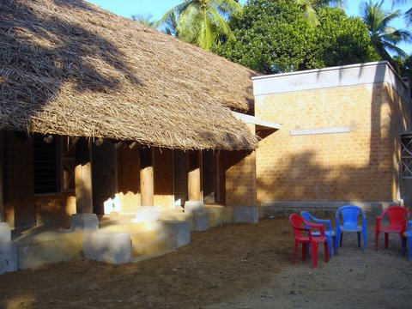
We constructed this eco-friendly building with local materials and the mud blocks produced by women, we have also mobilized additional money to construct this building. This centre will also serve as a short stay home for women affected by domestic violence. We still have some work to be completed like we have to buy furniture, learning/materials, we have to construct the compound walls. But with the present infra-structure we can conduct trainings for women and adolescent girls. With our place we can sustain the programme for long time.
Women owning the fishing assets:
In Chinna Paniyur Kuppam village after the skill training the women’s group requested to get a “Peruvalai” (big net). This is a big net it is put in the sea by the boatman in the night and in the next day 50-60 women have to pull the catch. That is more people will get the share from it. Since the fishing assets like boat and nets are owned by man, we thought it is good idea to help women to own these assets and we bought a “Peruvalai” and gave it to the women’s group, they will rent it and get some income. More than that it is a beginning for women to own the means of production.
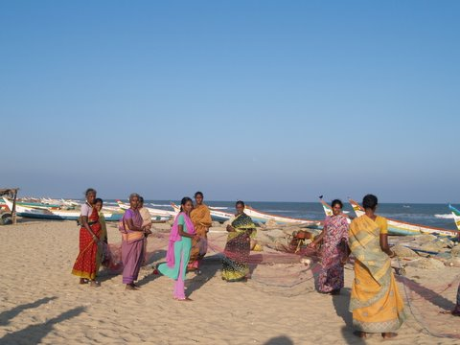

Women with the net
Seaweed cultivation training

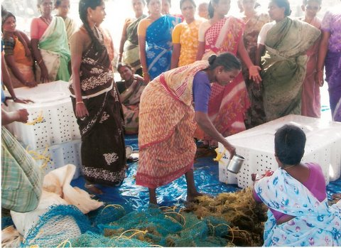

Seaweed Cultivation Training:
Seaweeds (red algae) are rich in vitamins and minerals and are consumed as food in various parts of the world. Seaweeds yields a substance called carrageenan, which is used in the manufacture of several food products, drugs and cosmetics. Growing seaweeds is an ideal vocation for the womenfolk of the fishermen community. The fishermen can also take it up as an alternative means of income when they do not venture out for fishing. Earlier we have organized a seeweed cultivation for women but they could not continue it, based on that experience we have conducted one more seaweed growing training for Chinna Paniyur and Thazuthalikuppam village women. 35 women participated in that training programme. Even though it is sea based it is a very new activity for them so they could not carry it out properly, so we are planning to take them for an exposure visit. Since it is the best income source for fishing people particularly for women we wish to develop the process and introduce it in our working areas.

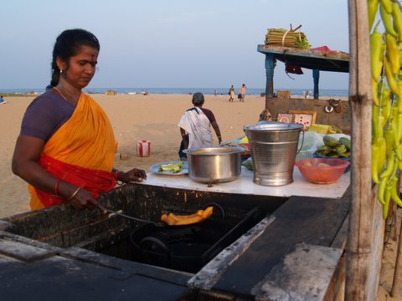
A single woman beneficiary with her shop in the beach
Income Generation Programme for Single women:
Many of the relief and rehabilitation work do not reach the single women in the fishing community. In the fishing community all those who goes for fishing has to pay a village tax to the local village panchayath (Traditional village group). Most of the relief and rehabilitation work is done through this village panchayth, they have given the benefits to those who pay the tax, because there is no one going for fishing form single women headed families they did not get the benefits. We realized it latter and made sure that our programmes reach single women. We have organized single women’s groups in 10 fishing villages and 100 single women were given entrepreneurship skill and we have also arranged for capital to start their own micro-enterprises like selling eatables, making flower garlands, small shops, fish and vegetable vending.

Life skill, sexuality education and vocational skill training for adolescent girls:
We are continuing this programme, more than 500 girls benefited from this programme. Weekend workshops were organized to provide life skill and sexuality education. Our computer skill and dress making training were ongoing. We have also organized short term trainings in screen printing, paper bag making, palm leaf product making, embroidery. We have also created a website www.snehidhi.org in Tamil for adolescent girls, the site has sexuality education, self development, tuition, doctors page, question and answer and their own pages. That can be used by all adolescent girls who knows Tamil.
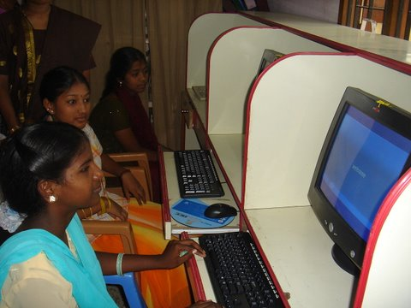
Adolescent girls learning computer skills

Improving the quality of education in local Government schools:
With GlovbalGivings support initially we started working with children like we provided supplementary nutrition, health services, education learning materials and recreational facilities. All the children in our working area are continuing their education. But In most of the government schools there is no proper infra-structure and enough teachers, usually two teachers manage 5 classes, but that is the state of schools in all over India. Initially we were running supplementary education classes in Tsunami affected areas, that time it was relevant and it also helped children to come out of trauma. Now we want to improve the quality of government school in our working area by providing additional teachers and infra-structures like learning/teaching materials, and toilets. So that children will get good education and do not drop out. So we have appointed an additional teacher in Othiryur village school. These appointments are done through the PTA-Parents Teachers Associations, we wish to extend this to other schools in our area. In rural area where we work there are 2 schools in 6 Tsunami affected villages. We wish to appoint 4 teachers in these schools we also wish to build two toilets each school so that children can use it. We also provide additional teaching learning materials like books, charts, and play materials. Nearly 600 children will benefit from this program.
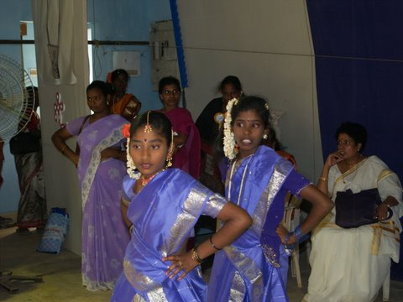
Adolescent girls dance program on International women’s day March 8th

After two years we know the people and the place better, the situation is also changed, as mentioned earlier to achieve equality of women in fishing communities will take more years, not only that to sustain the rehabilitation activities we have to continue our work for next 2-4 years. So based our experience we wish to implement the following activities. Based on that we have changed our budget and plan of action, What we are planning to do is build two model solar fish drying units to make dry fish, start two village information centers, two vermin-compost making units, paper and paper product making unit, Mushroom farm, provide further training on seaweed, crab growing for women, provide further training on palm leaf product making. All these activities would help 250-300 women earn regular monthly income of Rs.1500- 2000 ( US$33-44)

PROJECT BUDGET

Organization: Centre for Women’ s Development and Research
Project Title: Skill Training for 250 Tsunami Affected Women

Budget Date: 07th April 2007

Exchange Rate: $1 USD = Rupees 45

Activity 1: Setting up new business model units- Solar fish drying unit, Village information centre, vermi-compost making, handmade paper and paper product making, seaweed growing.
No. | Item | Unit cost (local currency) | Unit cost (USD) | Quantity | Community/  org. contribution (USD) | Requested amount (USD)
1 | Solar driers 50 Kg Capacity | 2,00,000 | 4,444 | 2 | 888 | 8,000
2 | Village information centre equipments- Computer, printer, digital cameras | 80,000 | 1,777 | 2 | 554 | 3,000
3 | Vermi-compost making Construction of cement tanks | 25,000 | 555 | 2 | 110 | 1,000
4 | Handmade paper and paper product making | 3,00,000 | 6,666 | 1 | 666 | 6,000
5 | Seaweed growing equipments | 6,000 | 133 | 10 | 330 | 1,000
I | Activity 1 total |  |  |  | 2,548 | 19,000

Activity 2:Income generation training program for women
No. | Item | Daily rate (local currency) | Daily rate (USD) | Number of Days | Community/  org. contribution (USD) | Requested amount (USD)
6 | Income generation program trainings for 250 women | 300 | 6.6 | 3 | 950 | 4,000
7 | Training program on managing village information centers for 10 women | 500 | 11 | 10 | 100 | 1,000
8 | Women and development training program | 300 | 6.6 | 3 | 950 | 4,000
9 | Traveling expenses | 500 | 11 | 150 | 150 | 1,500
10 | Administration | 300 | 11 | 250 | 250 | 2,500
II | Activity 2 total |  |  |  | 2,400 | 13,000

Activity 3: Furniture and equipments for training centre
No. | Item | Unit Cost (local currency) | Unit Cost (USD) | Quantity | Community/  org. contribution (USD) | Requested amount (USD)
11 | Tables and chairs | 5,000 | 111 | 5 | 55 | 500
12
13
14
15
III | Activity 3 total |  |  |  | 55 | 500
Final Project Request from Global Giving:

No. |  | Community/  org. contribution (USD) | Requested amount (USD)
I | Activity 1 total | 2,548 | 19,000
II | Activity 2 total | 2,400 | 13,000
III | Activity 3 total | 55 | 500
Sub-total |  | 5,003 | 32,500
Final Total (includes 10% Global Giving Fee) |  |  | 35,750

