Picture for ‘MID DAY MEALS FOR DISABLED CHILDREN’
(A project by Balajothi Centre for the Disabled - # 16999)
Funds required for this Project : $ 19,800
Funds raised to date through GlobalGiving : $9850.41
Report due on : Aug 3, 2019
Report resent on : July 24, 2019

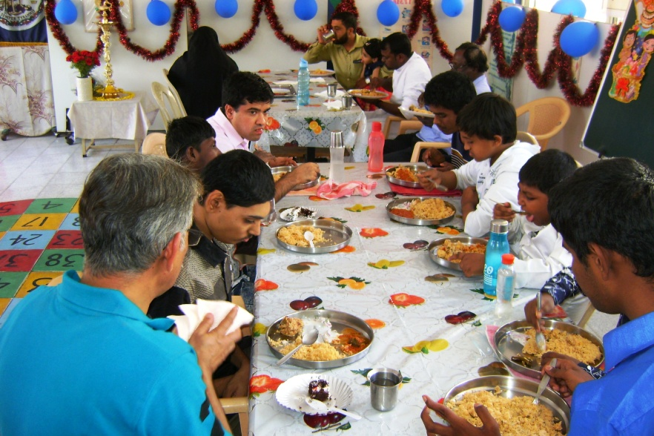
Mid day meal in progress
***

