Project Title: Pay School fees for Nomadic Girls in Kalapata

Johnstone Moru –Secretary, Alemun Pastoralists Empowerment Initiative
02-Apr-14

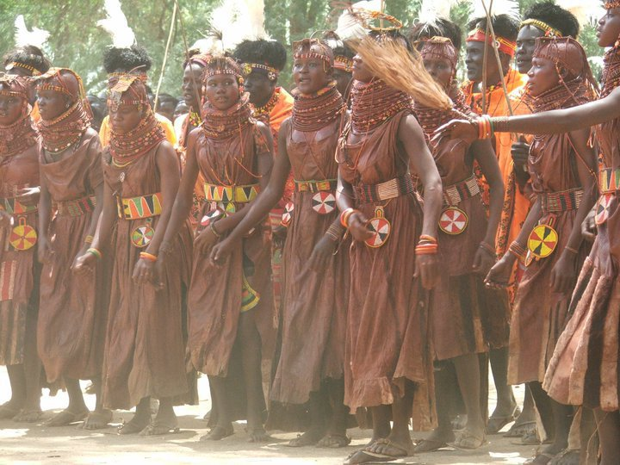
Project Location: Kalapata pastoralist area, Turkana County-Kenya.
Implementing Agency: Alemun Pastoralists Empowerment Initiative
P.O.Box 540-30500 Lodwar, Kenya.
apeicbn@yahoo.com, +254 726953096
Background information
APEI is a Community Based Organization operating in Turkana South District in Turkana County. It primarily targets pastoralists for its interventions geared towards secure livelihoods for sustainable socio-economic development. The organization was established in 1999 by four professionals from diverse disciplines (Agriculture, veterinary, development, and education). The idea was born out of a realization that most community members were lacking basic information necessary to stimulate their participation in community development activities for self-reliance.
The organization main objective is to enhance the capacities of community based institutions for effective management of their development initiatives. The delivery of effective of capacities is result of strong organization systems and strategic plans for good performance. The organization requires strengthen its capacities in resource mobilization strategies, improved partnership at all levels for visibility.
The vulnerability assessment exercise done identifies the Kalapata drought prone in terms of literacy level is below the Global and national target. The research shows 70% of Nomadic children have not acquired formal learning are still herding animals, lack of learning facilities in area, learning in a poor sanitation infrastructure environment, high rate of girls drop out, early marriages and girl child abuse.

Problem statement
Turkana County is located in the northwestern region of the country. It covers approximately 77,000 kilometer square and borders Uganda to the west, Sudan to the northwest and Ethiopia to the northeast. The county also borders West Pokot to the south-west, Samburu to the southeast and Lake Turkana to the east. Turkana has an estimated population of 855,399 people (KNBS, 2009). The poverty index is 94.3% (KIHBS). The county has been subjected to historical marginalization and underinvestment especially in education sector where illiteracy level threshold is 85% of the population.
APEI envisions promoting girl child education through paying school fees for 200 disadvantaged girls in Kalapata Pastoralists area. This is one of area where girls are underprovided with quality education, high rate of girls drop out from existing school, lack of well-equipped schools for girls.

Problem Justification.
Nomadic girls are deprived conducive learning environment due to high poverty among pastoralists’ households after losing pastoralism livelihoods as result of conflicts, droughts, and livestock diseases. This necessitates the families with girls to marry off to get animals to sustain pastoralism livelihood through receipt of animals as reward.

Goal, Objectives, Outcomes, Indicators outputs, Impact etc
Goal: Empowerment of 200 nomadic girls by paying their schools, personal effects and construction of one modern girl high school.
Objectives:
- Paying school for 200 disadvantaged nomadic girls.
- Building modern and equipping nomadic girls high school for Kalapata pastoralists area..
- Support 200 nomadic schooling girls with personal effects to reduce drop outs.

Outcomes:
- 200 girls socially and economically empowered.
- Increase participation of girls in community decision making and give back to community.
- Modern high learning institution for disadvantaged nomadic girls.

Indicators outputs:
- Support 200 nomadic girls in paying school fees.
- Building and equipping one high school for nomadic girls in Kalapata.

Impacts.
- Empowered girls socially and economically.
- Changed community perception on education.
Implementation strategy
- Enhance partnership with girls learning schools to identified disadvantaged nomadic girls.
- Formation of community committee to identify needy girls and disburse fees to respective schools.
- Formation of bursary committee at organization to vet the beneficiaries.

Monitoring and Evaluation plan
Monitoring Plan.
APEI Secretariat through the program Coordinator will fast track the implementation of girls payment fees activities.
Program Coordinator does reporting to technical team the daily progress of program activity implementation.
Evaluation Plan
The APEI organization will carry internal evaluation of the program while on-going with the primary stakeholders and later at end of the implementation stages of the program.

Work plan
Outcome Objectives | Planned Outputs | Activities | Indicators | Means of verification | Timeframe
200 girls socially and economically empowered | Identify nomadic girls for fees support | Paying fees | Support 200 girls for fees payment. | List of beneficiaries | 2 weeks
 | Baseline data collection | Bursary committee formation. | Formation of one  Bursary committee at ward level | Bursary committee list | 2 days
Building girls modern high school for nomadic girls | High school for disadvantaged nomadic girls | Built & equip girls high school. | School design plan | Procurement of building materials for school construction | 6 months
Buying personal effects for disadvantaged girls. | Socially support nomadic girls | Buying 200 school personal effects | High number of girls join schools, colleges & university | List of supported girls | 1 year

Budget
Output | Unit | #units | Unit cost | Budget Requested from Donors  USD $ | APEI Contribution in Cash. | Total  USD $
Payment of school fees for 200 nomadic children | student | 502 | 200 | 100400 |  | 100400
Building and equipping 1 girl’s high school. | 1 | 1 | 100000 | 100000 |  | 100000
Support 200 nomadic girls on personal effects. | student | 54 | 200 |  |  | 10800
Total costs |  |  |  |  |  | 211200

