Your support has helped us achieve our vision to provide dignified livelihoods to resource- poor women.

We are happy to share that the Women on Wheels initiative, is now got a new and stronger identity that of Women With Wheels that helps break patriarchal boundaries and structures so that the women from underprivileged backgrounds can exercise control over their lives, enjoy full citizenship, earn a livelihood with dignity and generate wealth and value for all.

95% women work in the informal sector which has very vulnerable conditions of employment with no social security net and. Recent data show that female participation in the workforce has further declined to 17% compared to 79% for men, and therefore it is important to support more and more women in formal workspaces.

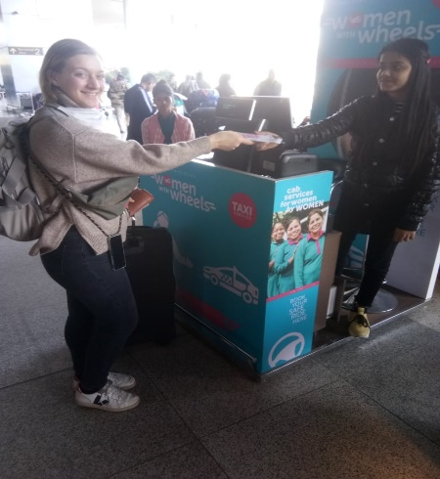
At Azad Foundation, this is done through gender just and transformative skill building that equips resource-poor urban women with knowledge and skills, using non-traditional livelihood (NTL) platform, so that they excel as professionals and entrepreneurs and earn a “livelihood with dignity” in jobs and markets that had traditionally been closed to them.

Azad Foundation’s objective to scale up to new locations we will soon see the Women with Wheels enter the new city of Chennai in southern India

It is with great pride that we announce the launch of the Women With Wheels booking counter at the Terminal-3, Indira Gandhi International Airport in Delhi to cater to the needs of women who are travelling alone.

Thank you for fuelling our growth and enabling us to spread the concept of women chauffeurs to more places.

Today a woman is challenged to draw upon traditional strengths while continuing to redefine her position in a rapidly changing society. And the only way to face all the challenges that come her way is to engage with the family and communities, especially the men in which these women reside. The project continuously works with young men and women to become change agents and help create an enabling environment by engaging to build awareness around women in non-traditional livelihoods.
Azad also undertakes research to advocate efforts & influence governments, corporates and other policy makers towards a more favourable ecosystem at not just the community as well as wider macro level with special focus on Women with Wheels.
Project Impact so far:
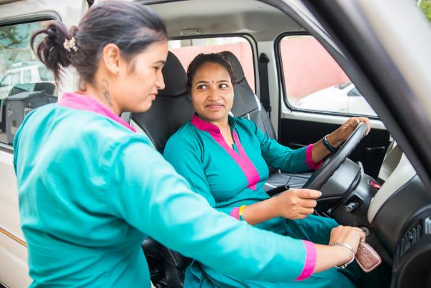
The program Women with Wheels has trained around 2000 women of whom around 1000 are working as professional drivers across Delhi, Jaipur, Kolkata and in also Ahmedabad, Indore, Lucknow and Bhubaneshwar where Azad operates in alliance with likeminded partners.
In terms of impact, the women drivers who trained at Azad Foundation and are working with our employment partner, Sakha, have been able to cumulative generate earnings of more than 17crore INR (approx. 2.3m$) over the years. At an individual level when the analysis of earnings is done, we have had 100% of the women employed as professional chauffeurs become ”financial decision makers“, building and investing in assets for themselves and their families.
The Women & Child Committee, PHD Family Welfare Foundation, recently conferred on Sakha with the Astitva Samman 2020 in honour and recognition for promoting women empowerment.

Driving the wheels of change …..

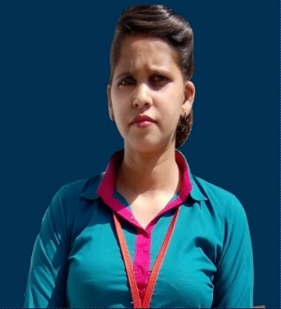
Babli, who is 26 years old is the only member in her family to complete her graduation in B.A in English, Political Science, Hindi and History. She lives with her parents and siblings. Her father who was the only earning member had to quit his job due to health issues and a couple of months later her mother too fell sick and is partially paralyzed. Given the financial pressures, Babli became financially independent early in life and she began supporting the family by doing tailoring assignments from home along with managing the household chorus too. But sadly the income was not much.
As she was looking at other means to supplement the income she learnt about Azad Foundation and the trainings. With her father‘s encouragement she enrolled and completed the Women with Wheels training despite all other odds.
Babli used to fear the dark and was afraid of being out alone before she started professionally working as a driver. Driving and being out, often late, has slowly taught her to be confident. Driving around the city gives Babli a lot of exposure to the world outside. She particularly appreciates the self-defense training she received that made her and her peer group aware of being able to defend themselves. First aid training was also very helpful; and she remembers put it to use a couple of times to help people around her.
Today she not just loves working as a commercial driver that has made her independent, she feels it excited as she explores new routes and her duty helps her meet new clients and people from across walks of life, thus enriching her experience and helping her grow as a professional driver.
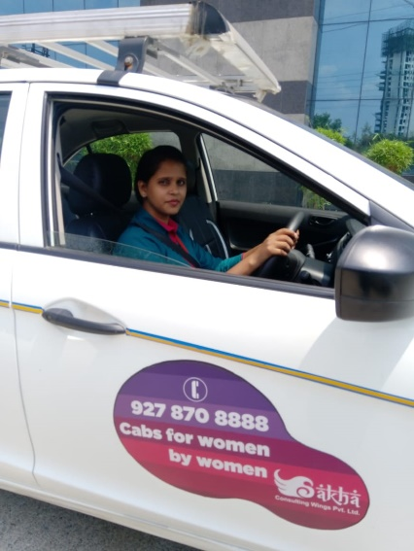
Earlier her mother would constantly pressurize her to get married before she joined Azad, but now Babli has learnt to stand up for her herself and negotiate her space. Her independence and change in attitudes and opinions, has stopped her mother from policing not just her but her sister too. Her neighbours initially discouraged her from learning to drive and take it up as a profession. But now seeing her drive has changed their attitude and made them believe in her credibility as a professional driver.
She has become an example for all the other girls in her neighborhood who today look up to her and are inspired by her some also wanting to follow in her footsteps. People appreciate her on the road too - some have taken selfies with her and she remembers an instant on the road when a man in a car next to hers gave her a salute.
Being the main breadwinner for her family, along with supporting her younger brother’s education and undergoing an eye surgery she plans to pursue her studies to do Masters and also invest in a house in the future.

Your support today will help transform the lives of many more women like Babli today and beyond.
Donate Now

