When women participate in the economy, everyone benefits!

The Women in Work Index 2019, released in March 2019, states that India struggles with low levels of female participation in the workforce, partly due to prevailing cultural norms about the role of women in society, women continue to drop out of the labor markets. As per the World Economic Forum’s Global Gender Gap Report 2018, India ranked 142 out of a total of 149 countries in the economic opportunity and participation sub-index. The gender pay gap is a massive 39%, and female employment rates low. Another study in 2017 by Azad Foundation & Asia South Pacific Association for Basic and Adult Education (ASPBAE) showed though the Indian economy is growing at 7%, the female workforce participation is declining – only 1 of every 4 women are participating in the workforce of which 90% work in low skill-low paid informal work. This informal work sector is devoid of any binding rules or regulations, leaving greater room for exploitation and discrimination.
Azad Foundation recognises that this situation needs to change and is working actively towards making non-traditional livelihood welcoming for women from resource poor background. Women are the largest untapped reservoir of talent in the world and there is no tool for development more effective than the empowerment of women.

In 2018-19, Azad Foundation’s Women On Wheels Programe enrolled 603 women from resource poor background of which 345 are qualified to be employable as professional drivers. Azad Foundation also facilitated more than 3000 women to access citizenship documents so that they become eligible to enroll in skill development trainings. The Women on Wheels programme has spread its wings to 2 more cities in India, Bhubaneshwar and Lucknow through its partners to facilitate entry of more women in to Non-Traditional Livelihoods thereby earning livelihoods with Dignity.
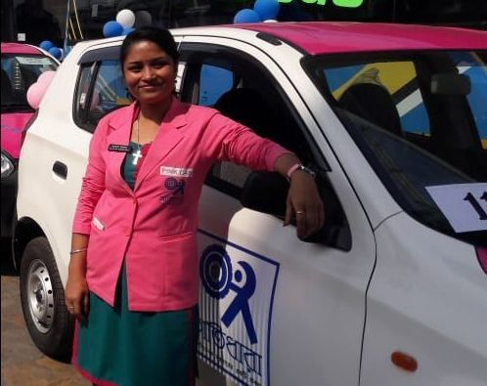
In our last report we shared the story of the Pink Cabs flagged off by the Chief Minister in Kolkata. Manasi was one of them - it has been quite a journey for her, she became a mother at 14 and was kicked out by her husband and in-laws. With no support at all Manasi worked her way thru’ odd jobs for her and her son’s survival.

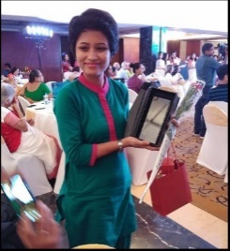
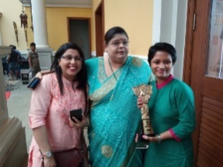
Today Manasi, a first-generation cab driver in her late twenties, had just begun her journey in this profession. Initially submissive, Manasi protested against the unfair practice of being bullied by other male cabbies for a parking spot on the street. She challenged them and fought for a place providing courage to many others like her, She says, “My fight is not just for myself, but for all who are similarly victimized”. And all this has been possible because YOU decided to support and help women like Manasi.

Her efforts have been recognized and she was awarded the, “Times Women Heroes” and the “Manyata” Award by the Rotary Club where ordinary women like her have done extraordinary things to challenge stereotypes, fight odds to carve out a niche place and bring about a change in society.
That’s the story of Manasi whom YOU have helped by giving to our project.
Help us transform many more lives … Together we can do it!

