
PROGRESS REPORT FOR
“Provide shelter for 20 Ugandan Rural Grandmothers” PROJECT

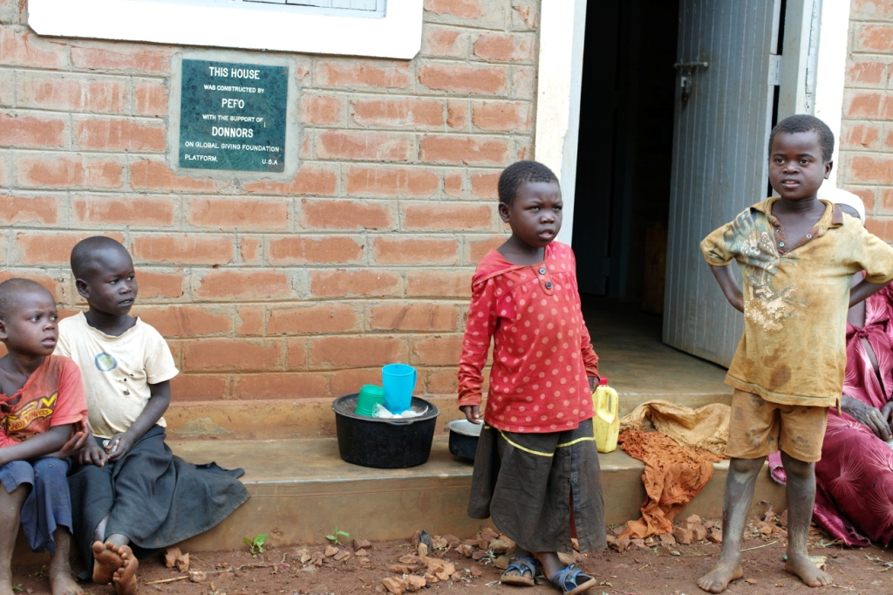

SUBMITTED
TO

GLOBALGIVING FOUNDATION PLATFORM
BY
PHOEBE EDUCATION FUND FOR ORPHANS AND VULNERABLE CHILDREN (PEFO)

Justine Ojambo
National Director

- Background Information
This report details the progress so far attained in the implementation of the project “Provide shelter for 20 Ugandan Rural Grandmothers” implemented by PEFO-Uganda with funding from our friends and partners on the Global Giving foundation platform. The objective of the project is to “improve the housing situation among grannies in rural Jinja Uganda”. The project is in its initial stages of constructing 20 houses for the older persons in Jinja district.

  - Name of the Organization
Phoebe Education Fund for Orphans and Vulnerable Children (PEFO)

  - Title of the project
Provide shelter for 20 Ugandan Rural Grandmothers
  - Starting date
July 2014
  - Total project planned budget
83000 US $
  - Total funds received so far
4,929.75 US $

  - Period covered by the report
September --November 2014

  - Date of submission of the report
O8TH/12/2014

Introduction:
Having registered as a partner with global giving in June 2014, PEFO successfully qualified for fundraising and has so raised 8,370 US$ of the required US$ 83,000 from the Global Giving Platform leaving a balance of US$ 74,630 to have the project completed.

The project was designed to respond to older person’s outcry on the pathetic housing conditions in which the majority of them reside. Lack of proper shelter exposes older persons to a number of health problems such as poor hygiene and sanitation, malaria, water borne infections and Pneumonia due to cold nights, lack of enough rest as their nights are at times interrupted with rains that flood their houses as the structures are weak and poorly roofed. The majority of the older persons, share their houses with animals such as goats and chicken in addition to using the same structures as cooking places hence making them susceptible to chronic obstructive pulmonary diseases due to smoke and poor ventilation.

Therefore the project is one of the interventions adopted by PEFO in partnership with Global giving foundation to respond to challenges faced by granny (older persons) households by building 20 houses for 20 Granny Households in the rural communities of Jinja - Uganda. So far money that can build two houses has been raised and the construction process for the second house will start as soon as PEFO receives enough money for the building of the second house.

Selection of beneficiaries;
Being the most vulnerable among the grannies with poor houses, Sanura was the first priority to receive a house. Being the first priority was based on the poor location being in the road reserve as well as the poor state of the house. Sanura was living in a very small house with her grand children. PEFO field staff worked alongside the members of the granny housing committee to select the most vulnerable 20 older persons who in addition of being weak have a bigger burden of taking care of orphans and other vulnerable children.

Construction
Construction of the house for Sanura, the first beneficiary of the project was begun in August 2014 and finalized in November 2014. Among the team that was involved in the construction included Sanura’s family, the grannies as well as the Canadian and Dutch grannies. The team was supportive and involved in fetching water, mixing of aggregates and cement, moving bricks closer to the builders, providing security and temporary storage of the construction materials such as cement, bricks and sand. They also prepared and shared their meals with the builders. The house has two bedrooms and a living room.
Sanura’s, old house was destroyed as it was illegally built in the road reserve and she never wanted to have its memories. Preparations to establish an appropriate sanitation facility (pit latrine) are underway with support from the community as they have already collected sand and bricks for building.
Therefore, Construction of the first house has been completed with painting and foundation stone installed. Sanura and her grandchildren are now occupying their new home and living a happy life. The old house was cleared as she never wanted any bad memories.

Handover of the house;
As we wait for the official handover, Sanura was allowed to occupy the house because the old house was in a very poor state and since was built in a road reserve and too small to accommodate the large family. The process for official handover of the house to the first beneficiary is still underway as we plan to invite government officials during the ceremony. This is aimed at drawing their attention towards implementing programs that support better living conditions for older persons and vulnerable Children. The official handover will be conducted in 2015.

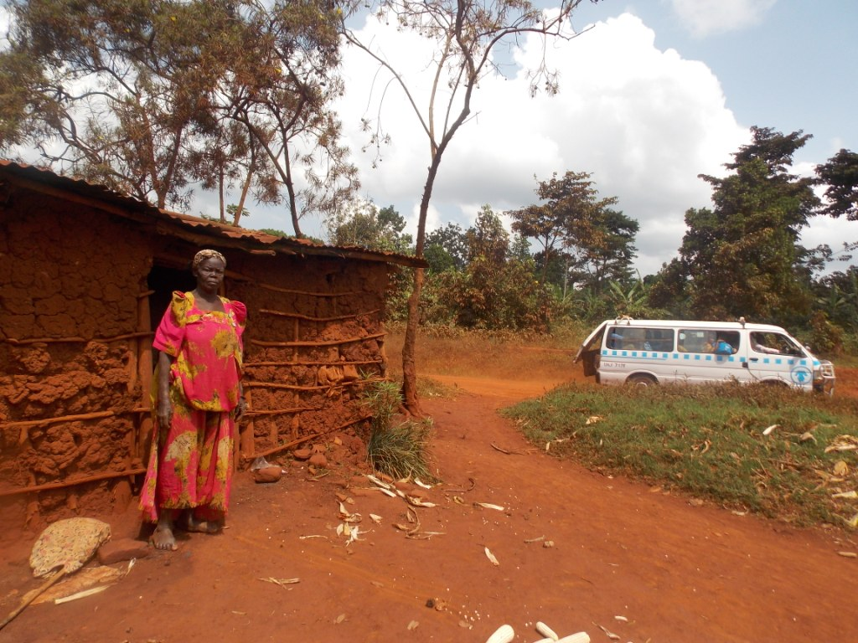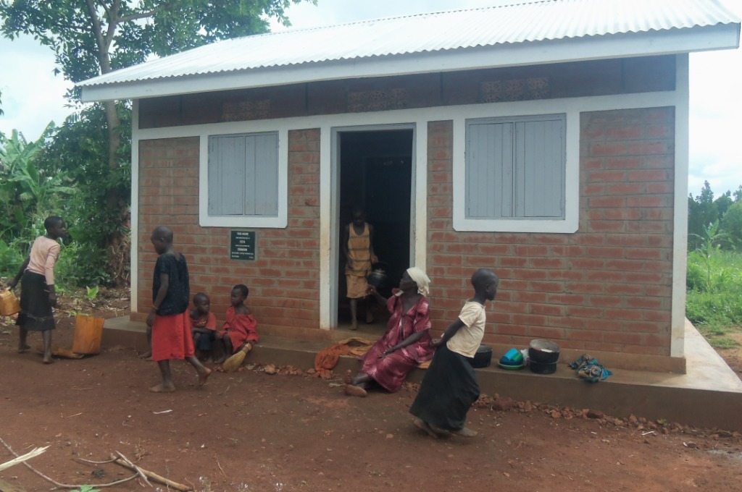
The old house where Sanura used to live The New House where Sanura lives with her family

Sanura’s tale about her New House
It’s a Monday morning; she is seated on a veranda at her new house as some of the grandchildren are coming from the water spring to fetch water. When she saw us, she jumped up praising PEFO for building her one of the nice houses around the village. This is what Sanura Kyakuwaire says about her new house.
I don’t know how I can express my happiness to appreciate PEFO for building me this new big house. My grand children are happy and joyfully living. I believe I can live for more 10 years as they grow up. I had lost hope because we used to live like animals in the small house, but now I live like a princess. Our lives have totally changed. We no longer have constant illness caused by malaria like we used to be.
One day one of the health workers went to the house I used to live in. she thought I died since I had taken long without going to the health center. She was surprised that mere having a new house changed my health status. People used to laugh at me saying the old woman would die at anytime, but I and the grandchildren no longer suffer from constant Malaria like it used be. My grandchildren now live and sleep safely because we are no longer scare of snakes that used to enter our house.
I am grateful to PEFO and her partners for having changed my life from grass to grace.
This house was built by Partners on the Global Giving Platform.

Below are some of the pictures of the New Home.
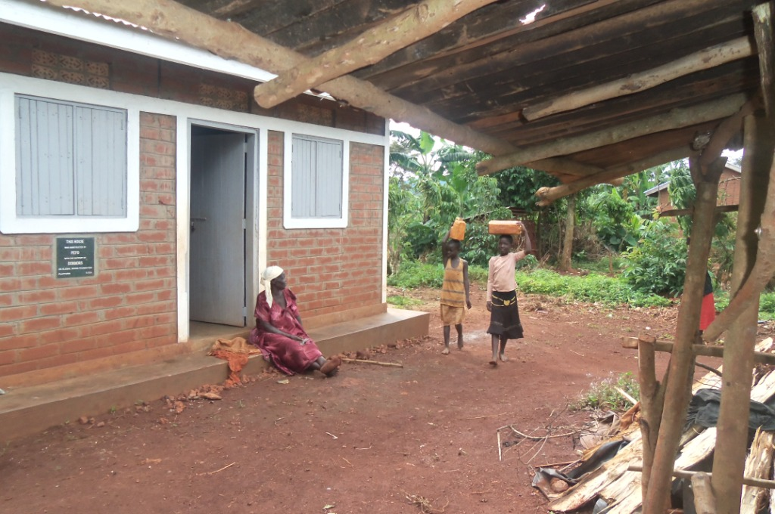
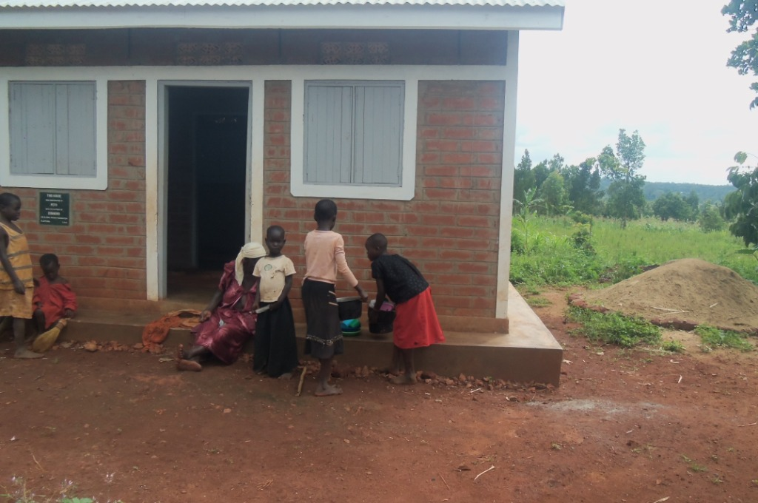

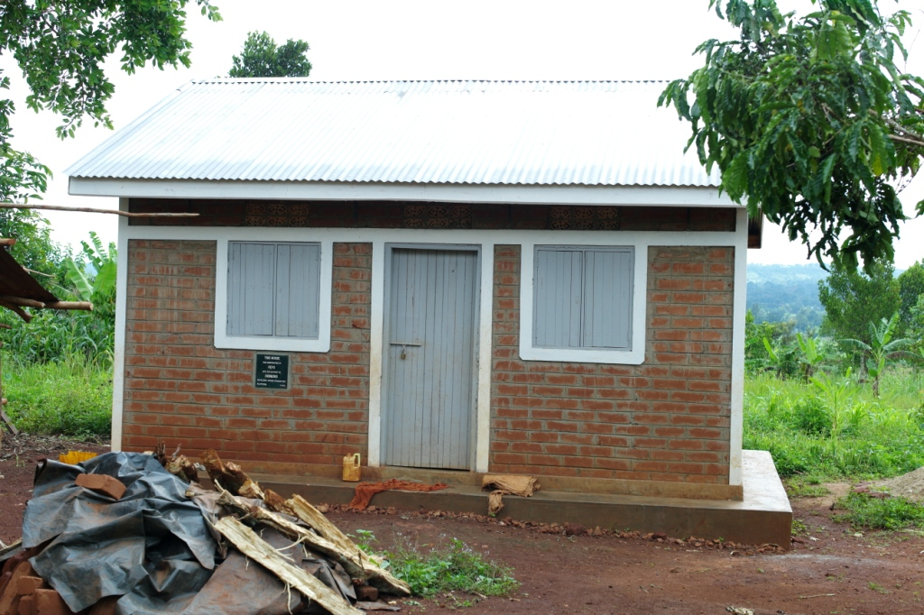

In conclusion therefore, we must note that many older persons live in pathetic houses while others are homeless, but as they get older they need to live in better homes with their grandchildren who they take care of. These calls for support to enable them continue living in their good homes in a dignified way.
PEFO would like to thank all partners and Donors on the GlobalGiving platform for your contribution towards sheltering grannies. We really appreciate your support, and we believe lives of older persons can change through housing them. You generous support makes it possible for our organization to make a community a great place where older persons can live. Thank you for your continued support. Please continue sharing this with friends as we still have to fundraise for 18 more houses.

