

PROGRESS REPORT FOR
“Provide shelter for 20 Ugandan Rural Grandmothers” PROJECT

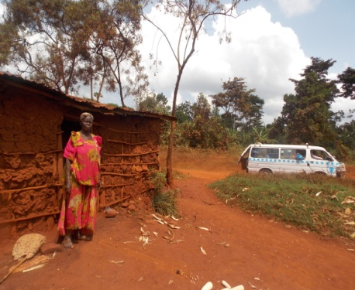
SUBMITTED
TO

GLOBALGIVING FOUNDATION PLATFORM
BY
PHOEBE EDUCATION FUND FOR ORPHANS AND VULNERABLE CHILDREN (PEFO)

Justine Ojambo
National Director

- Background Information
This report details the progress so far attained in the implementation of the project “Provide shelter for 20 Ugandan Rural Grandmothers” implemented by PEFO-Uganda with funding from our friends and partners on the Global Giving foundation platform. The objective of the project is to “improve the housing situation among grannies in rural Jinja Uganda”. The project is in its initial stages of constructing 20 houses for the older persons in Jinja district.

  - Name of the Organization
Phoebe Education Fund for Orphans and Vulnerable Children (PEFO)

  - Title of the project
Provide shelter for 20 Ugandan Rural Grandmothers
  - Starting date
July 2014
  - Total project planned budget
83000 US $
  - Total funds received so far
4,929.75 US $

  - Period covered by the report
July-August 2014

  - Date of submission of the report
28TH/08/2014

Introduction:
Having registered as a partner with global giving in June 2014, PEFO successfully( after the open challenge) qualified for fundraising and raised over 5,460 US$ of the required US$ 83,000 from the Global Giving Platform to build 20 houses for Uganda Rural Grandmothers in Jinja district in Uganda, East Africa. To build one house PEFO needs US$ 4,125.

The project was designed to respond to older person’s outcry on the pathetic housing conditions in which the majority of them reside. Lack of proper shelter exposes older persons to a number of health problems such as poor hygiene and sanitation, malaria, water borne infections and Pneumonia due to cold nights, lack of enough rest as their nights are at times interrupted with rains that flood their houses as the structures are weak and poorly roofed. The majority of the older persons, share their houses with animals such as goats and chicken in addition to using the same structures as cooking places hence making them susceptible to chronic obstructive pulmonary diseases due to smoke and poor ventilation.

Therefore the project is one of the interventions adopted by PEFO in partnership with Globalgiving foundation to respond to challenges faced by granny (older persons) households by building 20 houses for 20 Granny Households in the rural communities of Jinja - Uganda. So far one house has been completed out of the 20 houses planned for.

Selection of beneficiaries;
Selection of the 20 primary granny beneficiaries under this project was conducted by an established Housing selection committee among grannies. PEFO field staff worked alongside the members of the granny housing committee to select the most vulnerable 20 older persons who in addition of being weak have a bigger burden of taking care of orphans and other vulnerable children. The 20 grannies were mainly whose shelter (houses) were poorly ventilated, tiny, congested, with open and falling walls among others.
Below are some of the pictures of old houses that are occupied by the targeted beneficiary grannies:
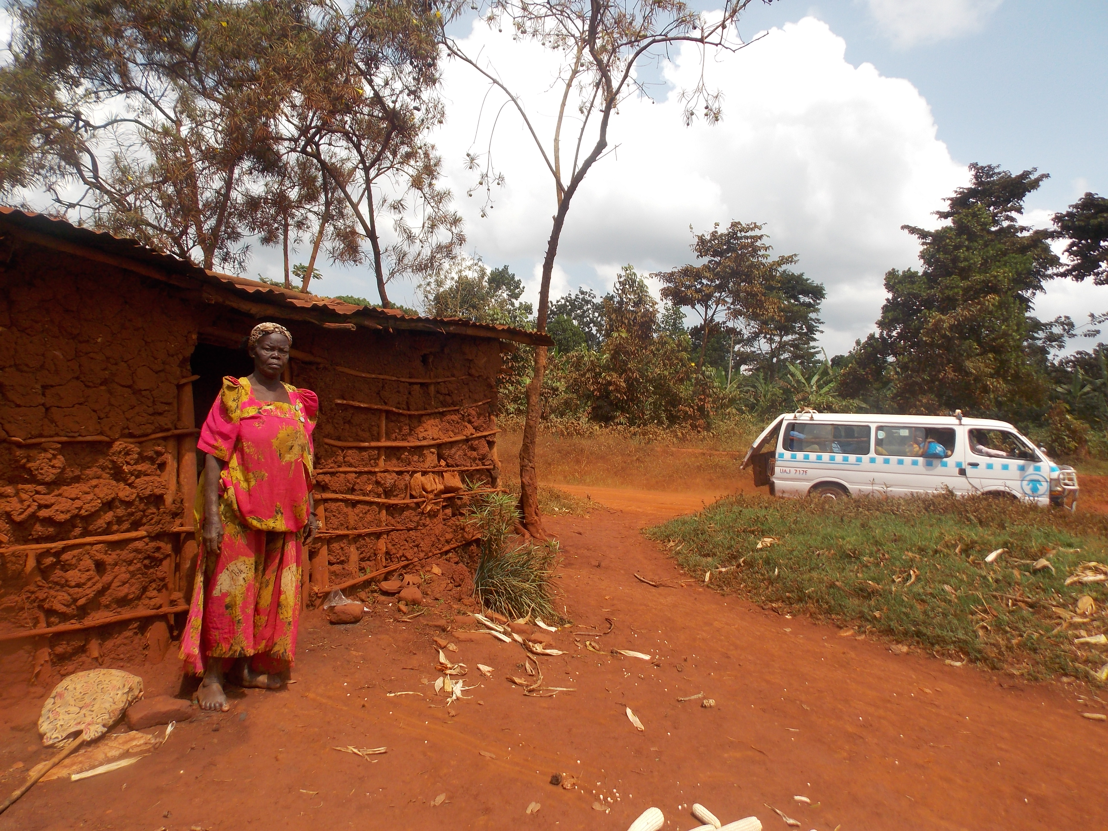
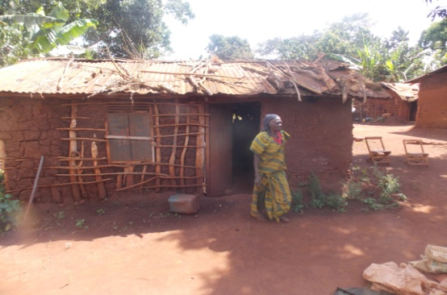

Some of the Houses currently occupied by the grannies
Actual construction work;
Construction of the house for Sanura Kyakuwaire, the first beneficiary of the project, (pictured above on the left) commenced on 4th/July/2014 by the PEFO construction department. The house has two bedrooms and a living room. The community around has been very supportive and were involved in fetching water, mixing of aggregates and cement, moving bricks closer to the builders, providing security and temporary storage of the construction materials such as cement, bricks and sand. They also prepared and shared their meals with the builders.
Normally, building a house takes 2 weeks excluding one month for brick production. Sanura’s, old house will be destroyed since it was illegally built in the road reserve. An appropriate sanitation facility ( pit latrine) will be provided with support from the community. Construction of the first house has been completed remaining with making the final touches ie leveling the veranda and installation of the Foundation stone. None the less, Sanura requested to occupy the house as they make the final touches due to fear that the old house may fall on her and her grandchildren because of its bad condition.

Handover of the house;
The process for official handover of the house to the first beneficiary is underway and we plan to invite government officials during the ceremony. This is aimed at drawing their attention towards implementing programs that support better living conditions for older persons and vulnerable Children.
Anticipated impact of the project to the beneficiaries;
While we may not out rightly speak of the impact (which is a long term effect-3-5years plus) at this time, the project is estimated to achieve a number of positive results which include but are not limited to;
- Psychosocial healing; just the feeling and knowledge of getting a new secure house even before actual construction gives beneficiary grannies psychosocial healing. There is a sudden change in attitudes and behaviors displayed by grannies that were selected to own the 20 houses; an attitude of gratitude and satisfaction; hope and belonging. This has been demonstrated by the fact that some grannies provided food during the construction of Sanura Kyakuwaire’s new house. Some have become more active during granny activities in the community among other indicators.
- Improved health: we believe that with better housing that has proper ventilation and is free from congestion, the incidences of older persons falling sick from respiratory related diseases and other commonly preventable diseases will reduce rendering them an opportunity to live more productive lives.
- All the grandchildren and orphans under Sanura`s care will now live in a good house where they are safe from the rains and also keep well their books for school.
Gratitude:
PEFO appreciates the support from individuals and organizations that responded to our call through global giving. We could not have made this much progress without your help. We pledge to use all donations to our organization exclusively for the intended work. Your support gives the elderly and vulnerable children under their care hope to live. We thank you all for your continued support as we still have to build 19 houses to complete the project. Kindly share widely this report among your family and networks.
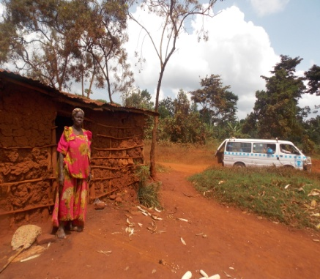
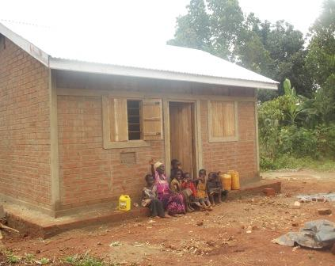
Left : Sanura in front of her old house. Right: Sanura seated with her grand children at the veranda of the new house built

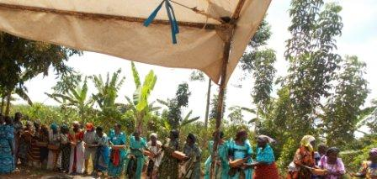
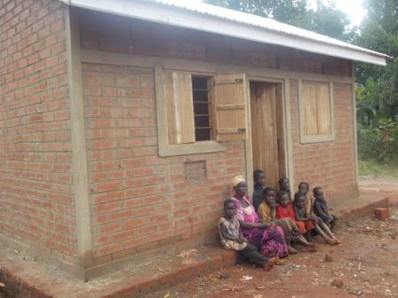

Grannies passing bricks during the construction

Below is Sanura’s story before;
Sanura Kyakuwaire is a daughter to the late Sania Mbwali and Yunus Tamuzadde. She was born in 1939 in a family of 4 children, only 2 still living. Being the youngest, Sanura never went to school since she lost her parents at the age of 7. At 17 years she got married to Akamadha Magumba with whom she produced 5 children and 1 died. It was a hard to raise and educate her children “it was a hustle to raise those kids. My husband never had a job. We only farmed on a small piece of land to get food. We had little to sell. We could not raise substantial income to educate them. The two who went to school never reached a high level, so they dropped out.” Sanura narrates
Sanura is a widow whose husband died in December 2013. She finds life difficult without anyone’s help. “I find life very hard together with my grand children since I lost my husband in December 2013. We used to struggle together for a living, but today I am helpless.” Sanura narrates. The death of her husband who was her right hand saddened her, till now she can hardly live without calling his name.
Today Sanura is helpless. Most of her kids who would have supported her are drunkards and the other died of HIV/AIDS. They cannot support her for her daily living with the grand children she is taking care of. “All my sons neglected their kids. I stay with them but they can’t even provide a kilo of sugar, they are a waste to me yet I cannot also abandon their kids, they are innocent.” She notes.
For her survival, Sanura together with her grand children grow food for home consumption. This is done especially during holidays. On a small piece of land, they grow maize, beans and sweet potatoes. She sells little and sometimes nothing for an income. However she faces a problem of intruders who usually steal her crops before harvest.
Her main trouble is the poor house. “My house that accommodates 5 people is scary. Whenever it rains, it leaks, everything gets wet. Water and mud fills inside. Being near the road every night I feel like vehicles are driving over the roof. Heavy vehicles make my poor house vibrate, it’s no longer strong, we fear any time it might fall on us. We are all scared” Sanura narrates. One day a truck lost control and suddenly stopped in her courtyard where one of her grandchildren narrowly survived.

