Gordy
San Jose, CA
January 2020
LB
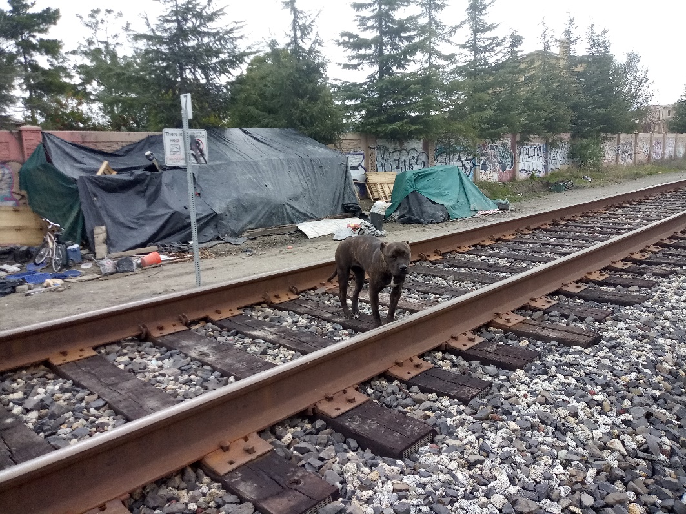
Hector Carrizo lives next to the railroad tracks in San Jose, CA. His dog, Gordy, an 8-month-old female Pit Bull Terrier was crying out in pain and losing weight. He found Feeding Pets of the Homeless™ on the internet and called us. We verified he is homeless with the above photo and approved an exam at Curtner Pet Clinic.
After the examination, the veterinarian called our Case Manager and recommended sedation, x-rays, bloodwork, fecal test, and urinalysis at a cost of $647.00. Knowing we would need to reserve funds for any treatment after diagnostics, we approved a basic blood panel and x-rays. Nothing was found in the testing. Gordy was given an appetite stimulant, pain medications and antibiotics. The vet said Gordy was not eating much, not vomiting, pooped normal, owner says barely walking, painful in back area, phlegm, bloodwork is ok, pet losing weight, is 50Lbs. X-rays - lower spine, changes, minimal, hips fine, kneecaps ok. Chest, mild allergic bronchitis, not enough to cause pain & weight loss. No infection, no anemia, kidneys normal, no evidence of tic borne disease. We assisted with $577.83 which included blood sample collection, biohazard waste disposal, 7 x-rays, sedation and IDEXX blood work. We also helped with $77.40 which included medications and appetite stimulant.
Gordy wasn’t getting better. Our Case Manager was communicating with Hector via email as his English was very broken, but he could write clearly. He wrote, “I’m devastated, sad, angry and I feel like I failed her. In 30 days, my 75 pound, strong, happy, loved, lovely puppy, became a sad, weak, lost skeleton with skin, dying puppy.” We approved a second opinion at MedVet in Silicon Valley.
We gave MedVet our Case Manager’s cell phone number for the after-hours visit. Hector took Gordy in on a Saturday, and unfortunately, the message of our cell number was not relayed. They tried calling the office when we weren’t in. A good Samaritan helped that day by paying $302.99 for meds, x-rays, and pain management. Gordy was diagnosed with pneumonia.
Our Case Manager followed up to see how Gordy was doing.
Hector responded that he “just got another ticket from the police for living in the rail road and gave me 48 hrs. to move away or I'm gonna be arrested, she's not gonna survive with this cold living outside, she is barely making it under this roof, so I'm not gonna exposed her to the cold to die, I'm gonna be arrested and deported, they already told me that in the last court. Again thank you, you did your best and I appreciate so much your help, I'm gonna keep her alive and with me the longer I can. Thanks.” Hector
A few weeks later we also asked how Gordy was doing. Hector responded, “She's not doing well, she keep losing weight, the pneumonia hasn't improve, again she had conjuntivitis and some other issues but the weight is really impressive. I keep giving her the medicines but if she keeps worsen her condition, I'm gonna have to taker her again to the doctor. The sheriff didn't showed up to kick us out, so she is sleeping in a warm place. I'll let you know how it goes. Thank you so much for your humanity. I'll never forget your help. Thanks.” Hector
We urged Hector to take Gordy back to the vet and approved a recheck.
After the exam, the veterinarian said Gordy’s eyes and respiratory were worse, she was not eating, was weak, and not responding to the meds. She was not feeling well at all and had a fever. The vet recommended hospitalization, chest x-rays, ultrasound. He also mentioned she was thin, lungs bad, and recommended supportive care with a low estimate of $5000 and high of $6000. We approved $400 in remaining funds towards this treatment.
Unfortunately Hector was unable to gather more funds and told the hospital that he was going to take Gordy to another hospital to try to find discounted rates.
We assisted with a total of $808.23 for Gordy.

