MONTHLY REPORT
Month: February 2026 to May 2026
Location: Mugumu & Butiama Safe Houses.
Prepared by: Domina W. Mabebe (Assistant Director)
Reviewed and approved by: Rhobi P. Samwelly (Executive Director)

ORGANIZATIONAL OVERVIEW
Hope for Girls and Women in Tanzania (HGWT) is legally registered non- governmental organization (Registration No. 00NGO/0009414) with its headquarters in Mugumu, Serengeti District, Mara Region.
The organization was established to protect, empower and advocate for the rights of girls and women who are at risk of or affected by; Female Genital Mutilation (FGM), Child marriage and Gender based violence (GBV).
HGWT operates two safe houses (Mugumu and Butiama) which provide shelter, psychosocial support, medical care, legal assistance and education to rescued girls. Beyond rescue, HGWT emphasizes long – term empowerment through; formal education support, vocational training (tailoring, beadwork and entrepreneurship), community sensitization campaigns and advocacy and collaboration with government, local leaders and international partners.
The vision of HGWT is to create a community free from FGM and child marriage where girls and women can thrive and live in dignity.
- INTRODUCTION
Between February 2026 to May 2026, Hope for Girls and Women in Tanzania continued its mission of protecting and empowering vulnerable girls. During this period we continue with our core work of protecting girls through our safe houses by rescuing them from danger as well as conducting reconciliation and family reintegration to some of the girls who ready to reunite with their families after the cutting seasons. Alongside providing rescue and care, HGWT conducted community sensitization, vocational training, school follow – ups and strengthened partnerships with local leaders and law enforcement to ensure child protection.

- ACTIVITIES CONDUCTED

  - Safe Houses (BUTIAMA AND MUGUMU)
- The total of 10 girls were rescued between February 2026 to May 2026, whereby in February we managed to rescue 2 girls, in March we rescued 2 girls, in April we rescued 2 girls and in May 2026 we rescued 4 girls. The admission number in is a bit low compared to the last six months June to December 2025 because it is not high cutting season.
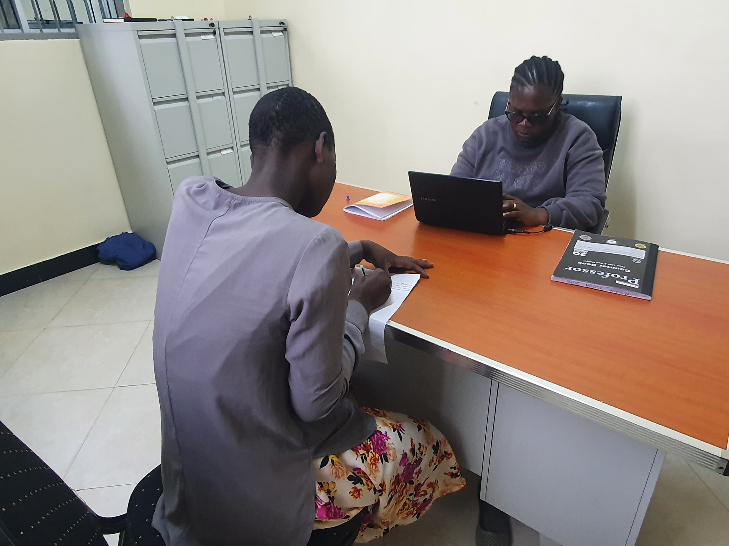Admission Process in one of our safe house
- A total of 176 girls are currently living in both safe houses
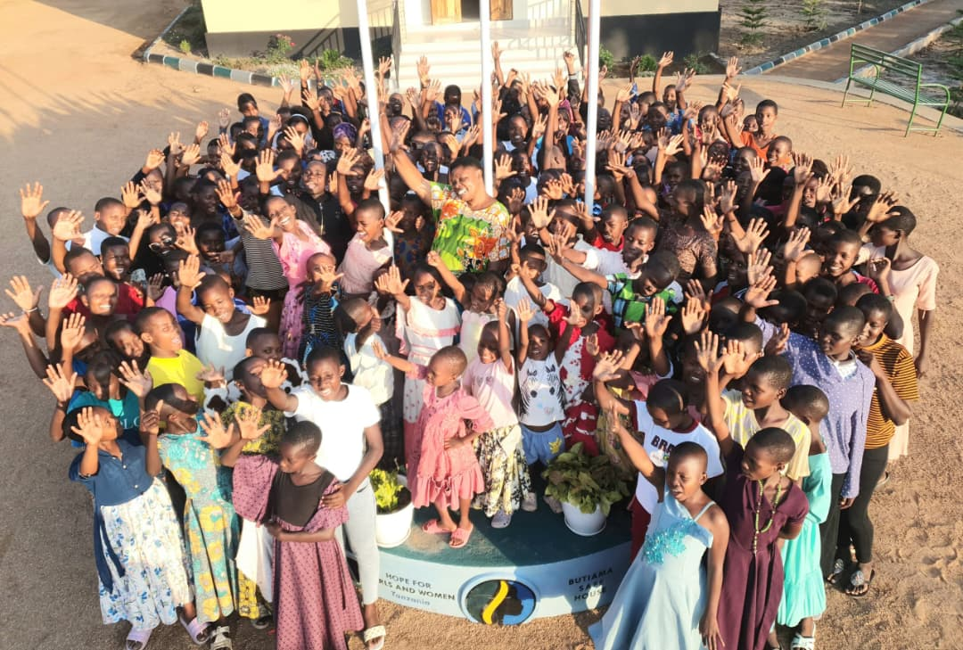Some of survivors in our safe house
- Services Provided:
- 176 girls received Psychosocial counseling
- 20 accessed medical care for injuries and illnesses.
- 80 girls received individual counseling from professional counselor, police gender desk officer and social welfare officer.
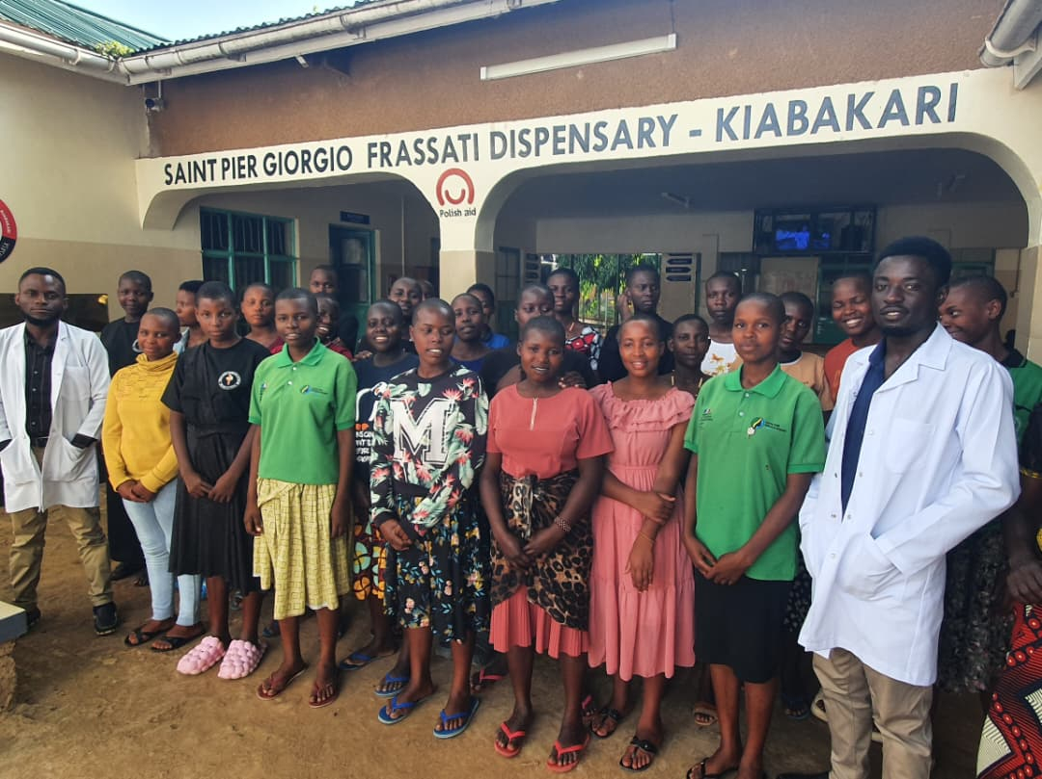Medical Checkup activity
- 80 accessed medical checkup as a regular routine.
- Between September 2025 and January 2026, Hope for Girls and Women in Tanzania (HGWT) conducted a total of five (7) capacity building training sessions for girls residing in the Mugumu and Butiama safe houses. The trainings focused on key life skills and protection related topics, including Sexual Reproductive health and rights, First Aid, self awareness, menstrual hygiene management during menstruation, academic skills and strategies for improving school performance, just to mention a few. The training sessions were implemented through collaborative approach involving HGWT staff, the department of social welfare, and the gender desk, these efforts contributed significantly to enhancing the well being, protection awareness and personal development of the girls living in the safe houses.

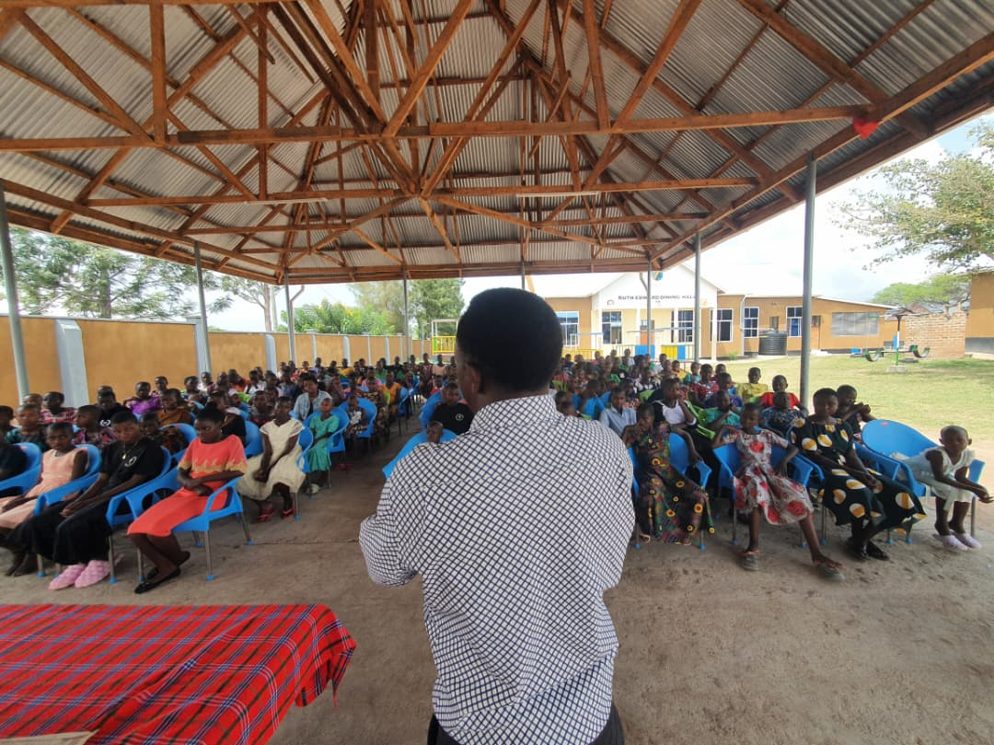In – house Training for the girls
- Between February 2026 to May 2026, we managed to conduct the total of 20 Yoga sessions (these sessions done by the girls in our both safe houses (Mugumu and Butiama) under the supervision of Hayley and her team through Zoom, these sessions helps the girls to be flexible, boost their brain power, better their immunity and help to have good sleep).
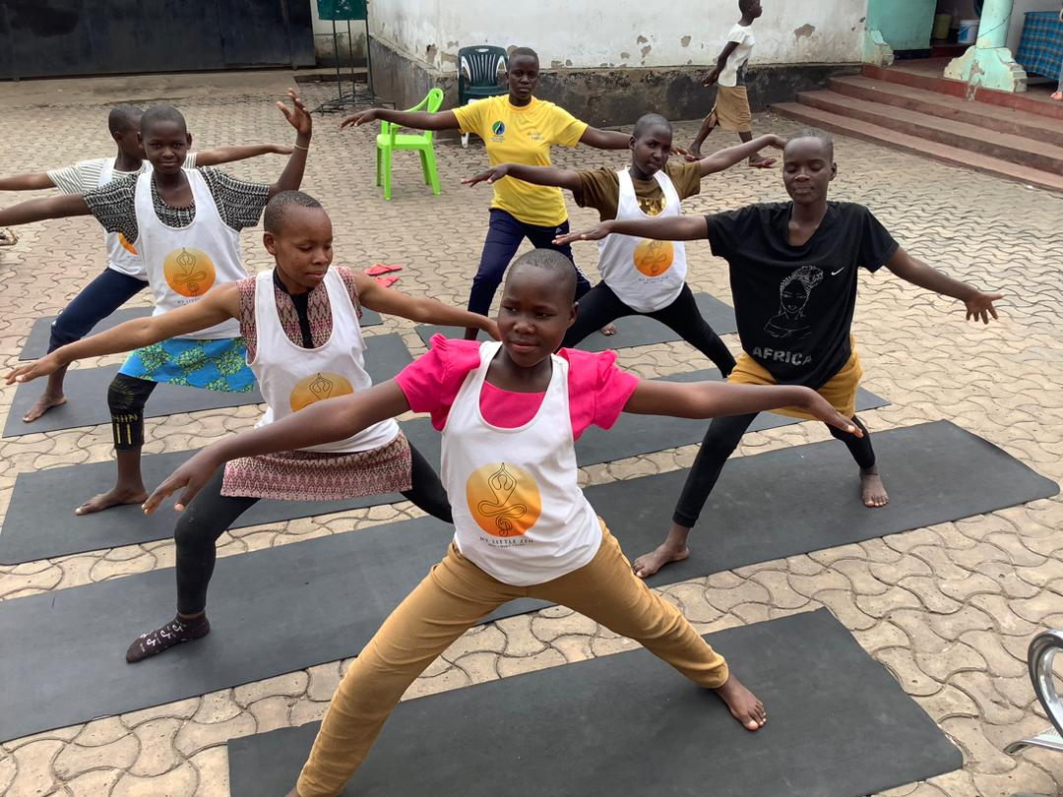Yoga Session

- Reintegration: the total of 15 girls were reintegrated back to their families after a successfully reconciliation with their parent.
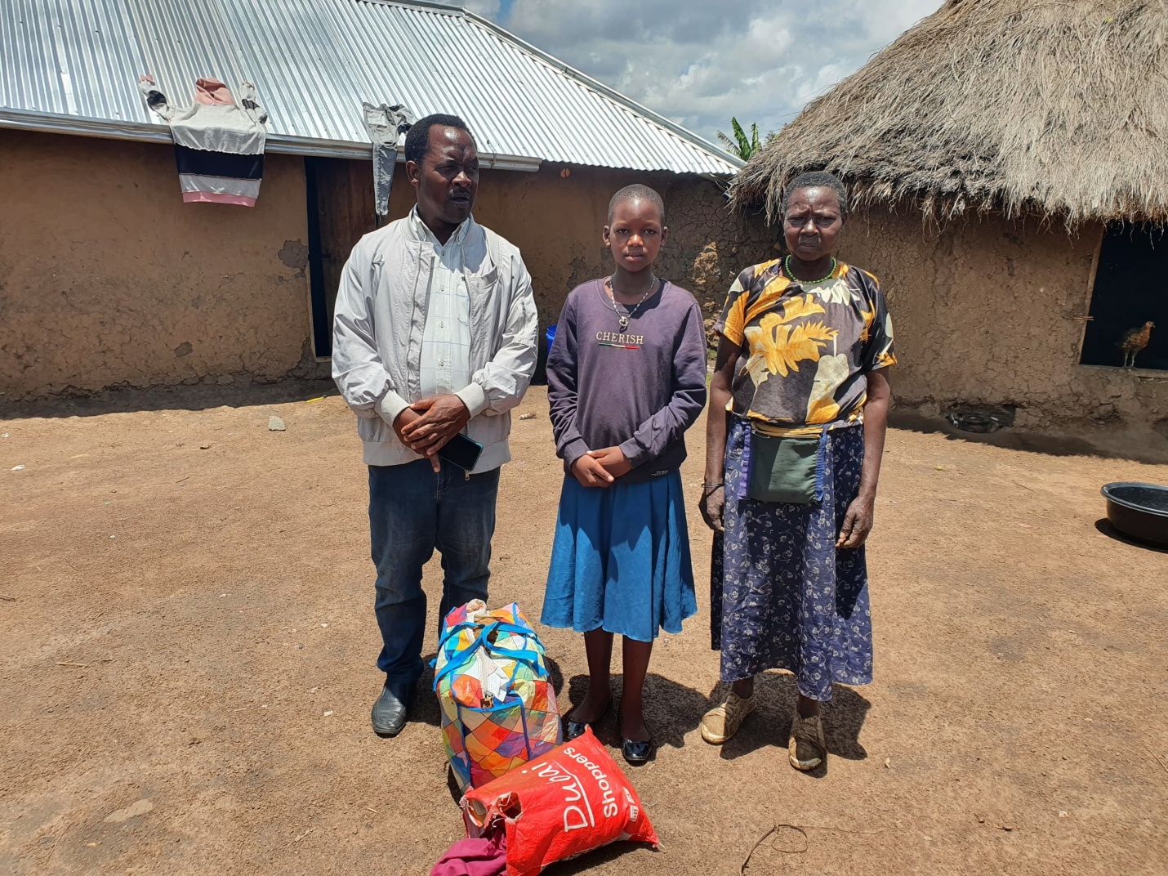Reconciliation process that involved HGWT staff, family, child, Social welfare officer, gender desk officer and local government authorities.
2.2. Education Support
- We managed to support the total number of 179 school children from primary level to colleges both day schooling and boarding schooling with the help from our donors with school materials such book, exercise books, pens, pencils, rulers, school bags, school uniforms etc during the school reopening after holidays in September 2026 and January 2026, in January 2026 5 children started their primary education level, 16 girls started their secondary journey. We have 9 girls who are pursuing their college and university studies, 3 who are at secondary advanced level, 76 in secondary education, 45 in primary education, 19 in vocational training and 5 who are still reading and counting prepared for next term.
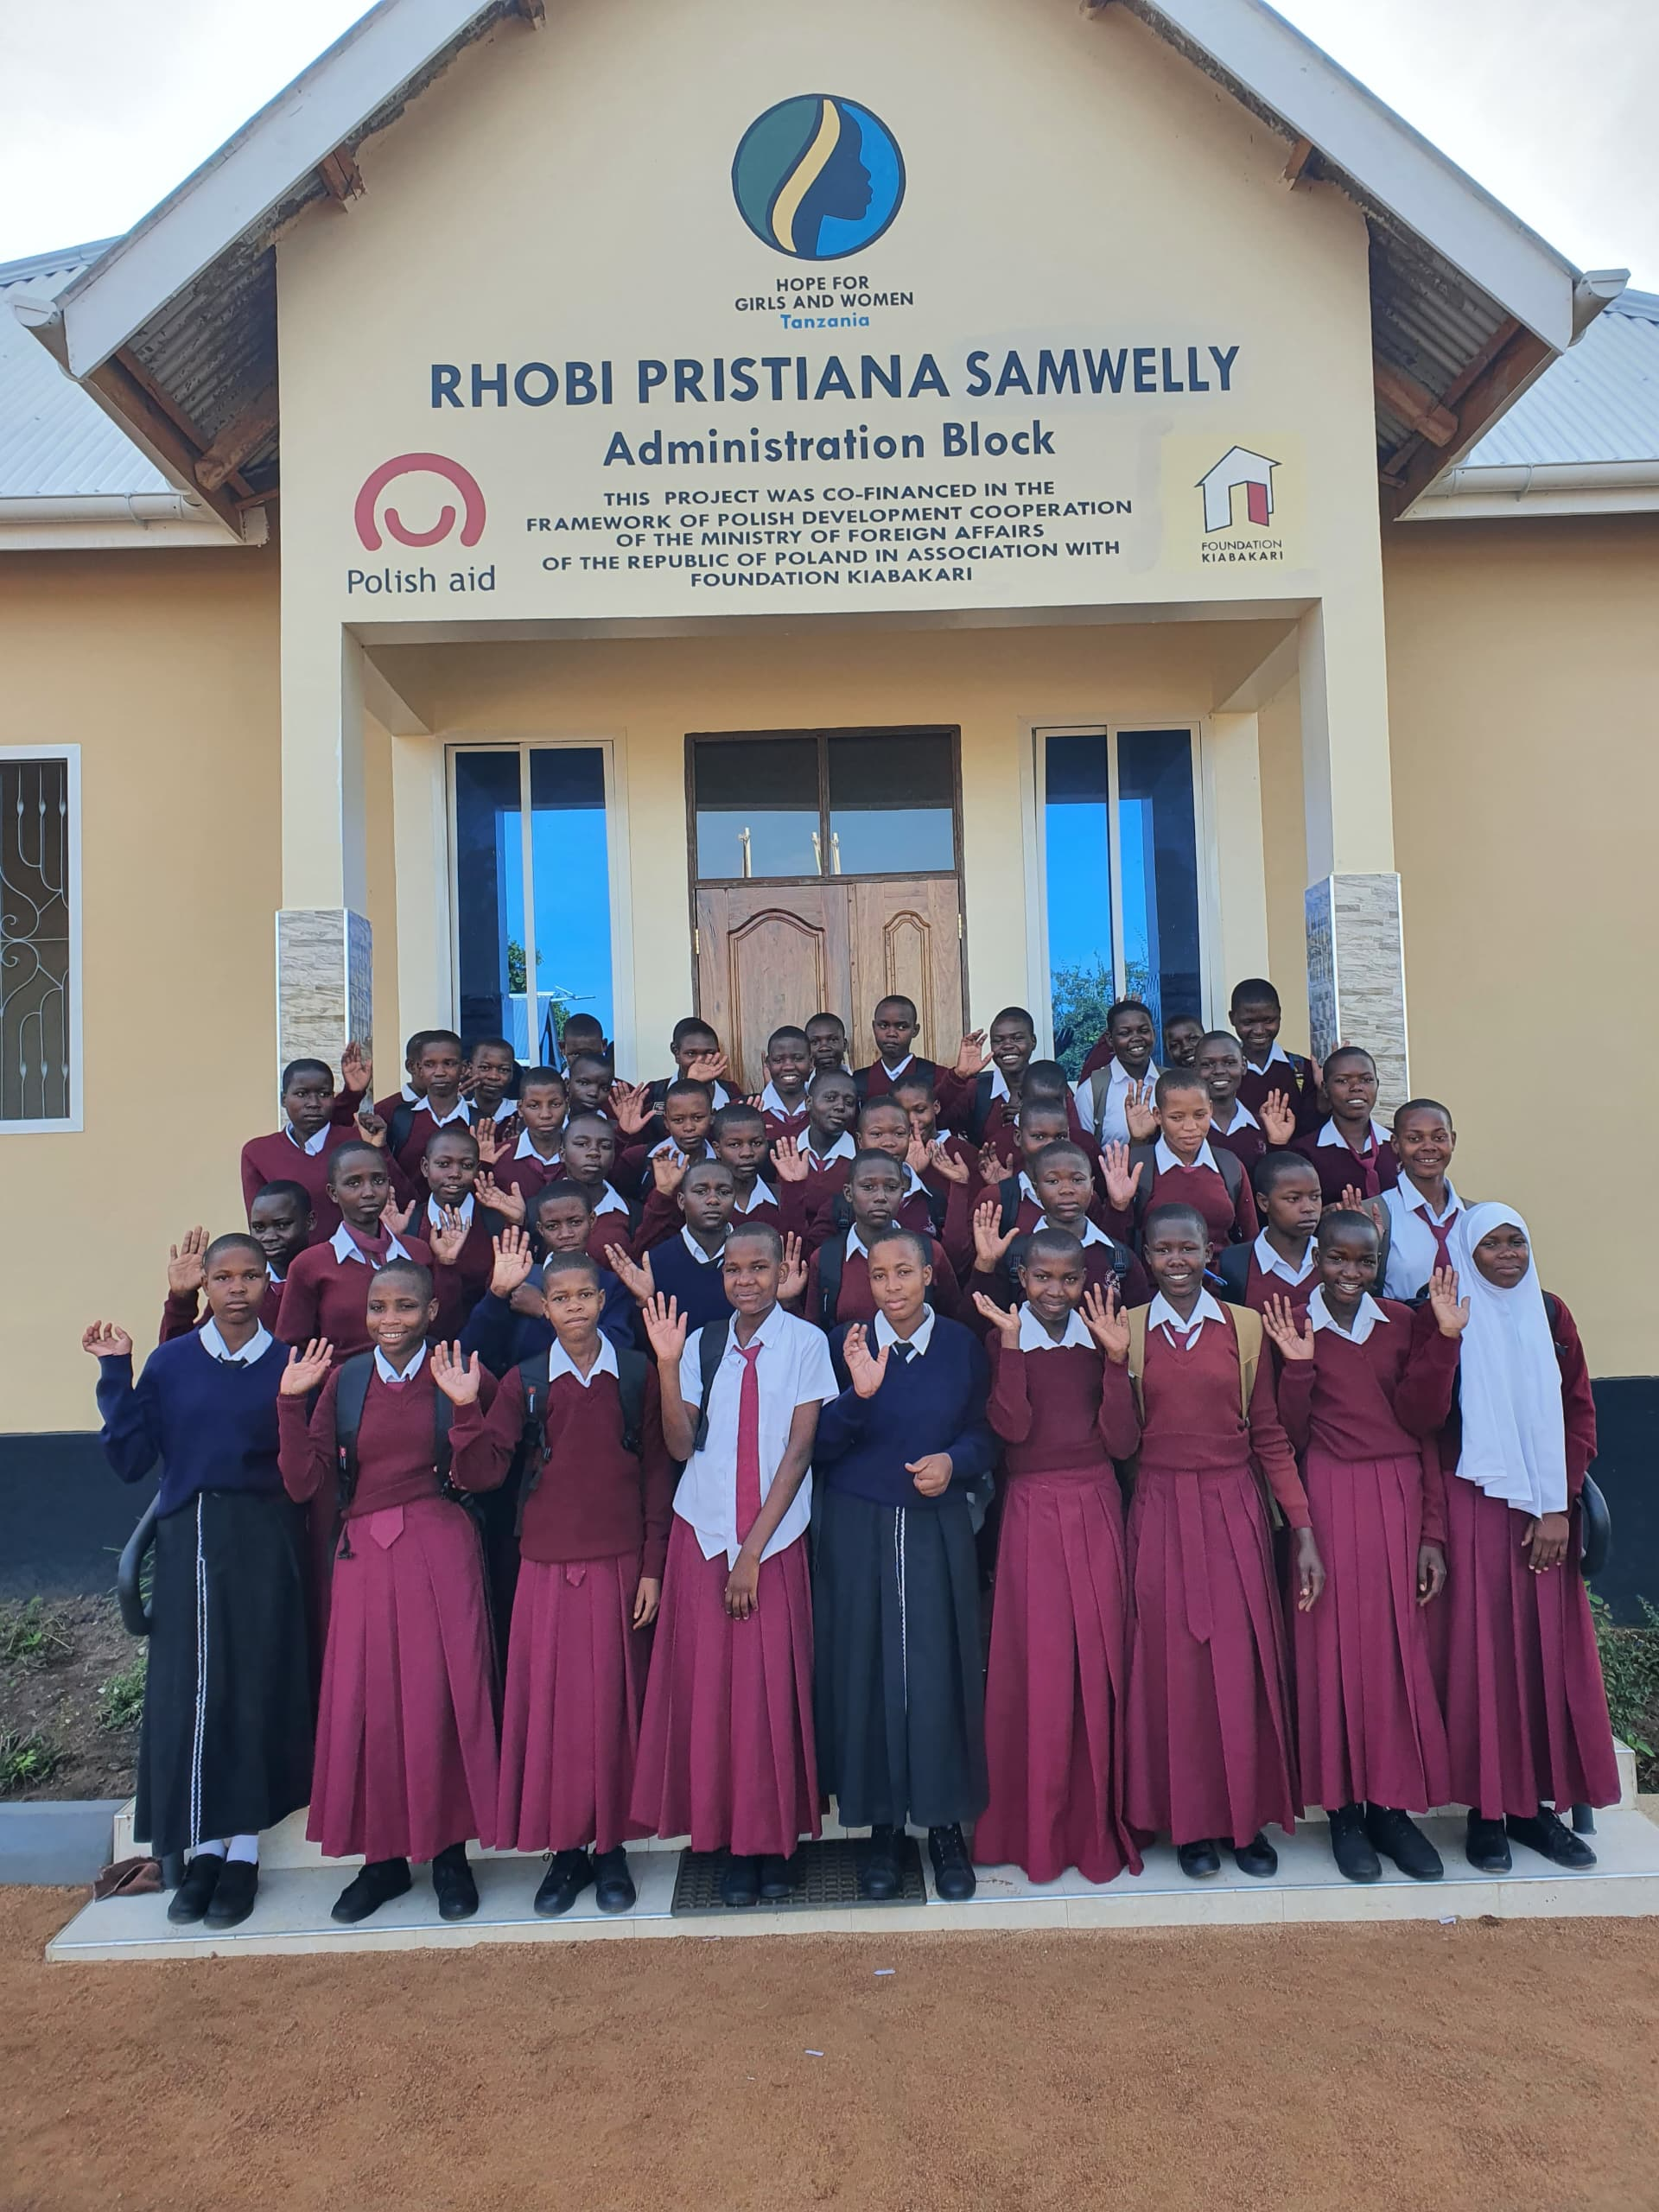
- Follow – up visits conducted in 4 secondary schools and 2 primary schools, aimed to follow up on the girl’s progress and assess their academic performance and discipline while at school as well as to continue fostering positive relationship between the organization and teachers. This is to ensure the development of a joint plan for nurturing these girls to help them achieve their dreams.
- Teachers reported 75% of supported girls showed improved academic performance compared to last term.
2.3. Vocational Training
- Beadwork & Jewelry: 12 girls trained and produced bracelets that was sold to Four Season Hotels, Mapito Camp and other individual visitors who visited our safe house in Mugumu
- The girls at the Butiama safe house also made various items such as hair clips and scarves using yarn. These items were sold to different stakeholders and the money generated was used to support other needs.
- Tailoring: 3 girls are continued with the tailoring training at Butiama safe house.
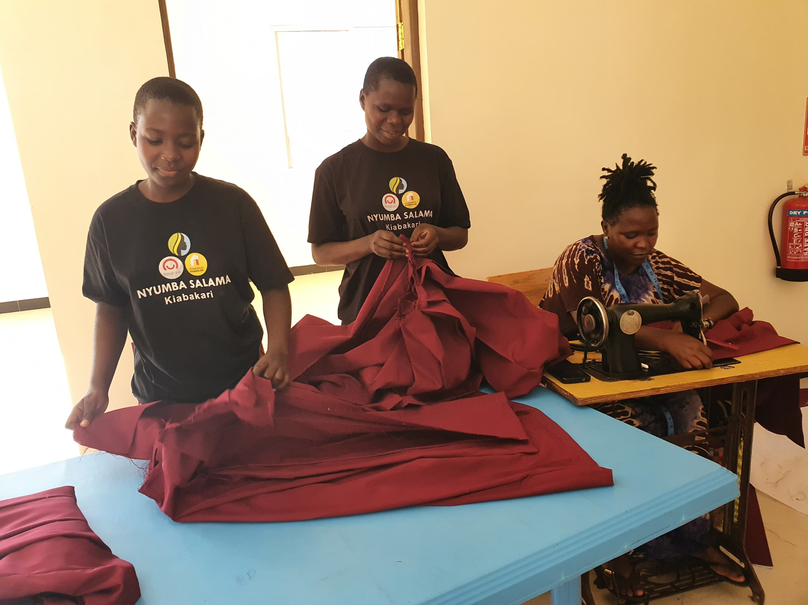Tailoring sessions to the girls at Butiama safe house
2.4. Agricultural Activity.
In our Sayuni Garden during these month, we manage to teach the girls to know on how to cultivate and plant different types of vegetables by using organic (without using chemicals) while at the safe house when they return home, they will have the know-how to plant a small number of vegetables for consumption or sale by using natural thing (organic thing). And in our 20 acres land we managed to plant maize and cassava to be used as food for the girls.

List of the vegetables got from our garden.
No | Verities Vegetable | Amount in KG
1. | Spinach (mchicha ) | 60kg
2 | Collard green | 60kg
3. | Tomato | 1600 kg
4. | African Nightshade | 30kg

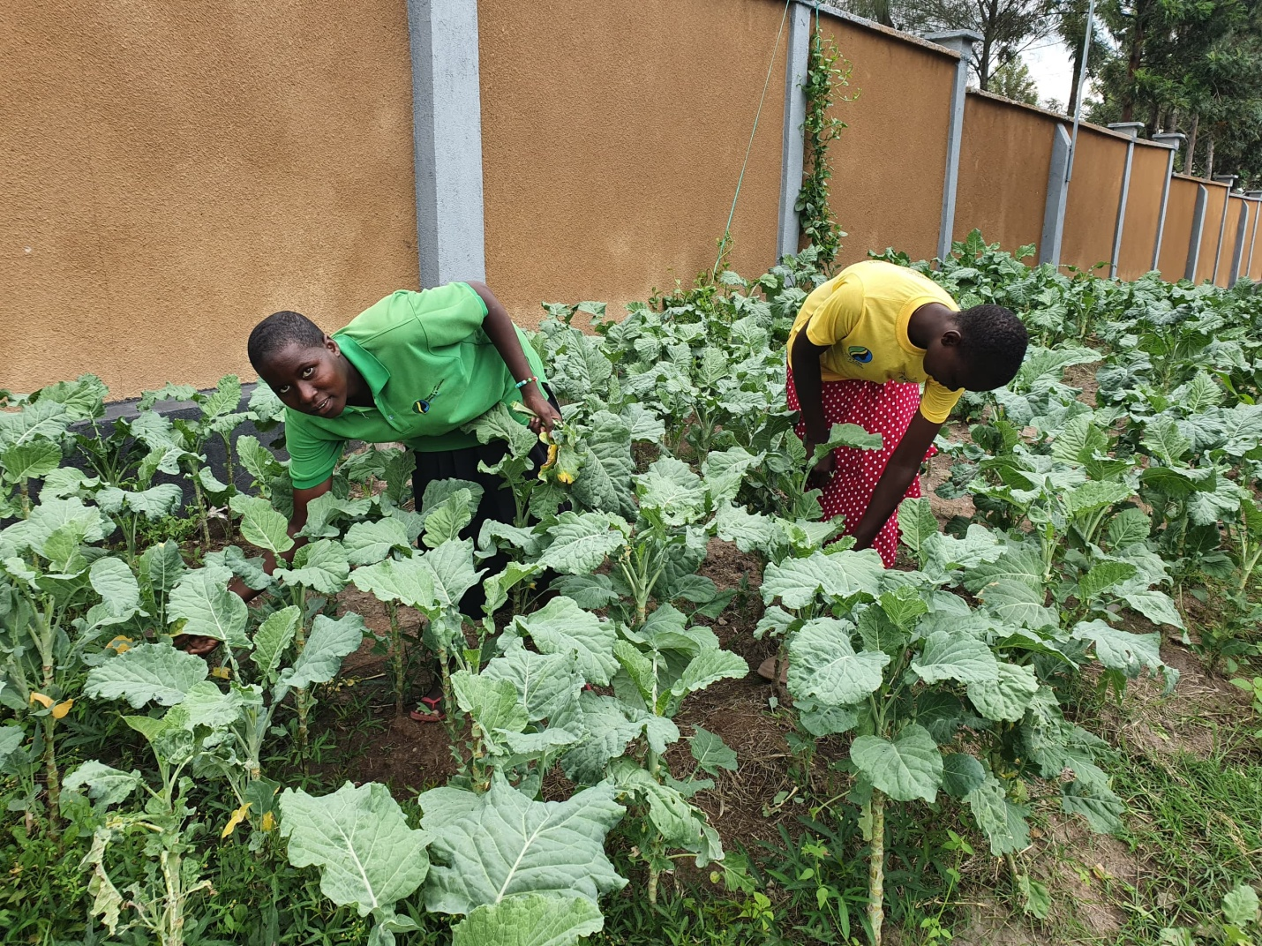The picture shows the girls picking vegetables to prepare their lunch.
2.5. Community Outreach & Awareness
- 5 community sensitization meetings held in Serengeti and Butiama District. The themes for these sensitization meetings were; FGM. GBV, child marriage and importance of girl’s education. These sessions reached 463 participants (186 men, 214 women, and 63 youth).
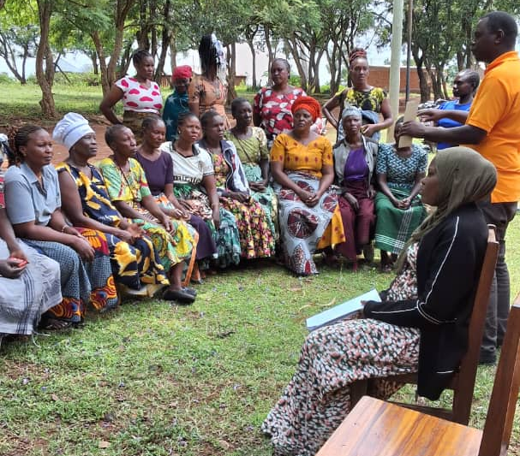One of the community sensitization awareness meetings

2.6. Partnership and Collaboration
During the period from February 2026 to May 2026, Hope for Girls and Women in Tanzania actively collaborated with various stakeholders in adavancing gender equality, child protection and the rights of women and girls.

One of the key activities was participating in the celebration of the international women’s day, organized in collaboration with other organizations and the Serengeti district leadership. During the vent, girls from the safe house were given an opportunity to perform educational songs that raised awareness about gender based violence and its negative impact on society. Their performance was warmly received and highly appreciated by community members and stakeholders.

The organization also participated in the launch of the National Symposium on Technology – facilitated gender based violence (TFGBV) which was organized through a partnership between the Government of Tanzania represented by the Ministry of Community Development, gender, women and special groups, UNFPA, Sema, Hope for Girls and Women in Tanzania and other key stakeholders. The symposium provided an important platform for discussing emerging forms of gender based violence and strategies for prevention and response.

We also participated in the National NGOs safe schools coalition, contributing to discussions and initiatives aimed at strengthening safe learning environment for children and adolescents.

In recognition of its outstanding contribution to combating gender based violence, including female genital mutilation (FGM), Hope for girls and women in Tanzania was honored with the legacy marker award 2026. This award acknowledges the organization’s leadership, commitment and impact in protecting the rights and well being of women and girls in Tanzania.

Additionally, Hope for girls and women in Tanzania had an opportunity to establish and strengthen a positive partnership with Mapito Camp. Representative from the camp continued to visit the Mugumu safe house, gaining a deeper understanding of the needs and challenges faced by the girls and the facility, as a result of this growing relationship, Mapito camp expressed its commitment to supporting the safe house by pleading to construct new buildings that will improve accommodation and services delivery for the girls. This partnership represents an important step toward enhancing the safety, well being and future opportunities of vulnerable girls supported by the organization.

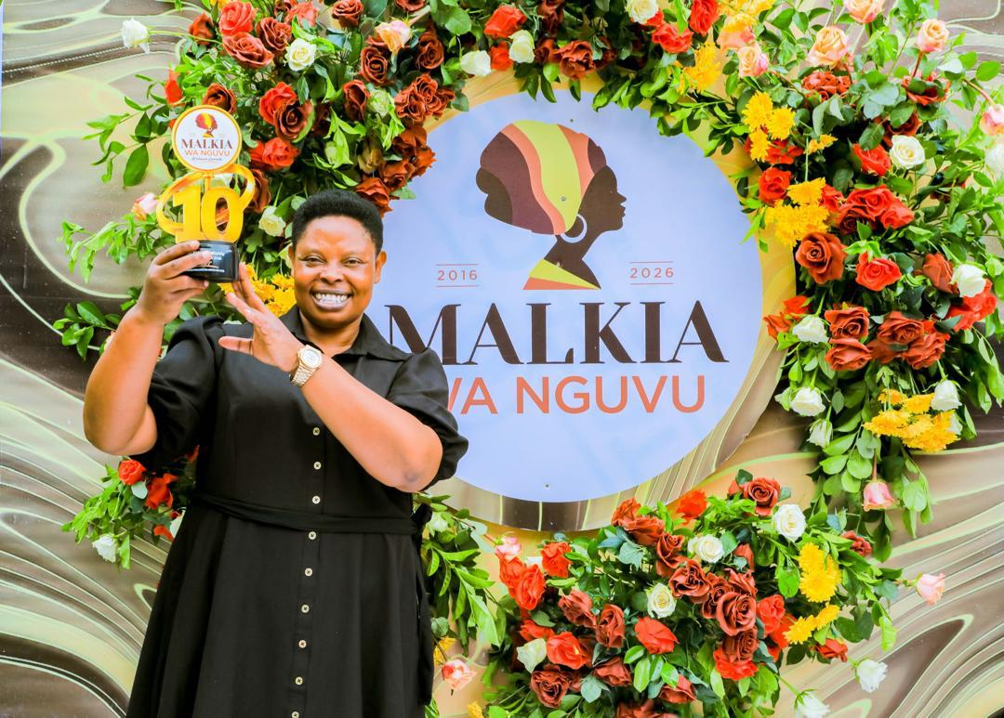

- Beneficiaries Reached (February 2026 to May 2026)
- Girls sheltered: 186 (10 new arrivals in five months).
- 19 girls were trained in vocational skills
- 463 community members reached through community awareness campaign
- Challenges Faced
- Shortage of sewing machines compared to the number of trainees.
- Some families remain resistant to anti – FGM messages
- Lessons Learned
- Engaging men and boys in awareness meetings reduces community resistance.
- Girls empowered with vocational skills gain confidence and independence.
- Collaboration with local leaders creates a safer reintegration process.
- Financial Summary (February 2026 to May 2026)
- Fund received: TZS 17,169,197
- Fund spent: TZS 17,169,197
- Safe houses operations (food, shelter, medical care):
- Education support(uniform, fees, scholastic materials):
- Vocational training(materials, trainers):
- Community outreach (transport, meetings, IEC materials):
- Administration/Other:
- Recommendation and Way Forward.
- Urgently mobilize additional resources to prepare for the 2026 FGM season.
- Expand ICT equipment to strengthen computer literacy
- Strengthen community outreach in remote villages with support from local government.
- Scale up economic empowerment programs to support survivor’s long term independence.
NB: In June 2026 to December 2026 a peak cutting season will be in place and we are expecting to receive many girls in our safe houses who flee away from FGM and child marriage.
- Stories/ Case studies
At just 16 years old, Joyce Chacha Mokoge has already faced challenged no child should ever endure. Born and raised in Nyamoko Village, Serengeti District. Joyce’s childhood was marked by hardship, fear and uncertainty.
Joyce lived with her biological father, stepmother and stepbrother. What should have been a place of safety and protection becomes a place of pain when her stepbrother began subjecting her to severe physical violence in an attempt to force her into an early marriage. The abuse become increasingly intense, leaving Joyce injured and living in constant fear for her safety and future.
Faced with the threat of losing her childhood, education and freedom, Joyce made a courageous decision. She fled from home and sought help from the police gender and children’s desk. Recognizing the urgent danger she was in, the police referred her to Hope for girls and women in Tanzania safe house in Mugumu.
When Joyce arrived at the safe house in 2023, she had just completed her primary education. For the first time in a long time, she found safety, care and an environment where she could begin healing from the trauma she had experienced. After spending one year at the Mugumu Safe house, Joyce was later transferred to the Butiama safe house, where she continues to receive protection, psychosocial support and educational assistance.
Today, Joyce is a form three student at kiabakari secondary school. Her determination to rebuild her life through education is inspiring. Despite the hardships she has faced, Joyce remains focused on her future and holds onto a powerful dream: to become a doctor.
Joyce’s story is a testament to the importance of safe spaces and timely intervention for girls at risk of violence and forced marriage. Through the support of Hope for girls and women in Tanzania, Joyce has been given a second chance not only to continue her education but also to dream again.
Her journey reminds us that when girls are protected, supported and empowered, they can overcome adversity and build brighter futures for themselves and their communities.

