MARY MOTHER OF PEACE-MEDJUGORJE CHARITY, INC.
8617 Irvington Avenue, Bethesda, MD20817-3603, USA. Tel: 1 301 530 5416; Fax: 1 301 530 3422
E-mail: mmpcharity@rcn.com ; Web: www.mmpcharity.org



SUMMARY ACTIVITY REPORT 2007

KEEPING HOPE ALIVE

1. In 2007, MMP-MC has pursued its mission to bring emergency relief to the poor, victims of natural disasters, refugees, war orphans, children and families in desperate need, helping beneficiaries of all faiths improve their living conditions and regain dignity, at home and overseas. MMP-MC brought relief in the form of food, food supplements, school supplies, shelter, money, educational training, medical and psychological assistance, and reconstruction of livelihoods with focus on India and Bosnia-Herzegovina this past year.
We closed programs in Argentina (successful life saving surgery for little girl Camila) and in Cambodia (poverty alleviation). In Afghanistan, Haiti, Mexico and the US, MMP-MC had mixed results or no progress due to limited budgets or no funding. MMP-MC strives to help disaster victims rebuild their lives. Beneficiaries, needs, costs and actions are clearly identified. Human development and relief activities are based on needs. Planned projects are reflecting this.
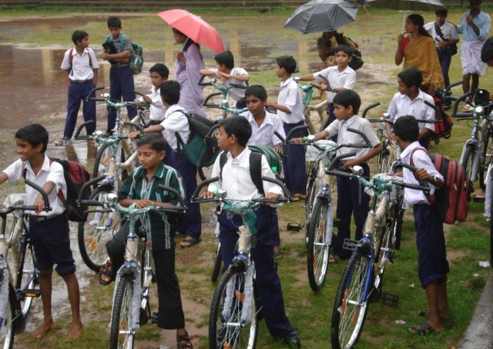
First delivery of bicycles to poor students in India

2. In 2007, Mary Mother of Peace-MC was active pursuing sustainable ongoing projects and responding to appeals for help. Annual cash funds collected, after increasing from US$16,916 in 2004 to US$42,954 in 2005, decreased to US$31,633 in 2006 and to a low $15,425 in 2007. To cash donations received in 2007 is added US$10,388 of donated services, i.e. a grand total of US$25,814 of contributions for the year. Most donations received are unsolicited. We will strengthen fund raising activities in 2007. Donors are partners.

3. Our 2007 program made progress along the lines of well-defined key priorities for 2007-2008 described in the previous annual report. With cash reserves at hand from previous years, total expenses in 2007 amounted to US$37,890, of which 94% went to final beneficiaries and 6% to administrative and fund raising cost. Resources were used to provide services to our core program and projects reaching about 450 beneficiary families and children. About 60% of funds used were for three active projects in India. MMP-MC performance ratio of management + fund raising expenses (US$2,416, a slight decrease compared with $2,601 in 2006) to total revenues for the year (US$26,042) deteriorated to 9.3% compared with 6.2% in 2006 due to reduced cash collection in 2007. However, less than 12% is an excellent performance according to best financial practices in the non-profit sector in the USA. Ratio is audited annually by MMP-MC tax return CPA. After seven years of existence, MMP-MC remains a small charity of less than $100,000 in annual revenues and expenses but each $ is used for its intended purpose.

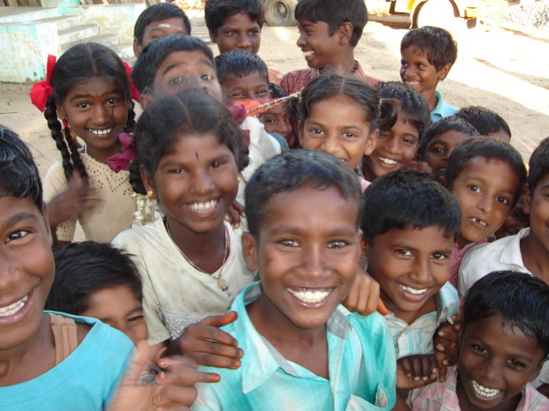 | 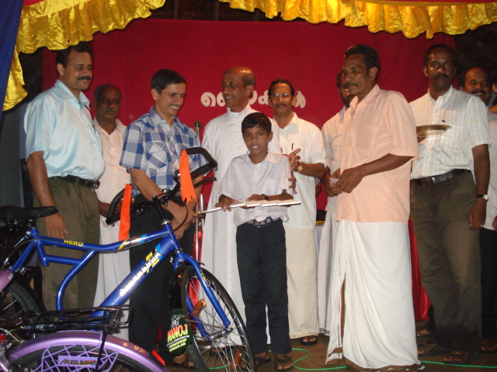
Post-tsunami children of hope Bikes distribution ceremony at the school

4. Our priority focus in 2007 has continued to be post-tsunami recovery in Southern India where we work in partnership with a reliable local NGO (see chapter A). Access to education is a key priority. God-parenthood program is operational in India and Bosnia (chapter B). Some poverty relief action and medical/ schooling assistance took place in Bosnia-Herzegovina, but did not restart in Mexico as planned for 2007-2008 (chapter D) because of lack of funding and volunteers. MMP-MC still has no active projects in Africa for same reasons, despite acute needs. In the US (chapter C), our local presence at the service of people in the Washington Metropolitan Area where we are based did not develop as expected these past two years due to limits and constraints of resources made available to us. God-parenthood program is open to also help war orphans in need. MMP-MC Board members and directors are unpaid volunteers.
A. POST-TSUNAMI RECOVERY IN INDIA

5. In India, priority focus this year has been to help a target of 300 poor children go to school in Kerala and a general population of about 400 people to rebuild their lives in 4 villages near Kochi and Chennai. Activities took place continuously all year, amounted to $23,423 and included:

(a) Providing a first delivery of 100 bicycles and pairs of shoes to 100 students --50 boys and 50 girls--to help them go to school in poor and flooded coastal areas of Kerala, India. Program will continue actively in 2008;
(b) Providing household utensils, clean water, food supplements, clothes, medical care, school supplies, sewing machines, and fishing nets to a target population of 400 villagers in Tamil Nadu and Kerala. New fishing boats are no more urgently needed;
(c) Repairing 6 homes and rebuilding 5 homes in Kerala and Tamil Nadu as part of ongoing post-tsunami recovery efforts;
(d) Sponsoring 10 poor children and helping 25 girls finish high school in Santhome, Chennai. Program will also continue in 2008.
(e) Protecting children’s life including medical assistance for a few critical cases, especially a chronically sick nine year old boy hospitalized in Bangalore because of brain damage, Michael Colin (now healed); and a two year old boy from Kerala, Joseph Enok whose needed life saving surgery was delayed by more than one year because the child got pneumonia. He was too weak to undergo open heart surgery in view of risks involved. Surgery is now planned for 2008. There is a 60 to 80% estimated chance of success. If not operated, the child is expected to die at a very young age. Decision is a tragic dilemma and responsibility for the parents and doctors.

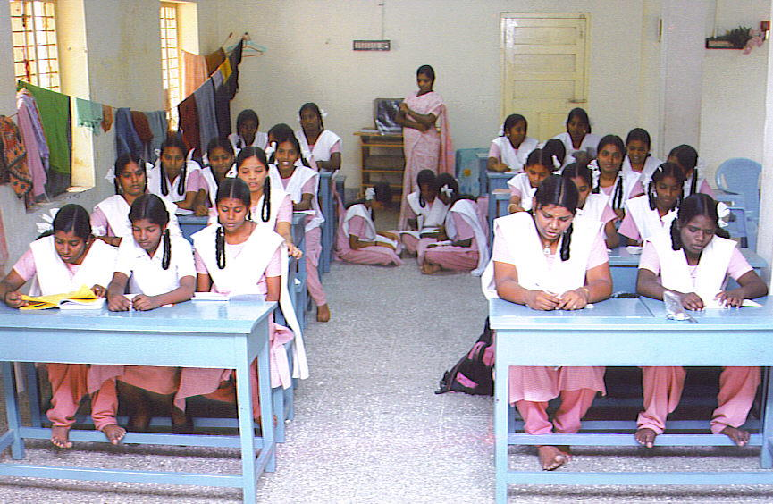 | 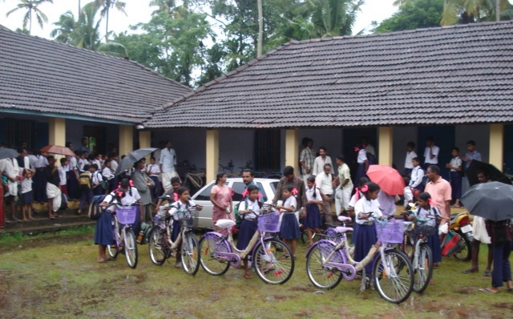
Tsunami affected high school students in Chennai Joyful girls with new bikes in Kerala coastal areas

6. Consolidated Results. Three years after the tsunami, most fishermen have resumed their productive activities to feed their families, which were left with nothing after the tragic disaster. Emergency relief has been practically completed at the cost of US$19,737 (2005-2007). It made a difference in the life of these families who were able to rebuild a livelihood in Tamil Nadu, Kerala, and Andhra Pradesh. Replacing destroyed fishing boats is no more needed as big donor agencies have given too many. Fishing nets are still occasionally given on a case by case basis. Andhra Pradesh component was completed beginning 2006. Special attention was given to ensure that the recovery effort does not exacerbate existing inequities and that all people being helped are on their way to a better and safer development path than they were prior to this tragic tsunami.

7. Specific Results in 2007. Community participation is essential to successfully rebuilding lives on a sustainable basis so as to improve living conditions beyond tsunami trauma recovery. A key priority since 2006 and for 2007 has been therefore home reconstruction. Other activities and services included, flood protection work at home,
village or population relocation at shelter level, medical/dental care, access to school for tsunami affected and other poor students and assistance to families in difficulty in Tamil Nadu and Kerala: clean water supply and electricity connection; food supplements; school tuition; medical assistance; clothing; small productive equipment; kitchen utensils, back to school items. US$7,970 has been spent on this updated program in 2007. Babu family home rebuilt in 2007
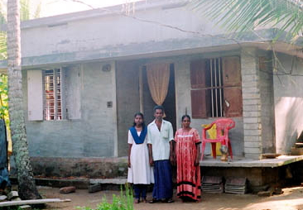

8. Slow Progress. Progress is still slow today because funds are needed (at least US$30,000 in 2008-09) to complete the planned activities. We seek another $35,000 ($20,000 in 2008 and $15,000 in 2009) for the bicycles project for students to help them attend school in poor isolated coastal areas prone to flooding. Project full implementation is possible thanks to the generosity of donors and all those who care, especially when the media are drawing attention to new calamities, and tsunami survivors are forgotten. Rebuilding a home is a long and painful process. Sending kids to school is costly. We are happy that many families are better off today. We still need to help a few. There are 20,000 families who are still homeless after the tsunami tragedy in India alone. Our target beneficiaries were about 400 families. We have helped about 50% of them so far.

9. Results are a continued success in 2007 for the God-parenthood program (see Chapter B): 10 children and nine families affected by the tsunami are currently sponsored (Cost: $550 per Godchild per year).
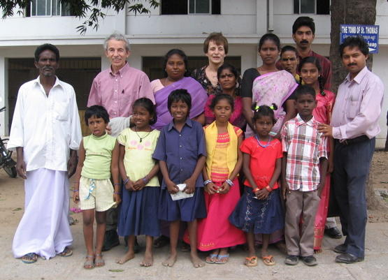

The project was able to help these children –boys and girls-- go back to school, to relocate their families out of relief camps and reunite two children with their mother. Families have now electricity and clean water.

10. Post-Tsunami Actions for 2008. Three years after the tragedy, as relief has given way to the long and difficult process of reconstruction, it is essential to continue to support the efforts of affected and/or forgotten communities in regaining some normalcy and rebuilding their shattered lives. Actions agreed for 2008 include:

- Pursuing and developing the successful God-parenthood program (US$5,500 for 10 children).

- Providing technical assistance for livelihoods recovery and continuing home reconstruction in tsunami affected areas. Focus since end 2006 was on five coastal villages, two in Tamil Nadu near the disaster area of Cuddalore; and three in Kerala along the coast North and South of Kochi: http://www.globalgiving.com/1055 , and an orphanage (action planned in 2008). Budget for 2008 is US$52,000. It includes medical assistance of US$8,000 for a few critical cases + Joseph Enok’s surgery, which was initially funded in 2006 and delayed till today because of risks (para. 5-e).

- Helping boys and girls go to school by providing them with at least 200 more bicycles. The first “Bicycles for Poor Students” project proposed for the coastal areas of Kerala near Azheekal has started successfully in 2007: http://www.globalgiving.com/1683 . Budget: at least US$20,000.

- Helping about 60 refugee families at Kannaki Nagar, this is a small village 30 kilometers (20 miles) away from Chennai in Tamil Nadu. It is the village/slum where the government relocated thousand of families who lost their houses in tsunami affected areas. Many are still living there under difficult conditions (no jobs, no electricity, no access to school and transportation, unclean water and just a few square feet to sleep on the floor). Proposed activities are to support 20 students; treat 5 persons in great need of medical care; provide paid city jobs to 10 unemployed rural head of families after training them; provide house maintenance needs to 20 families; and give marriage financial support to 5 girls (+ 5 girls in Kerala) to avoid their social exclusion and misery (US$475 for each bride). This action did not take off in 2007 for lack of funds. Budget needed for this program: US$15,500.

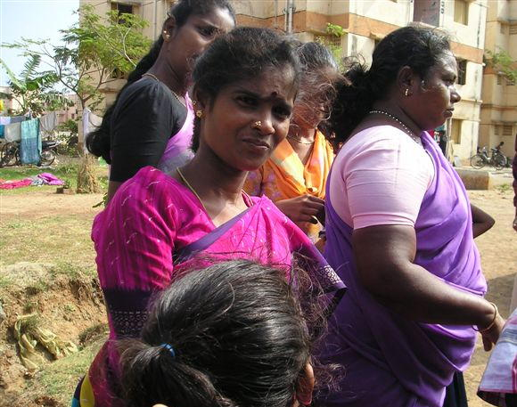 | 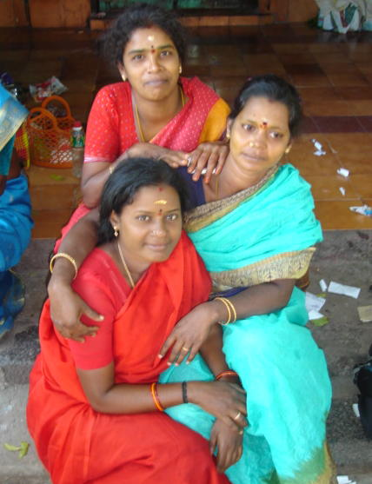

- Ensuring that the recovery effort does not exacerbate existing inequities
- Ensuring that all people being helped are on their way to a better and safer development path than they were prior to the tragic tsunami two years ago.

With a balance of $13,093 in the Charity account in Kochi end December 2007, total new funding needed for 2008-09 to implement the proposed activities and services in India (current and new) is about US$80,000 plus admin, volunteer travel and local supervision cost (10%). Some funds will be used for deserving poor people other than tsunami affected people.

11. Project management. The management of the projects and of the God-parenthood program in India is done by local volunteers under the supervision of MMP-MC and local partner Jesus Youth India/ Jeevana Samridhi (Life in Abundance).
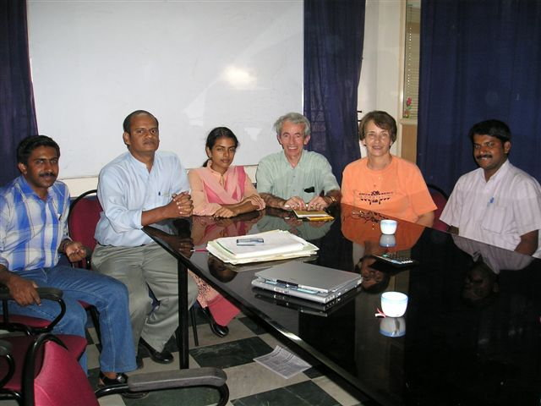
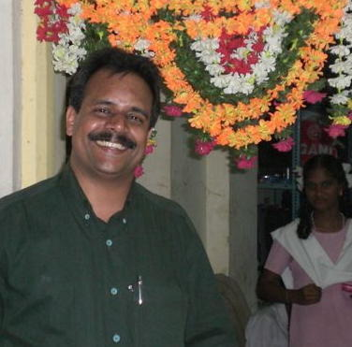
JS is JY’s new Charity arm recently registered in India. Key MMP-MC contacts are Manoj Sunny, International Coordinator of JY and Trustee member of JS; Berly Earnest, Coordinator of Relief Activities and Managing Trustee of Jeevana Samridhi; Mathew Sebastian, Field operations supervisor (picture on the right), and Dr. Edward Edezhath, one of the founders of JY and Trustee at JS, and Fr. Jose Narithookil, Chairman.

JY/JS are very professional and reliable partners. Their active presence on the ground is instrumental to: understand local situation and culture; bring appropriate solutions to the benefit of victim families and; use money properly while avoiding duplication of actions with other relief agencies or the government. Depending on funds available over time, project implementation will continue to be phased in gradually, and projects scope may be reduced or expanded accordingly. Global Giving Foundation in the USA is actively supporting joint projects of MMP-MC/JY/JS through some of its corporate sponsors and individual donors.

B. GOD-PARENTHOOD PROGRAM (India, Bosnia and USA)

12. MMP-MC is managing and continues developing a child sponsorship program (God-parenthood) for India, Bosnia-Herzegovina (BiH) and USA. A model contract is available. MMP-MC has a strong policy on the protection of children. In 2007 ten children of families affected by the tsunami were and still are helped. Three contracts are operational to support four Godchildren in BiH: two in Bosnia and two in Herzegovina. Benefactors from the USA, Canada and Europe are eligible.

13. When a child is identified for the program, the first step is to protect the child by bringing him/her in a place where he/she can be taken care of in a family-like and loving environment.
Helping a Godchild implies a tax deductible yearly donation of $550 for India; $660 for Bosnia-Herzegovina (picture in Mostar shows Terri, left, God-mother of boy Sabit with his sister and mother who is standing beside our volunteer Matthew); and $1,320 for USA payable in April or in two installments (April and September). Supporting a Godchild is therefore equivalent to a monthly donation of $50 to $100.
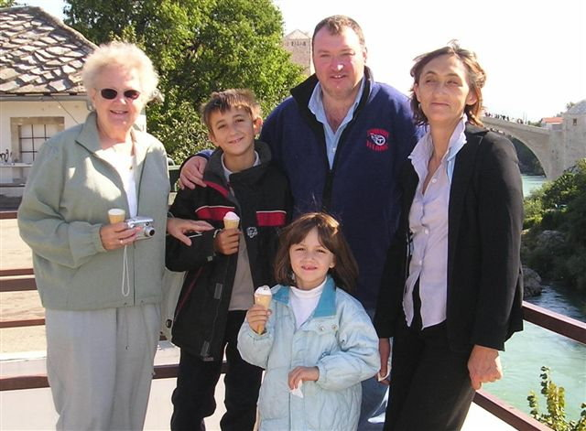

14. The program gives the Godparent(s) the right/obligation to influence the intellectual, social, cultural growth and development of the Godchild. The child is to be raised in a spirit of peace, justice and mutual respect. Godparents can also visit the child with the permission of the guardian, or the parent if child is not a complete orphan. The Godparent promises not to impose her/his religious belief if it is against the beliefs of the parent/guardian. A volunteer is needed to promote and supervise the program.

15. In the Washington Capital Area and nationwide, benefactors can help a war orphan/street child or a Katrina’s victim. Sponsoring a Godchild is a responsible and rewarding commitment and it helps also children go to school.

C. MMP-MC ACTION IN THE USA

Rebuilding Children’s Lives after Katrina

16. The two-year tentative program (2006-2007) to help a few children and their suffering families rebuild their lives in the aftermath of Hurricane Katrina with the support of corporate sponsors, and through a God-parenthood program sadly did not give results because of lack of sponsors and funding. As a consequence, MMP-MC was unable to provide useful services to any family in or from Louisiana/Mississippi disaster areas. The bad TV coverage on Katrina relief efforts because a few major relief/official organizations had wasted or unspent sizable financial resources did not help the cause.

Little Flower Project

17. Little Flower project to help US wounded service men and women and families who lost a loved one in Iraq or Afghanistan did not take off for various reasons including difficulties in identifying beneficiaries as a result of lack of institutional support. In 2007 we offered $2,000 to help wounded soldiers at Walter Reed Hospital (WRAMC). No response. This money has been therefore left untouched. In 2008, we plan to reallocate this money to help a school in Iraq that a US soldier has identified in Sadiyah near Baghdad and does not even have pens, paper and basic school supplies. Facilities are in disrepair. No electricity. Children of a catholic school in Bethesda collected some money for Christmas to start helping these Iraqi school children. MMP-MC plans to work with the mother of the US soldier to make this school project perhaps a reality if circumstances in Iraq permit. Our prayers go to all those who suffer and those who help.

Walk Across America

18. In 2007, MMP-MC supported again ($500) the annual educative activity of the Crossroads team that walks across America witnessing to the value of every human life.
This year 40 walkers participated: 30 American students, walked from the West Coast to the Capitol in Washington DC along three different routes starting mid-May in Los Angeles, San Francisco and Seattle; and 10 Canadians walked from Vancouver to Ottawa. Americans walkers were welcome at Capitol Hill by a Congressman and other personalities on August 11, 2007. These youth focused their summer entirely on prayer, sacrifice, witness to a culture and civilization of life in America, and helping suffering families along the way.
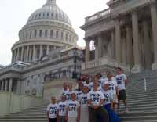

Other Activities and Services

19. Awareness and educative actions take place in some local high schools, churches, and community associations on what we do, with exhibits, presentations and conferences.
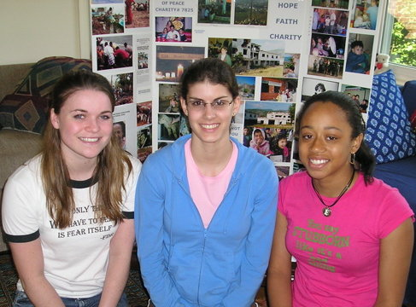
“Education is a necessary tool that is vital for the advancement of a nation and its people”, said these young volunteers during a school service day at the Charity’s office in Bethesda in 2006 (picture). We are also grateful to all the volunteers who helped the Charity in 2007.

20. MMP-MC was selected for the sixth year in a row to participate in the 2007 Combined Federal Campaign of the National Capital Area under designation CFC # 70490. We were invited to attend Federal agency charity fairs from September to beginning December. Our core program is also being promoted for a third year by Charitable Choices www.charitychoices.com . CFC funding in 2007 (Fall 06 campaign) brought to MMP-MC $3,173.31 of highly appreciated gifts as of February 2008. Thank you to all benefactors.

D. MMP-MC ACTION IN OTHER PARTS OF THE WORLD

Bosnia and Herzegovina (BiH) Orphans and Medical Assistance Program

21. Program in BiH has continued in 2007 in a reduced form and $3,445 has been spent to implement the core program including $45 to cover local admin expenses. Key actions that impacted positively the life of about 20 beneficiaries included:

(a) Children medical assistance program: The medical program to help injured children in need of reconstructive surgery and prostheses offered by generous US doctors was pursued less successfully in 2007 than in 2006 (program loosing steam more than 10 years after the end of the war);

(b) Mother’s Village orphanage: This family-like orphanage was developed and is run by the Franciscans in Bijakovici near Medjugorje. It is a model of children care and
protection in a loving environment. Our program for Mother’s Village in 2007 was aiming at:
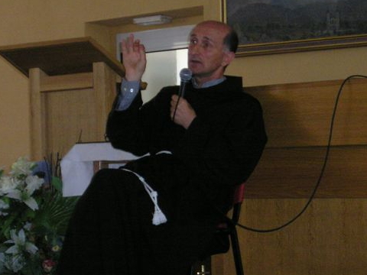
Assistance to handcraft workshop;
Some direct help for 10 children as needed;
Basic needs for winter, especially shoes; Training of staff for dental laboratory that MMP-MC equipped in 2004;
Fr. Svetozar, orphanage Director

(c) Job generating project/activity: no progress in 2007. Still to be refined; and

(d) God-parenthood program: ($2,400 provided for 4 children, see chapter B).

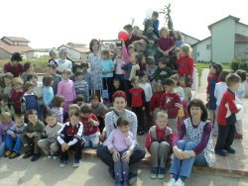 | 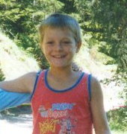
War orphans at Mother’s Village in Bijakovici God-child Danimir, sponsored by MMP since 2007

22. Implementation of these actions will be pursued actively in 2008 and results will depend on financial resources made available for them. Target funding is US$10,000.

Afghan Refugees Program

23. Our emergency program to help Afghan refugees, especially children and women both inside and outside Afghanistan is closed. Action continues directly on a case by case basis after careful screening. It is limited to help a medical student, Raza Khan (pro-American) with tuition and books at King Edward Medical College in Lahore. KEMC provided a Bonafide Certificate for the student.

Haiti Children Program
24. The focus of the project is on basic education of poor children. A donation of $500 was made to School Lamardelle in 2005. As funding is now lacking, the component aiming at improving the precarious living conditions prevailing in Haiti did not materialize since 2006 (no funding and no results in 2007).
Argentina Children Medical Program
25. The program was initiated in December 2005 and closed successfully in December 2006. This special action launched in response to an emergency appeal to help a 12 years girl in Mendoza, Argentina, Camila, in need of life saving spine reconstructive surgery. No activity in 2007 (follow-up e-mails only).

Mexico Poverty Relief and Children Protection Program

26. Project second phase to develop revenue-earning activities for the poor was closed for lack of progress and results. First phase of the project was completed end 2005 at a cost of $2,255 including two wheelchairs and relief aid to six poor families and 25 children in the town of Coatepec Harinas. A reassessed program may be revitalized in 2008 in same town or in a new geographic area where poverty prevails.

27. The impact of our programs and services when delivered is positive. Suffering families helped can rebuild their lives and livelihoods, improve health conditions (children’s medical program is active), and also improve access to school for their children both boys and girls, key to the future.

28. We are grateful to our donors, sponsors, benefactors, volunteers and Board directors and advisors who are all partners. At MMP-MC, individual donors are unsolicited people of goodwill and all faiths. They include friends of Medjugorje in the USA. MMP-MC humanitarian action overseas and at home depends on all of them. We pray that God will bless you all with his peace and love and bless those in need you help keep their hope alive.

Bernard and Claudine Dussert
____________________________________________________________________
The humanitarian non-governmental organization (NGO) MMP-MC, Inc is a 501(c)3 tax-exempt non-profit charitable organization helping war orphans, homeless children, natural disaster victims, poor families and refugees of all faiths improve their livelihoods and education overseas and at home, rebuild their lives and regain dignity. This mission and faith-based, independent organization, with headquarters and local presence in the Washington metropolitan area, relies on volunteers as Board members. CFC designation # 70490

Donations: If you wish to help with our mission and emergency relief and development program, make your check payable to Mary Mother of Peace-MC and mail check to MMP-MC, 8617 Irvington Avenue, Bethesda, MD20817-3603, USA. Donations are tax deductible. Ask for matching gifts from your employers. We are also looking for corporate sponsors to cover our cost-efficient administrative and fund raising expenses. For bank transfer, please wire funds in US$ at: Bank-Fund Staff Federal Credit Union, Washington DC, ABA # 2540-7417-0 for credit to Mary Mother of Peace-MC’s account # 383 610-S8. Thank you for helping break the cycle of poverty for a lifetime and bringing peace to the world. For more information, and to make secure donations on-line, visit our Web site at www.mmpcharity.org .

Board Members of MMP-MC are:
Claudine Dussert, Ph.D. President, 8617 Irvington Avenue, Bethesda, MD20817-3603; Tel 301 530 5416
Frank Dunn, Vice President, 6248 NE Brighton Street, Hillsboro, OR97124; Tel: 503 640 6704
Heide Sedwick, Ed.D. Director, 614 Blair Street, Portage, PA15946; Tel 814 736 3892
Bernard Dussert, Sec’y/Treasurer, 8617 Irvington Avenue, Bethesda, MD20817-3603; Tel 301 530 5416
Gina Leib, Director, 11835 Goya Drive, Potomac, MD20854; Tel 301 545 0351
Martha Nolan, Director, 9515 Gerwig Lane, Suite 109, Columbia, MD21046-1023; Tel 301 467 9259
Suzanne Bowler, Ph.D. Director, 10106 Bexhill Drive, Kensington, MD 20895; Tel: 301 946-0990

Volunteer part-time Administrative Officer:
Mary Levering, 3508 Leland Street, Chevy Chase, MD20815; Tel (h) 301 656 5346, (w) 202 707 8376

MMP-MC has also an Advisory Board of talented VIPs and caring personalities.

“NURTURE PEACE LIKE A FLOWER WHICH IS IN NEED OF WATER, TENDERNESS AND LIGHT”

with volunteer Matthew Procter and in partnership with the British NGO Miracles

